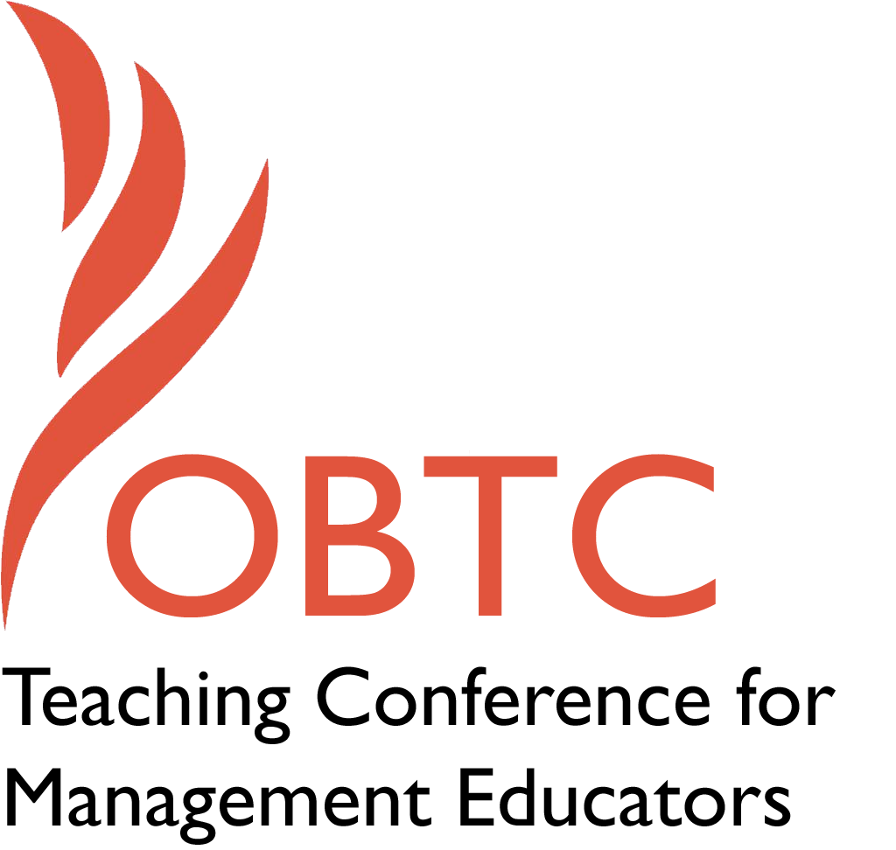

OBTC 2015 at University of La Verne
June 17th – 20th, 2015

Submission Template

SUBMISSION GUIDANCE
* Remove all identifying properties from this document *
* All files must be saved in PDF format *
*Please include ALL supplementary text at the end of this document* *Only one document should be submitted*

Submission Template for the
2015 OBTC Teaching Conference for Management Educators

- Title of Proposal:
Creating a Course Assignment On Building Community with Alumni

- Abstract:
Please include a brief session description (not to exceed 100 words).If your proposal is accepted, this description will be printed in the conference program.

Alumni are an important part of any university. They offer not only a source of funding, but they can become mentors, coaches and exemplars to our current students.

Rather than have session participants develop ideas about how to strengthen the bond between students and alumni, in this session participants will work together to develop a classroom assignment/project so that our students can discover/develop their own creative ideas and plans on how to build community with alumni.

- Keywords:
Use three or four keywords to describe your session.

Student-alumni community, course assignment development, student-alumni networks

- Format
X Activity or exercise
Discussion roundtable (60 minute only)
General discussion session

- Time Requested:
30 Minutes
60 Minutes (Roundtables must select 60 minutes)
X 90 Minutes

- Planning Details:
Does your session have any special requirements for space or materials?

A room with a large whiteboard(s) and/or two or three flipchart stands with chart paper.

- Learning Objectives or Goals for the Session:
What are 2-4 specific learning outcomes that participants will get from your session?

Using a handout on best practices developed by the session facilitator as a discussion guide, participants will discuss and share the methods/techniques/best practices they have found useful when designing class projects/assignments for their courses.

Participants will also work together toward developing a class assignment on building community with alumni that will include learning objectives, assignment purpose and outcomes, assignment description and (if time) a grading rubrics. A variety of options/alternatives will be discussed to fit different class situations and composition of students (undergraduate, graduate students, classes with all international students, etc).

Developing a strong bond with alumni can provide students with numerous opportunities in terms of jobs and internships, as well as coaching and mentoring opportunities. It is hoped that using the assignment developed in this session, the ideas and plans students themselves create will be shared with administrators and faculty in their own universities in order to create and develop strong communities with alumni.

- Management or Teaching Topics:
Describe what management and/or teaching topics are relevant to your session, and why. Please include theoretical, disciplinary, or theoretical foundations that will help reviewers understand how your ideas fit within the broader field of management.

Teaching topics include:
• best practices for developing clear, well thought out assignments/class projects. Using research on best practices, as well as strategies/techniques developed by session participants, members may gain some new knowledge and/or be able to streamline their own process when it comes to developing new assignments/projects for their classes.
• diverse student population in the classroom/student composition. We will discuss alternatives and options for this assignment based on level of student (what might be included/adjusted/changed to fit a class of graduate students, for example).
• the pros and cons of team versus individual assignments

Management topics relevant to this session include:
• Social networks. The assignment that will be developed will focus on building stronger bonds/networks/ community between students and alumni.

- Session Description and Plan:
What will you actually do in this session? What activities will you facilitate, how long will they take, and how will participants be involved? Reviewers will be evaluating how well the time request matches the activities you’d like to do, and the extent you can reasonably accomplish the session’s goals. Reviewers will also be looking for how you are engaging the participants in the session. Include a timeline for your session.

For a 90 minute session:
(20 minutes) The session will begin with a discussion of best practices for developing course assignments/projects using a handout developed by the session facilitator as the basis for discussion. Participants can add any “best practices” they themselves have developed, as well as discuss the process they go through to create new assignments/class projects (i.e. the use of mind-maps, etc.).

Within this timeframe, participants will also discuss what the important/necessary features/sections/ components of a course assignment are (for example, learning outcomes, assignment description, rubric, etc). Participants will then develop an outline of the important sections to include for an assignment about building community with alumni (i.e. purpose, learning objectives, etc.). This outline will be used as a template as participants work on assignment development.

How the next part of the session will be run/managed will depend on the number of attendees.

Small Number of Attendees (10 and under)
(65 minutes) If the group is small, the participants will all work together on the develop of a generic version of the assignment. Then the last 10 minutes of this part of the session is a discussion of possible alternative ideas/options (for example, what should/could be changed to fit a class of graduate students, what might be included in such an assignment if we teach a large number of international students and have many international alumni, etc.).

(5 minutes) Wrap up and Q&A

Larger Number of Attendees (more than 10)

(50 minutes) If the group is large, the participants will be broken up into small groups. (Groups may be divided up, for example, based on whether they teach undergraduate or graduate students. The exact composition in terms of membership within these groups will be discussed prior to their formation.) Each of these small groups will begin by using the same outline/template developed earlier in the session, changing that template if needed to fit their specific class composition.

(15 minutes) Sharing information/ideas from smaller breakout groups.

(5 minutes) Wrap up and Q&A

- For Activities and Exercises:
Attach any materials needed to run the activity and debriefing questions. Evidence for effectiveness may also be included.

A handout on best practices for developing assignments/class projects and grading rubrics will be developed for this session. Sources include:

• Angelo, T.A. and Cross, K.P. (1993) Classroom Assessment Techniques. NY, NY: Jossey-Bass.
• Baine, K. (2004) What the Best College Teachers Do. Cambridge, MA: Harvard University Press.
• Gross Davis, B. (2009) Tools for Teaching. NY, NY: Jossey-Bass.
• McKeachie, W.J. and Svinicki, M. (2013) McKeachie’s Teaching Tips: Strategies, Research, and Theory for College and University Teachers. (14 ed.) Cengate Learning

• Nilson, L.B. (2010) Teaching at Its Best: A Research-Based Resource for College Instructors. NY, NY: Jossey-Bass.

- Implications for Teaching or for Teachers:
What is the contribution of your session?

This session will provide both new and experienced instructors with best practices/new methods and ideas for developing class assignments and course projects. It will also provide participants with a template they can use for other course assignments/class projects they might wish to develop.

An additional “take away” will be the development of an assignment for the OB classroom which focuses on building bonds and community between students and alumni. This assignment would connect with course information about building/developing social networks, mentoring relationships/opportunities, career development, etc.

As mentioned earlier, it is hoped that using the assignment developed in this session, the ideas and plans students themselves create/develop will be shared with administrators and faculty in their own universities in order to create and forge strong communities between students and alumni.

- Application to Conference theme:
How does your session fit with the overall OBTC theme of Learning in Community?
It is hoped that using the outcomes from the assignment developed in this session, ideas and plans students themselves create/develop will be shared with administrators and faculty in their own universities in order to create and develop strong communities between students and alumni.

- Unique Contribution to OBTC:
Have you presented the work in this proposal before? If so, how will it be different? Is this proposal under current review somewhere else? If so, please explain. How will your proposal be different for the OBTC conference?

No, I have never presented this idea/session at another conference before.
- References and/or Additional Materials:

A handout on best practices for developing course assignments and class projects will be created specifically for this session. The handout will be used as a guide for discussion. A few of the sources that will be incorporated into this handout are mentioned earlier in this proposal.

