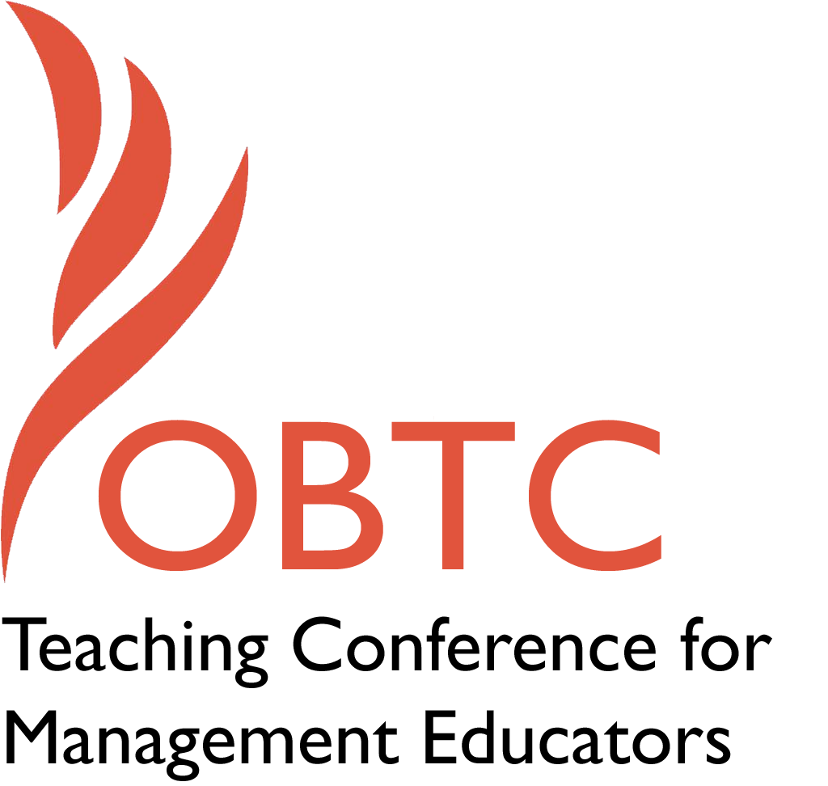

OBTC 2015 at University of La Verne
June 17th – 20th, 2015

Submission Template

SUBMISSION GUIDANCE
* Remove all identifying properties from this document *
* All files must be saved in PDF format *
*Please include ALL supplementary text at the end of this document* *Only one document should be submitted*

Submission Template for the
2015 OBTC Teaching Conference for Management Educators

- Title of Proposal:
Encouraging students to craft their work: Exploring the value of friendships in small learning communities

- Abstract:
Social learning theory, as well as research on informal learning, suggests that one of the most important ways students learn is through collaboration. We suggest that as social learners, students who experience friendships in their project team will engage in more job crafting, a specific type of proactive behavior. Our research finds that student job crafting is more prevalent for students with friends on their team because of the increased commitment and open discussion they experience. Participants in this session will engage in a powerful discussion regarding the implications of allowing students to work with friends as well as ways to create a classroom culture supportive of job crafting.

- Keywords:
Use three or four keywords to describe your session

Job crafting, commitment, friendships, communities

- Format
Activity or exercise
Discussion roundtable (60 minute only)
X General discussion session

- Time Requested:
30 Minutes
X 60 Minutes (Roundtables must select 60 minutes)
90 Minutes

- Planning Details:
Does your session have any special requirements for space or materials?

No

- Learning Objectives or Goals for the Session:
What are 2-4 specific learning outcomes that participants will get from your session?

- Participants will gain knowledge about the value of friendships in student work groups in terms of increased job crafting.
- Participants will gain knowledge about potential tools to encourage job crafting, commitment, and open discussion in the classroom.
- Participants will gain knowledge about the implications of group formation decisions, such as allowing students to form their own teams in the classroom.

- Management or Teaching Topics:
Describe what management and/or teaching topics are relevant to your session, and why Please include theoretical, disciplinary, or theoretical foundations that will help reviewers understand how your ideas fit within the broader field of management.

The use of collaborative learning groups (CLG) has recently begun to attract the attention of instructors and researchers who are interested in the potential benefits of pedagogical strategy. As a type of community of learning, CLGs are thought to promote collaboration, a competency which is necessary to perform effectively within today’s knowledge society (Wang, 2009). As a result, group work in the classroom is a popular instructional method.
The practicalities associated with group work in the classroom are many. Instructors face issues of task assignment, group composition, and methods of formation, to name a few (Mitchel, Reilly, Bramwell, Solnosky, & Lilly, 2004). For instance, instructors must decide whether to use a teacher-selected method or a student-selected method to group students. Given a choice during group formation, students will choose their friends and similar others as group members (e.g., Mitchell et al, 2004; Rienties Heliot, & Jindal-Snape, 2014). However, maximizing diversity through the formation of heterogeneous groups is thought to lead to benefits in achievement. Thus, a teacher-selected approach is supported by many learning models because it allows for instructors to maximize diversity of gender, race, and other qualities (Cohen & Lotan, 1995). This heterogeneous grouping is also seen as a way to reduce the likelihood that some students will feel alienated during the group selection process, and the consequences this perceived alienation may have (Mitchell et al., 2004). Yet, there are benefits associated with student-selected groups consisting of friends. Poulin and Denault (2013) found that having friends in organized activities outside of the classroom led to lower problem behavior and higher academic functioning. A recent study in Singapore found that in a collaborative learning environment created by allowing students to select group members based on friendship, both individual accountability and positive interdependence were promoted by the existence of friendships (Wang, 2009). The decisions about group formation should be based on the consequences of the approach used on relevant learning outcomes such as performance on group related assignments or creativity, as well as social and psychological outcomes affecting students.
Our study expands on existing literature examining student job crafting as an additional benefit of student-selected teams consisting of friendships. Research on job crafting, and proactive behavior in general, is surging in the OB literature as the modern work environment continues to become more fast-paced and complex, (Harrison, Johns, & Martocchio, 2000) and companies are depending on employees to be proactive, adaptable, and resourceful and to solve new problems autonomously (Reinhardt, Schmidt, Sloep, & Drachsler, 2011). Job crafting, a type of proactive behavior, occurs when individuals alter the boundaries of their work and shape work practices to better match their own interests, preferences, and competencies (Leann, Appelbaum, & Schevchuk, 2009; Wrzniewski & Dutton, 2001; Orlikowski, 1996). In essence, group members proactively work together to initiate changes and re-frame their work (Tims & Baker, 2010). Rather than passively reacting and doing what they are told, they will begin to customize their work to better meet their needs and abilities (Wrzesniewski & Dutton, 2001). In the work setting, job crafting has been shown to increase worker motivation, engagement, satisfaction, and performance (Tims, Bakker, & Derks, 2012).
Although prevalent in the OB literature with respect to employees and their jobs, job crafting has yet to be explored with respect to students and their coursework. We should expect students to craft their work within the prescribed parameters of the assignment in the same way that employees craft their work within the designated boundaries of the job. For example, students might experiment with a new way of performing their work that was not explicitly suggested by an instructor, or they might use additional resources for their group project that were not mentioned by the teacher. More specifically, students might write a song or poem to present the material or dress in costume, even if it is not required for the assignment. Incorporating their own personal beliefs and talents from outside of the classroom into the group project represent ways that students craft their work within the boundaries of an assignment.
In addition to the lack of research on student job crafting in a university setting, the research we have seen in the area of group formation has been conducted primarily in secondary schools and not a University setting. Our research expands upon and joins together these two streams of research. We used a sample of 86 students, each of whom completed two surveys to test our hypotheses. Analytic findings support our hypotheses and suggest that friendships in student groups enhance commitment and open discussion among team members, which results in increased job crafting. In other words, friendship has an indirect effect on job crafting through the mediating mechanisms of student commitment and open discussion. We emphasize that the value of both friendships and job crafting in the University setting need further attention from both researchers and practitioners. The results of our study should provide an increased understanding of the value of friendships and the mechanisms through which friendships increase job crafting.

- Session Description and Plan:
What will you actually do in this session? What activities will you facilitate, how long will they take, and how will participants be involved? Reviewers will be evaluating how well the time request matches the activities you’d like to do, and the extent you can reasonably accomplish the session’s goals. Reviewers will also be looking for how you are engaging the participants in the session. Include a timeline for your session.

The first ten minutes of the session will be spent presenting the results of our study which examined the value of friendships in classroom teams on outcome behaviors such as job crafting. This will include an explanation of the variables included in the study, such as job crafting, friendship, commitment, open discussion, and project teams or communities of learning.

We will then ask participants to get into small groups for about 15 minutes to consider our first discussion point.

- Given the nature of jobs today where students will be expected to productively handle ambiguous situations or assignments and take ownership of their work, it is important that management educators are providing students with similar experiences in the classroom.
- What are some ways that management educators can enhance job crafting among their students?
- How might management educators increase crafting by facilitating open discussion and commitment among teams in the absence of friendships?
- What are some things that management educators might be doing that hinder student job crafting?

After the small group discussions we will spend the next 10 minutes having a whole group discussion about this topic by asking each group to share their ideas. Once the groups have shared their ideas, about half way through this time, we will pass out Handout # 1 with some of our recommendations for creating a classroom culture supportive of job crafting. We will discuss our recommendations for the remaining time.

After that interactive session, we will then ask participants to get into small groups again for about 10 minutes to consider our second discussion point.

- If we want students to craft their work in a way that is meaningful to them, and we know that friendships in project teams facilitate more crafting it seems like allowing students to work with friends would be ideal, then……
- What are some of the challenges associated with allowing students to choose to work with their friends? (e.g., free-rider problem, lack of team diversity, people in class who do not know anyone)?
- How do we, as management educators, overcome some of the challenges of allowing students to choose to work with their friends so that we can still recognize the benefits?

After the small group discussion we will spend the next 10 minutes having a whole group discussion about this topic by asking each group to share their ideas. Once the groups have shared their ideas, about half way through this time, we will pass out Handout #2 with some of our recommendations for group formation. We will spend the reaming time discussing our recommendations.

The last 5 minutes will be spent summarizing the major takeaways of the session including our recommendations for group formation and encouraging job crafting in the classroom from Handout #1 and Handout #2. We will also incorporate any major takeaways and ideas that were established by the group during our session.

- For Activities and Exercises:
Attach any materials needed to run the activity and debriefing questions. Evidence for effectiveness may also be included.

N/A

- Implications for Teaching or for Teachers:
What is the contribution of your session?

Instructors often grapple with the decision of how to form teams in the classroom. The teacher-centered approach and the student-centered approach are the most common methods. This session will shed light on the value of utilizing a student-centered approach to encourage the maintenance or formation of friendships. In addition, we will identify some ways in which instructors can empower students to be proactive in the classroom enabling them to craft their own work in a meaningful way within the boundaries of class expectations.

- Application to Conference theme:
How does your session fit with the overall OBTC theme of Learning in Community?

The proposed session examines the value of friendships between team members in the classroom. We view the teams as small communities of learning in which commitment to shared goals increases job crafting. Thus, one of the primary variables of interest to us in this session is that of a small community of learning.

- Unique Contribution to OBTC:
Have you presented the work in this proposal before? If so, how will it be different? Is this proposal under current review somewhere else? If so, please explain. How will your proposal be different for the OBTC conference?

We have not previously presented the work in this proposal. It is not currently under review somewhere else.

- References and/or Additional Materials:

Cohen, E. & Lotan, R. (1995). Producing equal status interaction in the heterogeneous classroom. American Educational Research Journal, 32, 99-120.
Harrison, D. A., Johns, G., & Martocchio, J. J. (2000). Changes in technology, teamwork, and diversity: New directions for a new century of absenteeism research. In G. Ferris (Ed.), Research in personnel and human resources management (Vol. 18, pp. 43–91). Greenwich, CT: JAI Press.
Leanna, C., Appelbaum, E., & Schevchuk, I. (2009). Work process and quality of care in early childhood education: The role of job crafting. Academy of Management Journal, 52(6), 1169-1192.
Mitchell, S.N., Reilly, R., Bramwell, F.G., Solnosky, A., & Lilly, F. (2004). Friendships and choosing groupmates: Preferences for teacher-selected vs. student selected groupings in high school science classes. Journal of Instructional Psychology, 31(1), 20-32.
Orlikowski, W. (1996). Improvising Organizational Transformation Over Time: A Situated Change Perspective. Information systems research : ISR : a journal of the Institute of Management Sciences., 7(1), 63.
Poulin, D. & Denault, A.S. (2013). Friendships with co-participants in organized activities: Prevalence, quality, friends’ characteristics, and associations with adolescents’ adjustment. In J. A. Fredricks & S. D. Simpkins (Eds.), Organized Out-of-School Activities: Settings for Peer Relationships. New Directions for Child and Adolescent Development, 140, 19–36.
Reinhardt, W., Schmidt, B., Sloep, P., & Drachsler, H. (2011). Knowledge worker roles and actions: results of two empirical studies. Knowledge and Process Management, 18.3, 150-174.
Rienties, B., Alcott, P., & Jindal-Snape, D. (2013). To let students self-select or not: That is the question for teachers of culturally diverse groups. Journal of Studies in International Education, 18(1), 64-83.
Rienties, B., Heliot, Y.F., & Jindal-Snape, D. (2014). Understanding social learning relations of international students in a large classroom using social network analysis. Higher Education, 66, 489-504.
Tims, M., & Bakker, A. B. (June 01, 2010). JOB CRAFTING: TOWARDS A NEW MODEL OF INDIVIDUAL JOB REDESIGN. Sajip: South African Journal of Industrial Psychology, 36, 2.)
Tims, M., Bakker, A. B., & Derks, D. (2012). The development and validation of the Job Crafting Scale. Journal of Vocational Behavior, 80, 173–186.
Wang, Q. (2009). Design and evaluation of a collaborative learning environment. Computers & Education, 53, 1138-1146.
Wrzesniewski, A., & Dutton, J. E. (2001). Crafting a Job: Revisioning Employees as Active Crafters of Their Work. Academy of Management Review, 26, 2, 179-201.

Handout # 1
Creating a classroom culture supportive of job crafting

- Empower students:
- Encourage students to share ideas and suggestions and use those ideas/suggestions to make decisions relevant to class.
- Provide students risk-free feedback. Help students by suggesting ways to improve work without any penalty.
- Have clear expectations without a pre-established rubric. Provide students with concrete objectives and goals. Expect students to do their best within the boundaries of the expectations.
- Show concern for student success. Give students honest and fair answers.
- Provide a psychologically safe environment that encourages risk taking:
- Encourage students to try new approaches and share ideas even if they might make a mistake.
- Encourage students to ask all questions even if students feel the questions are bad questions.
- Work method autonomy:
- Explain to students that they are responsible for deciding what methods to use to complete their work.
- Provide independence and freedom as to how the work gets done.
- Grading
- Have students do activities and submit drafts of their work before ever having anything that is graded. Don’t assign point values until culture is established.

Handout # 2
Recommendations for Student group formation

Below is a recommendation for student group formation that capitalizes on friendship while overcoming the challenges associated with friendships in groups.

- Have students consider individually their preferred work styles and social styles in the classroom setting and while working in groups:
- Do you prefer to work together face-to-face, or online?
- When are you available to meet?
- Do you procrastinate, or try to finish early and get feedback on a draft?
- What grade do you realistically expect to get on the assignment?
- Allow students to talk amongst themselves and find a peer (friend) with whom they would like to work. Students should make sure that their expectations for critical issues such as final grades, how frequently to meet, procrastination, etc. match, and if not they should find someone else with whom to work. Depending on final group size expectation they may need to find more than one peer (e.g., 1 other friend if final group is expected to be 4 people; 2 friends if final group size is expected to be 6 people).
- Ask these pairs to complete a “contract” that addresses the four issues above to demonstrate that they are in agreement as to the expectations for this assignment.
- Collect the contracts and match groups of 2 (or 3) based on their responses.

