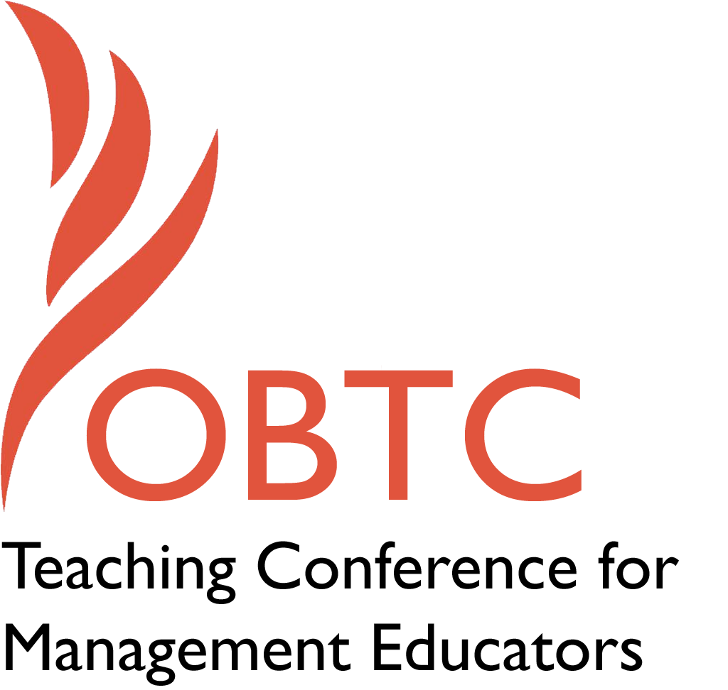

OBTC 2015 at University of La Verne
June 17th – 20th, 2015

Integrating the Undergraduate Curriculum: Models for Success

2015 OBTC Teaching Conference for Management Educators

- Title of Proposal:
Integrating the Undergraduate Curriculum: Models for Success

- Abstract:
Please include a brief session description (not to exceed 100 words).If your proposal is accepted, this description will be printed in the conference program.

Historically business school faculty and Deans have agreed that integrating the functional areas of business in an undergraduate curriculum is desirable. Traditionally, that integration has taken place in the senior year through a capstone strategy course delivered by Management faculty. There are colleges and universities that have been delivering functional integration to freshman, sophomore and junior undergraduate students for a few years and others who have been delivering an integrated curriculum for twenty or more years. This session will share our learning and insights to the experiences of multiple colleges and universities, which integrated their undergraduate curriculum.

- Keywords:
Use three or four keywords to describe your session.

Team teaching, integration, innovation, curriculum

- Format
Activity or exercise
X Discussion roundtable (60 minute only)
General discussion session

- Time Requested:
30 Minutes
X 60 Minutes (Roundtables must select 60 minutes)
90 Minutes

- Planning Details:
Does your session have any special requirements for space or materials?

Room setup should be modular allowing for both small and larger group discussions.

- Learning Objectives or Goals for the Session:
What are 2-4 specific learning outcomes that participants will get from your session?
- Identify best practices of collaborative teaching and learning
- Discuss the faculty benefits and challenges of team teaching while integrating the undergraduate curriculum.

- Management or Teaching Topics:
Describe what management and/or teaching topics are relevant to your session, and why Please include theoretical, disciplinary, or theoretical foundations that will help reviewers understand how your ideas fit within the broader field of management.

This is a pedagogical session. The session fits with research on experiential learning, team-based learning, and holistic learning. The business education innovation literature includes many examples of individual institution’s successes and challenges (see references and additional material below). The authors would like to use the session to share and augment their own research on team-based, team-taught, integrated business curricula.

The benefits for student learning include collaboration, conflict resolution, communication, and critical thinking skill development. The benefits to faculty are less clearly articulated than the challenges of lost autonomy, lower student evaluation of faculty scores, and an uncompensated higher workload.

- Session Description and Plan:
What will you actually do in this session? What activities will you facilitate, how long will they take, and how will participants be involved? Reviewers will be evaluating how well the time request matches the activities you’d like to do, and the extent you can reasonably accomplish the session’s goals. Reviewers will also be looking for how you are engaging the participants in the session. Include a timeline for your session.

The session will begin with the story of one institutions journey to integration and then move to presenting a comparison of integration models from colleges and universities across the US. The session will conclude with an open discussion of the experiences of those attending including the pros and cons of integrating the undergraduate curriculum. Ideally, the session will be 30% presentation and 70% discussion with and among participants.

This session will encourage participants to share their own experience with team teaching/learning and hear from others about the successes and pitfalls of integrating undergraduate curricula. Presenters will share what has been learned through in-depth interviews with faculty from twelve institutions which implement integrative team teaching.

- For Activities and Exercises:
Attach any materials needed to run the activity and debriefing questions. Evidence for effectiveness may also be included.

Questions to participants:
Do you/have you team taught a cross-disciplinary course?
What is the integrating mechanism?
What advice do you have for faculty wishing to develop such a course?
What is are the positive aspects for faculty/students from cross-disciplinary courses?
What are the challenges faced by faculty/students from cross-disciplinary courses?
What ideas do you suggest to improve the teaching of integrated curriculum courses and the learning experiences of students in those courses?

- Implications for Teaching or for Teachers:
What is the contribution of your session?
The session provides a variety examples of institutions integrating the undergraduate curriculum. At an AACSB forum on undergraduate curriculum innovation, it was learned that many institutions of varying types have an interest in curricular innovation but do not know where to start.

- Application to Conference theme:
How does your session fit with the overall OBTC theme of Learning in Community?
Many of the examples used in the session will include team based learning. Some of the examples will point to partnering with clients from outside the learning institution which enhances the students’ understanding of managements’ functions and thought processes.

- Unique Contribution to OBTC:
Have you presented the work in this proposal before? If so, how will it be different? Is this proposal under current review somewhere else? If so, please explain. How will your proposal be different for the OBTC conference? Not previously presented.

- References and/or Additional Materials:

Athavale, M., Davis, R., Myring, M. (2008). The integrated business curriculum: An examination of perceptions and practices. Journal of Education for Business, 9(4), 295-301

Buttermore, J. A. (2011). The Team-Taught Cross-Functional Core: Insights From a Long-Term Undergraduate Program. Journal of Education for Business, 86: 240-247.

Brunel, F.F., & Hibbard, J.D. (2006). Using innovations in student learning: Evidence from a fully integrated undergraduate core. Marketing Education Review, 16(3), 15-23.

DeMoranville, C. Aurand, T.W. & Gordon, G. L. (2000). The delivery of an undergraduate cross-functional business principles program: One university’s continuing journey. Marketing Education Review, 10(3), 29-41.

Pharr, S.W. (2000). Foundational considerations for establishing an integrated business curriculum. Journal of Education for Business, 76, 21-31.

Smith-Ducoffe, S. J., Tromley, C.L., & Tucker, M. (2006). Interdisciplinary team-taught, undergraduate business courses: The impact of integration. Journal of Management Education, 30, 276-294.

