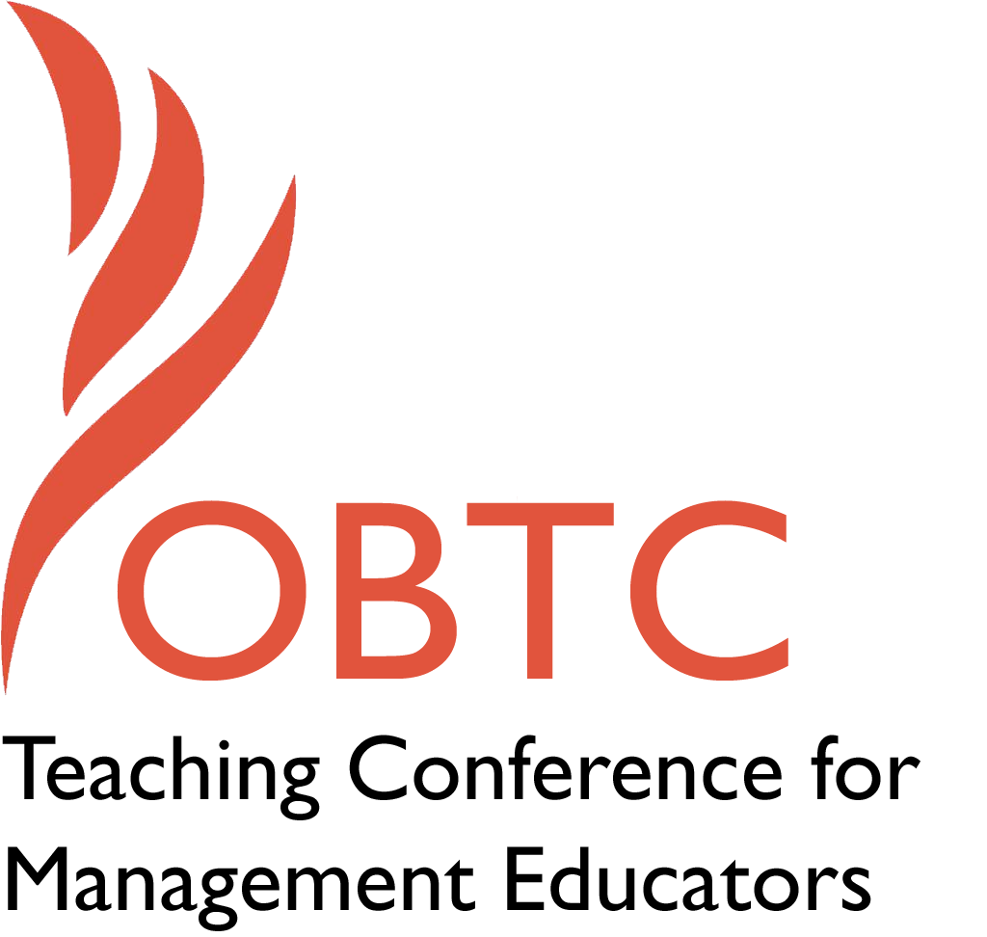

OBTC 2015 at University of La Verne
June 17th – 20th, 2015

Submission Template

SUBMISSION GUIDANCE
* Remove all identifying properties from this document *
* All files must be saved in PDF format *
*Please include ALL supplementary text at the end of this document* *Only one document should be submitted*

Submission Template for the
2015 OBTC Teaching Conference for Management Educators

- Title of Proposal:
Meet the Editors: Journal of Management Education and Management Teaching Review

- Abstract:
Please include a brief session description (not to exceed 100 words).If your proposal is accepted, this description will be printed in the conference program.

The Journal of Management Education is our society’s journal and is a well-respected journal for research and exercises. New this year, the society is adding a second independent journal called Management Teaching Review. Come to this session to learn about the mission and scope of these two journals, and to understand the distinctions between them. We will discuss the submission and review process, and offer advice for preparing manuscripts for each outlet.

- Keywords:
Use three or four keywords to describe your session.
Publishing, reviewing

- Format
Activity or exercise
Discussion roundtable (60 minute only)
x General discussion session

- Time Requested:
30 Minutes
60 Minutes (Roundtables must select 60 minutes)
X 90 Minutes

- Planning Details:
Does your session have any special requirements for space or materials?

No special requirements or space needed.

- Learning Objectives or Goals for the Session:
What are 2-4 specific learning outcomes that participants will get from your session?
Participants in this session will
- Learn about the mission and scope of the Journal of Management Education (JME) and Management Teaching Review (MTR), with comparisons and distinctions highlighted
- Understand the submission and review process followed by JME and MTR
- Review helpful advice for getting their scholarly teaching work published in both journals

- Management or Teaching Topics:
Describe what management and/or teaching topics are relevant to your session, and why. Please include theoretical, disciplinary, or theoretical foundations that will help reviewers understand how your ideas fit within the broader field of management.

All management teaching topics are relevant to this session. As members of the editorial staffs of JME and MTR, we will share with session participants the aims and scope of both journals, with a strong emphasis on highlighting the appropriate submission venues for typical manuscript topics and approaches. We will spend time exploring the differences between the domains of JME and MTR, and will briefly explore the domains of related journals such as the Academy of Management Learning & Education (AMLE), the Decision Sciences Journal of Innovative Education (DSJIE), the Organization Management Journal (OMJ), and Management Learning (ML).

We will cover key tasks of translating teaching excellence into sound pedagogical research, such as following the precepts of the scholarship of teaching and learning (Schmidt-Wilk, 2010) and how the Association for the Advancement of Collegiate Schools of Business’s (AACSB) 2013 accreditation standards regarding the impact of teaching and teaching-related research (http://www.aacsb.edu/en/accreditation/standards/) inform this process.

Finally, we will also cover some of the mechanics of the manuscript submission and publication process, including general writing and submission tips, responding to editor and reviewer feedback, and common items that lead to desk rejections (such as lack of alignment with the domains of each journal) or unfavorable reviews (such as lack of acknowledgement of previous research on the topic).

- Session Description and Plan:
What will you actually do in this session? What activities will you facilitate, how long will they take, and how will participants be involved? Reviewers will be evaluating how well the time request matches the activities you’d like to do, and the extent you can reasonably accomplish the session’s goals. Reviewers will also be looking for how you are engaging the participants in the session. Include a timeline for your session.

This will be a highly interactive session, with a lot of questions being posed by session participants regarding the journals, the publication process, and becoming an effective management education scholar. We propose to structure the session as follows:

5:00 minute overview of the session and its goals and to introduce the editors

10:00 minutes to describe JME and MTR, with a strong emphasis on the rationale for creating MTR and how it fits into the OBTS vision

20:00 minutes to compare and contrast the journals, along with a discussion of each journals’ sections, an overview of the Web site of JME, http://www.sagepub.com/journals/Journal200931 and MTR (if it is up and running), and some of the mechanics of the submission and review process.

25:00 minutes of strongly focused Q&A about becoming a successful management pedagogy researcher in general, and specifically about publishing in JME and MTR—what to do, what to avoid, what’s expected, and so on.

25:00 minutes of breakout sessions for participants to meet with the editors of JME and MTR to gain more information and insights about unique ideas, questions they may have about publishing in either journal. Participants will be free to move back and forth between the JME and MTR breakout groups.

5:00 minutes for wrap-up and combined Q&A that may have emerged from the breakout groups.

- For Activities and Exercises:
Attach any materials needed to run the activity and debriefing questions. Evidence for effectiveness may also be included.

None needed. This is not an activity or exercise.

- Implications for Teaching or for Teachers:
What is the contribution of your session?

Excellent pedagogical research is firmly grounded in excellent teaching. This session aspires to help session participants translate their innovative and impactful teaching practices into meaningful research, which serves both their individual career goals and the ever-increasing demands of accreditation agencies for teachers and schools to document that their teaching is having an impact on learner development and growth.

- Application to Conference theme:
How does your session fit with the overall OBTC theme of Learning in Community?

While OBTC is a wonderful once a year gathering, the society’s journals represent the always accessible and permanent part of our learning community. They are the ongoing conversation among management educators about excellence in teaching and they are the frontline resource for the community to share our combined wisdom and insights. We hope that all OBTS members contribute our shared learning community as authors, reviewers, and journal readers.
- Unique Contribution to OBTC:
Have you presented the work in this proposal before? If so, how will it be different? Is this proposal under current review somewhere else? If so, please explain. How will your proposal be different for the OBTC conference?

JME holds a session at OBTC every year to make sure both old and new members know about the journal. This year we have the addition of Management Teaching Review, which will add new information to the session.
- References and/or Additional Materials:

Schmidt-Wilk, J. (2010). “Evidence: Where scholarship meets artistry.” Journal of Management Education, 34(2): 195-199.

