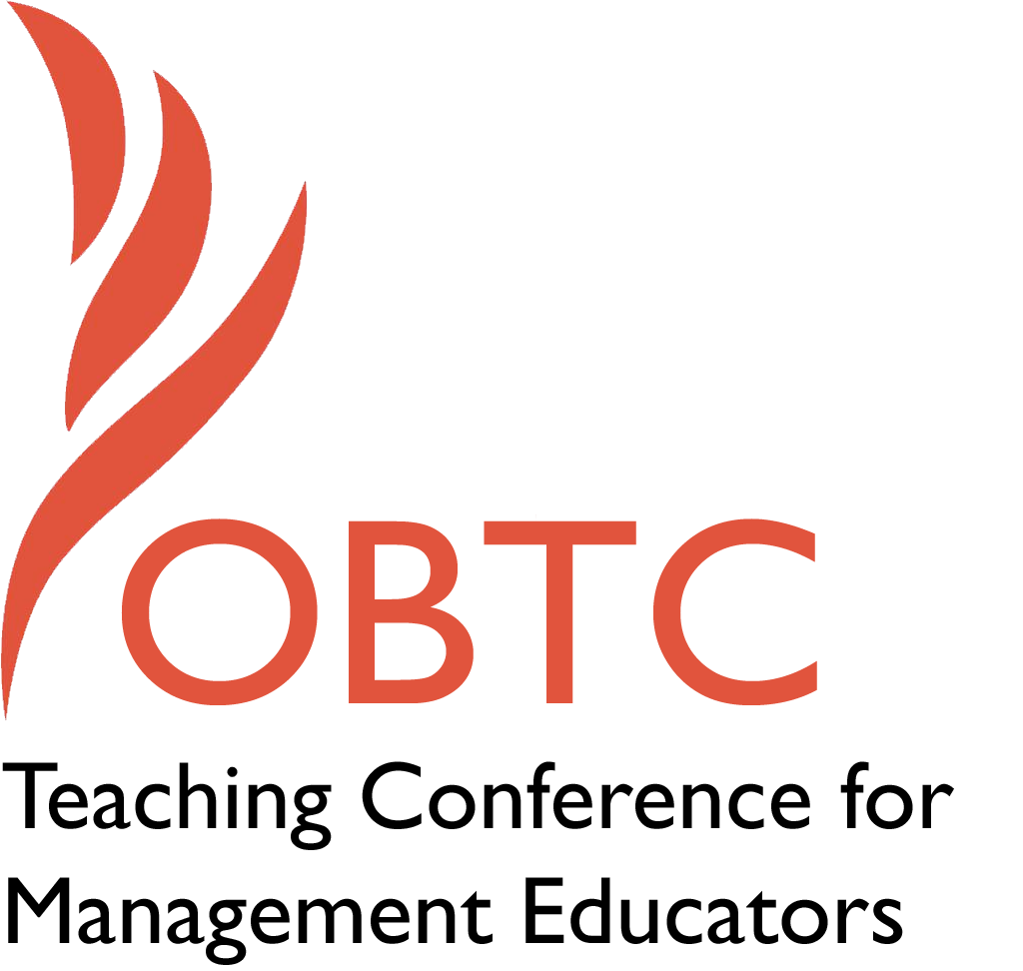

**OBTC 2015 at University of La Verne**

**June 17th – 20th, 2015**

Submission Template

SUBMISSION GUIDANCE

*\* Remove all identifying properties from this document \**

*\* All files must be saved in PDF format \**

*\*Please include ALL supplementary text at the end of this document* *Only one document should be submitted\**

|  |
| --- |
| **Submission Template for the**  **2015 OBTC Teaching Conference for Management Educators** |

1. **Title of Proposal:**

|  |
| --- |
| The comparison of Chinese and American classroom dynamics |

1. **Abstract:**

|  |
| --- |
| *Please include a brief session description (not to exceed 100 words).If your proposal is accepted, this description will be printed in the conference program.*  This interactive session will discuss the differences of American and Chinese classrooms. With more international students coming to American classroom, teachers are facing the challenges of motivating Asian (e.g. Chinese) students to participate in the class and fuse together students from different culture. This session will analyze in details how different the students are in class preparation, in-class and after-class study. At the end of this session, there will be a short open discussion on sharing strategies of effectively managing mixed-culture classroom. |

1. **Keywords:**

|  |
| --- |
| *Use three or four keywords to describe your session.*  Cross-culture education; classroom dynamics; Chinese and American; comparison. |

1. **Format**

Activity or exercise

Discussion roundtable (60 minute only)

√_General discussion session

1. **Time Requested:**

√_ 30 Minutes

60 Minutes (*Roundtables must select 60 minutes*)

90 Minutes

1. **Planning Details:**

|  |
| --- |
| *Does your session have any special requirements for space or materials?*  No |

1. **Learning Objectives or Goals for the Session:**

|  |
| --- |
| *What are 2-4 specific learning outcomes that participants will get from your session?*  The participants will learn the distinguish difference between American and Chinese classroom dynamics.  The participants will learn how to manage a classroom dominated by Asian students.  The participants will learn how to manage a classroom has a large percentage of Asian students. |

1. **Management or Teaching Topics:**

|  |
| --- |
| *Describe what management and/or teaching topics are relevant to your session, and why Please include theoretical, disciplinary, or theoretical foundations that will help reviewers understand how your ideas fit within the broader field of management.*  This topic is relevant to cross-cultural education. It fits all face-to-face class with significant ethnic diversification. |

1. **Session Description and Plan:**

|  |
| --- |
| *What will you actually do in this session? What activities will you facilitate, how long will they take, and how will participants be involved? Reviewers will be evaluating how well the time request matches the activities you’d like to do, and the extent you can reasonably accomplish the session’s goals. Reviewers will also be looking for how you are engaging the participants in the session. Include a timeline for your session.*  I need about 20-30 minutes.  Brief plan:   1. Introduction to the purpose of the session, my experience of classroom transition. 5 mins 2. Comparisons of Chinese and American classroom dynamics (with audience participation) 10-15 mins 3. Sharing strategies of managing culturally diverse classroom 5 mins 4. Soliciting audiences’ strategies and experiences Q&A 5 mins |

1. **For Activities and Exercises:**

|  |
| --- |
| *Attach any materials needed to run the activity and debriefing questions. Evidence for effectiveness may also be included.* |

1. **Implications for Teaching or for Teachers:**

|  |
| --- |
| *What is the contribution of your session?*  This session contributes to the teaching strategies for cross-cultural classrooms, given the increasing impact of international students on American classrooms. It is imperative for our educators to learn more about the differences of culturally diverse classrooms and how the manage it effectively. |

1. **Application to Conference theme:**

How does your session fit with the overall OBTC theme of Learning in Community?

|  |  |
| --- | --- |
| More and more international students joining to American universities nowadays, it is imperative for our educators to learn more about the differences of culturally diverse classrooms and how the manage it effectively.     1. **Unique Contribution to OBTC:**   *Have you presented the work in this proposal before? If so, how will it be different? Is this proposal under current review somewhere else? If so, please explain. How will your proposal be different for the OBTC conference?*  No, this would be the first time I present. The proposal is not under any review. The proposal will enrich the conference by bringing in cross-cultural education.   |  | | --- | | 1. **References and/or Additional Materials:** | |

|  |
| --- |
|  |