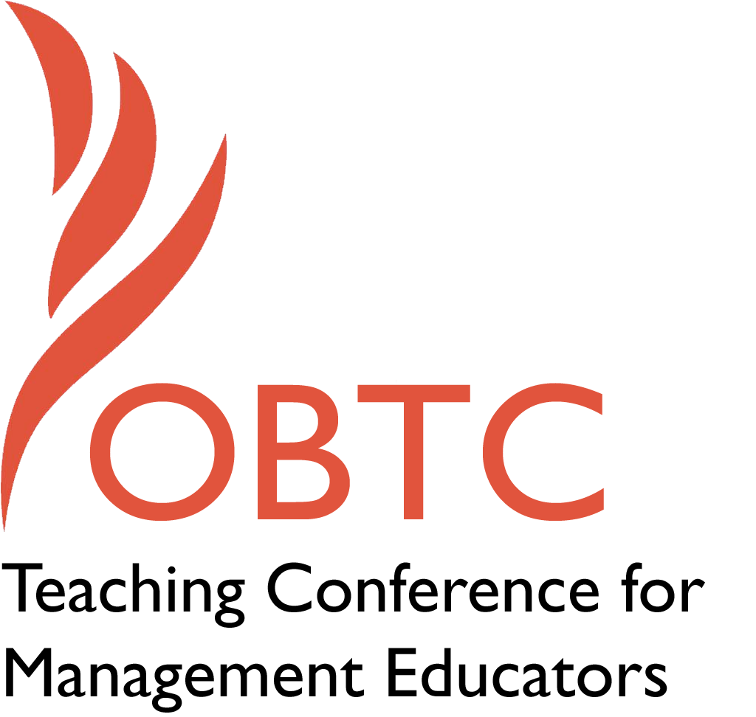

OBTC 2015 at University of La Verne
June 17th – 20th, 2015

Submission Template

SUBMISSION GUIDANCE
* Remove all identifying properties from this document *
* All files must be saved in PDF format *
*Please include ALL supplementary text at the end of this document* *Only one document should be submitted*

Submission Template for the
2015 OBTC Teaching Conference for Management Educators

- Title of Proposal:
Tackling concept overload in survey courses by using student groups

- Abstract:
Organizational Behavior survey courses can be a vocabulary heavy course where students become lost in memorization rather than application. This session will share the presenters experience having students bring concept cards to class with examples of selected concepts. Student groups then discuss and identify the best examples to be discussed as a larger class. This engagement enabled students to use the vocabulary during experiential learning activities.

- Keywords:
Organizational Behavior; Learning activity

- Format
X Activity or exercise
Discussion roundtable (60 minute only)
General discussion session

- Time Requested:
X 30 Minutes
60 Minutes (Roundtables must select 60 minutes)
90 Minutes

- Planning Details:
Does your session have any special requirements for space or materials?
No.

- Learning Objectives or Goals for the Session:
What are 2-4 specific learning outcomes that participants will get from your session?
- Participates will learn about the presenters experience helping students learn OB vocabulary.
- Participants will explore how they might use the process in their own classrooms.

- Management or Teaching Topics:
Describe what management and/or teaching topics are relevant to your session, and why Please include theoretical, disciplinary, or theoretical foundations that will help reviewers understand how your ideas fit within the broader field of management.

Experiential learning activities have been touted by Organizational Behavior (OB) faculty for many years. These activities bring OB to life in memorable ways. Unfortunately, if students are unprepared and don’t know the language of OB the deeper meaning of the activity and it’s connection to OB theory is often lost. To address this issue I used a day to engage students in learning the vocabulary of OB and a second day for more traditional experiential learning activities. This session focuses on the first process using concept cards to learn the vocabulary which can be applied to any management field.

Each time a new chapter was introduced in class students were asked to create an example for five assigned concepts in preparation for class. The concept, the example and the student ID were the only things written on each of the five index cards for each student. The same five concepts where assigned to each member of a five member team. Similar and/or related topics were given to the same group as much as possible. This required students to come up with unique examples that demonstrated the nuisance difference between the concepts.

During the reading quiz concept cards were collected from students. Students who made a credible effort on their examples were given full credit. Partial credit was given for sloppy and lack luster work. Primarily this was assessed quickly in class however cards were collected at the end of class for more detailed review randomly during the semester. This pre-class work ensures individual accountability so that each student engages the material first without being dependent on the team.

After the reading quiz all the concept cards from one team were given to another team. The result was that each team received five examples of five different terms. The team then reviewed and critiqued the examples for each term. The goal was for the team to identify the best example. If they did not like any of the examples provided the team was free to write their own or modify an example to be more correct. This process allowed for collective learning in community.

The quality of examples varied widely. Some were simply rehashes of the definition rather than an example while some examples where just plain wrong. In some cases students used the same example for two related concepts without acknowledging the difference in the concepts. As students reviewed the examples they became more sophisticated at identifying good examples that got to the key elements of the concept.

A selected number of concepts examples were then discussed as a whole class. Some selected “best” examples were still incorrect or missed the mark in some way. I discussed with the class why the example was lacking to help students gain a better understanding of the concept. This allowed for students to develop their skills at developing example. Examples not only help students better understand and apply the concept but can also help students remember the concepts for further application and assessment.

This process gave students the opportunity to personally engage five concepts prior to class by writing examples. They critiqued five additional examples with their team in class. They also participated in the discussion about selected concepts with the entire class. While the process did not allow each student to focus in great detail on every concept in the chapter it did allow for them to gain insight into the development of good examples that would help them understand the material and recall it during experiential activities and other assessments. It also helped that some of the examples presented by students were very entertaining making them memorable and easier for students to recall.

As students became better at the process I utilized them to provide feedback to other students. Since only student ID numbers were on the cards students did not know whose examples they were reviewing. Students wrote comments and “graded” each person. I then returned the cards with comments back to the individual who wrote them. I did not read or keep the feedback. This process helped students critique the examples more thoughtfully and get feedback from their colleagues to improve their examples in the future.

Examples certainly have an element of application but they still are primarily identification of the concept in life. To really utilize OB it needs to be applied and understood more experientially. To that end on a second day more traditional experiential learning activities were used. Because of the increased engagement with the concepts on the first day students more readily used the vocabulary of OB when discussing their experiences after the activities.

- Session Description and Plan:
What will you actually do in this session? What activities will you facilitate, how long will they take, and how will participants be involved? Reviewers will be evaluating how well the time request matches the activities you’d like to do, and the extent you can reasonably accomplish the session’s goals. Reviewers will also be looking for how you are engaging the participants in the session. Include a timeline for your session.

10 minutes
The presenter’s experiences will be presented using concept note cards as described above.
10 minutes
Participants will be given student concept examples and work through the process of identifying the best example.
10 minutes
The last portion of the time will be used for Q&A and discussion of modifications and use in their own classrooms.

- For Activities and Exercises:
Attach any materials needed to run the activity and debriefing questions. Evidence for effectiveness may also be included.

There are no special materials needed to run this activity.

I have used this process during one semester in two sections of the OB course. I recognized in classroom observations and talking with students that this process was helpful to many students. I was surprised on my student evaluations that 18% of them noted concept cards in response to the question “what worked the best in assisting your learning in this course?”. This was pretty surprising since not all students answer these open ended questions.

I intend to use the process again in four sections prior the conference and will collect specific feedback on the process in all four sections. I will have more detailed student feedback and evidence of effectiveness at that time.

- Implications for Teaching or for Teachers:
What is the contribution of your session?

The contribution of this session is that is identifies another tool in the teachers toolbox for helping students learn.

- Application to Conference theme:
How does your session fit with the overall OBTC theme of Learning in Community?
This activity is very much suited to learning in community. Students initially work individually but then must work in their team to critique concepts and share their results with the larger class.

- Unique Contribution to OBTC:
Have you presented the work in this proposal before? If so, how will it be different? Is this proposal under current review somewhere else? If so, please explain. How will your proposal be different for the OBTC conference?

This presentation’s unique contribution is its focus on learning of OB vocabulary while typically activities presented at the conference focus on application or a specific topic. This activity is not under review elsewhere.

- References and/or Additional Materials:

