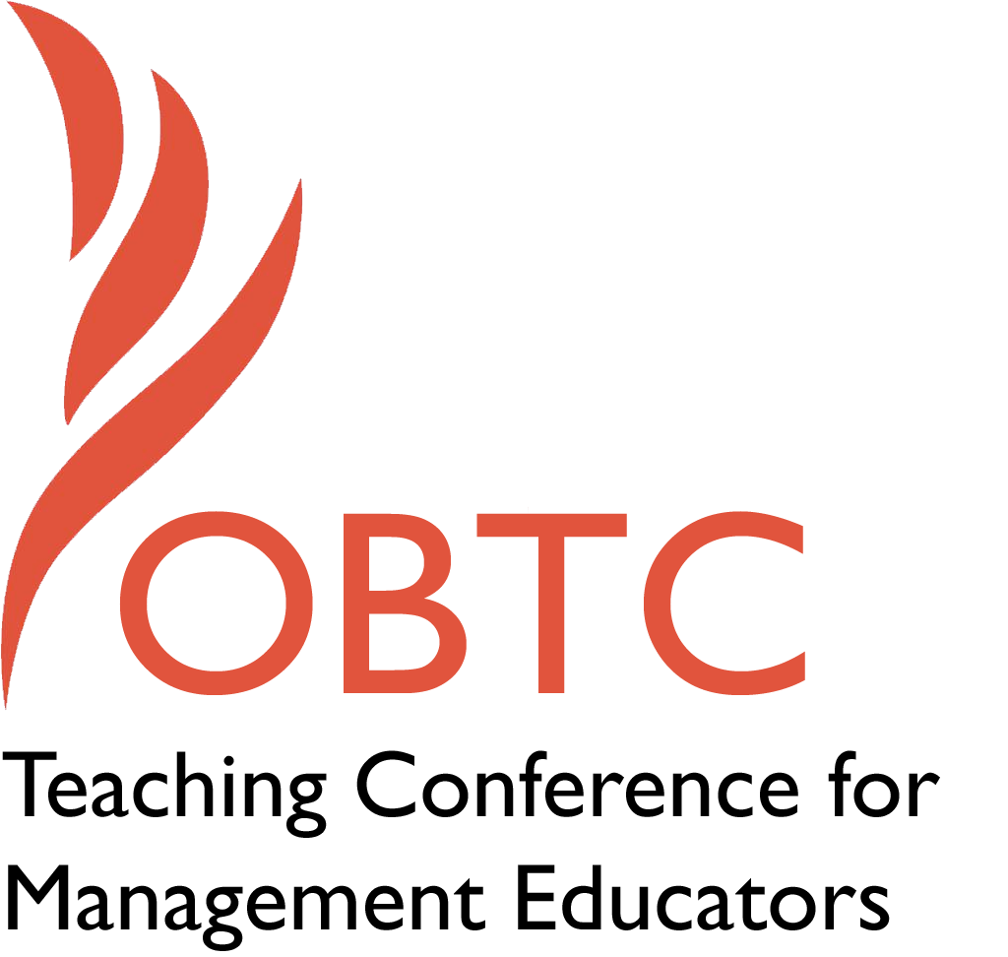

OBTC 2015 at University of La Verne
June 17th – 20th, 2015

Submission Template

SUBMISSION GUIDANCE

Submission Template for the
2015 OBTC Teaching Conference for Management Educators

- Title of Proposal:
Building Collaborative Community Development Tools

- Abstract:
Please include a brief session description (not to exceed 100 words).If your proposal is accepted, this description will be printed in the conference program.

A collaborative application (from here on out referred to as an app) tool for handheld devices is being created in the state of Alaska in order to enhance leadership development programming and community learning across external and regional boundaries. The app will increase the reach and effectiveness of this “learning community” during constrained economic times. It acts as a “social network” for program developers and educators alike, by increasing knowledge sharing and leveraging participants’ expertise. Think of it as a Facebook for program developers that adds in a way to assign tasks. In this session, a short video will be shared, demonstrating learning opportunities, as well as functions that are included in the application.

- Keywords:
Use three or four keywords to describe your session.
Community, Collaboration, Leadership

- Format
Activity or exercise
Discussion roundtable (60 minute only)
X General discussion session

- Time Requested:
30 Minutes
X 60 Minutes (Roundtables must select 60 minutes)
90 Minutes

- Planning Details:
Does your session have any special requirements for space or materials?

Classroom layout for video projection and power point presentation.

- Learning Objectives or Goals for the Session:
What are 2-4 specific learning outcomes that participants will get from your session?

- Introduce technology driven community impact tool
- Increase awareness of collaborative tools
- Demonstrate ease of building applications for handheld devices that can be used for teaching purposes

- Management or Teaching Topics:
Describe what management and/or teaching topics are relevant to your session, and why Please include theoretical, disciplinary, or theoretical foundations that will help reviewers understand how your ideas fit within the broader field of management.

Leadership development is understood as a necessary ingredient in management training across diverse settings, while the pedagogy on leadership is vast. Working in a field where leadership development happens across various fields and at multiple levels (e.g., within school districts, at local club meetings, within organizations of all sizes), there is a need to make connections between these settings in order to create efficiencies within the larger economy (i.e., state or city). By developing a collaborative tool, those that specialize in leadership development can work together, as apposed to “stepping on each other’s toes” or “recreating the wheel” - essentially. This tool, not only has the possibility of increasing communication while practicing leadership development, but also demonstrates various areas of interest for managers, such as collaboration, networking, creating efficiencies, and possible economic impacts.

- Session Description and Plan:
What will you actually do in this session? What activities will you facilitate, how long will they take, and how will participants be involved? Reviewers will be evaluating how well the time request matches the activities you’d like to do, and the extent you can reasonably accomplish the session’s goals. Reviewers will also be looking for how you are engaging the participants in the session. Include a timeline for your session.

- 30-minutes- A presentation on the background and purpose of the application, research and findings that were used for development will be discussed, and the apps functionality will be reviewed.
- 5 minutes - A short YouTube video demonstrating the uses of the app will be shown to the audience.
- 15 minutes- After asking the audience to form small groups, I will then ask them to come up with examples of how they could use such collaborative phone apps in their own communities and/or classrooms.
- 10 minutes- Participants will be asked to report out about possible uses in their areas and what they would like to see in such applications.
- End- Participants will be asked to sign up if interested in receiving more information about the application about the app and to receive a free trial download. They will also be asked to fill out the evaluation form for the session.

- For Activities and Exercises:
Attach any materials needed to run the activity and debriefing questions. Evidence for effectiveness may also be included.

Debriefing questions would include:
- How would you utilize a collaborative tool, such as this, in your area?
- What do you think would be the benefits of using such a tool?
- How could we modify these types of collaborative tools to benefit classrooms?
- What teaching moments, in terms of management education, can you take from this session?

- Implications for Teaching or for Teachers:
What is the contribution of your session?

This session will help fellow faculty and instructors to develop ideas on how to utilize collaborative tools in their work in classrooms and their communities. It will also get participants to consider creating their own collaborative tools to enhance their service and classroom functions.

- Application to Conference theme:
How does your session fit with the overall OBTC theme of Learning in Community?
This session is directly linked to the theme of “Learning in Community”, as it discusses ways to increase collaboration between peer groups and institutions in order to enhance knowledge areas within communities. It also shows ways for teachers to demonstrate management topics (e.g., collaboration, networking, etc..) to students through hands on applications.

- Unique Contribution to OBTC:
Have you presented the work in this proposal before? If so, how will it be different? Is this proposal under current review somewhere else? If so, please explain. How will your proposal be different for the OBTC conference?

I have not presented this work before, and it is not under review.

- References and/or Additional Materials:
N/A

