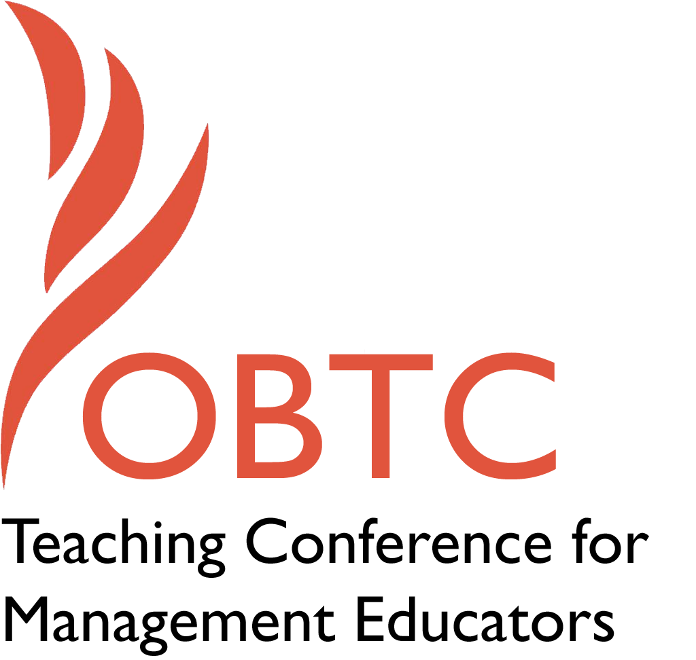

OBTC 2015 at University of La Verne
June 17th – 20th, 2015

Submission Template

SUBMISSION GUIDANCE
* Remove all identifying properties from this document *
* All files must be saved in PDF format *
*Please include ALL supplementary text at the end of this document* *Only one document should be submitted*

Submission Template for the
2015 OBTC Teaching Conference for Management Educators

- Title of Proposal:
Harry Potter And The Keys of the Academic Kingdom—The Ones You Can’t Find On Google.

- Abstract:
Please include a brief session description (not to exceed 100 words).If your proposal is accepted, this description will be printed in the conference program.

Our students are not aware of the different types of source material available on the Web and the varying perspectives they present. A professor and a librarian have formed a partnership to teach students to do research using business databases that have greater depth and breathe than anything available on the Web. In our session, we will describe how our students engage in and apply database research [eight minutes], conduct a search for articles in ABI/INFORM on a current OB topic [twelve minutes], and invite our participants to discuss how our approach could enrich their courses [ten minutes].

- Keywords:
Use three or four keywords to describe your session.
Professor/librarian partnership; information literacy; business databases.

- Format
Activity or exercise
Discussion roundtable (60 minute only)
X General discussion session

- Time Requested:
X 30 Minutes
60 Minutes (Roundtables must select 60 minutes)
90 Minutes

- Planning Details:
Does your session have any special requirements for space or materials?

We will require a projector for a limited number of PowerPoint slides and Internet access so that we can log into our university library web site to demonstrate a search a business database, ABI/INFORM.

- Learning Objectives or Goals for the Session:
What are 2-4 specific learning outcomes that participants will get from your session?

- Improve information literacy by introducing students to the trove of information housed in proprietary library databases.
- Challenge students to apply what they learn creatively and critically in oral and written exercises.
- Demonstrate students’ enhanced learning augured by a partnership between management professors and business librarians.

- Management or Teaching Topics:
Describe what management and/or teaching topics are relevant to your session, and why Please include theoretical, disciplinary, or theoretical foundations that will help reviewers understand how your ideas fit within the broader field of management.

Two topics underscore our session. First, we stress research efficiency, manifested in the exploitation of potent business databases, to better inform the decision making process of our students. Second, we extoll the virtues of a close partnership—bolstered by an encouraging librarianship literature (Atwong & Heichman Taylor, 2008; Campbell & Cook, 2009; May & Leighton, 2013; Wu, & Kendall, 2006)—between a management professor and a business librarian that we have found enhances the learning of our students.

- Session Description and Plan:
What will you actually do in this session? What activities will you facilitate, how long will they take, and how will participants be involved? Reviewers will be evaluating how well the time request matches the activities you’d like to do, and the extent you can reasonably accomplish the session’s goals. Reviewers will also be looking for how you are engaging the participants in the session. Include a timeline for your session.

We will discuss how we teach database research and challenge students to practice their research skills in oral and written exercises [eight minutes], provide an abbreviated tutorial in which we search for articles on an OB topic in a particularly robust business database, ABI/INFORM [twelve minutes], and close by inviting participants to discuss how our approach can be applied in their courses [ten minutes].

- For Activities and Exercises:
Attach any materials needed to run the activity and debriefing questions. Evidence for effectiveness may also be included.

Not applicable.

- Implications for Teaching or for Teachers:
What is the contribution of your session?

To encourage management faculty to work more closely with reference librarians and to demonstrate the impact enhanced informational literacy has on students’ learning and decision-making.

- Application to Conference theme:
How does your session fit with the overall OBTC theme of Learning in Community?
Our partnership creates a data continuum that extends learning far beyond the walls of our classrooms. In its acquisition, community is manifested when students avail themselves of high quality information published in databases that are housed in the libraries of universities and leading organizations. In its application, students are challenged to creatively and critically exploit this trove in oral and written exercises. Sadly, too many of our students believe that passively “googling” on a smartphone or tablet constitutes research. We aim to defeat that myth. Thus, we promote an exciting active learning community revolving around research, contemplation and debate. Moreover, our partnership empowers more effective online research by introducing students to potent business databases that capture theories and evidence produced by scholars, journalists and practitioners from around the world.

- Unique Contribution to OBTC:
Have you presented the work in this proposal before? If so, how will it be different? Is this proposal under current review somewhere else? If so, please explain. How will your proposal be different for the OBTC conference?

We presented a nascent formulation of our partnership to California State University faculty in April 2011. The session we propose for OBTC 2015 is much more advanced since it builds on our original approach with changes suggested by years of trial and error as well as with evidence of how our partnership enhances our students’ decision-making.

- References and/or Additional Materials:

Atwong, C. & Heichman Taylor, L. (2008). Integrating information literacy into business education: a successful case of faculty-librarian collaboration. Journal of Business & Finance Librarianship, 13 (4), 433-449.

Campbell, D. & Cook, R. (2009). An experiential market research analysis: a partnership between teaching and library faculty. Journal of Business & Finance Librarianship, 15 (1), 171-178.

May, D. & Leighton, H. (2013). Using a library-based course page to improve research skills in an undergraduate international business law course. Journal of Legal Studies Education, 30 (2), 295-319.

Wu, Y. & Kendall, S. (2006). Teaching faculty’s perspectives on business information literacy. Reference Services Review 34 (1), 86-96.

