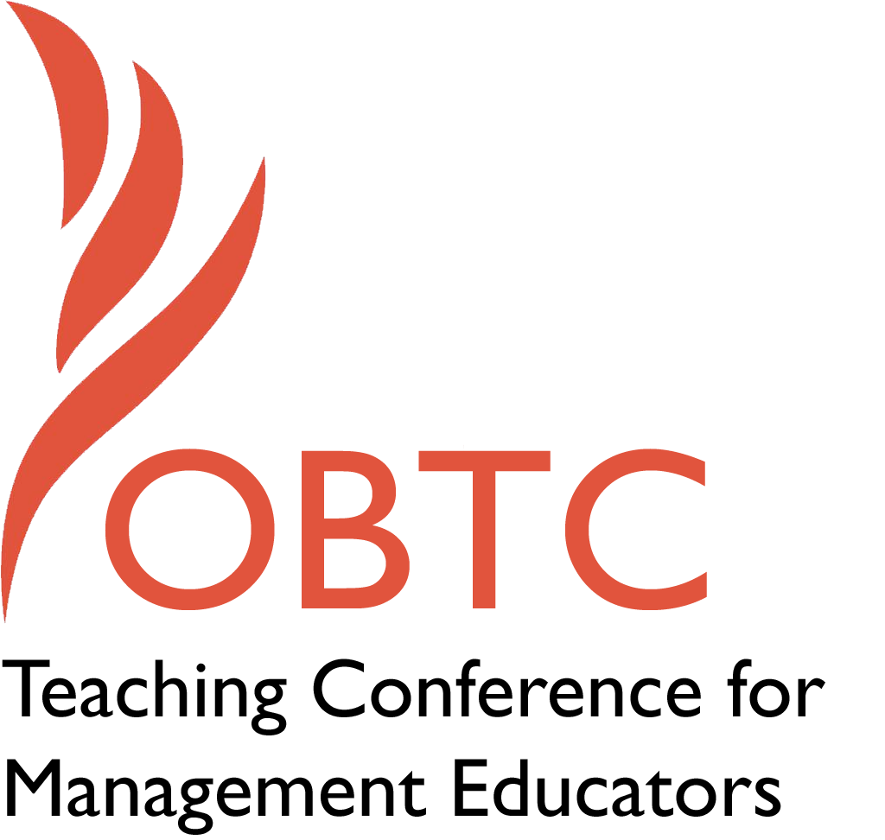

OBTC 2015 at University of La Verne
June 17th – 20th, 2015

Submission Template

SUBMISSION GUIDANCE
* Remove all identifying properties from this document *
* All files must be saved in PDF format *
*Please include ALL supplementary text at the end of this document* *Only one document should be submitted*

Submission Template for the
2015 OBTC Teaching Conference for Management Educators

- Title of Proposal:
Not just for kids: Using Dora the Explorer Techniques to teach Leadership in the classroom

- Abstract:
Please include a brief session description (not to exceed 100 words).If your proposal is accepted, this description will be printed in the conference program.

Leadership is a tricky lesson that can be taught in a variety of ways, shapes and sizes. Sometimes, however, it’s the simplest form of education that can stick in a student’s mind. This training applies the lessons of a popular children’s program, Dora the Explorer to an actual leadership lesson (“Take Care of your People, Take Care of your Job”), and includes comments from Dora’s Executive Producer. The session will show a simple way including activities and handouts to educate students in the classroom community.

- Keywords:
Leadership, Management Education Technique, Educating through Student Problem Solving

- Format
X Activity or exercise
Discussion roundtable (60 minute only)
General discussion session

- Time Requested:
30 Minutes
X 60 Minutes (Roundtables must select 60 minutes)
90 Minutes
**If needed, I can reduce this to 30 minutes and just talk about the DTE as a concept instead of demonstrating it through the class itself.

- Planning Details:
Does your session have any special requirements for space or materials?
If available, a classroom with a projector would be preferred to show some relevant movie clips. If not, other activities can be chosen to demonstrate the classroom activities – or a classroom with some room to allow 4-5 people to stand in one area is also acceptable.

- Learning Objectives or Goals for the Session:
What are 2-4 specific learning outcomes that participants will get from your session?

- Explain the teaching method of the children’s show, Dora the Explorer (DTE)
- Using the DTE teaching method, present an example of teaching leadership concepts
  - Share activities that can be used in the educating employee motivation and goal accomplishment

- Management or Teaching Topics:
Describe what management and/or teaching topics are relevant to your session, and why. Please include theoretical, disciplinary, or theoretical foundations that will help reviewers understand how your ideas fit within the broader field of management.

Summary: How illustrating use of DTE? DTE is based on Howard’s (1983) theory of multiple intelligences – for example, using music to teach math. Showing DTE in an OBTC classroom brings this theory to light in a different way than educators may be used to and will illuminate Howard’s methods in a management setting.
My goal for this session is to first explain DTE’s learning techniques and then show how it’s applied in the classroom. The second 20 minutes shows some examples of how I have applied DTE principles. For example, using a clip from “Morning Glory” supports my classroom teaching of how employees are motivated (think Herzberg 2-factor theory – motivator/ hygiene or intrinsic v extrinsic rewards). Using a movie clip to teach a theory is one application of DTE teaching – getting a student out of ‘rote’ learning and combining something they know (watching movies) to something they don’t (motivation theory).

Use of DTE in management topics: Nearly 60% of experienced managers think that the management technique of “Take care of your people, take care of your job” is the second most important management skill (Lesko, 2014), behind only “Listen, Stop Talking, Listen” (this technique was discussed in OBTC 2014) that new managers (NM) need to learn. This session will demonstrate teaching management the way that DTE teachings – using a sample topic of “Take care of your people” to demonstrate its applicability. Its goal is to show how to use the Problem solving and goal setting techniques to create a management “hard skill” of actual steps and process. These problem solving techniques can then be applied to help the NM figure out what is needed to get the job done (through taking care of their people, in this example): If you take care of your people first (Problem solving, cause), then you can take care of your job (Goals, effect).
Many NM do not necessarily have the tools ready in their management toolbox to solve management problems – but these techniques can be learned. This session would examine the children’s program Dora the Explorer (DTE) and it techniques of applying problem solving, learning in the community and goal theory for learning individuals. For children ages 2-5, this is areas such as how to open a door or get something off a shelf (because they are too short) or asking for help on a problem they don’t know how to solve (problem solving) DTE (C. Gifford, personal communication, December 11, 2014). In NM, these techniques can be taught in the classroom in areas such as expectancy theory and intrinsic vs extrinsic motivation and applied through the use of activities to demonstrate OJT, simulated experiences and working through situations.
DTE uses Howard Gardner’s approach of Theory of Multiple Intelligences to address different ways of learning (C. Gifford, personal communication, December 11, 2014). The show embraces the 7 areas: musical-rhythmic, visual-spatial, verbal linguist, logical-mathematical, bodily-kinesthetic, interpersonal, intrapersonal and naturalist (Gardner, 1983). For example, Dora, the main character, and her friends may teach new learning (such as a new Spanish word, or how to paddle in a river) with learning they already know (such as basic counting and shapes) in a community environment (where everyone benefits). Following this method, activities for this session are selected that allow the student to learn in such ways that take them out of rote learning and into a way to retain and apply knowledge in a leadership setting.

- Session Description and Plan:
What will you actually do in this session? What activities will you facilitate, how long will they take, and how will participants be involved? Reviewers will be evaluating how well the time request matches the activities you’d like to do, and the extent you can reasonably accomplish the session’s goals. Reviewers will also be looking for how you are engaging the participants in the session. Include a timeline for your session.

Timeline
**If needed, I can reduce this to 30 minutes and just talk about the DTE as a concept instead of demonstrating it through the class itself. If this is the case, then the middle section is removed (20-40) and the last section would be reduced by 10 minutes.

0- 20 minutes – Introduction. Explanation of Dora the Explore (DTE) and showing a clip of the show, to explain the concept of problem solving, and teach how the show can be applied to management education in a community setting. Information shared based on interview held with Chris Gifford, Executive Producer of DTE (C. Gifford, personal communication, December 11, 2014) and the concept around the show (as per section 8) and how it aims to educate.

20 - 40 minutes – Explanation of the specific leadership concept “Take Care of your People, Take care of your Job” - use of three– step approach
- Theory/ Practitioner
  - How are employees motivated? Herzberg 2-factor theory (motivation/ hygiene , Intrinsic/ extrinsic rewards (employee participation, work/life, giving praise),
  - Get out what you put in, fairness – does it matter? - Vroom expectancy theory & Equity theory
  - Goal Setting - why is it important? - Locke’s goal theory, SMART, Reinforcement theory
  - Can you make a job better? Job characteristics theory, Job design, Career Anchor, WE - Work Engagement
- Stories – application of management technique in application through stories of real-world managers
- Activities - (see section 10 below) – based on classroom setting – will focus on motivation of employees and goal theory with movie clips, role play demonstration. Discussion of activities and handouts of activity topics.

40 – 60 minutes – Set aside to demonstrate additional activities as time allows , and allowance for discussion of topics, areas of opportunity, and questions of this management technique.

- For Activities and Exercises:
Attach any materials needed to run the activity and debriefing questions. Evidence for effectiveness may also be included.

Movie clips from current movies such as “Morning Glory” and “Van Wilder” will support motivation theories and demonstrate the use of problem solving using the DTE format. If movie clips cannot be used (based on format of the classroom available) then activities using student engagement techniques (Barkley, 2010) such as role play and journalist “5 W’s” format to walk through the leadership lesson of “Take care of your people” will be used. Choice of activities will be determined by room environment as several flexible methods can be used to educate on this topic.

Why use other movie clips? DTE is a teaching method. I am demonstrating the use of the DTE method in teaching management. As a result- in a management classroom, DTE would not be shown, but the concepts used. The movie clips (which would not be shown at OBTC, but suggested) would be one use of the DTE teaching method.

Main goal for activities is to demonstrate applicability of management skill (“Take care of your people, take care of your job”) in a meaningful and resounding way that will stay with students to use in a real-life practical application.

Evidence for effectiveness: The movie clips have been used to demonstrate applicability and students tend to recognize themselves or others when using those clips. Many times, they have already seen the movies (use of movies from the last 10 years) and they already know the result of the clip. Role play allows them to step into a situation that is loosely guided, and has allowed them to practice techniques in a safe environment. This has been one of the best used techniques for this format, and has even been videotaped for feedback at certain times.

How session would be interactive? The first part of the session would explain DTE by explain the children’s’ show, talk about the Exec Producer’s viewpoint of the show, and show a clip of the show. I would request feedback from participants on what they learned from the clip, how they perceived it – and apply their feedback to Howard’s (1983) theory used in DTE.
  - If I get the chance to explain the course – another movie clip such as the one in “Morning Glory” would be used – and follow up questions would be given to the participants – allowing them to give suggestions as well.
  - If not a movie clip, then there are role play activities or 5 Why’s that can be used as well. The importance of the activities are to show the use of a DIFFERENT teaching method than rote teaching to suggest learning, hence multiple intelligences in Howard’s theory.

- Implications for Teaching or for Teachers:
What is the contribution of your session?

Those learning how to be a leader, and new managers in the workplace do not necessarily have the tools in the toolbox to solve management problems. However, they can learn them - through application in the classroom to then apply in the workplace and OJT (through different managers, experience, working through situations.

This session shows a different viewpoint of teaching leadership. Teaching a problem-solving method using a children’s show, and applying it to an actual leadership lesson can give educators a new way to teach management.

Takeaways for Participants? Knowledge of Howard’s theory of multiple intelligences (illustrated by DTE) – and suggested application by example of one classroom setting (teaching motivation

- Application to Conference theme:
How does your session fit with the overall OBTC theme of Learning in Community?
Dora the Explorer (DTE) teaches problem solving in the community – as Dora meets and interacts with other characters on the show, the community educates her on how to solve the current problem. In the class, the students and educators are the community that allow for education and reflection of the management topics. By understanding the topic through another’s eyes, the student better learns the concepts (employee motivation, for example).

- Unique Contribution to OBTC:
Have you presented the work in this proposal before? If so, how will it be different? Is this proposal under current review somewhere else? If so, please explain. How will your proposal be different for the OBTC conference?

This work has never been presented before.

- References and/or Additional Materials:

Aaron, J. (2014) Will Dora teach my Child Spanish? Retrieved from
http://www.speekee.co.uk/articles.php?p=6.
About Dora the Explorer. (2014). Retrieved from http://www.nickjr.com/dora-the-
explorer/about-dora-the-explorer/about-dora-the-explorer-tv-show.html.

Barkley, E. F. (2010). Student Engagement Techniques: A Handbook for College

Faculty. Jossey-Bass Press. San Francisco, CA.
Gardner, Howard (1983). Frames of Mind: The Theory of Multiple Intelligences, Basic
Books, New York, NY.
Gardner, Howard (1993). Multiple Intelligences: The Theory in Practice. Basic Books,
New York, NY.
Lesko, A. P. (2014). Experienced manager’s viewpoint on leadership requirements for
new managers. Unpublished manuscript, Department of Management, Sullivan
University, Louisville, KY.

Response to feedback (update to template)
- Clarify Learning Objectives. Updated. The goal of DTE is to show how DTE is a learning tool, and to demonstrate its use in a leadership/motivation class. The entire class would not be repeated, but examples of the use would be show.

- Takeaways for Participants? Updated. Knowledge of Howard’s theory of multiple intelligences (illustrated by DTE) – and suggested application by example of one classroom setting (teaching motivation

- How illustrating (and use of) DTE? Updated. DTE is based on Howard’s (1983) theory of multiple intelligences – for example, using music to teach math. Showing DTE in an OBTC classroom brings this theory to light in a different way than educators may be used to and will illuminate Howard’s methods in a management setting.
My goal for this session is to first explain DTE’s learning techniques and then show how it’s applied in the classroom. The second 20 minutes shows some examples of how I have applied DTE principles. For example, using a clip from “Morning Glory” supports my classroom teaching of how employees are motivated (think Herzberg 2-factor theory – motivator/ hygiene or intrinsic v extrinsic rewards). Using a movie clip to teach a theory is one application of DTE teaching – getting a student out of ‘rote’ learning and combining something they know (watching movies) to something they don’t (motivation theory).

- Why use other movie clips? DTE is a teaching method. I am demonstrating the use of the DTE method in teaching management. As a result- in a management classroom, DTE would not be shown, but the concepts used. The movie clips (which would not be shown at OBTC, but suggested) would be one use of the DTE teaching method.
  - **If needed, I can reduce this to 30 minutes and just talk about the DTE as a concept instead of demonstrating it through the class itself.

- How session would be interactive? The first part of the session would explain DTE by explain the children’s’ show, talk about the Exec Producer’s viewpoint of the show, and show a clip of the show. I would request feedback from participants on what they learned from the clip, how they perceived it – and apply their feedback to Howard’s (1983) theory used in DTE.
  - If I get the chance to explain the course – another movie clip such as the one in “Morning Glory” would be used – and follow up questions would be given to the participants – allowing them to give suggestions as well.
  - If not a movie clip, then there are role play activities or 5 Why’s that can be used as well. The importance of the activities are to show the use of a DIFFERENT teaching method than rote teaching to suggest learning, hence multiple intelligences in Howard’s theory.

