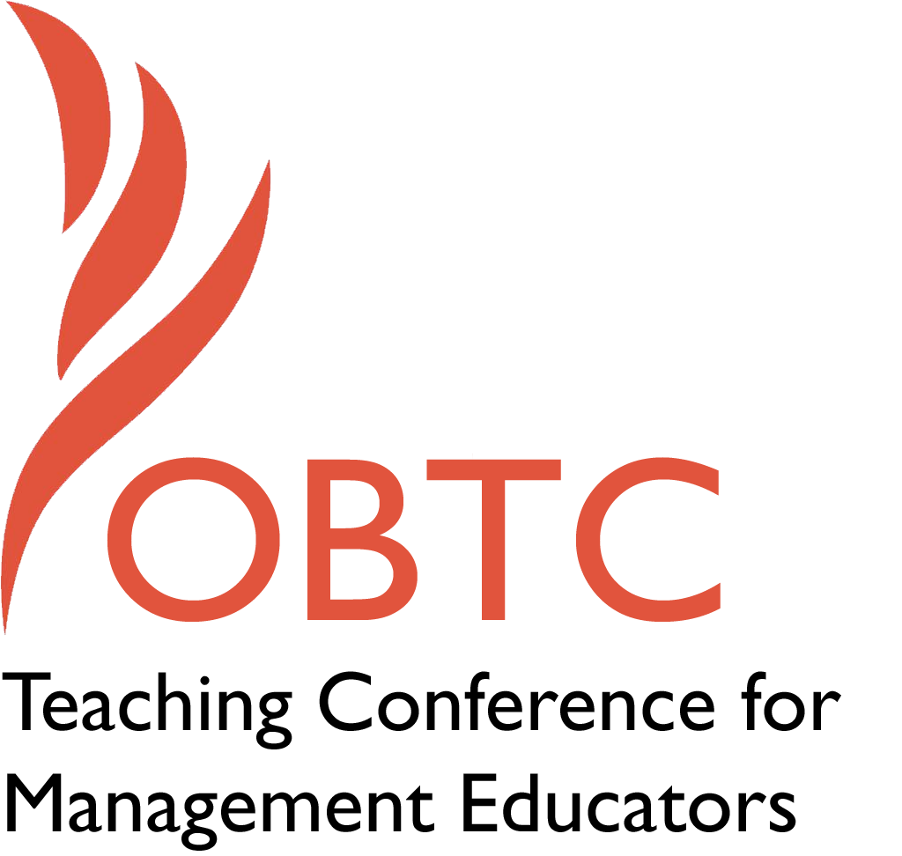

OBTC 2015 at University of La Verne
June 17th – 20th, 2015

Submission Template

SUBMISSION GUIDANCE
* Remove all identifying properties from this document *
* All files must be saved in PDF format *
*Please include ALL supplementary text at the end of this document* *Only one document should be submitted*

Submission Template for the
2015 OBTC Teaching Conference for Management Educators

- Title of Proposal:
Learning Governance: Community-Based Partnership for Capacity Building

- Abstract:
Please include a brief session description (not to exceed 100 words).If your proposal is accepted, this description will be printed in the conference program.

This presentation will describe the development of the Governance & Leadership Development Practicum, a senior undergraduate course that substantiates community-based experiential learning and capacity building. The goal of the course is to provide students with an exceptional learning opportunity, mentored tacit knowledge transfer about organizational structures and leadership, and—equally important—to contribute to leadership sustainability in the community. We provide an account of the course design, development, and implementation, and the unique foundations of this process that were grounded in principles of partnership, collaboration, and stakeholder engagement. Lastly, we offer considerations for development of similar courses (or course components).

- Keywords:
Use three or four keywords to describe your session.

Experiential learning; Community engagement; Governance education; Student leadership development

- Format
__ Activity or exercise
_ Discussion roundtable (60 minute only)
X General discussion session

- Time Requested:
__ 30 Minutes
_X_ 60 Minutes (Roundtables must select 60 minutes)
_ 90 Minutes
- Planning Details:
Does your session have any special requirements for space or materials?

There are no special requirements for this session. Although we selected ’60 minutes’ for our requested time, we could potentially abbreviate our session to fit a 30 minute timeslot if needed (thought this would unfortunately necessitate fewer ‘takeaways’ for attendees and probably less dialogue).

- Learning Objectives or Goals for the Session:
What are 2-4 specific learning outcomes that participants will get from your session?
Session participants will gain:
- An innovative, experiential course model for their teaching ‘toolbox’ that can be translated into many contexts;
- Ideas/discussions about partnering with community boards and/or organizations;
- Ideas/discussions about incorporating community mentors into courses;
- Alternatives for course calendar scheduling of community-based courses;
- Understanding of the benefits of an Advisory Board for community-based experiential learning

- Management or Teaching Topics:
Describe what management and/or teaching topics are relevant to your session, and why. Please include theoretical, disciplinary, or theoretical foundations that will help reviewers understand how your ideas fit within the broader field of management.

There are three main topics within research and practice that are most germane to this presentation: At the broadest level, it speaks to community-university partnerships and experiential learning, and because of the specific context it also highlights leadership and governance education.

Organizations are governed by boards of directors whose purpose is to maximize resources, achieve goals, and ensure accountability (Viader & Espina, 2014). Boards play a critical role in the operation and viability of organizations by fulfilling two major responsibilities: “providing oversight, advice, and counsel…[and] monitoring” (Finkelstein & Mooney, 2003, p. 101). Board governance is therefore essential knowledge for individuals in nearly all organizational contexts, regardless of whether those organizations are considered for-profit or non-profit, and regardless of industry or sector. An understanding of the principles of governance is particularly relevant for graduates of business and management education programs. In spite of this, governance is not commonly included in the formal curriculum of many business schools. Where governance training is available, another challenge exists: many business school students have little to no ‘real world’ experience with governance and therefore have little upon which to anchor any theoretical or conceptual knowledge they might gain from classroom-based learning. Moreover, given the nature of board governance and organizational leadership, it is arguably difficult to truly understand “how it works” in practice without experiencing it in practice. Approaches that socialize learners through the exchange of ‘tacit knowledge’—a process of “observation, imitation, and practice” (Nonaka, 1998) are required.

Community-based experiential learning can create opportunities for acquiring tacit knowledge through exposure to governance and leadership in action, and opportunities for students to apply what they are learning in the classroom in real time. Numerous articles in the scholarly literature have cited the benefits to students of community-based experiential learning, such as personal and community learning outcomes (Bartel et al., 2001), skill development (Madsen & Turnbull, 2006), and tolerance for diversity (Dumas, 2002). Students also acquire hands-on experience (e.g., McLaughlin, 2010), and enhance their ability to translate theory into practice (McClam et al., 2008). Community-based experiential courses may be particularly beneficial for students in business and management education programs, in light of calls for business schools to devote greater attention to social issues and community engagement (Dumas, 2002).

There can be inherent challenges, however, in creating a platform for community-based experiential learning that (a) takes each party’s needs into account in design and implementation, (b) ensures mutually beneficial outcomes, such as high-level learning and application for students and a meaningful contribution to community organizations, and (c) is feasible and sustainable. The impetus for the Governance & Leadership Development Practicum was partly founded upon these elements, in addition to targeting theory and practice of governance and leadership as specific ways to build capacity for both community and students.

- Session Description and Plan:
What will you actually do in this session? What activities will you facilitate, how long will they take, and how will participants be involved?

This session will be comprised of a presentation and dialogue with attendees. Although we will share our experiences and reflections, we place a high value on including the expertise and perspectives that session participants will bring. Thus, we will pose several discussion questions throughout out presentation, invite participants to contribute their own ideas, and encourage an open dialogue among everyone present.

- For Activities and Exercises:
Attach any materials needed to run the activity and debriefing questions. Evidence for effectiveness may also be included.

No materials will be needed.

- Implications for Teaching or for Teachers:
What is the contribution of your session?

This session will provide instructors with a road map for transferring tacit knowledge about complex and multi-faceted organizational processes, like governance and leadership, that students often only acquire later in their careers through vocational experience. Faculty members or instructors can use the information presented in this session to inform or inspire the development of courses focused on governance and/or leadership development, as well as community-based experiential courses on any number of topics. Administrators and curriculum development specialists may also be interested in this presentation, because our case can serve as a basis for adopting a stakeholder engagement approach to course or program development, designing community-based experiential learning opportunities, and informing institutional policy and governance practices regarding curriculum development. Although our work can contribute in particular to research and practice in business and management education, the contributions are not restricted to this context; rather, the course development process and stakeholder engagement principles described in our case could be leveraged in many other disciplines.

As alluded to in prior sections of this proposal, we also anticipate that additional insights will arise from attendees’ own experiences and expertise, so session participants will learn from each other and build on everyone’s perspectives and input.

- Application to Conference theme:
How does your session fit with the overall OBTC theme of Learning in Community?

Our session is directly linked to the conference theme, as the Governance & Leadership Development Practicum (about which our session is focused) is wholly centered on the practice of learning in community. Moreover, the development and implementation of the course was co-created through a process of stakeholder engagement, which included community leaders, students, and faculty peers. Thus, our session will demonstrate learning with community as well as learning in community.

- Unique Contribution to OBTC:
Have you presented the work in this proposal before? If so, how will it be different? Is this proposal under current review somewhere else? If so, please explain. How will your proposal be different for the OBTC conference?

This is a new proposal, thus we have not presented this work elsewhere.

- References and/or Additional Materials:

Bartel, C. A., Saavedra, R., & Van Dyne, L. (2001). Design conditions for learning in community service contexts. Journal of Organizational Behavior, 22, 367-385.
Dumas, C. (2002). Community-based service learning: Does it have a role in management education? International Journal of Value Based Management, 15, 249-264.
Finkelstein, S., & Mooney, A. C. (2003). Not the usual suspects: How to use board process to make boards better. Academy of Management Executive, 17, 101-113.
Madsen, S. R., & Turnbull, O. (2006). Academic service learning experiences of compensation and benefits course students. Journal of Management Education, 30, 724-742.
McClam, T., Diambra, J. F., Burton, B., Fuss, A., & Fudge, D. L. (2008). An analysis of a service-learning project: Students’ expectations, concerns, and reflections. Journal of Experiential Education, 30, 236-249.
McLaughlin, E. (2010). The “real-world” experience: Students’ perspectives on service-learning projects. American Journal of Business Education, 3, 109-117.
Nonaka, I. (1998). The knowledge-creating company. In D. Neef, G. A. Siesfeld, and J. Cefola (Eds.). The economic impact of knowledge, pp. 175-188. Butterworth-Heinemann: Woburn, MA.
Viader, A. M., & Espina, M. I. (2014). Are not-for-profits learning from for-profit organizations? A look into governance. Corporate Governance, 14, 1-14.

