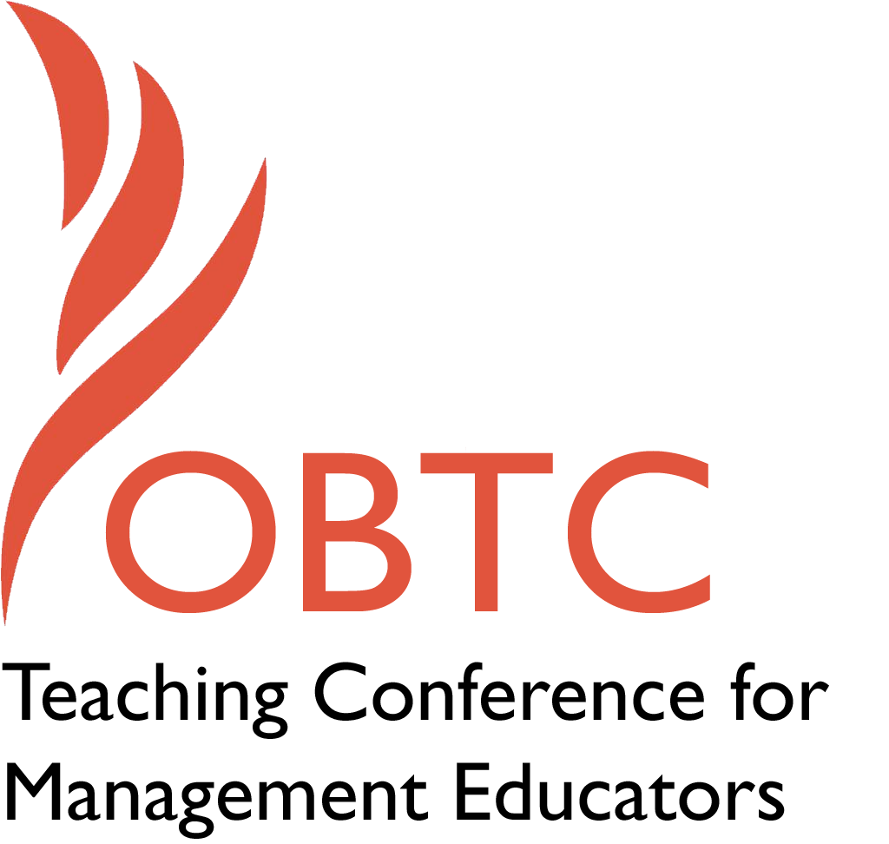

OBTC 2015 at University of La Verne
June 17th – 20th, 2015

Submission Template

SUBMISSION GUIDANCE
* Remove all identifying properties from this document *
* All files must be saved in PDF format *
*Please include ALL supplementary text at the end of this document* *Only one document should be submitted*

Submission Template for the
2015 OBTC Teaching Conference for Management Educators

- Title of Proposal:
How Do We Teach and Measure Creativity and Innovation as a Learning Outcome?

- Abstract:
Please include a brief session description (not to exceed 100 words).If your proposal is accepted, this description will be printed in the conference program.

The Hart Research report conducted for the Association of American Colleges and Universities (2013) stats that 71% of employers surveyed wanted more emphasis placed on the ability to be creative and innovative as learning outcomes. Research shows that creativity and innovation are necessary for organizations to thrive in the global arena. So how do we teach students to be creative and innovative? How do we measure creativity and innovation? Does the Business curriculum have a place for this learning outcome? Learning communities are a place to exchange ideas and experience, in this session we will discuss these questions and exchange ideas.

- Keywords:
Use three or four keywords to describe your session.

Creativity, Innovation, Assessment, Liberal learning

- Format
Activity or exercise
Discussion roundtable (60 minute only)
X General discussion session

- Time Requested:
30 Minutes
X 60 Minutes (Roundtables must select 60 minutes)
90 Minutes

- Planning Details:
Does your session have any special requirements for space or materials?

It would be helpful to have a white board and projection available.

- Learning Objectives or Goals for the Session:
What are 2-4 specific learning outcomes that participants will get from your session?

- Exchange ideas on how colleges are incorporating creativity and innovation learning outcomes into their curriculum.

- Discuss how to measure and assess creativity and innovation. Review examples of creativity surveys/questionnaires.

- Create a learning community to address a learning outcome. Create a list of interested individuals to continue the exchange of ideas and knowledge.

- Gain a better understanding of incorporating creativity into the curriculum and how to promote creativity in business students.

- Management or Teaching Topics:
Describe what management and/or teaching topics are relevant to your session, and why Please include theoretical, disciplinary, or theoretical foundations that will help reviewers understand how your ideas fit within the broader field of management.

Hart Research Associates (2013) survey completed for the Association of American Colleges and Universities found that 80 percent of employers surveyed felt the college students needed broad knowledge found in liberal arts and sciences in addition to their major. Employers put a significant emphasis on innovation as key to the survival of their company. Ninety-five percent give priority to hiring individuals that will advance the company through their innovative skills. Creativity leads to innovation. Students need to develop their creative skills so that they are ready to apply them to the work environment.

Many hold the theory that creativity is a type of soft, and malleable talent that can be seen in one’s ability to change one insignificant substance or set of substances into something significant; such as the writer who with paper and ink creates a story. This stands true for our purposes as well; we can take business and art, and proceed to blend them into innovation, technology, and entrepreneurial advances. How is this done in the Business curriculum or is it incorporated in the arts and humanities? Baker and Baker (2012) discuss using lessons from art schools as models for teaching creativity in business school. Driver (2001) also talks about creating an environment within the classroom that fosters creativity. As we develop these ideas we need to also ask, how do we know we are developing and fostering creative thinkers.

While there are many questionnaires to assess whether a person is creative, do these provide a measure for assessing a student’s increase in creativity through the business curriculum? Kaufman, Cole, and Baer (2006 as cited in Kaufman 2012) developed a questionnaire which they believed accurately represented creativity across multiple fields. After reassessing their work in 2009, they decided the survey was not broad enough, and transformed it from a series of questions regarding certain activity into creative capability in that activity (Kaufman 2012). With the development of the Kaufman Domains of Creativity Scale(K-DOCS) this has become a much more realistic measure. Other surveys available are the creativity models surveyed by Eder (2007) and the Biographical Inventory of Creative Behaviors (BICB), Creative Behavior Inventory(CBI), and the Creativity Styles Questionnaire—Revised(CSQ-R). (Kumar, V.K., Kemmler, D., & Holman, E. R., 1997).

- Session Description and Plan:
What will you actually do in this session? What activities will you facilitate, how long will they take, and how will participants be involved? Reviewers will be evaluating how well the time request matches the activities you’d like to do, and the extent you can reasonably accomplish the session’s goals. Reviewers will also be looking for how you are engaging the participants in the session. Include a timeline for your session.

- Quick creativity exercise. This is just as a warm up for the attendees. 5 minutes
- Overview of creativity and innovation as learning outcomes and where they typically reside, liberal arts versus business. The need for creativity within the business curriculum. Present various thoughts on how to include creativity in the curriculum, drawing from Baker and Baker (2012), Driver (2001) and Halpern (2010)15 minutes
- I will facilitate an open discussion on two main themes – Developing student creativity within the classroom and How to measure whether students are more creative. The questions posed: What/how do you include creativity in the business classroom? If we want students to be creative, how are we being creative? How do you know it is working, how are you measuring it? 30 minutes
- Wrap up and summarize. 10 minutes

- For Activities and Exercises:
Attach any materials needed to run the activity and debriefing questions. Evidence for effectiveness may also be included.

Warm up activity will be for the attendees to come up with as many creative uses of an object beyond what the object is typically used as.

- Implications for Teaching or for Teachers:
What is the contribution of your session?

The session will bring together individuals to share their own expertise, experience, and thoughts on creativity and the business curriculum. I will try to record as much information to get back to attendees and hope to continue the discussion after the conference through email or a listserv. This session provides a venue for educators to discuss an important learning outcome for business students, one that has become more and more important in the workplace

- Application to Conference theme:
How does your session fit with the overall OBTC theme of Learning in Community?
A twist on Learning in Community… creating a learning community of conference attendees by providing an opportunity to exchange ideas, best practices, experiences, knowledge on a topic that is important for students’ success in the workplace. “McMillan and Chavis (1986) state that there are four key factors that defined a sense of community: “(1) membership, (2) influence, (3) fulfillment of individuals needs and (4) shared events and emotional connections.” (Wikipedia, Learning Community)

- Unique Contribution to OBTC:
Have you presented the work in this proposal before? If so, how will it be different? Is this proposal under current review somewhere else? If so, please explain. How will your proposal be different for the OBTC conference?

No
- References and/or Additional Materials:

Baker, D.F.& Baker, S. J. (2012). To “Catch the Sparkling Glow”: A canvas for creativity in the management classroom. Academy of Management Learning and Education. 11(4), 704-721
Batey, M. (2007). A psychometric investigation of everyday creativity. (Unpublished Doctoral Thesis). University College, London.
Driver, M. A. (2001).Fostering creativity in Business Education: Developing creative classroom environments to provide students with critical workplace competencies. Journal of Education for Business, September/October, 28-33.
Halpern, D. F. (2010). Creativity in college classrooms, In R. A. Beghetto & J. C. Kaurman, eds. Nurturing creativity in the classroom, 380-393. Cambridge: Cambridge University Press.
Eder, P. J. (2007). Integrating the componential and interactionist models of employee creativity. (Doctoral Dissertation). Proquest Psychology Journals. (3277817).
Hart Associates (2013). http://www.aacu.org/leap/documents/2013_EmployerSurvey.pdf
Hocevar, D. (1980). Intelligence, divergent thinking, and creativity. Intelligence, 4, 25-40.
Kaufman, J. C. (2012). Counting the muses: Development of the Kaufman domains of creativity scale (K-DOCS). Psychology of Aesthetics, Creativity, and the Arts, 6(4), 298-308. doi: 10.1037/a0029751
Kumar, V.K., Kemmler, D., & Holman, E. R. (1997). The creativity styles questionnaire—revised. Creativity Research Journal, 10(1), 320-323.
Kushner, R. J. (1999). Curriculum as strategy: The scope and organization of business education in liberal arts colleges. The Journal of Higher Education, 70(4), 413-440.
Pamp Jr. E. F. (1955). Liberal arts as training for business. Harvard Business Review, 33(3), 42-50.
Paris, D. (2007). Business and the liberal arts: Integrating professional and liberal education. Report of a Symposium on the Liberal Arts and Business.
Sterling, C. (1995). The evolving symbiotic relationship of arts education and U.S. business. Arts Education Policy Review, 97(2).

