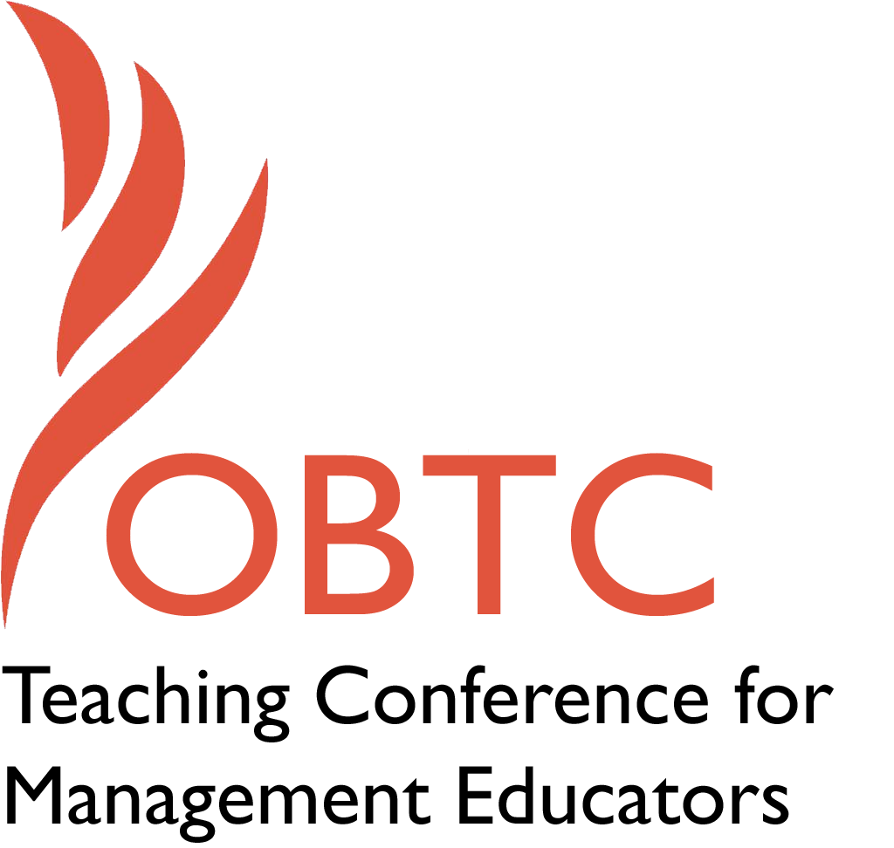

OBTC 2015 at University of La Verne
June 17th – 20th, 2015

Submission Template

SUBMISSION GUIDANCE
* Remove all identifying properties from this document *
* All files must be saved in PDF format *
*Please include ALL supplementary text at the end of this document* *Only one document should be submitted*

Submission Template for the
2015 OBTC Teaching Conference for Management Educators

- Title of Proposal:
Community as Co-educators: Beyond the lip service of Service Learning

- Abstract:
Please include a brief session description (not to exceed 100 words).If your proposal is accepted, this description will be printed in the conference program.

The field of service learning often totes the phrase of “community as co-educators”, but still maintains the strict boundaries between the academy and community. By pursuing the Carnegie Foundation’s Community Engagement designation the University of La Verne was able to map its assets and build upon relationships with community partners by inviting them to be both instructor and service learning host. This interactive workshop will introduce participants to the Carnegie journey and how through the leveraging of partnerships we developed a community mental health course that is mutually beneficial to the community partner and the university.

- Keywords:
Use three or four keywords to describe your session.
Community as co-educator, Service Learning, Community-based Learning, Community Partnerships, Carnegie, community engagement

- Format
X Activity or exercise
Discussion roundtable (60 minute only)
General discussion session

- Time Requested:
30 Minutes
60 Minutes (Roundtables must select 60 minutes)
X 90 Minutes

- Planning Details:
Does your session have any special requirements for space or materials?

Computer, projector, access to wi-fi

- Learning Objectives or Goals for the Session:
What are 2-4 specific learning outcomes that participants will get from your session?

- Participants will learning about the Carnegie Classification process that the University of La Verne engaged in
- Participants will be introduced to successful examples of sustainable, reciprocal community-university partnerships
- Participants will exchange ideas, possibilities and pitfalls in regards to their own institutions
- Participants will systems-map their own community-university context

- Management or Teaching Topics:
Describe what management and/or teaching topics are relevant to your session, and why Please include theoretical, disciplinary, or theoretical foundations that will help reviewers understand how your ideas fit within the broader field of management.

We will engage the management topics of:
- Leadership
- Team building
- Creativity and Innovation
- Engagement and Motivation

We will engage the teaching topics of:
- Service Learning
- Community Engagement
- Community Mental Health
- Experiential Learning

- Session Description and Plan:
What will you actually do in this session? What activities will you facilitate, how long will they take, and how will participants be involved? Reviewers will be evaluating how well the time request matches the activities you’d like to do, and the extent you can reasonably accomplish the session’s goals. Reviewers will also be looking for how you are engaging the participants in the session. Include a timeline for your session.

- Presenters will facilitate roundtable activities, which include – gifts of the head, hands, and hearts.
- Presenters will present on the Carnegie application process that the University of La Verne experienced.
- Presenters will show and discuss what the results of the self-assessments were and how that lead to a focus on community as co-educators
- Presenters will provide an example of a successful university-community partnership
- Presenters will invite participants to share their own examples and engage in a systems-mapping activity to identify the possibilities and pitfalls of university-community partnership.

- For Activities and Exercises:
Attach any materials needed to run the activity and debriefing questions. Evidence for effectiveness may also be included.

Hand, Head and Heart Exercise
Pair up with a person you don’t know very well. Take a few minutes to think about your assets and then take about five minutes each to share these assets with the other person in three realms of knowing.
Hand–Physical skills you possess that you would be willing to teach others. I.E., carpentry, photography, painting, bicycle repair…
Head –Knowledge that you have in a particular area like child development, health care, history of the neighborhood…
Heart–What are your passions; what stirs you to action; what would you walk across hot coals for?

- Implications for Teaching or for Teachers:
What is the contribution of your session?

This session will contribute to assisting teachers to intentionally think about the way in which they send students out to the community and the way they engage their community partners in mutually beneficial and reciprocal relationships to create transformational learning experiences.

- Application to Conference theme:
How does your session fit with the overall OBTC theme of Learning in Community?
It speaks directly to the idea and theory of learning in community and provides examples of how that can be achieved.

- Unique Contribution to OBTC:
Have you presented the work in this proposal before? If so, how will it be different? Is this proposal under current review somewhere else? If so, please explain. How will your proposal be different for the OBTC conference?

No

- References and/or Additional Materials:
- http://carnegieclassifications.iu.edu/

- http://tricitymhs.org/index.php?option=com_rssearch&view=results&module_id=37&search=lisa+naranjo&cmdSearch=Search&Itemid=101

