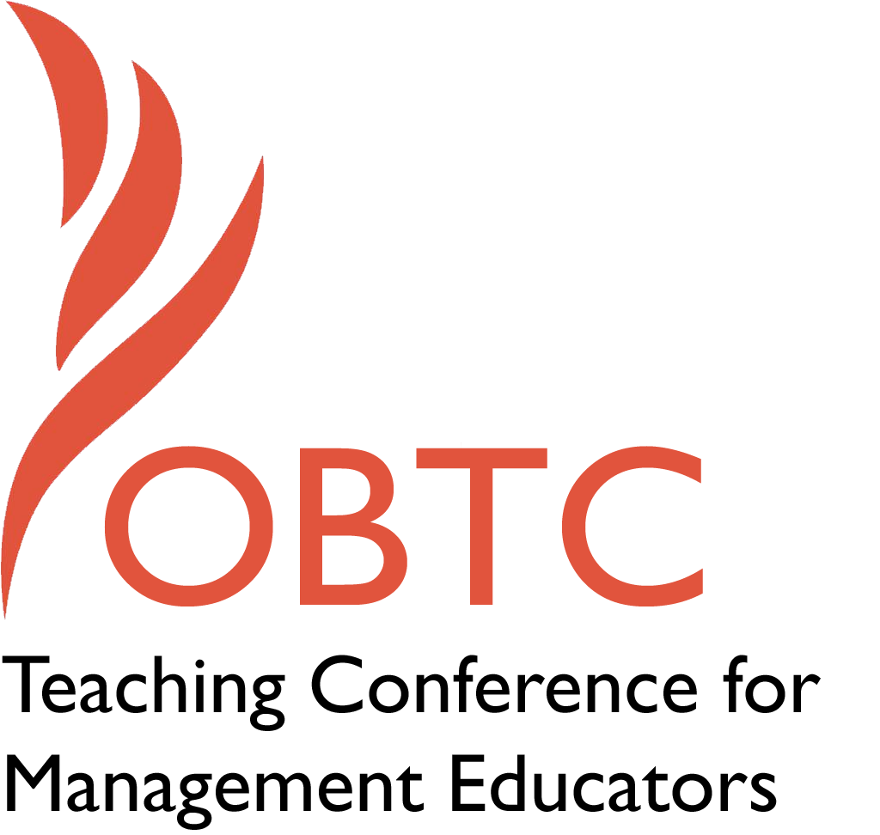

OBTC 2016 at Walsh University
June 8th – 11th, 2016

Submission Template

SUBMISSION GUIDANCE
* Remove all identifying properties from this document *
* All files must be saved in PDF format *
*Please include ALL supplementary text at the end of this document* *Only one document should be submitted*

Submission Template for the
2016 OBTC Teaching Conference for Management Educators

- Title, Abstract & Keywords

In your abstract, please include a brief session description (not to exceed 100 words), and three to four keywords. If your proposal is accepted, this description will be printed in the conference program.

Using Student Self-Filmed Videos to Teach Integrative Negotiation
Teaching negotiation can be both enjoyable and frustrating. Students enjoy negotiating their in-class role plays. However, when it comes to students demonstrating specific behaviors, there is a knowledge-skill gap that can be frustrating.
This session will demonstrate an exercise I have developed and refined over time to improve students’ ability to demonstrate integrative behaviors. Student-pairs film themselves negotiating, then analyze their performance and that of other students in class using a rubric. The session will ask participants to participate in grading a video.

Terms: negotiation, win-win, student video

- Format
X Activity or exercise
Roundtable discussion (60 minute only)
General discussion session

2a) For activities and exercises only, is yours best suited for
A traditional classroom
An online class
X Either

2b) For activities and exercises only, is yours best suited for
Undergraduate students
Graduate students
X Either

- Time Requested:
X 30 Minutes OR
X 60 Minutes (Roundtables must select 60 minutes)
90 Minutes

- Planning Details:
Each room contains a white board with markers, computer (PC) with DVD capability and computer projector. Does your session require any other equipment?

I will need to use the PC to connect to the internet and YouTube, if possible.

- Teaching Implications:
What is the contribution of your session to management pedagogy/andragogy? Specifically, please include your learning objectives, and describe what management and/or teaching topics are relevant to your session, and why. Also, include theoretical, disciplinary, or theoretical foundations that will help reviewers understand how your ideas fit within the broader field of management.

Negotiation is a part of every job in management. Integrative negotiation, especially, is a problem-solving style of negotiation that is valuable across a wide range of situations. So becoming better (integrative) negotiators can improve students’ jobs, careers, and lives. This session demonstrates a method to improve the integrative/problem-solving behaviors that students need to be more successful at this task, and at problem-solving in general.

This exercise was developed for an undergraduate negotiation course, but it could also be used in any course that incorporates negotiation or problem-solving approaches.

Fisher and Ury’s Getting to Yes and Getting Past No are classic books on the subject of integrative negotiation. See also:

Bardone, R. (2000) Teaching interpersonal skills for negotiation and for life. Negotiation Journal, 16(4): 377-385.
Coleman, P. and Lim, Y. (2001). Systematic approach to evaluating the effects of collaborative negotiation training on individuals and groups. Negotiation Journal, 17(4): 363
ElShenawy, E. (2008). Does negotiation training improve negotiators’ performance? JEIT 35(3)
Patton, B. (2009). The deceptive simplicity of teaching negotiation: Reflections on thirty years of the negotiation workshop. Negotiation Journal
Peppet, S. (2002) Teaching negotiation using web-based streaming video. Negotiation Journal. 18(3): 271-283

- Session Description and Plan:
What will you actually do in this session? If appropriate, please include a timeline estimating the activities will you facilitate: how long will they take, and how will participants be involved? Please remember that reviewers will be evaluating how well the time request matches the activities you’d like to do, and the extent you can reasonably accomplish the session’s goals. Reviewers will also be looking for how you are engaging the participants in the session.

I will start with a short introduction to distributive vs integrative negotiation, how they differ, and the types of behaviors/tactics associated with them. Then I will discuss the frustrations in trying to get students to demonstrate the more complex integrative behavior, and how the exercise changed over time to improve that goal. Next I will give out two different evaluation sheets for the participants to use to evaluate two different student self-filmed videos I will show. Each video is approximately 5 minutes long. A discussion of the tactics and students’ performance will follow. Finally, participants will be asked for feedback and suggestions for further improvement.

- Application to Conference theme:
How does your session fit with the overall OBTC theme of United in Service?

This session uses “united in service” in two ways. First, the exercise I use in class has students help each other perform better. Second, the demonstration I will do at the conference will help me improve my work and will help teachers improve their teaching of others.

- Unique Contribution to OBTC:
Have you presented the work in this proposal before? If so, how will it be different? Is this proposal under current review somewhere else? If so, please explain. How will your proposal be different for the OBTC conference?

I presented a very early draft of some of these ideas at a local conference. However, I have added to and improved the exercise, the research, and the performance greatly. Also I have added the videos, tactics discussion, and review of student performance.

It is not under current review. I want feedback to help me write this up for a journal.

