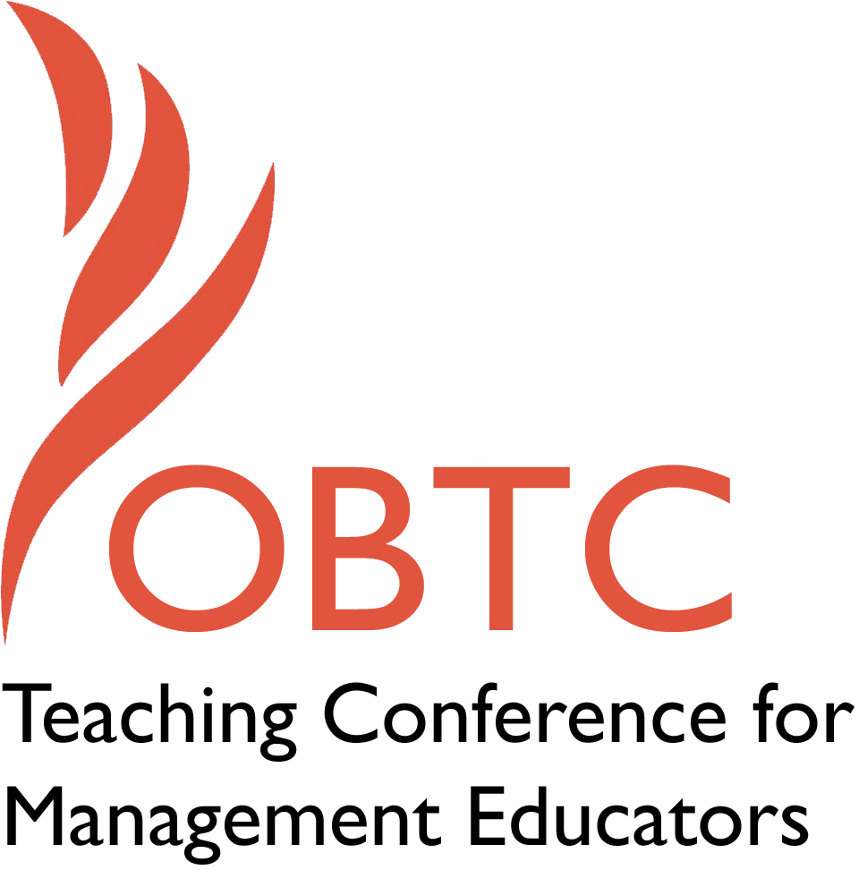

OBTC 2016 at Walsh University

June 8th – 11th, 2016

Submission Template

SUBMISSION GUIDANCE
* Remove all identifying properties from this document *
* All files must be saved in PDF format *
*Please include ALL supplementary text at the end of this document* *Only one document should be submitted*

Submission Template for the
2016 OBTC Teaching Conference for Management Educators

- Title, Abstract & Keywords

Changing Employers at Mid-Career: Thoughts to Ponder Before Making the Jump

In this session, two mid-career OBTCers who recently changed employers share their experiences and provide tools and resources to those pondering a similar change. This session will look at what brings about a job change at mid-career, things to consider before changing employers, the mid-career job search process, and first year experiences in your new role. Due to the sensitive nature of this session, we ask all session participants to abide by Las Vegas rules – who comes to and what happens in this session, stays in this session! Come and explore the possibilities.

Keywords: Job change, culture, self-awareness

- Format
Activity or exercise
Roundtable discussion (60 minute only)
X General discussion session

2a) For activities and exercises only, is yours best suited for
A traditional classroom
An online class
Either

2b) For activities and exercises only, is yours best suited for
Undergraduate students
Graduate students
Either

- Time Requested:
30 Minutes
X 60 Minutes (Roundtables must select 60 minutes)
90 Minutes
- Planning Details:
Each room contains a white board with markers, computer (PC) with DVD capability and computer projector. Does your session require any other equipment?

Our session does not need any other equipment than the items noted above.

- Teaching Implications:
What is the contribution of your session to management pedagogy/andragogy? Specifically, please include your learning objectives, and describe what management and/or teaching topics are relevant to your session, and why. Also, include theoretical, disciplinary, or theoretical foundations that will help reviewers understand how your ideas fit within the broader field of management.

A 2012 survey of full-time faculty found 65% of the full time faculty surveyed have considered leaving their institution, with 78% of these potential job changers saying they would leave their institution to find a more supportive job environment (English & Avakian, 2012). Changes in employment can be good because it provides individuals with greater opportunities for professional development and career renewal, but the structure of higher education and tenure systems may prevent many faculty from leaving their positions due to the perceived increased risk of giving up a tenured or long-term secure position especially at mid or late career (Zhou & Volkwein, 2004). Among the faculty who left their positions for nonretirement reasons in 1998, less than 14% were tenured (NCES, 2001). The goal of this session is to provide attendees who are contemplating leaving their current institution with information and tools to use when contemplating a change and share experiences from those who have changed institutions at mid-career.

Career theorists (Engels, 1995; Super, Savickas & Super, 1996) suggest a common practice among middle-age individuals, defined as the ages of 35 to 65 years, is midlife renewal during which individuals take stock of themselves and reevaluate where they are going and what they are doing with their lives. Vander Zanden (2000) calls midlife "a time of looking back and at the same time looking forward" (p. 488). Power and Rothausen’s (2003) Midcareer Development Model suggests as a result of reflective life assessment, an individual may decide to make a voluntary career change as some find that the original reasons for their choices are no longer valid (Barclay, Stoltz & Chung, 2010). Although research on mid-life career changes has increased (Maddox-Daines, 2016; Bimrose, Barabasch, Brown & Mulvey, 2015), the unique environment of higher education makes job changes for mid-career faculty unique and particularly challenging as faculty may be giving up the security of tenure or a long-term contract if they change employers. This session will provide tools to guide higher education faculty through the renewal process and give participants alternatives to explore in response to the results of this process.

- Session Description and Plan:
What will you actually do in this session? If appropriate, please include a timeline estimating the activities will you facilitate: how long will they take, and how will participants be involved? Please remember that reviewers will be evaluating how well the time request matches the activities you’d like to do, and the extent you can reasonably accomplish the session’s goals. Reviewers will also be looking for how you are engaging the participants in the session.

The following is a summary of the proposed session:

Activity | Time
Introduction of Facilitators, Subject, and Rules for session | 5 Minutes
How a mid- career search differs from an initial PhD search | 10 Minutes
Evaluating the reasons for changing employers | 20 minutes
The Job Search process at mid-career | 10 minutes
The first year in your new position | 10 minutes
Wrap Up & Closing | 5 minutes
Total Time | 60 Minutes

The following is an overview of what activities that will occur throughout the session:

- Introduction of Facilitators, Subject, and Rules for session
The session will begin with the introduction of the facilitators who both changed employers after a long tenure with their previous institutions. As we anticipate that some participants may be concerned with disclosing that they are contemplating a change with colleagues, we will ask all session participants to abide by Las Vegas rules – who comes to and discussions within the session are confidential We will ask all participants not to personal information disclosed with those outside of the session.

- How a mid- career search differs from an initial PhD search
During this activity, the facilitators will discuss how a mid-career job search differs from a job search for a new PhD, which is most familiar to potential participants in this session. A mid-career search is a much more informed job search, with the applicant coming into the search with experience and perceptions that will influence the job search process. In addition, we will discuss how employers will view a mid-career applicant and how it differs from a new PhD applicant.

- Evaluating the reasons for changing employers
In this activity, we will use questions from Power and Rothausen’s (2003) Midcareer Development Model, person-environmental fit assessments, and other tools to help participants understand who they are, what they want from their career, and what they need to achieve career goals. We will also guide participants through an assessment of the organizational culture of their current institution comparing the elements of culture they were attracted to when they first went to their current institution versus the current culture, to understand wants and needs of a new employer. We have included a copy of some of the tools we will use in Appendix A. The goal of these activities is to develop a listing of wants and needs of any employer to meet the participant’s career goals.
- The Job Search process at mid-career
In this activity, the facilitators will discuss how to inventory and quantifying strengths and weaknesses from an employer’s eyes and how to position oneself if he or she decides to undergo a job search. We will discuss resources available and the experience of the facilitators and participants who have undergone a mid or later career faculty job searches.

- The first year in your new position
In this final activity, the facilitators will discuss the challenges encountered, rewards, and lessons learned during their first year at their new institution.

- Application to Conference theme:
How does your session fit with the overall OBTC theme of United in Service?

Although research on mid and late job changers is increasing, the unique environment of higher education with its long-term employment guarantees for faculty through tenure and long-term contracts, makes job changing among the population represented by most OBTC participants particularly challenging with great personal risks. We believe this session will provide a service to our community and will help our conference attendees pondering a job change make better decisions and understand the risks and rewards associated with changing employers. Having participated in this session, we believe participants with be more informed about their career choices, whether they remain with their current employer or make a change, resulting in better service to our universities, our students, and ourselves.

- Unique Contribution to OBTC:
Have you presented the work in this proposal before? If so, how will it be different? Is this proposal under current review somewhere else? If so, please explain. How will your proposal be different for the OBTC conference?

We have not presented this work before and this work is not under review with any other outlet.

References

Barclay, S. R., Stoltz, K. B., & Chung, Y. B. (2011). Voluntary midlife career change: Integrating the transtheoretical model and the life-span, life-space approach. Career Development Quarterly, 60, 386-399. DOI: 10.1002/j.2161-0045.2011.tb00966

Bimrose, J., Barabasch, A., Brown, A., & Mulvey. R. (2015) Midcareer
changes symposium, British Journal of Guidance & Counselling, 43:3, 255-262, DOI:
10.1080/03069885.2015.1037098

Engels, D.W. (1995). Common themes in midlife career transitions, Career Development Quarterly, 44, 83-88. DOI: 10.1002/j.2161-0045.1995.tb00531

English, L. & Avakian, L. (2012). Transforming higher education through faculty well-being. Horizons Workforce Consulting

Maddox-Daines, K.L. (2016), Mid-career as a process of discovery, Career Development International, 21(1), DOI: 10.1108/CDI-10-2014-0132

National Center for Education Statistics (NCES; 2001). Institutional Policies and Practices: Results from the 1999 National Study of Postsecondary Faculty, Institution Survey (NCES 2001-201), U.S. Department of Education, Office of Educational Research and Improvement, Washington, DC.

Power, S.J. & Rothausen, T.J. (2003) The Work-Oriented Midcareer Development Model: An Extension of Super's Maintenance Stage, The Counseling Psychologist, 31(2), 157-197. DOI: 10.1177/0011000002250479

Super, D.E., Savickas, M.L. & Super, C.M. (1996). The life-span, life-space approach to careers. In D. Brown and L. Brooks (Eds.), Career Choice and Development (3rd Ed., pp. 121-178). San Francisco: Jossey-Bass.

Zhou, Y. & Volkwein, J. (2004). Examining the influence on faculty departure intentions: A comparison of tenured versus non-tenured faculty at research universities using NSOPF-99. Research in Higher Education, 45(2), 139-176. DOI: 10.1023/B:RIHE.0000015693.38603.4c

Vander Zanden, J.W. (2000). Human Development (7th ed.) Boston: McGraw-Hill.

Appendix A: Forms and Resources for the Session
Form we will use in Section 3 of Session
Evaluating Your Organizational Environment
Question | Answer
- Think about what your current employer was like when you first started with this employer. What elements of the culture and job did you enjoy most and led you to accepting this position.

- Looking at your list above, which elements do you still enjoy at this career stage?

Question | Answer
- Think about your current employer today. What elements of the culture and job do you enjoy most?
- Still thinking about your current employer today, Are there elements of the culture and job that have changed over time that have made you change your impression of your employer? (Positive & Negative)
- If you could design the perfect position for you, what would it look like?

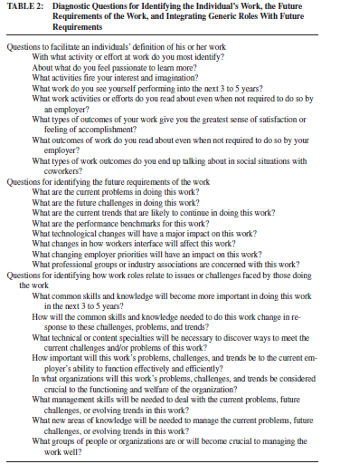
Source: Power, S.J. & Rothausen, T.J. (2003) The Work-Oriented Midcareer Development Model: An Extension of Super's Maintenance Stage, The Counseling Psychologist, 31(2), 157-197. DOI: 10.1177/0011000002250479

