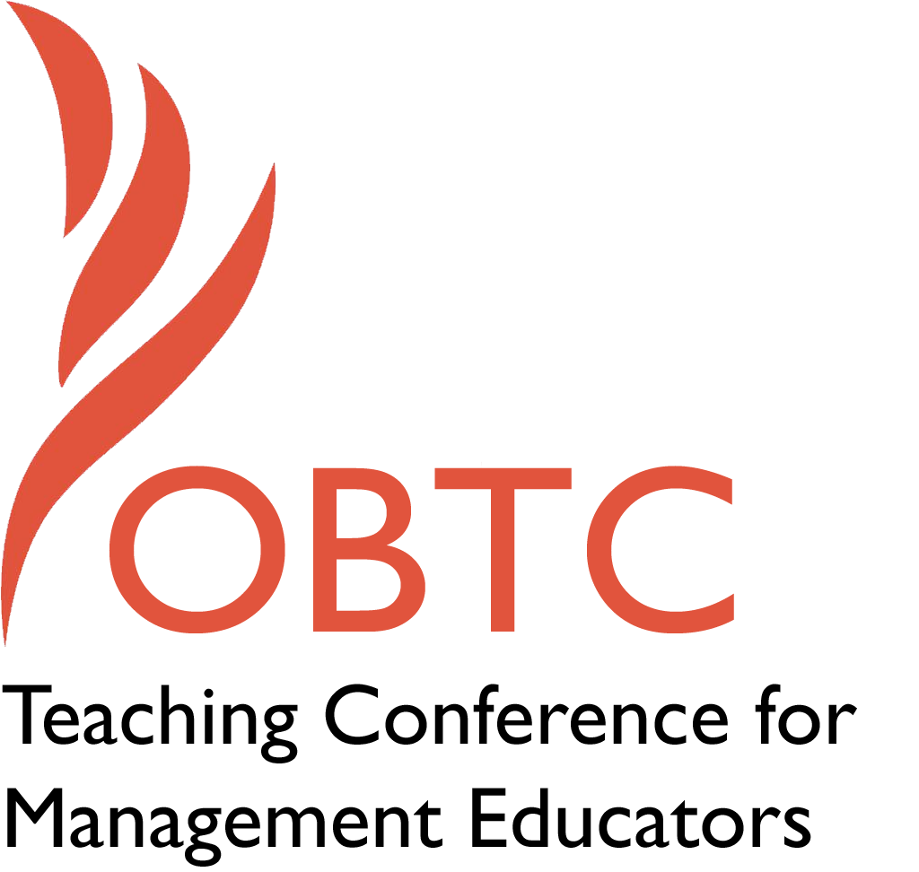

OBTC 2016 at Walsh University
June 8th – 11th, 2016

Submission Template

SUBMISSION GUIDANCE
* Remove all identifying properties from this document *
* All files must be saved in PDF format *
*Please include ALL supplementary text at the end of this document* *Only one document should be submitted*

Submission Template for the
2016 OBTC Teaching Conference for Management Educators

- Title, Abstract & Keywords

In your abstract, please include a brief session description (not to exceed 100 words), and three to four keywords. If your proposal is accepted, this description will be printed in the conference program.

Service learning: A primer

Service learning is a powerful tool in the teaching of management. Many of our OBTS colleagues utilize service learning in their classrooms, and some publish extensively on the topic. This workshop, intended as a primer for faculty new to service learning, will feature several experienced faculty who will clarify service learning, explain benefits and challenges, share specific examples and lessons learned (before, during and at the end of the course). The discussion will be instructive (materials provided) and interactive-- engaging participants’ questions throughout--and will close with tips for identifying and gaining support from mentors.

Key words: service learning, impact, non-profits, local, international

- Format
Activity or exercise
Roundtable discussion (60 minute only)
X General discussion session

2a) For activities and exercises only, is yours best suited for
A traditional classroom
An online class
X Either

2b) For activities and exercises only, is yours best suited for
Undergraduate students
Graduate students
X Either

- Time Requested:
30 Minutes
60 Minutes (Roundtables must select 60 minutes)
X 90 Minutes

- Planning Details:
Each room contains a white board with markers, computer (PC) with DVD capability and computer projector. Does your session require any other equipment?

No

- Teaching Implications:
What is the contribution of your session to management pedagogy/andragogy? Specifically, please include your learning objectives, and describe what management and/or teaching topics are relevant to your session, and why. Also, include theoretical, disciplinary, or theoretical foundations that will help reviewers understand how your ideas fit within the broader field of management.

There is a large and growing body of literature on service learning (SL), which is balanced pedagogy anchored in reciprocity. Students gain broadened perspectives and hone important skills while as a result of their working and learning in the external environment, and community members benefit as recipients of students’ (individuals or teams) efforts to introduce or enhance services and “products.” Some of the skills learned or enhanced through SL include networking, nurturing contacts, and collaborating, developing a sense of responsibility, self-efficacy, problem-solving and critical thinking, and ethical awareness, cultural sensitivity, and adaptability.

Several OBTCers have used SL extensively in their classrooms, and some have also published papers and edited special issues on the topic. While the use of SL has significant benefits in the development of future leaders, it doesn’t come without challenges and start-up costs. We’ve designed this workshop as an introduction for faculty new to SL, and feature several who have both utilized SL in their classes and contributed to the growing body of SL literature. After a brief introduction of SL and its possibilities and benefits, we focus sequentially on four main components of the implementation process—first sharing examples and best practices, and next engaging participants’ questions and concerns.

- Session Description and Plan:
What will you actually do in this session? If appropriate, please include a timeline estimating the activities will you facilitate: how long will they take, and how will participants be involved? Please remember that reviewers will be evaluating how well the time request matches the activities you’d like to do, and the extent you can reasonably accomplish the session’s goals. Reviewers will also be looking for how you are engaging the participants in the session.

00-10: Introduction of participants, identification of SL experiences, challenges, desires.
10-15: Introduction of panelists and framework: (1) determining SL fit (with faculty, course, students, community), (2) project ideas and preparation (weeks/months before the class), (3) during the class (specific deliverables/project mapping, client/student expectation mapping, grading (individual and group deliverables) (4) end of class, including external communication
15-25: Present and discuss SL benefits, costs, challenges, fit determination
25-40: Present and discuss project ideas and preparation
40-60: Present and discuss best practices for SL processes during the class
60-75: Present and discuss best practices for end of class
75-80: Discuss the role of mentoring in facilitating SL implementation success
80-90: Identify mentor partnerships, next steps

- Application to Conference theme:
How does your session fit with the overall OBTC theme of United in Service?

There is no stronger match than a “how-to” session on implementing service learning in OBTC faculty’s teaching.

- Unique Contribution to OBTC:
Have you presented the work in this proposal before? If so, how will it be different? Is this proposal under current review somewhere else? If so, please explain. How will your proposal be different for the OBTC conference?

No. As noted in the abstract, this session is intended as a primer. Faculty who have extensive experience with SL would probably not gain many new insights from attending this session, but are of course welcome to come and share experiences and offer mentoring support.

Kenworthy-U’ren, A. & Peterson, T. (2005). From the Guest Co-Editors: Service-learning and management education: Introducing the "WE CARE" approach. Academy of Management Learning & Education, 4(3), 272-277.
de Janasz, S.C., & Whiting, V.R. (2009). Using service to transform learning: Rescripted ABCs for our changing environment. International Journal of Organizational Analysis, 17(1): 60-75.
Lamb, C.H., Swinth, R.L., Vinton, K.L., & Lee, J.B. (1998). Integrating service learning into a business school curriculum. Journal of Management Education, 22(5), 637-654.
Eyler, J., & Giles, Jr., D.E. (1999). Where’s the learning in service-learning? San Francisco, CA: Jossey-Bass.
Moore, K.P., & Sandholtz, J. H. (1999). Designing successful service learning projects for urban schools. Urban Education, 34(4).
Astin, A. W., Vogelgesang, L. J., Ikeda, E.K., & Yee, J.A. (2000). Executive summary: How service learning affects students. Los Angeles: UCLA Higher Education Research Institute.
de Janasz, S.C., & Whiting, V.R. (2009). Using service to transform learning: Rescripted ABCs for our changing environment. International Journal of Organizational Analysis, 17(1): 60-75.
Kenworthy-U’Ren, Lund Dean, Fornaciari, Peterson, Leigh, Fairfield, de Janasz, Whiting…to name a few.
One of the most recent and comprehensive special issues on SL was edited by Kenworthy and Fornaciari in 2010 in the Journal of Management Education. Kenworthy, A.L. & Fornaciari, C. (2010). Guest editorial: No more reinventing the service-learning wheel: Presenting a diverse compilation of best practice “how to” articles. Journal of Management Education, 34(1), 3-8.

