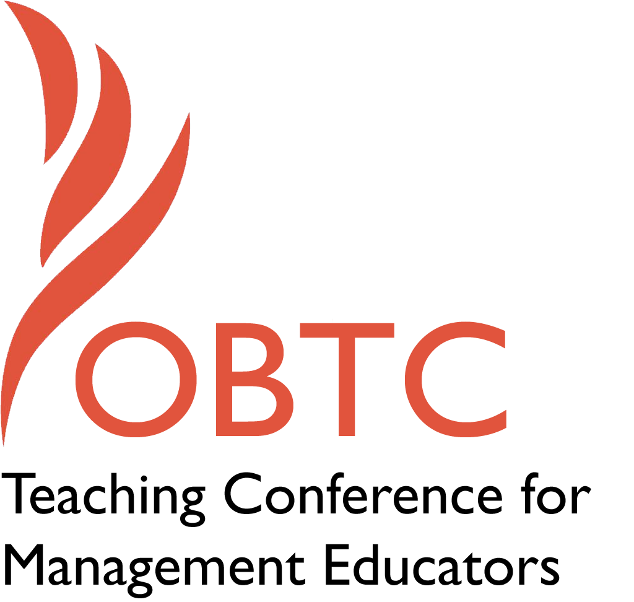

OBTC 2016 at Walsh University
June 8th – 11th, 2016

Submission Template

SUBMISSION GUIDANCE
* Remove all identifying properties from this document *
* All files must be saved in PDF format *
*Please include ALL supplementary text at the end of this document* *Only one document should be submitted*

Submission Template for the
2016 OBTC Teaching Conference for Management Educators

- Title, Abstract & Keywords

In your abstract, please include a brief session description (not to exceed 100 words), and three to four keywords. If your proposal is accepted, this description will be printed in the conference program.

Title: By Teaching (Teachers), We Learn

In this session, we present a group project titled “Teach me to teach you” that requires students to develop innovative ways to teach a topic. Its purpose is to foster deep learning for the students by placing them in the role of the educator, while providing educators with valuable, student-centered point of views that include ideas for future delivery of course topics. We first describe how this project has been implemented in a business ethics course and present the results and feedback received from several teams. In addition, we explain how this model can be adapted across the management curriculum.

Business ethics, learning by teaching, student as teacher
- Format
X Activity or exercise
Roundtable discussion (60 minute only)
General discussion session

2a) For activities and exercises only, is yours best suited for
A traditional classroom
An online class
X Either

2b) For activities and exercises only, is yours best suited for
Undergraduate students
Graduate students
X Either

- Time Requested:
X 30 Minutes
60 Minutes (Roundtables must select 60 minutes)
90 Minutes

- Planning Details:
Each room contains a white board with markers, computer (PC) with DVD capability and computer projector. Does your session require any other equipment?

No

- Teaching Implications:
What is the contribution of your session to management pedagogy/andragogy? Specifically, please include your learning objectives, and describe what management and/or teaching topics are relevant to your session, and why. Also, include theoretical, disciplinary, or theoretical foundations that will help reviewers understand how your ideas fit within the broader field of management.

The idea that teaching often leads to instructors’ learning is not new. In fact, this idea, summarized in the Latin maxim docendo discimus (by teaching, we learn), can be traced to the first century philosopher – and tutor to the infamous Roman emperor Nero – Seneca (Kiddle & Schem, 1877). Since then, educators, including those in management, have frequently exploited this pedagogical approach to enhance learning (Cortese, 2005; or Rasmussen, 1981, for an early example highlighting the benefits accrued to both students and tutors through the process of student-led instructing). This session describes an exercise for teaching business ethics that capitalizes on, but also extends, this central idea by requiring students to develop teaching materials and explore innovative ways to teach them. That is, this exercise puts the student in the place of the instructor’s pedagogical teacher, challenging the student to not only confront the obstacles to their classmates’ learning, but also the limitations of the instructor and instruction.

While educators frequently look amongst their peers to identify relevant teaching practices, this project refocuses that effort directly on the students. While we recognize that students typically do not have pedagogical training and may not be aware of the rationale behind, nor always agree with, the educators’ teaching decisions, we nonetheless believe that there is great value in this exercise. Today’s student population is highly diverse and educators need to understand that teaching strategies that work for one group of students, for instance traditional undergraduates, might not work for others such as MBA students, non-traditional students, or international students, and vice versa. Hence, this project helps educators identify teaching strategies that are targeted specifically towards their students, as the students themselves drive the process.

In addition, the project requires students to see the topic from the educator’s point of view.

Teaching is often a self-reflective exercise that highlights areas of instructor weaknesses and ignorance (Cortese, 2005). By remedying that ignorance and weakness, the project goes beyond finding innovative ways to teach and supports a more comprehensive understanding of the subject matter. In this line, others have developed projects around students developing business ethics training plans (Giacalone, Jurkiewics, & Knouse, 2003) that may lead, at least in part, to learning through teaching. We take this further by broadening the scope of the project beyond simple ethics training that targets organizational members. Moreover, the focus on teaching others requires consideration of both the ultimate pupil and the mediating instructor. This calls upon students to examine and evaluate the manner in which the educator has delivered a particular topic in order to identify and address any limitations. Thus, the exercise serves as an educational tool for the students and the educators on multiple levels.

Learning objectives:

At the conclusion of this exercise, students should be able to:

1. Demonstrate understanding of one or more key course topics (including, but not limited to, specific theories of ethics, specific ethical decision making models, corporate social responsibility);

2. Evaluate potential barriers to learning in how the instructor delivers the material; and,

3. Develop an original lesson plan that overcomes students’ barriers to learning the chosen topic; and,

4. Develop a teaching note that prepares an instructor to deliver the lesson plan while overcoming any barriers to learning.

References:

Cortese, C. G. (2005). Learning through teaching. Management Learning, 36, 87-115.

Giacalone, R. A., Jurkiewicz, C. L, & Knouse, S. B. (2003). A capstone project in business ethics: building an ethics training program. Journal of Management Education, 27(5), 590-607.

Kiddle, H., & Schem, A. J. (Eds.). (1877). The Cyclopӕdia of Education: A Dictionary of the Information for the Use of Teachers, School Officers, Parents, and Others. New York, NY: E. Steiger.

Rasmussen, R. B. (1981). Using students as instructors. Exchange: The Organizational Behavior Teaching Journal, VI(4), 14-18.

- Session Description and Plan:
What will you actually do in this session? If appropriate, please include a timeline estimating the activities will you facilitate: how long will they take, and how will participants be involved? Please remember that reviewers will be evaluating how well the time request matches the activities you’d like to do, and the extent you can reasonably accomplish the session’s goals. Reviewers will also be looking for how you are engaging the participants in the session.

Timeline:

1. Present exercise and rubric for evaluation (7 minutes)
2. Share and reflect on the pilot exercise results and student feedback (7 minutes)
3. Gather session participants’ thoughts and ideas on how to implement improvements based on theirs and students’ feedback (6 minutes)
4. Discuss with conference participants potential applications outside of business ethics (7 minutes)
5. Closing / Q&A (3 minutes)

- Application to Conference theme:
How does your session fit with the overall OBTC theme of United in Service?

The 2016 OBTC Call for Papers notes, “We serve our students by helping them to learn and thrive. They serve each other when they work together and help each other, and students, faculty, staff, businesses and the community often unite and serve each other’s mutual needs.” The process of developing lesson plans and teaching notes serves to educate the student “instructors” on important business ethics concepts and the course instructor on how to create a better learning environment for future students.
As a result, this exercise reflects the theme of the 2016 conference very well. Moreover, it capitalizes on the growing diversity of the student body by allowing those diverse students to drive the learning process in unique ways. Lastly, given the stakes of good (and bad) ethical management, this exercise serves not only the learning needs of the students and instructors, but also the broader society’s need for more ethically grounded managers.

- Unique Contribution to OBTC:
Have you presented the work in this proposal before? If so, how will it be different? Is this proposal under current review somewhere else? If so, please explain. How will your proposal be different for the OBTC conference?

We have not presented this proposal before and it is not under review at any journal or conference. However, we would like to further develop this proposal for submission to the upcoming JME special issue: “Behavioral ethics: Exploring the global landscape in ethics education”. Any and all constructive feedback is greatly appreciated!

