ABSTRACT
Buying a Car: An introductory role play for teaching about negotiations

This proposal describes a simple, introductory negotiations role play that can easily be created by the reader using local information. Briefly, a recent graduate has gotten a job and can afford an apartment and new car payments. He/she goes to a car dealer with a specific model and color in mind, but not much experience buying a car. A sales person talks to the buyer and tries to settle on the price for a car. An option provides half of the buyers with additional information about what other dealers charge and what comparable buyers have paid for this make and model car. Debrief questions are included. During the session, the author will discuss constructing and using role plays and ask participants to share their experiences with negotiation role plays.
(129 words).

Buying a Car: An introductory role play for teaching about negotiations

Introduction
I teach a course in negotiations and here present a simple format for an introductory exercise and optional addition. Most people have some degree of experience buying a car. Part-time MBA students and some undergraduates have usually purchased a car themselves. It is one of the few consumer purchases where one can actively negotiate the price. While other car buying role plays are available (e.g. Little vs. Jenks or Bentley Convertible from the Program on Negotiations at the Harvard Law School - http://www.pon.harvard.edu/shop/category/role-simulations/ or New Car from the Dispute Resolution Research Center at Northwestern University www.negotiationexercises.com or http://www.slideshare.net/mgibbs/negotiation-exercise ), I present a simple format with an added optional feature. Briefly, a recent graduate has gotten a job and can afford an apartment and new car payments. He/she goes to a car dealer with a specific model and color in mind. A sales person talks to the buyer and tries to settle on the price for a car. I have found it easy each semester to update the basic role play by looking at an ad in a newspaper for a car and going to that manufacturer’s website for further information and a nice picture to add to the roles. Thus, near any large city, each semester, the students are buying a car that is “new” An optional extension is also presented that adds pricing information from an online source and allows the instructor to talk about how preparing for the negotiation impacts on the outcome.
In the example presented in Appendix 1, the buyer is fairly naïve, knowing the model and color of the car they want, but little about the price other than that they can probably buy the car for less that the Manufacturer’s Suggested Retail Price (MSRP). The seller (car salesperson) is given information taken from the website www.truecar.com or www.Edmunds.com or similar pricing website. The sales person knows the MSRP, the dealer inventory price plus expected profit level, has information on financing the car and has the recent experience of selling a car too close to the minimum and having his/her manager be upset. This becomes a simple distributive negotiation (see Chapter 3 in Leigh L. Thompson, the Mind and Heart of the Negotiator, 6th edition, 2015) with one issue (price) and is realistically a one-time negotiation. After giving the students a few minutes to read the roles and negotiate, I begin the debrief by asking each pair in the class to tell me the price for which they bought the car. I list these on the whiteboard. Typically a few buyers were unable to make a deal, but most give amounts within a fairly narrow range between the inventory price and MSRP. I then ask several questions (see Appendix 3) to further debrief the exercise.
A variation that I often use if the class is large enough is to give half the pairs the roles described above and for the other half, give the buyer additional information about the price of the car (see Appendix 2). This includes what others have paid for a similar car, the number available at other dealers in the area, the price from the newspaper and when available a contracted price (Truecar.com calls this the “Truecar estimate” (www.truecar.com) which is a no negotiations price already contracted with specific dealers). In my classroom, there is a center isle which makes comparisons of the left and right side of the class easy, but I’ve also taught in rooms where front and back was easier to distinguish. Typically, but certainly not always, the selling price is a bit lower for the students with more information. This allows me to talk about the importance of preparation when negotiating a car purchase. Frequently students will tell stories of the time they bought a car or I can relate my own experiences.

Schedule of exercise:
- Introduce exercise, create pairs and give people time to read the roles in Appendix 1 (5 minutes). Alternative, use role in Appendix 2 for the buyers in ½ the class.
- Pairs negotiate (10 minutes)
- Debrief using questions from Appendix 3 (15-30 minutes)

Plan for OBTC session (30 minutes requested)
- Introduce exercise and form pair to participate in the exercise. (5 minutes)
- Pairs negotiate (10 minutes)
- Brief debrief (5-10 minutes)
- Discuss how one can create an introductory role play for a negotiations course. Brief question and answer (5-10 minutes)

Experience using “Buying a Car”

The exercise runs smoothly and students are generally highly engaged in the discussion. Most students identify with the idea of having to buy a car and/or have already done so and realize that is one of the few times in our consumer society that they can negotiate a price. They also recognize that in a business setting deals can often be made, although few students in my courses have had that experience. Some students will bargain aggressively on the price of the car while others are more passive and will settle for a much less. I often use the role play immediately after lecturing on “styles of conflict resolution” (Ruble and Thomas, 1976; Thomas and Kilmann, 1977) and ask people about the style they used. Again, this usually leads to a good discussion. Questions for debriefing are in Appendix 3.

References
Kilmann, R. and K. Thomas (1977) Developing a forced-choice measure of conflict-handling behavior: The MODE instrument. Educational and Psychological Measurement, 37: 309-325.

Ruble, T. and K. Thomas (1976) Support for a two-dimensional model of conflict behavior. Organization Behavior and Human Performance 16: 145
Appendix 1

Buying a Car Role Play – Buyer Role

You graduated from college this past May and finally got a job. You will be able to move out of your parent’s house into the apartment you just rented. Now you need to get yourself a car, today. You expect to keep this new car for many years, so you plan to buy and finance the car rather than lease. One of your friends recently bought a new 2016 Camry Hybrid LE and you really like it. They even let you drive it and you are sure that this is the car for you. You really want to buy a hybrid. You walk into a Toyota dealership and they have the red Camry you have been dreaming of right there on the showroom floor. You look at the door and the sticker says that the Manufacturer’s Suggested List Price (MSLP) is $28,010. You have been working on your budget. You were a Finance major and have calculated that you could just afford the monthly payment for this car at the sticker price (including tag and tax). You have already budgeted for gas, insurance, etc. You really don’t have any money saved for a downpayment and you never owned a car before so you don’t have a trade-in. Your father told you that people rarely pay as much as the MSLP. A salesman walks over.

You really want to buy this car, today. Negotiate the best price you can.

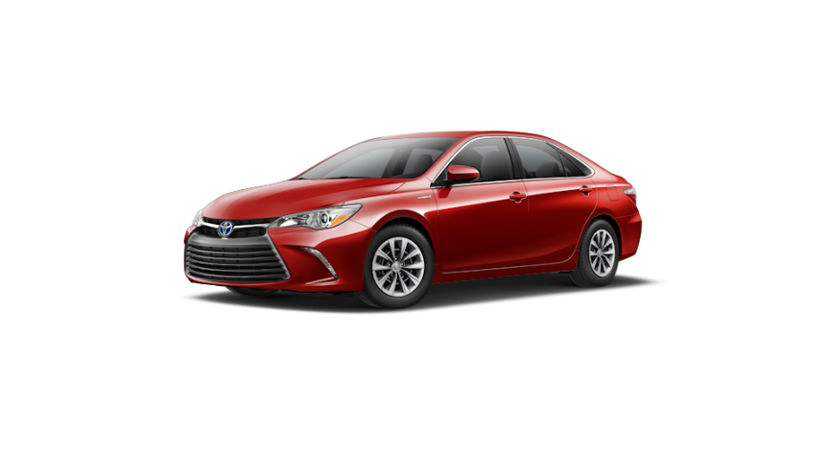

Buying a Car Role Play – Sellers Role

You are a salesperson at a Toyota dealership. You work primarily on a commission basis and want to sell as many cars as possible. Your job is greet people who walk into the showroom, give them information about the cars you have available and try to persuade them to make a purchase, preferably today. You see a young person looking at the red 2016 Camry Hybrid on the showroom floor. You know that the sticker on the door says that the Manufacturer’s Suggested List Price (MSLP) is $28,010. You also know that your company was running an ad in the newspaper yesterday that offered this type of car for $26,948. You sold a similar car last week for $25,900. You know that the dealer inventory price is $25,400 and that the company won’t sell for less than that. You can tell the person that if they finance the car for 60 months for $$466.76 with no money down and a annual percentage rate of 0% or can lease it for $229.00 for 36 months with $1,999 down. After 36 months, they can buy the car for $17404. If they wanted one of the 2015 Camry Hybrids you have in stock, the monthly payment is about $420 for 60 months or a lease of $219.00 with $1799 down. Your boss wants you to sell cars for as much as possible, although if the sales price is over the inventory price, you are allowed to make the sale. Your boss gave you a hard time with the $25,900 sale because there wasn’t much profit left for the company. He threatened to reduce your commission unless you can make another sale at well above that price, although you aren’t sure he would actually do that. Currently there is a rebate of $1000 on a 2016 Camry Hybrid if the buyer doesn’t take the 0% APR, or $1500 on a 2015 model with no deal on the APR. The lease agreements are about the same, except for the 2015 lease, the buyer gets a $500 rebate. Your manager doesn’t care if you sell the car for cash, finance it or lease it. He just wants you to make a sale.

Of course, the important thing is negotiating the final price. You walk over to the person with the hope that you can make a sale, today.

Appendix 2

Buying a Car Role Play – Buyers Role

You graduated from college this past May and finally got a job. You will be able to move out of your parent’s house into the apartment you just rented. Now you need to get yourself a car, today. You expect to keep this new car for many years, so you plan to buy and finance the car rather than lease. One of your friends recently bought a new 2016 Camry Hybrid LE and you really like it. They even let you drive it and you are sure that this is the car for you. You really want to buy a hybrid. You walk into a Toyota dealership and they have the red Camry you have been dreaming of right there on the showroom floor. You look at the door and the sticker says that the Manufacturer’s Suggested List Price (MSLP) is $28,010. You have been working on your budget. You were a finance major and have calculated that you could just afford the monthly payment for this car at the sticker price (including tag and tax). You have already budgeted for gas, insurance, etc. You really don’t have any money saved for a downpayment and you never owned a car before so you don’t have a trade-in. Your father told you that people rarely pay as much as the MSLP. A salesman walks over.
You investigated on Truecar.com and found that people in your area pay on average $26,948 for a 2015 Camry LE Hybrid and that the dealer inventory price is $25,400. You saw an ad in the newspaper yesterday that offered a 2016 Camry LE Hybrid for $26,948. From Truecar.com you learned that there were 10 red 2015 Camry LE Hybrids from 5 different dealerships in the area. Because Truecar.com uses actual sales and there haven’t been many sales yet of 2016 models, they only have prices for 2015. From the Toyota website you know that there isn’t much difference in MSRP of 2015 and 2016 Camry Hybrids. Partially this is because Toyota is offering $1500 off on a 2015 and $1,000 off a 2016 if you buy rather than lease. You could also buy a 2011 Camry Hybrid for $16,352, but there is only one red one available, it is at a different dealership, and has 42,000 miles on it. You really don’t want to lease the car, because you expect to keep this first car many years and a lease isn’t a good deal. You would do better to finance it. A salesman walks over.

You really want to buy this car, today. Negotiate the best price you can.
Appendix 3
Suggested debrief questions

- Typically, I begin the debrief by asking each pair to tell me the final selling price of the car, including if they were unable to come to an agreement. I list these on the whiteboard.
- I ask what happened during the negotiation and get several responses.
- I ask how they felt about doing the negotiation.
- I ask about the “styles of managing conflict” that each party used in the negotiation.
- I announce the buyer maximum and seller minimum from the roles, talk about the “positive bargaining zone” and ask for comment.
- I usually ask the buyers what their alternatives were to buying this car from this dealer and reference to the idea of “BATNA”
- If I have used the alternative of splitting the class, I will announce that I’ve done so and try to compare the numbers on the whiteboard to see if there are differences. Then I’ll ask the class to comment about the value of additional information and how preparing for a negotiation can change the outcome.
- Finally, I’ll ask how many people had purchased a car themselves and what their experiences were. If not very many students have bought a car themselves, I will relate some of my own experiences.

