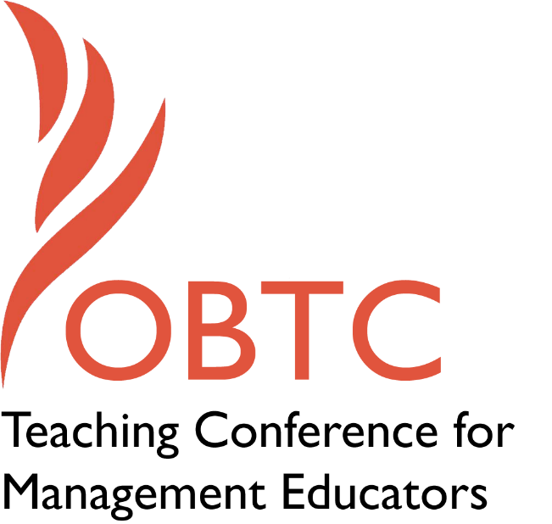

OBTC 2016 at Walsh University
June 8th – 11th, 2016

Submission Template

SUBMISSION GUIDANCE
* Remove all identifying properties from this document *
* All files must be saved in PDF format *
*Please include ALL supplementary text at the end of this document* *Only one document should be submitted*

Submission Template for the
2016 OBTC Teaching Conference for Management Educators

Title, Abstract & Keywords
In your abstract, please include a brief session description (not to exceed 100 words), and three to four keywords. If your proposal is accepted, this description will be printed in the conference program.

Title:
Team-Learning Their Way to Unity: It’s All About Personal Information

Abstract:
This session explores one way to increase student team performance by focusing on providing opportunities to increase interpersonal understanding and social learning among team members, which has been shown to have positive effects on team performance in organizations. We will briefly review the process model of team learning and will describe how as instructors, we can positively influence the group process and ultimately increase team performance, with the added positive outcomes of cohesiveness and trust.

Keywords: team-learning, social learning, group dynamics

- Format
Activity or exercise
Roundtable discussion (60 minute only)
x General discussion session

2a) For activities and exercises only, is yours best suited for
x A traditional classroom
An online class
Either

2b) For activities and exercises only, is yours best suited for
Undergraduate students
Graduate students
x Either

- Time Requested:
30 Minutes
x 60 Minutes (Roundtables must select 60 minutes)
90 Minutes

- Planning Details:
Each room contains a white board with markers, computer (PC) with DVD capability and computer projector. Does your session require any other equipment?

The session does not require any other equipment.

- Teaching Implications:
What is the contribution of your session to management pedagogy/andragogy? Specifically, please include your learning objectives, and describe what management and/or teaching topics are relevant to your session, and why. Also, include theoretical, disciplinary, or theoretical foundations that will help reviewers understand how your ideas fit within the broader field of management.

Interest in the concept of team learning proliferated after Senge (1990) stated that “learning teams are an essential element of a learning organization.” Team learning has a positive influence on different aspects and levels of organizational as well as classroom functioning, and most management educators would agree that to best equip our students for their future careers, we must not only introduce students to the experience of working as a team, but also to the underlying models surrounding team learning so that they may be better able to navigate an environment in which they may serve on multiple teams and hold various roles. As described below, the objectives of this session will be to briefly outline the definition of team learning the instructor uses in the classroom, as well as a related process model of team learning which allows for continuous attention on dynamics within the teams so as to better equip students to improve their outcomes, whatever they may be.
A long history of theory beginning perhaps with Dewey (1938) and continuing to the present day suggest that experience is an essential process of learning; furthermore, Lewin’s impact on the development of ELT (experiential learning theory) demonstrates the importance of providing students with the ability to talk about their own experience and behavior as it relates to a team. In addition, Schon (1983) describes learning as a reflective process, and subsequent research on groups suggests how an ongoing reflective process is often related to increased performance outcomes including positive attitudes, group cohesiveness, and increased problem solving. As educators, we must be cognizant of student learning at the individual level and at the group or team level, just as organizational researchers study levels of learning at the individual, team, and organizational levels.
If we extend findings regarding team learning in organizations to the classroom, we can examine this type of learning in a variety of ways, using a wide array of definitions or models. Team learning has been defined in terms of behavior, outcomes, understanding, change of behavior or attitude, performance, collective knowledge, shared experience, problem solving, and team norms (Edmonson, 1999; Rayes et al., 2015; Vanguard, 2010). One review of team learning identified three areas of team learning research: outcome improvement, task mastery, and group process (Edmondson et al., 2007). As management educators, we perhaps have the most influence on the third area, that of the group process. If we utilize Druskat and Kayes’ (2000) definition of team learning, which is a team-level process of member behaviors that include reflection, knowledge sharing, experimentation, feedback, error correction, helping, and continuous improvement, we can perhaps identify components that affect the group process as well as behavioral outcomes that could be considered proxies for enhanced learning.
Furthermore, an adaptation of Kayes and Kayes (2007) process model as developmental questionnaire of team learning is applicable to use in classrooms where teamwork is a priority in order to better understand how particular student inputs (roles, goals, trust, interpersonal understanding, goals, and confidence) coupled with learning behaviors (coordinating, adapting, and continuous improvement) affects team performance. The use of this model as well as techniques to assess student inputs, focusing on the team learning task belief of roles as well as the interpersonal belief of understanding, will be modeled and discussed in this session.
Finally, drawing upon Jehn and Rupert’s (2008) typology of team learning (specifically social learning), the session will briefly outline how in addition to the previously described process learning, an instructor’s focus on increasing social learning can increase team performance. Research suggests that social learning occurs when team members learn about personal information of team members such as character, personal life, habits, and values, which enhances familiarity and understanding of each other’s motives for behavior, creates empathy and facilitates relational interaction with other team members (Huckman et al., 2009).
References
Druskat, V. U., & Kayes, D. C. (2000). Learning versus performance in short-term project teams. Small Group Research, 31(3), 328-353.
Edmondson, A. (1999). Psychological safety and learning behavior in work teams. Administrative Science Quarterly, 44(2), 350-383.
Dewey, J. (1938). Experience and education. New York: Collier Books.
Edmondson, A. C., Dillon, J. R., & Roloff,, K. S. (2007). Three perspectives on team learning. Academy of Management Annals, 1(1), 269-314.
Huckman, R.S., Staats, B.R. and Upton, D.M. (2009). Team familiarity, role experience, and performance: evidence from Indian software services. Management Science, 55, 85-100.
Jehn, K.A. & Rupert, J. (2008). Group faultlines and team learning: how to benefit from different perspectives. In Sessa and London (Eds), Work Group Learning: Understanding, Improving & Assessing How Groups Learn in Organizations, Lawrence Erlbaum Associates, Mahwah, NJ, 19-148.
Kayes, A. B., & Kayes, D. C. (2007). The team leadership questionnaire: Team
leadership through learning. Working paper, George Washington University,
Washington, DC.
Raes, E., Boon, A., Kyndt, E., & Dochy, Filip. (2015). Measuring team learning behaviors through observing verbal team interaction. Journal of Workplace Learning, 27, 476-500.
Schon, D. A. (1983). The reflective practitioner. New York: Basic Books.
Senge, P. M. (1990). The fifth discipline: The art and practice of the learning
organization. New York: Doubleday.

- Session Description and Plan:
What will you actually do in this session? If appropriate, please include a timeline estimating the activities will you facilitate: how long will they take, and how will participants be involved? Please remember that reviewers will be evaluating how well the time request matches the activities you’d like to do, and the extent you can reasonably accomplish the session’s goals. Reviewers will also be looking for how you are engaging the participants in the session.

As it is with many OBTC presentations, sometimes the best plan is no plan, and instead allow the attendees to shape the session. However, one plan could be to outline the process model and the social learning focus that the instructor utilizes in the classroom, and to share the different techniques that have evolved over time, along with results from different sized classrooms and graduates versus undergraduates, and have attendees share methods that have worked well with respect to how they have facilitated/modified groups/teams in their classrooms. In addition, it could be that what has worked in this instructor’s classroom may be heavily influenced by factors unbeknownst to her, and session attendees are often quite skilled at suggesting how similar results could be replicated with some contextual changes and/or modifications. And finally, the author hopes that those skilled in evaluating team performance attend, so as to provide their expertise into an area in which the author has yet to publish.

- Application to Conference theme:
How does your session fit with the overall OBTC theme of United in Service?

The session addresses the sub-theme of “Creating a climate where students unite and serve each other” as well as the sub-theme of “Appreciating the diversity in our classrooms and our world and leveraging it to create a unified front as we serve our communities”. The desired outcome of the session would be to provide attendees with a framework which they might be able to use in their own classrooms, whether undergraduate, graduate, or perhaps even online.
The way in which the first sub-theme is addressed is by outlining the way in which we create high functioning and highly cohesive groups, or teams, in our classrooms which have resulted in positive outcomes, including increased participation and engagement, social connections between students which extend beyond the classroom, and in our experience, a higher degree of learning. The way in which we address the second sub-theme is by providing students with the opportunity to examine a process model of team learning and apply it to their own functioning as a team member, with the addition of understanding how increasing social learning among team members illustrates differences between individuals and gives students the opportunity to value these differences. It is our hope, of course, that our students who gain experience working on a team in our classrooms will carry that learning on with them, to other classes and eventually to the workplace.

- Unique Contribution to OBTC:
Have you presented the work in this proposal before? If so, how will it be different? Is this proposal under current review somewhere else? If so, please explain. How will your proposal be different for the OBTC conference?

This is a unique contribution to OBTC that has not been presented previously nor is it under current review elsewhere.

