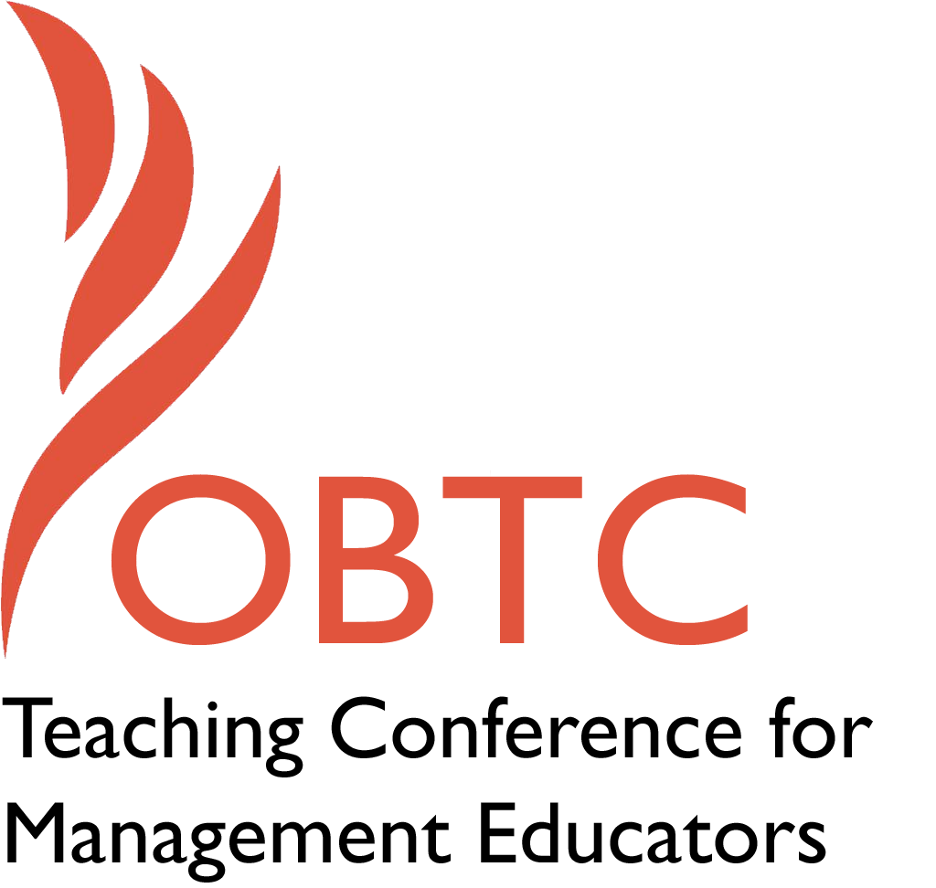
OBTC 2016 at Walsh University
June 8th – 11th, 2016
Submission Template

- Title, Abstract & Keywords

Title: Experiential Educator Workshop: Building Learning Spaces that Unite Educators and Learners

Abstract: This Session is intended to further an educator’s understanding about experiential teaching and learning by providing educators with a better understanding of their preferred approach to educating others. This session sets into practice the Kolb experiential learning model. Participants will learn about the four dynamic experiential educator roles in lifelong learning - the framework and the rationale. Research results of the ERP, used to assess varying educator characteristics will be discussed. Participants will be given access to take the ERP to identify their instructional characteristics.
Keywords: Experiential Educator Roles, Experiential learning, Adult learning
- Format
X Activity or exercise
Roundtable discussion (60 minute only)
X General discussion session

2a) For activities and exercises only, is yours best suited for
A traditional classroom
An online class
X Either

2b) For activities and exercises only, is yours best suited for
Undergraduate students
Graduate students
X Either

- Time Requested:
30 Minutes
60 Minutes (Roundtables must select 60 minutes)
X 90 Minutes

- Planning Details:
Each room contains a white board with markers, computer (PC) with DVD capability and computer projector. Does your session require any other equipment? No

- Teaching Implications:
What is the contribution of your session to management pedagogy/andragogy? Specifically, please include your learning objectives, and describe what management and/or teaching topics are relevant to your session, and why. Also, include theoretical, disciplinary, or theoretical foundations that will help reviewers understand how your ideas fit within the broader field of management.

The purpose of the Experiential Educator Development Workshop is to broaden participant’s understanding and utilization of educator teaching roles that when combined, produce deep and relevant learning. The Experiential Educator Development Workshop is intended to further an educator’s understanding about experiential teaching and learning by providing educators, trainers and coaches with a better understanding of their preferred approach to educating others. This session sets into practice the Kolb Experiential Learning framework. We will explore the characteristics of each of the four roles assessed in the Educator Role Profile (ERP) and the significance of having educators change roles as they guide learners through the learning cycle. Results of the ERP, used to assess varying educator characteristics, will be discussed. Participants will learn about the dynamic experiential educator roles in lifelong learning - the framework and the rationale. Using this framework in a supportive space, participants will assess their instructional strategies and learn how to integrate an experiential approach into a teaching practice. Finally, participants will be given online access to take the ERP to identify their own instructional characteristics. This Workshop will incorporate related hands on experiential activities to illustrate the distinctive role characteristics. We all teach in different ways. Knowing one’s instructional style(s) allows educators to focus specifically on strengths and challenges in their own professional development to create learning that in turn helps students thrive and unite in both online or traditional classroom spaces.
Workshop objectives:
-Explore your own teaching values and preferences.
-Become familiar with the characteristics of the four educator roles.

- Session Description and Plan:
What will you actually do in this session? If appropriate, please include a timeline estimating the activities will you facilitate: how long will they take, and how will participants be involved? Please remember that reviewers will be evaluating how well the time request matches the activities you’d like to do, and the extent you can reasonably accomplish the session’s goals. Reviewers will also be looking for how you are engaging the participants in the session.

The first part of our workshop is devoted to an initial exploration of values about teaching and learning. Our values serve as the rudder to inform, guide and shape our practice as educators. For example, a belief in the importance of creating shared leadership and democratic classrooms will shape one’s teaching methodology to include discussion and dialogue about what students are thinking, reading, observing and doing. As educators, how do we live our values so that we are teaching in ways that create inspiring, significant, and meaningful, sticky learning experiences for our students?
We will facilitate a discussion about the changing student needs and expectations in our ever-changing world. Afterwards, we pose a set of questions to participants who will be formed into small groups where they will reflect upon their own values and philosophy about teaching practices. We invite participants to reflect upon and discuss the following questions:
- How have your teaching values and philosophy changed over the years?
- What values currently guide your practice?
- How are your values reflected in your teaching?
- What do you appreciate most about your teaching?
- What does it mean for you to work at a critical/philosophical level?

In the second part of our Workshop, we share the framework for the Educator Role Profile (ERP) which describes four dynamic role positions—Facilitator, Expert, Evaluator and Coach. The ERP was created and designed to help educators clarify their preferred educator role in helping others learn and to help educators sharpen their awareness of their preferences so better able to make deliberate choices about their teaching. (Kolb, 2013 Sharima ) This role includes educational philosophy, teaching style, goals set for learners, and the practices educators use to promote learning. While the educator role is most often associated with teaching in the classroom or workshops, it is also useful for managers, consultants and, parents. Educators play these roles as they help learners maximize learning by moving through the four stages of the experiential learning cycle (Kolb, 1984). Most of us adopt each of these roles to some extent in our educational and teaching activities. As an educator, do we focus on the learner’s experience and interest or subject matter requirements? Do we focus on effective performance and action or on a deep understanding of the meaning of ideas? All are required for maximally effective learning.
Because of one’s educational philosophy, personal teaching style, and the requirements of a particular educational setting including administrative mandates and learner needs, educators tend to have a definite preference for one or two roles over the others. Using the ERP typology (Kolb, 2013), we will review and discuss with participants the dominant regions of the four educator roles—Coach, Evaluator, Facilitator and Subject Expert Roles. We then organize the participants into groups for which they self assessed as their strongest educator role. Knowing we all teach in different ways with different strengths, challenges, preferences and levels of comfort, we invite participants to discuss with other participants in small groups how they exemplify what they perceive as their role characteristic strengths. For example, one may feel most comfortable beginning class with an organized mini lecture to anchor her students even though her strength as an educator is in her capacity as a facilitator in the classroom. She may have developed her facilitator role by integrating activities, story telling and simulations to engage her students. On the other hand, an educator may enjoy beginning a classroom experience with an agenda and perhaps facilitating a question and answer period for open discussion. Another educator may prefer beginning a class with a simulation to ground students in a common experience before debriefing in light of the concepts being discussed.
Over the years we all have needed to develop our teaching capabilities to meet our student’s learning needs. After their table discussions about their educator role strengths, we invite participants to identify the next role they would like to develop and why that would that be their choice. We also invite participants to consider how developing their role capabilities would help their students or clients achieve their learning goals. For example, if assessing student’s work is not their strong suit, then how can those skills and abilities be strengthened in this area? Participants are challenged to consider what they can learn to do as an educator that they never thought they could before. Results of the ERP, used to assess varying educator characteristics, will be discussed. At the conclusion of the Workshop, participants will be given the link to take the online profile. Each will receive an email with a personalized report of their results and an interpretative guide to aid them in applying the results to their work as an educator. By the conclusion of the workshop, participants will have learned how to analyze student feedback using a pedagogical reflective framework and then determine educator role developmental practices.

90 Minute Workshop Outline:
Introductions and significance of Workshop: 3 minutes

Workshop Agenda and objectives: 2 minutes

Warm-up: 10 minutes

Values exploration: 15 minutes

KERP lecturette: 15 minutes

Small group discussion of role strengths/challenges: 20 minutes

Discuss research results to date of ERP: 15 minutes

Conclusion/summary and instructions to take KERP and our Workshop: 10 minutes

- Application to Conference theme:
How does your session fit with the overall OBTC theme of United in Service?

Our workshop provides a meaningful career developmental opportunity not just for new and seasoned educators who teach in traditional classroom settings, but for distance learning educators as well. Today, technology affords learning spaces for several different generations of learners whose technical literacy ranges from low to high familiarity, along with multiple digital devices (Hunter-Jones, 2012; Oblinger, 2012). In creating these effective distance-learning spaces for students, educators must consider: the course content, the transactional distance of the educational environment, the level of the learners’ and their own technology competency. The development of such distance- learning structures is rooted in an educator’s teaching characteristics as well as their philosophy and values (Anderson & Dron, 2011). A value of student centered practices (guide on the side) rather than educator centered (sage on the stage) will result in teaching characteristics that are very different and have different results in student’s learning outcomes (Oblinger, 2012). In this workshop, opportunities are afforded to explore and clarify educational values, beliefs and professional philosophy and their alignment with participant’s teaching practices.

Practitioner reflection
- Unique Contribution to OBTC:
Have you presented the work in this proposal before? If so, how will it be different? Is this proposal under current review somewhere else? If so, please explain. How will your proposal be different for the OBTC conference?

No, we have not presented the work in this proposal before. This work is new and unique in combining experiential learning theory with educator characteristics.

References
Anderson, T., & Dron, J. (2011). Three generations of distance education pedagogy. The International Review of Research in Open and Distance Learning, 12(3), 80-97. Retrieved from http://www.irrodl.org/index.php/irrodl/article/view/890/1663

Hunter-Jones, P. (2012). The continuum of learner disengagement : Ethnographic insights into experiential learning in marketing education. 2012Journal of Marketing Education, 34(1), 19-29. doi: 10.1177/0273475311430801

Kolb, A. Y., & Kolb, D. A. (2013). The Kolb learning style inventory 4.0: a comprehensive guide to the theory, psychometrics, research on validity and educational applications. Retrieved from Experience Based Learning Systems, Inc.

Kolb, A. Y., Kolb, D. A., Passarelli, A., & Sharma, G. (2014). On becoming and Experiential Educator: The Educator Role Profile. Simulation & Gaming, 45(2), 204-234. http://dx.doi.org/10.1177/1046878114534383

Kolb, D. A. (1984). Lifelong learning and integrative development. In Experiential Learning: experience as the source of learning and development (pp. 208-230). Englewood Cliffs, NJ: Prentice-Hall, Inc.

Obinger, D. G. (Ed.). (2012). Game changers: Education and information technologies (1st ed.). Retrieved from http://www.educause.edu/books

Submitted by Elizabeth Fisher Turesky. June 13, 2016
Associate Professor
Leadership and Organizational Studies Program
University of Southern Maine
eturesky@maine.edu
207-831-0506

