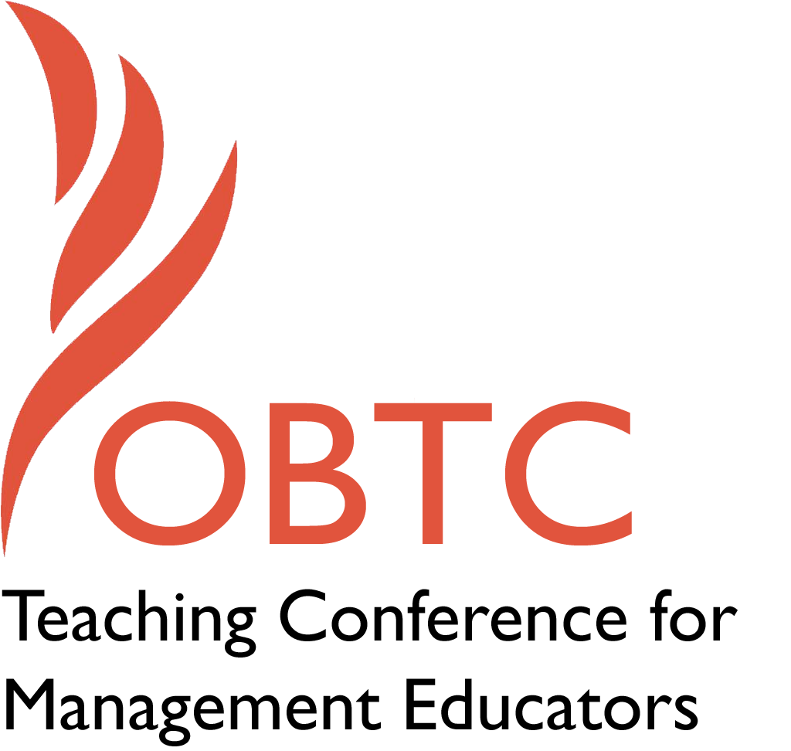

OBTC 2016 at Walsh University
June 8th – 11th, 2016

Submission Template

SUBMISSION GUIDANCE
* Remove all identifying properties from this document *
* All files must be saved in PDF format *
*Please include ALL supplementary text at the end of this document* *Only one document should be submitted*

Submission Template for the
2016 OBTC Teaching Conference for Management Educators

- Title, Abstract & Keywords

Expanding the Pie: Negotiating in Academia
This session will be an opportunity for academics on the job market to practice negotiating for an academic job with actual academic administrators. Participants will review best negotiation practices, observe others negotiating, and role-play a negotiation themselves. During the session, individuals will learn to expand the pie, negotiate with long-term relationships in mind, and increase confidence. The session is particularly targeted toward DI participants, but all interested individuals are welcome to experience how to teach a negotiation process.
Keywords: Negotiation, Academic jobs, Doctoral Students
- Format
X Activity or exercise
Roundtable discussion (60 minute only)
General discussion session

2a) For activities and exercises only, is yours best suited for
X A traditional classroom
An online class
Either

2b) For activities and exercises only, is yours best suited for
Undergraduate students
Graduate students
X Either

- Time Requested:
30 Minutes
60 Minutes (Roundtables must select 60 minutes)
X 90 Minutes

- Planning Details:
Each room contains a white board with markers, computer (PC) with DVD capability and computer projector. Does your session require any other equipment?

Moveable furniture for diverse room configurations and working in small groups.

- Teaching Implications:
What is the contribution of your session to management pedagogy/andragogy? Specifically, please include your learning objectives, and describe what management and/or teaching topics are relevant to your session, and why. Also, include theoretical, disciplinary, or theoretical foundations that will help reviewers understand how your ideas fit within the broader field of management.

This session will be a follow-up to the basic principles explained in the Doctoral Institute (DI) and will be offered to DI participants that want an expanded opportunity to role play negotiating for an academic job with an academic administrator. The session will be open to all interested conference attendees, hence, it will begin with an overview of basic principles. There are certain negotiation concepts that should be included in any negotiation course. This session will be based upon the work produced in the seminal book, Getting to Yes by Fisher and Ury (1981), and much research that has occurred since. The overall learning objectives of the session are that participants will learn to negotiate with long term relationships in mind, expand the pie, and increase their confidence.

The session will first highlight the importance of negotiation, pinpointing the gender differences in propensity to negotiate and the salary differences amongst negotiators versus non-negotiators (Babcock, Laschever, Gelfand & Small, 2003). A short list of best practices will be reviewed including having a Best Alternative to A Negotiated Agreement (BATNA) and integrative versus distributive tactics such as expanding the pie and negotiating for long-term relationships (see list below) (Fisher & Ury, 1981). These specific tactics will be discussed in short so participants have a toolbox from which to draw on during the role play. Expanding the pie will also be a focus of the session, specifically as it is related to academic jobs. In other words, participants will discuss aspects other than salary which may be negotiable (e.g., teaching load, research support, etc.).

Distributive Tactics
- Hostile demeanor
- Sacrifice relationship
- Conceal own interests
- Conceal information
- Give in only a little, if forced
- Push decisions through quickly

Integrative Tactics
- Neutral turf
- Act professional and pleasant
- Build trust
- Describe your interests, seek to understand interests of others
- Be truthful
- Talk about problem solving
- Be creative
- Take as much time as you need

References

Babcock, L., Laschever, S., Gelfand, M., & Small, D. (2003). Nice girls don’t
ask. Harvard Business Review, 81(10), 14-16.
Ury, W., & Fisher, R. (1981). Getting to Yes. New York: Penguin Group.

- Session Description and Plan:
What will you actually do in this session? If appropriate, please include a timeline estimating the activities will you facilitate: how long will they take, and how will participants be involved? Please remember that reviewers will be evaluating how well the time request matches the activities you’d like to do, and the extent you can reasonably accomplish the session’s goals. Reviewers will also be looking for how you are engaging the participants in the session.

After the short discussion of basic concepts, the first negotiation roleplay will begin with volunteers in a fishbowl in front of the whole group. The fishbowl example will be discussed and debriefed by the group as a whole and then participants will break into groups of two or three where everyone will get a turn to negotiate for themselves with an experienced academic administrator. The goal is for each participant to get a turn at the negotiation table, so if groups are comprised of three individuals, one person will observe the interaction with the expert and then get a turn. If groups are comprised of four people, then there will be two observers, etc.

Timeline

Topic | Time
Introduction of facilitators | 5 minutes
Basic Concepts | 10 minutes
Large Fishbowl | 10 minutes
Debrief | 10 minutes
One-on-one negotiations (with one observer) | 45 minutes
Large Group Debrief | 10 minutes
TOTAL | 90 minutes

- Application to Conference theme:
How does your session fit with the overall OBTC theme of United in Service?

This session will support faculty development and aligns directly with the conference theme. We encourage doctoral students and faculty to participate in an effort to support each other as we progress through our various career stages

This session will provide an opportunity for doctoral students and others to better themselves through this experience.

- Unique Contribution to OBTC:
Have you presented the work in this proposal before? If so, how will it be different? Is this proposal under current review somewhere else? If so, please explain. How will your proposal be different for the OBTC conference?

This proposal has not been submitted to OBTC nor any other conference.

