Encouraging Team Formation with the Caterpillar Obstacle Course

Early in an undergraduate management course it is difficult to get teams through the forming stage using traditional classroom methods. Interactions are often stiff and awkward between group members. Challenge course type activities can serve as an icebreaker for a new team and help begin conversations about group dynamics. This session will demonstrate the Caterpillar Obstacle Course exercise where teams are challenged with completing a variety of tasks as a team. This activity builds on individual activities from other sources, adds new activities and can be accomplished in less than an hour in the classroom environment. Volunteers will be asked to attempt the activity during the session.

Keywords: challenge activity, experiential learning, stages of team development

Many college classes have students work in teams to accomplish assignments and complete tasks, but many students don’t know how teams can work effectively. Motivating students groups to get past the forming stage into the norming can jump-start teams that only have a short window of time to accomplish their goals. (Goltz & Hietapelto, 2006) During the forming stage students are balancing their personal goals with the team goals and are typically exhibited by primary tension; awkward social interactions, minimal expression of opinion and an being overly polite. (Engelberg & Wynn, 2013). This stage is especially evident in the course where this exercise is utilized because of the variety of majors that can be represented (business, technical communication, forestry, computer networking, sports management and engineering.) The lack of a common cohort and experiences can lead to an extended forming stage and inhibit the norming stage of the team’s development.

This session will use experiential learning to encourage the forming stage of team development at the undergraduate level. The activity supports the following learning objectives:
- Learn how effective teams are developed and examine team processes and dynamics
- Practice team skills
- Using experiential exercises and group activities to provide skill development opportunities
- Reflecting on team experiences and the stages of team development as they occur rather than through feedback after an assignment
- The Caterpillar Obstacle course is an experiential learning activity done soon after the formation of semester long project teams in an introductory management course. The teams will be working together for 12 weeks with an external client to identify performance gaps, develop solutions, identify solution criteria, evaluate solutions and hopefully implement those solutions. Teams typically consist of 3 to 5 students.

- In this activity the teams are challenged with completing 5 different activities as a team, the major challenge is that they will be tied together at the ankles with bandanas during the exercise. The obstacles include the zig-zag, magic carpet, Venn diagram, figure 8 and a hurdle. The variety of activities requires the team to have clear, effective communication and to start to develop trust in their team members. The activity is timed and they get multiple opportunities to complete the activity in an attempt to improve upon their initial attempt. This encourages them to develop creative solutions, plan and create camaraderie and trust. This activity has proven to get student teams beyond the awkward forming phase and start to develop an understanding of individual and team strengths.

Typical Layout of the entire course

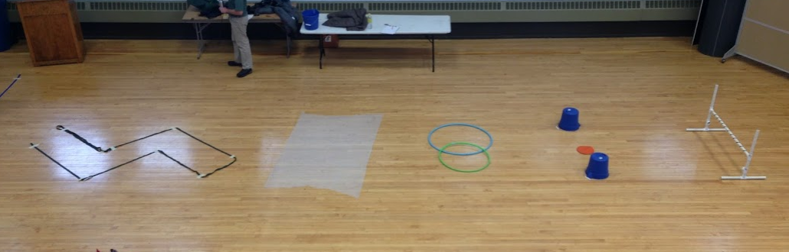

- Obstacle descriptions:

- Zig-Zag: Using rope or long straps a path is taped to the floor wider than the typical shoe length. Since the team is tied together at the ankles the team must communicate how they are going to move as a team and change direction, the zig-zag requires them to navigate with their backs to the team removing some non-verbal cues.
- 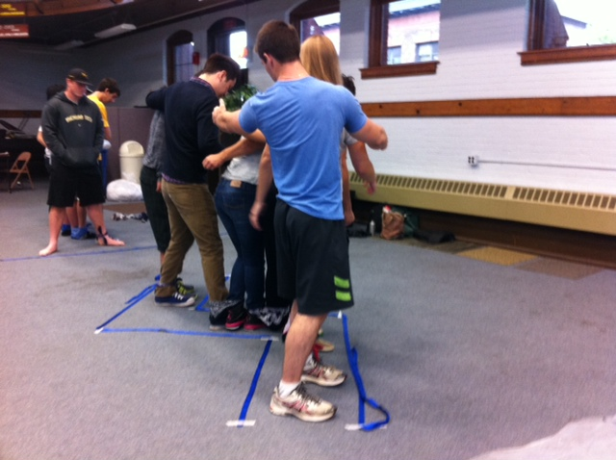
- Magic Carpet: This activity is noted in many previous publications as an effective team building exercise (Page, 2004). The team must flip the magic carpet over without stepping off the carpet during the attempt without using their hands. If a team member steps off the carpet the team must start this portion of the exercise over. Typically this exercise is done on this size of “carpet” with 8 to 12 students, but they are not tied together by the ankles giving them additional freedom to accomplish the task. This task requires problem solving skills and negotiation as to which strategy should be pursued. This can also introduce some storming when a team is required to restart the task.

- 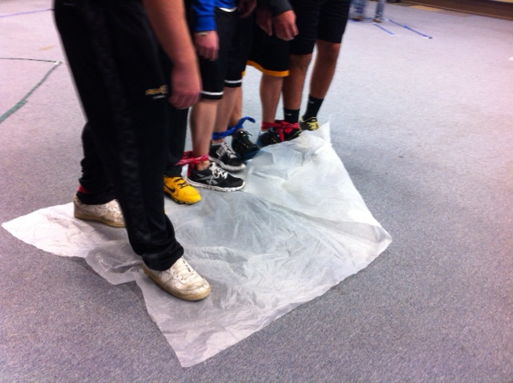

- The Venn Diagram: Hula hoops are used to create a basic Venn Diagram on the floor.

- Each team members foot must be placed in each of the three portions of the Venn diagram in order to complete the task. See the picture on the next page for an example of the Venn Diagram during the exercise.
- 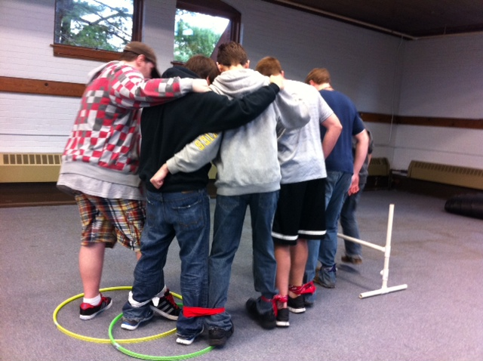

- Hurdle: A simple horizontal “hurdle” needs to be traversed by the team, this was done using a hurdle created for dog agility training, but can be any object that is approximately 12-16” off the ground (shown in the picture above)

- Figure 8: This obstacle requires the team to do a figure 8 around two objects. Buckets have been used as the center part of the 8 with a dot on the floor representing the middle of the 8. All of the team members must step on the dot 3 times to complete the task.

Caterpillar Obstacle Course Instructions
Summary: A series of obstacles are set up for a team of students to traverse while bound together at the ankles. Suitable for indoor use in a gymnasium or outdoor use, weather permitting.
Suggested obstacles:
- serpentine walk (a zigzag path is marked on the floor using ropes and/or tape as a boundary marker
- hurdle (a low hurdle is constructed using PVC piping)
- magic carpet (consists of a 4’ x 6’ sheet of heavy duty plastic (will fit 10 students), students must start by standing “all aboard” the plastic and turn the plastic over without using their hands and without stepping off the plastic and onto the surrounding floor at any time)
- figure 8 walk (the team must walk a figure 8 around 2 buckets or other markers, a spot on the floor to mark the beginning and ending will help to ensure a full figure 8)
- hula hoop Venn diagram (two hula hoops are placed in overlapping Venn diagram fashion, the caterpillar must walk through each of the 3 areas of the diagram without ever having more than 2 feet in a single area at a time yet having all feet experience all areas)
Additional supplies needed:
start lines
stopwatches (enough capability to time 4 teams simultaneously)
bandanas or short ropes to bind ankles
Timing:
It will take a team of 5 students approximately 10 minutes to traverse this set of 5 obstacles if they are arranged in a room the size of half a basketball court. Greater spacing will increase the time required, as will larger teams. A team of 3 may complete the exercise in as little as 4 minutes. Two teams can be placed on the same course simultaneously, adding an additional planning variable since teams will need to avoid wanting to tackle the same obstacle at the same time as another team. Parallel courses should be set up as needed to accommodate class size. For a class size of 30, 2 parallel courses were adequate.
Rules:
- Teams must tie their ankles together so they are arranged in a long line “caterpillar style”. It is up to the team whether they wish to all face the same direction. Knots should be tight since walking will loosen them.
- The clock starts when the first person crosses the start line, and stops when the last person returns over the same line.
- Obstacles may be done in any order, but all 5 obstacles must be completed according to the rules for each obstacle. Teams may redo an obstacle until they have a “clean run”; the penalty in this case is the additional time required to complete the obstacle. If teams do not complete an obstacle cleanly and do not repeat, a time penalty should be added. 1-2 minutes is suggested.
- If multiple teams are on the same course simultaneously, they should not expect to have access to all elements in the order they prefer to complete them. Someone on each team should be aware of what the other team is doing and set their course accordingly. Exceptions to this rule may apply if a very fast team is sharing the course with a very slow team. Timers may need to pause the clock in some instances.
Suggested debriefing topics:
Commitment to a common goal
Dealing with frustration
Encouraging/supportive climates versus hostile climates
Competition as a motivator
Effective communication (of needs, of wants, of direction, etc.)
Role specialization
Planning/sequencing (deciding the order of obstacle completion to avoid conflicting with another team, have early success, etc.)
Problem solving (Did things go as planned? If not, how did you adjust? Did you take time to practice a “solution”, such as walking, before having the time start?
Mutual support (not just standing there waiting on magic carpet)
Idea sorting and implementation (not discarding ideas too fast for magic carpet)
Taking into account situations of all group members (e.g., “end” of caterpillar getting swung around too fast on figure 8)
Strategic planning of obstacle sequence (e.g., not always leaving hard task for last and having to wait—losing time--because other team also did that but beat you to it)
Benchmarking (did the team use other team’s ideas?)

