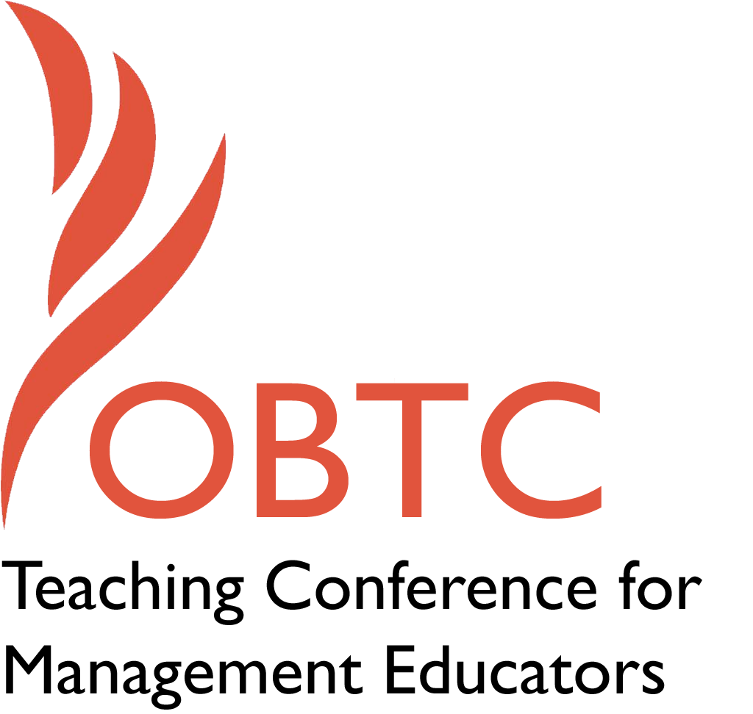

OBTC 2016 at Walsh University
June 8th – 11th, 2016

Submission Template

SUBMISSION GUIDANCE
* Remove all identifying properties from this document *
* All files must be saved in PDF format *
*Please include ALL supplementary text at the end of this document* *Only one document should be submitted*

Submission Template for the
2016 OBTC Teaching Conference for Management Educators

- Title, Abstract & Keywords

In your abstract, please include a brief session description (not to exceed 100 words), and three to four keywords. If your proposal is accepted, this description will be printed in the conference program.

Teaching in Learning Groups: The Power of Peer Participation and Evaluation of Performance

In keeping with the theme of service, this discussion focuses on how students learn to be of service to others during the semester of class. Students are placed in groups of diverse learning styles at the beginning of the semester and must rely upon each other to complete assignments and participate in class activities (Osland, Kolb, Rubin, & Turner, 2007). At the end of the semester students conduct performance appraisals on team members as a means of teaching experientially this important topic. Experience teaching in this manner over the past 4 years in an Organizational Behavior course will be shared. In addition, this session provides an opportunity to engage with others as to how performance appraisals and peer feedback is conducted by others through discussion with participants.

Key words: Experiential Learning, Peer Evaluation, Performance Appraisals

- Format
Activity or exercise
Roundtable discussion (60 minute only)
x General discussion session

2a) For activities and exercises only, is yours best suited for
A traditional classroom
An online class
Either

2b) For activities and exercises only, is yours best suited for
Undergraduate students
Graduate students
Either

- Time Requested:
x 30 Minutes
60 Minutes (Roundtables must select 60 minutes)
90 Minutes

- Planning Details:
Each room contains a white board with markers, computer (PC) with DVD capability and computer projector. Does your session require any other equipment?

No additional equipment is required.

- Teaching Implications:
What is the contribution of your session to management pedagogy/andragogy? Specifically, please include your learning objectives, and describe what management and/or teaching topics are relevant to your session, and why. Also, include theoretical, disciplinary, or theoretical foundations that will help reviewers understand how your ideas fit within the broader field of management.

Learning Objectives:
- Participants will be exposed to an opportunity for collaborative learning that incorporates learning styles in the classroom that can be duplicated in other settings.
- Participants will share ideas for expanding the concept of teamwork to include performance appraisals that enable students to contribute to the learning of others based on peer feedback.

In order to prepare students for the prevalence of teamwork in organizations, the use of collaborative learning and effective teamwork are essential components to business education (AACSB, 2013). In fact, studies have shown that teams also outperform individual efforts the majority of the time (Kemery & Stickney, 2013). In order to gauge the effectiveness of this type of learning, peers may prove to have more of an impact than do instructors by offering differing opinions (McClure, Webber & Clark, 2015). And when evaluated anonymously by their peers, students’ effectiveness has been shown to increase (Brutus & Donia, 2010).

In addition, this approach to teaching is based upon Experiential Learning Theory (Kolb, 1984) in which the knowledge gained from teaching in this manner engages all 4 stages of the learning cycle: students engage in concrete experience by working together of projects throughout the semester, they reflect on performance, then apply concepts of conducting effective performance appraisals by writing up an evaluation and sharing it with team members. Finally, based on this knowledge from peers, students are able to engage the last cycle and determine how their actions might differ in the future. This experiential approach to teaching provides for deeper learning of course concepts.

- Session Description and Plan:
What will you actually do in this session? If appropriate, please include a timeline estimating the activities will you facilitate: how long will they take, and how will participants be involved? Please remember that reviewers will be evaluating how well the time request matches the activities you’d like to do, and the extent you can reasonably accomplish the session’s goals. Reviewers will also be looking for how you are engaging the participants in the session.

The session will begin with a brief overview of current practices used to organize a classroom based on learning groups with diverse learning styles and examples will be given as to the types of activities the groups engage in during class that lead to interdependence as the semester progresses. Since students often see a different side to performance than do instructors, the concept of performing performance appraisals on team members serves as the final exam for the course. A handout containing assignment instructions and feedback from students will be shared.

Questions will be asked of the audience as to how they teach the concept of performance appraisals in their classes. Ideas will be collected and later shared via email as to other methods used to obtain and provide peer feedback.

0 – 5 minutes: Overview of Current Practices
5 – 25 minutes: Group Discussion and Sharing of Ideas
25 – 30 minutes: Wrap Up and Summary of Key Takeaways

- Application to Conference theme:
How does your session fit with the overall OBTC theme of United in Service?

The session fits with the overall OBTC theme of United in Service because this session illustrates how students may enhance learning of a concept while also being of service to other’s learning and ultimately performance as a result of conducting a performance appraisal, as well as giving and receiving feedback.

- Unique Contribution to OBTC:
Have you presented the work in this proposal before? If so, how will it be different? Is this proposal under current review somewhere else? If so, please explain. How will your proposal be different for the OBTC conference?

This concept has not been presented or proposed elsewhere.

References

AACSB. (2013) Business Accreditation Standards: Eligibility Procedures and Accreditation Standards for Business. Accreditation. Retrieved from http://www.aacsb.edu/accreditation/standards/2013-business

Brutus, S., & Donia, M. B. (2010). Improving the effectiveness of students in groups with a centralized peer evaluation system. Academy of Management Learning & Education, 9(4), 652-662.

Kemery, E. R., & Stickney, L. T. (2013). A Multifaceted Approach to Teamwork Assessment in an Undergraduate Business Program. Journal of Management Education, 1052562913504762.

Kolb, D.A. (1984). Experiential learning as the science of learning and development. Englewood Cliffs NPH, editor1984.
Osland, J. S., Kolb, D. A., Rubin, I. M., & Turner, M. E. (2007). Organizational behavior: An experiential approach: Pearson.

McClure, C., Webber, A., & Clark, G. L. (2015). Peer Evaluations in Team Projects: What a Major Disconnect Between Students and Business Instructors. Journal of Higher Education Theory and Practice, 15(5), 27.

