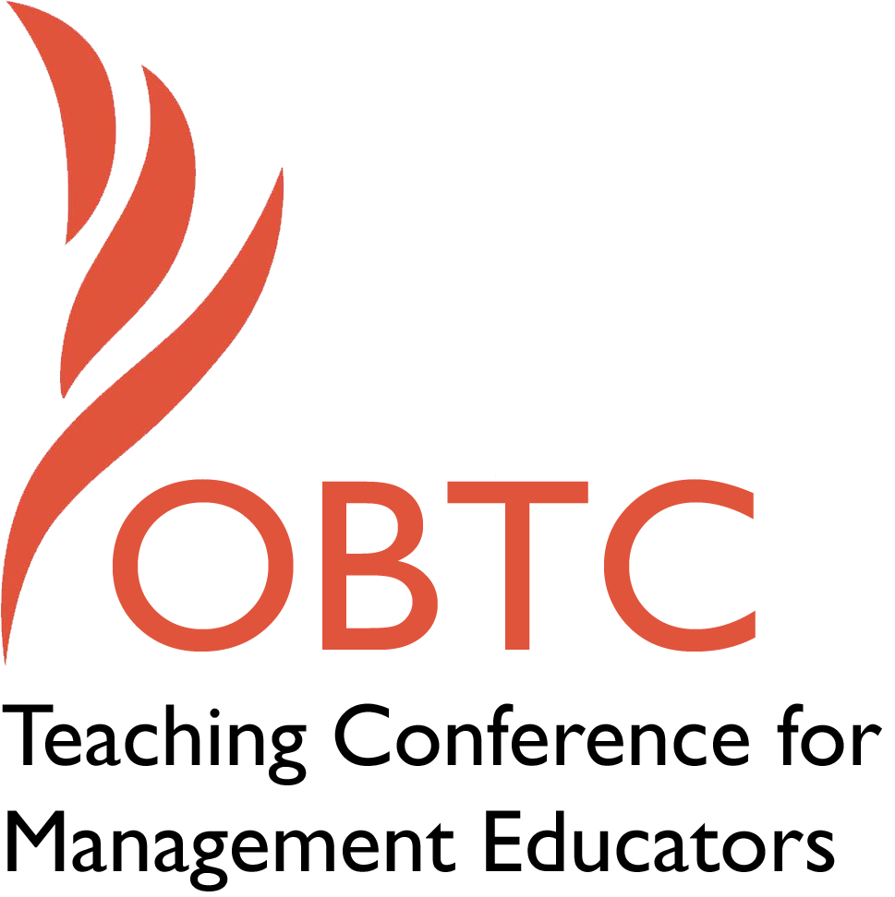

OBTC 2016 at Walsh University
June 8th – 11th, 2016

Submission Template

SUBMISSION GUIDANCE
* Remove all identifying properties from this document *
* All files must be saved in PDF format *
*Please include ALL supplementary text at the end of this document* *Only one document should be submitted*

Submission Template for the
2016 OBTC Teaching Conference for Management Educators

- Toward a Blended Learning Large Lecture: Doing More with Less (Space)

In your abstract, please include a brief session description (not to exceed 100 words), and three to four keywords. If your proposal is accepted, this description will be printed in the conference program.

To meet the conflicting demands of mushrooming enrollments, shrinking resources, and the need to engage digital natives, we are evolving a blended learning approach for our OB survey class. The format extends the flipped classroom model, which combines an online course presentation with a subsequent class session, by integrating self-customizable aspects of online learning with large lecture sessions. Participants will review and discuss the model being phased in here: its individual processes taught mainly through lectures and self-assessments, small group processes largely online with face-to-face and experiential exercises, and organization-wide aspects taught via the two modalities in roughly equal proportions.

Keywords: Blended learning, methodology, student-centered

- Format
Activity or exercise
Roundtable discussion (60 minute only)
X_ General discussion session

2a) For activities and exercises only, is yours best suited for
A traditional classroom
An online class
Either

2b) For activities and exercises only, is yours best suited for
Undergraduate students
Graduate students
Either

- Time Requested:
X 30 Minutes
60 Minutes (Roundtables must select 60 minutes)
90 Minutes
- Planning Details:
Each room contains a white board with markers, computer (PC) with DVD capability and computer projector. Does your session require any other equipment?

No.

- Teaching Implications:
What is the contribution of your session to management pedagogy/andragogy? Specifically, please include your learning objectives, and describe what management and/or teaching topics are relevant to your session, and why. Also, include theoretical, disciplinary, or theoretical foundations that will help reviewers understand how your ideas fit within the broader field of management.

Blended learning is seen by some as a transitional phase between the traditional class format and its more student-centered all-online alternative. Others consider it a permanent middle ground that combines the two content delivery systems. A third view likens—or limits—it to any of its most popular manifestations. These known forms range from lectures with independent activities “bolted-on,” to MOOCs, to flip teaching. The opinion here is that blended learning is all of these things and more, even a new learning paradigm that is both familiar and revolutionary— at once stable and infinitely configurable. Not only can blended learning address a number of resource and motivation problems, but it features active and interactive environments that retain the benefits of face-to-face teaching while enabling instructors and students to individualize the whole learning experience.

A comprehensive definition, articulated by the Clayton Christensen Institute for Disruptive Innovation, describes blended learning as a hybrid form that integrates student-controlled online learning with work at a supervised brick-and-mortar location. That respected organization’s taxonomy of blended learning models derives largely from the concept’s applications in K-through-12 programs:

The Rotation Model, which includes flip teaching, applies to instances where the instructor schedules students to alternate in some fashion between mainly fixed site and some online activities.

In the Flex Model, students work through a primarily online customized program reinforced by some amount of face-to-face support. The level of that support may vary from program to program.

An a La Carte Model offers students the option to take one or more “courses” (in the strictly prescribed K-12 sense of the word) either on the brick-and-mortar campus or off-site.

The Enriched Virtual Model extends the state of art to a point where students have required face-to-face learning sessions, yet they carry out nearly all their coursework off-site. Students meet the teacher far less than they would in the flipped classroom model but, unlike the fully online system, those meetings are required.

We are implementing blended learning as a way to accommodate diverse students’ special needs and learning styles. We see it evolving to address several key challenges: attracting and retaining new enrollments, promoting student engagement, and maximizing the use of our resources (especially physical classroom space), and expanding nontraditional students’ access to existing offerings. At this point we fit the Rotation Model. Students spend considerable time in a traditional-looking classroom setting, albeit one employing what we call “full-contact” instruction. Among other tools of engagement, the class features one or more “warm calls”—like the dreaded “cold call,” but with a few moments’ notice and/or a team caucus—a Twitter-like in-class process for contributing online, and the Hotseat. That exercise is a unique participation requirement in which each student serves on an expert panel in front of the room for one full class session.

The individualized online portion of the course, intended to account for 50% of “content contact,” may consist of video presentations and cases, lecture capture video review sessions, experiential learning exercises, an individual project, and virtual group work. Other published and instructor-designed materials—and even videos produced by individual students and teams—may also be subtituted.

We are progressing to a second and more customized stage of the blended learning project, which is more learner-centered with its expanded online component. As is generally the case, our OB survey class is segmented according to the field’s levels of analysis—individual processes and outcomes, small group mechanisms, and organizational processes—each of the three with its own balance of the various online and brick-and-mortar methods. We are working to develop mostly face-to-face sessions (supplemented with some self-assessments) to introduce individual characteristics and outcomes, and we will cover group and teamwork processes largely through online and other off-site small group exercises. The organizational level aspects including culture, structure, and several other topics are to be covered using a relatively equal mix of online and face-to-face activities. At some point, different instructors may take on subjects and/or methods best aligned with their particular interests or comfort levels.

The choice to develop this model in our large OB survey class was not a random one. Its instructor was an enthusiastic early adopter of a number of teaching innovations, including our first learning management system (LMS), virtual teams, clickers, Twitter in and out of class, flip teaching, and virtual review sessions, mostly as a way to “make a large lecture class feel smaller.” Many of these techniques are to be incorporated in the customization of the online and face-to-face components of this blended learning model. A key selling point of this model was that it can free up a large lecture hall for half the semester’s class sessions. This would enalbe the institution eventually to double the number of registered students at that hour from just over 200 to 400+ by scheduling a second course or section into the same time slot.

- Session Description and Plan:
What will you actually do in this session? If appropriate, please include a timeline estimating the activities will you facilitate: how long will they take, and how will participants be involved? Please remember that reviewers will be evaluating how well the time request matches the activities you’d like to do, and the extent you can reasonably accomplish the session’s goals. Reviewers will also be looking for how you are engaging the participants in the session.

For the first 5-10 minutes, we will outline the development of blended learning with a brief mention of some of its notable—and controversial—proponents: Bill and Melinda Gates, Clayton Christensen, and KIPP (Knowledge is Power Program) Academy charter schools’ founders, Dave Levin and Mike Feinberg. We will reference some of the innovative methods and learning styles research that fit into this format. We will also recap the circumstances that led to this project, review our progress so far, and reflect on some of the pitfalls of blending a course that is a foundation of our business program.

The next 15-20 minutes will be an interactive discussion of blended learning in diverse OB teaching environments and how it can apply to other classes, audiences, and teaching styles. Participants are also expected to consider the issues of garnering administrative and colleague support, managing assessments, tackling faculty and technical staff workload issues, and addressing other practical and theoretical aspects.

The session’s last few minutes should involve some discussion of future directions. If there is interest in creating a discussion list or putting together future presentations, I will volunteer to help get these things started.

- Application to Conference theme:
How does your session fit with the overall OBTC theme of United in Service?

The fact that this project is designed to put diverse groups of students to work “outside the books” on experiential exercises touches on several of the points noted in the call for papers. That the project creates a distance learning environment and benefits from a variety of teacher competencies (virtual and face-to-face meeting facilitation, assessment, stand-up lecturing, video lesson production, etc.) makes it a good way to support colleagues in different career stages. Blended learning is by nature a low residency option, which suits the needs nontraditional groups of students—and faculty.

- Unique Contribution to OBTC:
Have you presented the work in this proposal before? If so, how will it be different? Is this proposal under current review somewhere else? If so, please explain. How will your proposal be different for the OBTC conference?

Since they are the only classes I teach, I often present topics associated with large lectures. For instance, I ran a session to introduce flip teaching not long after I incorporated it into my teaching several years ago. The topic is mentioned in this presentation, as are several other “full-contact” teaching methods and technologies—Wikis, Twitter, online groups, student-produced videos, etc.—that I have presented in sessions here and at the Academy of Management. I did not repeat any of the “how to” content for those earlier topics; they are merely cited here as tools that are useful in constructing a blended course.

This proposal is not under review anywhere else.

