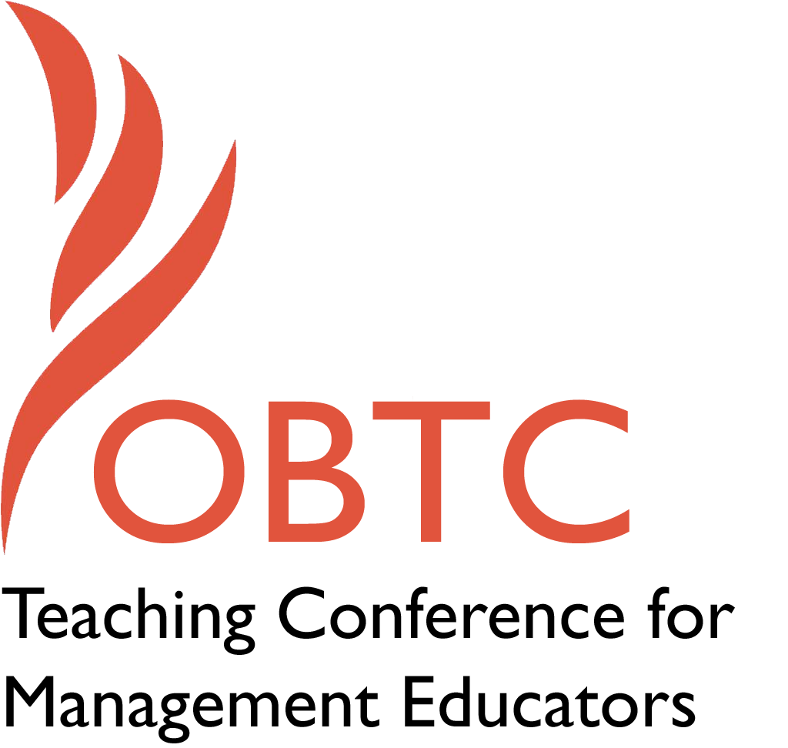

OBTC 2016 at Walsh University
June 8th – 11th, 2016

Submission Template

SUBMISSION GUIDANCE
* Remove all identifying properties from this document *
* All files must be saved in PDF format *
*Please include ALL supplementary text at the end of this document* *Only one document should be submitted*

Submission Template for the
2016 OBTC Teaching Conference for Management Educators

- Title, Abstract & Keywords

Title: Gather Around the Experiential Fire

Abstract: Come join us as we “gather around the experiential fire” once again to experience and enjoy a collection of engaging experiential exercises from a number of presenters in a hands-on “speed dating” format. This session includes traditional face-to-face and social media-based exercises on topics including personality, perception, team building, self-management, task interdependence, paradigm shifts, problem solving, leadership, followership, decision-making, and communication. The full details for using these exercises will be available in the Proceedings.

Keywords: Experiential exercises, teaching tools, teaching and learning activities, blended and online learning

- Format
X Activity or exercise
Roundtable discussion (60 minute only)
General discussion session

2a) For activities and exercises only, is yours best suited for
X A traditional classroom
An online class
Either

2b) For activities and exercises only, is yours best suited for
Undergraduate students
Graduate students
X Either

- Time Requested:
30 Minutes
60 Minutes (Roundtables must select 60 minutes)
X 90 Minutes

- Planning Details:

Wi-Fi access, PPT projection, and the room should have a flexible arrangement of chairs if possible. Tables are not necessary but we can deal with them if they are in the room. A tiered case room with fixed seats is preferred over roundtables. A large white board is also requested. This is not an appropriate roundtable session.

- Teaching Implications:

In this session, participants gather to learn about a variety of experiential exercises suitable for face-to-face (in person) as well as some virtual contexts. Although experiential exercises are frequently presented at OBTC, the exercises presented in this session differ in that their essence can be communicated in just five minutes or less. The brevity of presentations is intended to be a “teaser” to highlight a fraction of the learning potential in these exercises; thus this session provides the participants a smorgasbord of ideas and connections with facilitators whom they can follow up with about subtle details and explanations. In short, this session offers a useful collection of a wide assortment of exercises that can be used to both achieve a number of instructional objectives and address a wide variety of possible topics at the undergraduate and graduate levels.

The domain specific topics that are targeted through the Experiential Fire exercises vary every year. What remains the same for this session is its theoretical and practical foundation. As Jeanie Forray and Kathy Lund Dean aptly state in their first Journal of Management Education (JME) introduction as Editors-in-Chief, “We view this time as ripe for innovation with SOTL in ways that honor external stakeholders’ legitimate concerns about teaching quality and the learning experience of the next generation in college and University settings” (2014, p. 484). As scholarship and practice are intimately and inextricably tied together, there can be no doubt of the pivotal role that innovative teaching and learning practice, as a partner to scholarship, will play as we shape the learning experience of the next generation. Using experience to create learning is the basis of our “Fire” time together. The theoretical foundation underpinning the Experiential Fire is experiential learning theory (Kolb, 1984; Kolb & Kolb, 2005). Just as we do for our students in terms of providing them with experiences to illustrate concepts, we do here for faculty members with respect to illustrating, via “doing”, innovative teaching tools. Rather than review that theory and related calls for this type of approach to education and learning (e.g., Kalliath & Laiken, 2006; Kenworthy & DiPadova-Stocks, 2010; Whetten, 2007) we will use the space below to provide you with an overview of the actual session and each of the experiential exercises that we would like to present.

In terms of contribution, this unique format allows for all members of our community—those new to the society as well as those “long-timers”— to engage in both presenting and participating roles. Faculty at all career stages can learn about established experiential exercises, slight adaptations of these, and new innovations in teaching and learning exercises. Additionally, the actual participation in the exercises allows for networking and connection between presenters and participants and participants and participants which often results in ongoing dialogs on shared experiential teaching topics. To draw similarities to other resources in our field, this session is analogous to a real-time, face-to-face, hands on, visual and experiential, “short and sweet” mini-representation of the type of resources we all read about in the Journal of Management Education’s (JME) Teaching Innovations and Resource Reviews sections as well as most of what can be found in the new Management Teaching Review (MTR) portfolio. Those journal sections are incredibly valuable resources to our management education community, and, thus, so is this session.

- Session Description and Plan:

After a brief introduction to the format of the session, each presenter will have five minutes to present his or her experiential exercise. The audience is asked to participate in each of the exercises to better understand the essence of each exercise and its respective capacity to enhance student learning as well as to facilitate subsequent discussion. Complete instructions and any necessary materials (e.g., role descriptions, score sheets, pictures, or figures) will be included in the proceedings. These will provide more details as to typical reactions/questions from various learner populations, suggested courses or topics for the exercises, and suggested audiences (e.g., undergrad, graduate, executive). Presenters will try to cover some of these specifics as time permits, however historically the experiential aspects fill the 5 minute allocation. A brief summary of each of the proposed exercises is described below and detailed “how to” descriptions of each exercise will be shared in the conference Proceedings.

Exercise #1: To Tweet or Not to Tweet: That is the Question

Using Twitter to get students engaged in the class material: In a required core class for undergrad business majors, how do you get them really engaged in the material? How do you get them to see the relevance and applicability of the course concepts? I’ve been using experimenting with Twitter and other forms of social media and have had a good response. Students have commented at the end of the term reflection papers that one of the most valuable things that this class offered was engaging in a meaningful way with what is going on in the “real world.” Many have said that as they were interviewing for their internships and jobs, they were able to speak intelligently about a current event, thanks to this class. In this session, I'll be sharing the key lessons learned as well as most useful strategies for leveraging Twitter and other social media-based forums into learning platforms for my students

Exercise #2: A Role Play to Teach the Three Levels of Task Interdependence

When people (particularly teams) work together on a task, there are three possible levels of interdependence (Thompson, 1967). Task interdependence is “The extent to which team members must share materials, information, or expertise in order to perform their jobs “(McShane & Von Glinow, 2014, p. 137). The simplest is pooled, where each person works alone and submits the product of their work to another. An example would be a researcher writing a report; the team members write their portions separately from one another and submit them to the researcher, who “pools” the contributions. In sequential interdependence the output of one team member is the input of the next, and so on. An example is an assembly line, or production line of some sort. The third and most complex type is reciprocal interdependence. The lines of communication go from each member to each other member. An example would be a new product design team, where representatives from all functions of the organization need to be involved, and in close communication with one another throughout the design process.

The concept of task interdependence can sometimes be difficult for students to grasp. The purpose of this role play is to demonstrate the three types of interdependence by members of the same team, with three “acts,” in which each type of interdependence is modeled in each successive act. The role players simulate members of a team in an automobile manufacturing company assigned to develop a new model of sports sedan.

Exercise #3: Talking and Walking Culture: Is it Observable at your University?

Espoused values are the explicit documented values that are established by the founder(s) and/or the executive team of an organization. Espoused values are supposedly communicated to employees and, one would hope, influences employee behavior. On the other hand, enacted values are the values that are actually observed through employee behavior. However, walking and talking organizational values do not always align. In other words, top management’s behavior may not reflect the values of their organizations.

To facilitate a deeper understanding of this concept, I send students on a self-guided field trip on campus to locate observable artifacts that reflect the values of our University’s espoused values. Students are provided with our University’s documented values and given 30 minutes to scour the campus for artifacts that align with the values. Students take pictures of artifacts and immediately email the pictures to me to create a PowerPoint presentation.

Students return to the class and present their pictures of artifacts and demonstrate how the artifacts align with the university’s espoused values. After presentations, I ask “now that you have seen artifacts of our values, does the executive team of the university “walk the talk” (enacted values)? The majority of the time, the students do not know the executive team of their university and/or have never met them. This gives me the opportunity to invite the Dean to the next class to share how he and his team are “walking the talk” of the university.

Exercise #4: It’s a Puzzle: A Self-organizing Activity

Have you ever experienced students who have difficulty in transitioning from abstract concepts to practical application of those concept? If so, this experiential activity may be for you. One way to mitigate this abstract to practical application difficulty is to provide students with an activity in which they experience the abstract concept in a concrete way. From their concrete experience, the students are able to more easily understand the abstract concept in a way that allows them to appropriately apply the concept in a real world situation.

Come join us in discovering self-organizing through an experiential learning activity. The purpose of this activity is to provide students with an opportunity to experience self-organizing as a group, to reflect on the self-organizing interaction from the perspective of self and group, and to apply the learning experience to systems thinking and complexity/chaos concepts. This experiential activity incorporates elements identified with Dewey and Lewin—interactive situation, inquiry, and a whole-part-whole (Gestalt) structure (Kolb, 1984; Knowles, Holton, & Swanson, 2005) as well as self and group reflection. Learning to conduct the puzzle activity will increase your repertoire of techniques for enhancing students’ ability to apply abstract concepts to organizations.

Exercises #5 and #6: The U.S. 2016 Presidential Race: Leadership Power in Action-– Fact, Fiction, or Does it Matter Anyway?

The 2016 U.S. Presidential Race has been groundbreaking in challenging public perception about effective leadership. Specifically, the Republican candidate race for the nomination has been filled with conflict and gender stereotyping, and different opinions as to how the media, politicians, and candidates should respond. Despite significant amount of press in social media about his bias-related language, public opinion in support of Donald Trump has risen. By participating in this exercise, students will explore how power influences perception of (in)effective leadership, and whether gender plays a role in how individuals choose to respond to or ignore conflict. This two part exercise considers how Trump influenced public perception in rising to the top of public polls. Using debates, poll results, news coverage, political analyst opinions, and leadership theory, students analyze the issues and conflicts that surround leadership decision-making and behavior.

Part 1 includes the “And the Winner is…” Activity through which students consider the Fox News August 7, 2015 Republican Debate watched by 24 million viewers, and create an argument for who the best leader was and who won the debate by integrating power theory. Class discussion includes students coming to consensus about the winner, while the instructor provides political analysts’ commentary about who won.

Part II includes the “Did S/he Really Say That?” Activity through which students explore how gender played a role in the analysis of the debate, and the subsequent decisions of the media, political analysts, politicians, and leaders to speak out about what happened, or ignore it.

Exercise #7: What Is a Paradigm? Experiencing a Vague Construct

Barker (1992) defined a paradigm as a set of rules and regulations that does two things: (1) defines the boundaries and (2) tells people how to be successful inside these boundaries. He goes on to say that a new skill set that business leaders will require is anticipation. Barker posits that reason for this is because the paradigm that allowed an individual or organization to be successful can easily shift away from the individual or organization when the rules or regulations change. When this happens, the old rules and regulations no longer work and success becomes failure. At the same time, this construct is often difficult to impart to students. Through a simple game, students can come to understand both the construct and how a paradigm shift can occur. All participants will receive a copy of the game and instructions to be used back in class plus reference materials to expand their delivery of content on paradigms as they apply in businesses.

Exercise #8: "Start Smart: A Job Negotiation Exercise for Undergraduates”
This role play activity simulates a job negotiation; it is written such that the salary level and issues on the table are appropriate for what many undergraduates will face in today’s labor market (e.g., bonuses are not being offered). This activity allows students to practice negotiating the details of an offer and to compare their outcome with others facing an identical set of possibilities. It is designed to allow the instructor to introduce negotiation basics in a highly relevant manner. In this session, participants will engage in a fast-paced version of this role play focused one of four main issues in the full activity. I'll then share some debrief routes with different emphases for students enrolled in organization behavior or human resource management courses.

Exercise #9: Cluster!

In an effort to encourage students to experience the challenge of problem solving, I use a simple activity called Cluster! Embedded in this activity is another challenge – battling the conceptual blocks (mental barriers that inhibit creative problem solving), working on them as they attempt to solve the puzzle. At the 2016 OBTC in Canton, Ohio, I'm looking forward to using three balls, six blindfolds, and a roll of masking tape (yes, simple materials can result in powerful learning) to share this exercise with the larger group of Experiential Fire participants.

- Application to Conference theme:

This proposed session, now in its ninth iteration and originally conceived by Rae André, has become an extremely popular session at OBTC simply because it is all about exploring targeted and fun exercises together. Participants are united in their desire to learn and explore and there is certainly no better service we can give to each other than to share about the tools and techniques we use that we have found really “work” in terms of generating learning. Stated simply, there would be no “Fire” without a community of united and interested people working together (i.e., serving each other) to build it. To actively engage with others in a room full of colleagues and friends during a session where a series of passionate experiential education facilitators are presenting exercises they have tested and found powerful in terms of student learning is an amazing uniting experience.

For many of us, experiencing a “Fire” is akin to going to a buffet of your favorite foods with a group of people who love food as much as you do – some of the dishes (exercises) you will like more than others, it’s likely you’ll only have room for a few of them when it comes to actually eating (using) them, you can come and go in a relatively quick timeframe and be completely satiated with what you ate (learned), and the entire meal is made exponentially better because of the process of experiencing it with like-minded, invested, and interested others. We are all a united group of interested and passionate colleagues who care about serving each other, our students, and our larger communities in terms of maximizing everyone’s potential for developing the skills required to be a lifelong learner.

We can honestly think of no better conference theme than this one, United in Service, for the type of session we are proposing here. Speed dating for your new favorite experiential learning tool at what we already know is the world’s most service-oriented and warm (in terms of bringing people together to actively, thoughtfully, and genuinely share with each other) management education and learning conference – OBTC.

- Unique Contribution to OBTC:

As above, if accepted, this will be the ninth iteration of the Experiential Fire session at OBTC. As such, “The Fire” has become something of an institution at our conference. Although the format remains similar throughout the years, the actual exercises presented at each “Fire” are different. This year’s exercises are all new and have not been shared at OBTC in this format before. Just as every new fire requires fresh wood as its fuel, every iteration of our Experiential Fire requires new exercises as fuel for our minds.

- References and/or Additional Materials:

Barker, J.A. (1992). Future edge: Discovering the new paradigms of success. New York, NY: William Morrow and Company, Inc.

Forray, J.M. & Dean, Kathy L. (2014). Some thoughts on JME’s direction… Journal of Management Education, 38(4): 483-485.

Kalliath, T. & Laiken, M. (2006). Use of teams in management education. Journal of Management Education, 30(6): 747-750.

Kenworthy, A. & DiPadova-Stocks, L. (2010). Scripting the next wave of exigent issues for service-learning in our unscripted future: When technology, globalism, and community engagement collide. International Journal of Organizational Analysis, 18(2): 173-180.

Knowles, M., Holton, E., & Swanson, R. A. (2005). The adult learner (6th ed.).
New York: Butterworth-Heinemann.

Kolb, D. A. (1984). Experiential learning: Experience as the source of learning and development. New Jersey: Prentice-Hall.

Kolb, A. Y. & Kolb, D. A. (2005). Learning Styles and Learning Spaces: Enhancing Experiential Learning in Higher Education. Academy of Management Learning & Education, Vol. 4, No. 2, 193–212.

McShane, L. & Von Glinow, M. (2014). Organizational Behavior, 2nd edition, McGraw-Hill/Irwin: New York, NY.

Palmer, P. J. (1998). The courage to teach: Exploring the inner landscape of a teacher’s life. San Francisco: Jossey-Bass.

Thompson, James D. (2003) [1967]. Organizations in Action: Social Science Bases of Administrative Theory (With a new preface by Mayer N. Zald and a new introduction by W. Richard Scott Ed.). New Brunswick, New Jersey: Transaction Publishers.

Whetten, D.A. (2007). Principles of effective course design: What I wish I had known about learner-centered teaching 30 years ago. Journal of Management Education, 31(3): 339-357.

