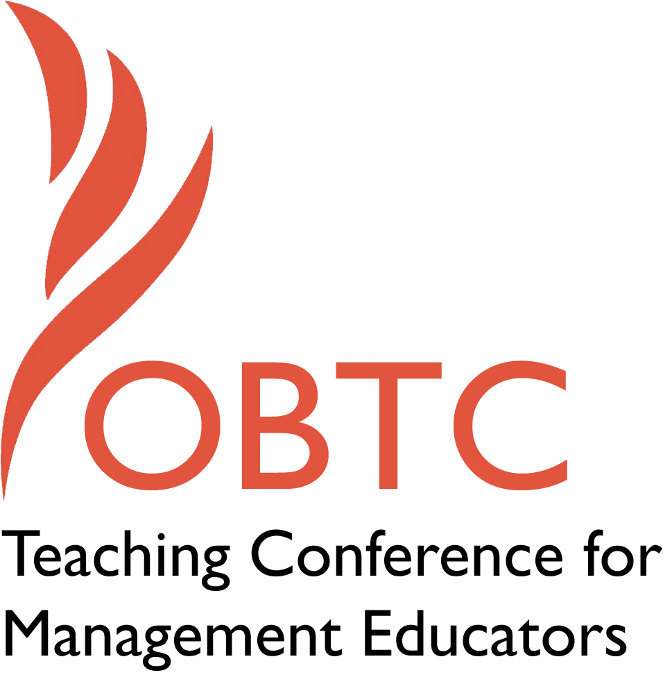

OBTC 2016 at Walsh University
June 8th – 11th, 2016

Submission Template

SUBMISSION GUIDANCE
* Remove all identifying properties from this document *
* All files must be saved in PDF format *
*Please include ALL supplementary text at the end of this document* *Only one document should be submitted*

Submission Template for the
2016 OBTC Teaching Conference for Management Educators

- Title, Abstract & Keywords

Edutainment: Using Technology to Increase Student Engagement
Edutainment, while seemingly a new and trending idea, is quite simply the combination of education and entertainment, or improving learning by making it more fun. What began as a way to teach children concepts such as multiplication with music (e.g. - School House Rock) has evolved into an integration of technology, design, and academics (e.g. - TED talks). Technology allows educators to become edutainers more easily by providing user-friendly formats and digital distribution that facilitates the creation of specialized content. This session will provide an overview of three edutainment technologies and how they can be used to increase student engagement.

Keywords: technology, learner engagement, edutainment

- Format
Activity or exercise
Roundtable discussion (60 minute only)
x General discussion session

2a) For activities and exercises only, is yours best suited for
A traditional classroom
An online class
x Either

2b) For activities and exercises only, is yours best suited for
Undergraduate students
Graduate students
x Either

- Time Requested:
x 30 Minutes
60 Minutes (Roundtables must select 60 minutes)
90 Minutes

- Planning Details:
We only need access to a projector and the appropriate cords to connect our laptop to the projection system. While there will be very little “presentation”, we will use the screen to provide examples.

- Teaching Implications:
What is the contribution of your session to management pedagogy/andragogy? Specifically, please include your learning objectives, and describe what management and/or teaching topics are relevant to your session, and why. Also, include theoretical, disciplinary, or theoretical foundations that will help reviewers understand how your ideas fit within the broader field of management.

Edutainment often fosters thoughts of shows such as Sesame Street, Schoolhouse Rock, and Bill Nye the Science Guy that combine music and video to teach topics like language, math, and history to children. Yet the field of edutainment has grown and changed drastically over the years. Technological programs and digital distribution has made it easier than ever for educators to create specialized and personalized content for learners to enjoy. Research in education and instructional design over the past 20 years has indicated that digital content can be educational, that the current generation wants multiple streams of information that includes frequent interaction, and that fun activities can enhance inductive reasoning, problem solving, and engagement (Van Eck, 2006). Edutainment relies largely on visual material in narrative or game-like formats and is typically more informal than other teaching techniques (Buckingham & Scanlon, 2000). Edutainment is an interactive pedagogy that seeks to attract and hold the attention of learners by engaging them in the education process. It facilitates knowledge construction, where learners build mental representation and apply existing experiences and knowledge to new information and interact with the learning process (Salomon & Almog, 1998). Technology used in this process can help create learning environments through the construction and processing of information and knowledge.

Although a variety of edutainment technologies exist, this session will focus on three in particular. These particular tools were chosen due to their accessibility and ease of use as well as their ability to engage learners. First, Zaption allows educators to take pre-assembled content such as youtube videos and add interaction such as introductory text, multiple choice questions, or open-ended responses throughout the presentation. Second, PowToon provides users the ability to quickly create animated presentations using predesigned formats. Third, GoAnimate has a wide variety of whiteboard characters and content that use drag and drop menus to facilitate animation and demonstrate role plays or complex topics.

This session contributes to management pedagogy and teaching topics by describing three edutainment technologies that can be used to increase engagement by students in both in person and online classes. The topic is therefore relevant to any management topic and any level of instructor (undergraduate or graduate). In addition, it would be particularly beneficial to anyone teaching human resources or training course since many corporations are already using edutainment and these technological tools in training and developing their employees. Participants in this session will walk away with three new tools that they can incorporate into their own teaching as well as a new perspective on edutaining and ideas for utilizing edutainment tools in engaging learners.

Learning Objectives:
- Recognize the potential of edutainment technologies in facilitating student learning.
- Understand the effectiveness of various edutainment techniques.
- Develop a toolbox of edutainment techniques determined to be most connected to student success.

Goals:
- Provide an overview of how edutainment technologies can be used in teaching to facilitate learner engagement.
- Demonstrate how edutainment technologies relate to learning outcomes.

- Session Description and Plan:
What will you actually do in this session? If appropriate, please include a timeline estimating the activities will you facilitate: how long will they take, and how will participants be involved? Please remember that reviewers will be evaluating how well the time request matches the activities you’d like to do, and the extent you can reasonably accomplish the session’s goals. Reviewers will also be looking for how you are engaging the participants in the session.

We strive to make this an exploratory session with a balance of interactive discussion, theory exploration, and recommendation sharing and development. Our activity plan and timeline is listed below.
- Introduction. (2 minutes)
- Interactive discussion and presentation on the theoretical background of edutainment and various approaches for using edutainment (5 minutes)
- Small group discussion focused on the following questions: What technologies do you use to engage students? How successful are they? What are the advantages and disadvantages of edutainment? (5 minutes)
- Interactive demonstration of three different edutainment technologies that can be used in face-to-face or online classes (10 minutes)
- Small group discussion focused on the following questions: What recommendations do you have in using these tools? What assignments or activities do you think would be beneficial for edutainment?
- Closing remarks and takeaways. (3 minutes)

- Application to Conference theme:
How does your session fit with the overall OBTC theme of United in Service?

This session fits the overall theme of “United in Service” by providing ideas to engage learners through edutainment and technological tools. In doing so, students will feel more connected to one another and the course and will better be able to facilitate the learning process. In addition, the digital distribution and ease of use of these edutainment tools allows us as educators to better serve the wants and needs of the current generation of students.

- Unique Contribution to OBTC:
Have you presented the work in this proposal before? If so, how will it be different? Is this proposal under current review somewhere else? If so, please explain. How will your proposal be different for the OBTC conference?
This work has not been presented and is not under review anywhere else.

References:

Buckingham D & Scanlon M (2000) That is edutainment: media, pedagogy and the market place. Paper presented to the International Forum of Researchers on Young People and the Media, Sydney.

Salomon G & Almog T (1998) Educational psychology and technology: a matter of reciprocal relations Teachers College Record 100, 1, 222–241.

Van Eck, R. (2006). Digital game-based learning: It’s not just the digital natives who are restless. Educase Review, 41,2, 1-16.

