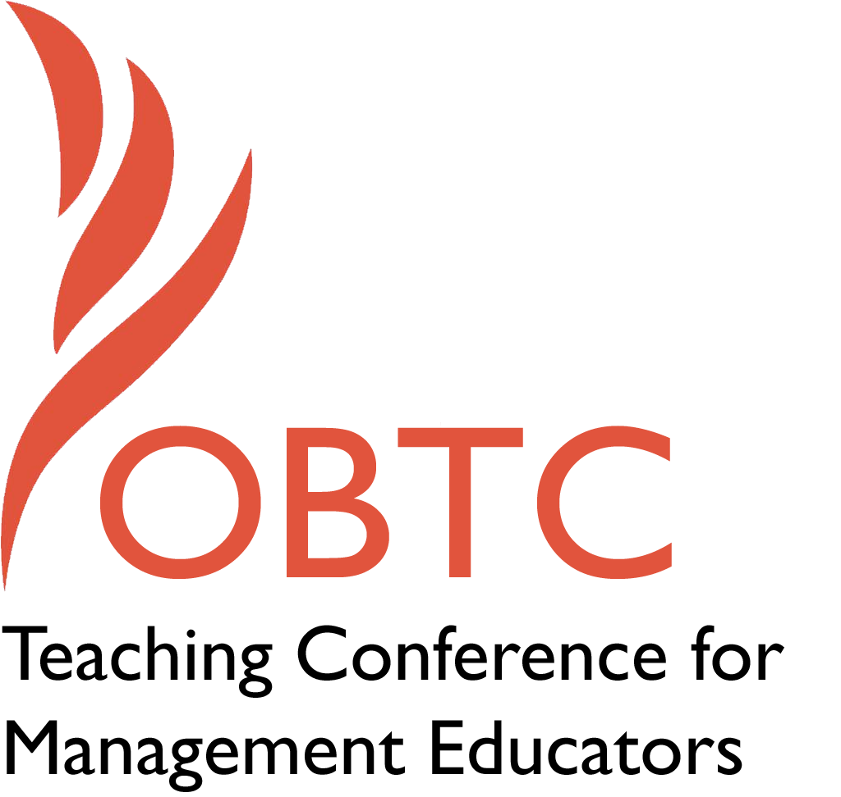

OBTC 2016 at Walsh University
June 8th – 11th, 2016

Submission Template

SUBMISSION GUIDANCE
* Remove all identifying properties from this document *
* All files must be saved in PDF format *
*Please include ALL supplementary text at the end of this document* *Only one document should be submitted*

Submission Template for the
2016 OBTC Teaching Conference for Management Educators

- Title, Abstract & Keywords
Storytime for Business Students

In your abstract, please include a brief session description (not to exceed 100 words), and three to four keywords. If your proposal is accepted, this description will be printed in the conference program.

Title: Story Time for Business Students

Abstract:

We may not consider using stories – especially children’s stories – to achieve our learning objectives, but storytelling has a rich tradition. It can translate the dry numbers and analytics that we tend to scrutinize in business into compelling images of a leader’s or teacher’s goals. Storytelling improves learning because it activate multiple areas of the brain. Storytelling has recently entered the management classroom and is relevant to many management topics. Come learn how the story time we first knew as children can provide a effective learning method. See firsthand some examples of how storytelling can be used to teach many topics.

Keywords: Storytelling; Learning through stories; Brain science;

- Format
X Activity or exercise
Roundtable discussion (60 minute only)
General discussion session

2a) For activities and exercises only, is yours best suited for
X A traditional classroom
An online class
Either

2b) For activities and exercises only, is yours best suited for
Undergraduate students
Graduate students
X Either

- Time Requested:
30 Minutes
60 Minutes (Roundtables must select 60 minutes)
X 90 Minutes

- Planning Details:
Each room contains a white board with markers, computer (PC) with DVD capability and computer projector. Does your session require any other equipment?

Chairs and open space so participants can gather around a story teller.

- Teaching Implications:
What is the contribution of your session to management pedagogy/andragogy? Specifically, please include your learning objectives, and describe what management and/or teaching topics are relevant to your session, and why. Also, include theoretical, disciplinary, or theoretical foundations that will help reviewers understand how your ideas fit within the broader field of management.

We may not consider using stories – especially children’s stories – to achieve our learning objectives, but storytelling has a rich tradition. In ancient pre-literate cultures, stories were told to pass on the history and knowledge of previous generations to the next generation. This ancient way of sharing the values of a community can also be used to shape and share the values of a current organization (Tate, 2012). It can translate the dry numbers and analytics that we tend to scrutinize in business into compelling images of a leader’s goals (Denning, 2004).

Stories help us to remember important messages because of their structure has a beginning, a middle, and an end (Denning, 2004). Stories activate multiple areas of the brain (Nabben, n.d.) in addition to the language processing parts, motor cortex, sensory cortex, and the insula, which helps us relate it to one of our existing experiences (Widrich, 2012). A Princeton study showed that brains of storyteller and listener can synchronize (Widrich, 2012). Blood chemistry changes; research found increases in cortisol and oxytocin after hearing a story that created empathy (Stillman, 2014; Weldon, 2014).

Story telling has gained increased visibility within Fortune 500 companies as a legitimate business and leadership practice. This has enabled practitioners to expand the concept to audiences of adults rather than just children (Tyler, 2009).

Story telling has recently entered the management classroom as evidenced by three articles in the Journal of Management Education (Billsberry & Gilbert, 2009; Comer & Holbrook, 2005; Verbos, Kennedy, & Gladstone, 2011). This session will bring storytelling to life in order to accomplish two learning objectives:
- participants will become aware of the underlying theory of why stories are an effective pedagogical/andragogical method
- participants will leave with three examples of storytelling and will know how they can be used.

Storytelling is relevant to many management topics. In addition to the stories that will be shared in this session, participants will be introduced to a book that provides examples of stories that relate to several topics including leadership, core values, self-management, quality and service, change, creativity, and innovation (Armstrong, 1992).

- Session Description and Plan:
What will you actually do in this session? If appropriate, please include a timeline estimating the activities will you facilitate: how long will they take, and how will participants be involved? Please remember that reviewers will be evaluating how well the time request matches the activities you’d like to do, and the extent you can reasonably accomplish the session’s goals. Reviewers will also be looking for how you are engaging the participants in the session.

This session will begin and end with “bookends” of discussion about storytelling as a pedagogical method. The majority of the time (60 minutes) will be spent in a “speed dating” format in which participants will be able to choose 3 storytelling sessions to attend. Six storytellers will have circles of chairs and a sign displaying both the title of the book to be used and the management topics that it will illustrate. Each session will have some time for participants to share ideas about ways to use each story, or other stories that would also be effective. When the chime sounds after 20 minutes, each participant will select another storytelling group.

Storyteller 1: Did I ever tell you how lucky you are? will illustrate Theory X/Theory Y
Storyteller 2: Go to Grandma’s House (Dora the Explorer) will illustrate Motivation: Overcoming Challenges and Difficulties
Storyteller 3: The Parts We Play will illustrate Teamwork/Interdependence
Storyteller 4: Yoko will illustrate multiculturalism, diversity, and appreciating differences
Storyteller 5: The Giving Tree will illustrate service and giving without expectation much in return
Storyteller 6: Rooster’s Off to See the World will illustrate planning, preparation, and execution
Storyteller 7: Stand Tall Molly Lou Mellon will illustrate authentic leadership

Specific Time | Cumulative Time | Topic
10 Min. | 10 Min. | Introductions
5 Min. | 15 Min. | Why Stories Work – advance organizer
20 Min. | 35 Min. | Storytelling Round 1
20 Min. | 55 Min. | Storytelling Round 2
20 Min. | 75 Min. | Storytelling Round 3
10 Min. | 85 Min. | Why Stories Work – feedback from participants
5 Min. | 90 Min. | Wrap up/Closure

- Application to Conference theme:
How does your session fit with the overall OBTC theme of United in Service?

Stories unite us. Stories enable organization members to use more than just logical analysis but also involve the heart and emotions. As mentioned above, the brains of storyteller and listener can synchronize (Widrich, 2012), and an increase in oxytocin can result in the creation of empathy (Stillman, 2014; Weldon, 2014).

If we forget to tell stories, there can be a negative impact. De Pree (1989) described a village in Nigeria in the last 1960s, where each family received a single light bulb in their hut. The family members started spending the evenings in their huts, staring at this modern advancement. Many of them didn’t know how to read and most did not have any books, so they just sat in their huts marveling over the light. There was a downside: they were no longer gathering around the tribal fire where the elders passed on the history and values of the tribe. When we do not share stories, we begin to forget who we are.

- Unique Contribution to OBTC:
Have you presented the work in this proposal before? If so, how will it be different? Is this proposal under current review somewhere else? If so, please explain. How will your proposal be different for the OBTC conference?

This work has not been presented in any other format at any conference and is not under review anywhere else.

References

Armstrong, D. M. (1992). Managing by storying around: A new method of leadership. New York, NY: Doubleday.

Billsberry, J., & Gilbert, L. H. (2008). Using Roald Dahl’s Charlie and the Chocolate Factory to teach different recruitment and selection paradigms. Journal of Management Education, 32(2), 228-247.

Comer, D. R., & Holbrook, R. L., Jr. (2005). All I really need to know I learned in kindergarten: How Dr. Seuss reinforces management concepts and promotes community citizenship. Journal of Management Education, 29(6), 870-887.

Denning, S. (2004). Telling tales. Harvard Business Review, 82(5), 122-129.

De Pree, M. (1989). Leadership is an Art. New York, NY: Doubleday.

Nabben, J. (n.d.). The science behind storytelling. Retrieved from https://www.melcrum.com/research/strategy-planning-tactics/science-behind-storytelling

Stillman, J. (2014). This is your brain on good storytelling. Inc. Retrieved from http://www.inc.com/jessica-stillman/this-is-your-brain-on-good-storytelling.html

Tate, M. L. (2012). “Sit & get” won’t grow dendrites: 20 professional learning strategies that engage the adult brain (2nd ed.). Thousand Oaks, CA: Corwin Press.

Tyler, J. A. (2009). Charting the course: How storytelling can foster communicative learning in the workplace. In J. Meziros, E. W. Taylor, and Associates (Eds.) Transformative learning in practice: Insights from community, workplace, and higher education, pp. 136-147. San Francisco, CA: Jossey-Bass.

Verbos, A. K., Kennedy, D. M., & Gladstone, J. S. (2011). “Coyote was walking…”: Management Education in Indian Time. Journal of Management Education, 35(1), 51-65.

Weldon, M. (2014). Your brain on story: Why narratives win our hearts and minds. http://www.psmag.com/books-and-culture/pulitzer-prizes-journalism-reporting-your-brain-on-story-why-narratives-win-our-hearts-and-minds-79824

Widrich, L. (2012). The science of storytelling: Why telling a story is the most powerful way to activate our brains. Retrieved from http://lifehacker.com/5965703/the-science-of-storytelling-why-telling-a-story-is-the-most-powerful-way-to-activate-our-brains

