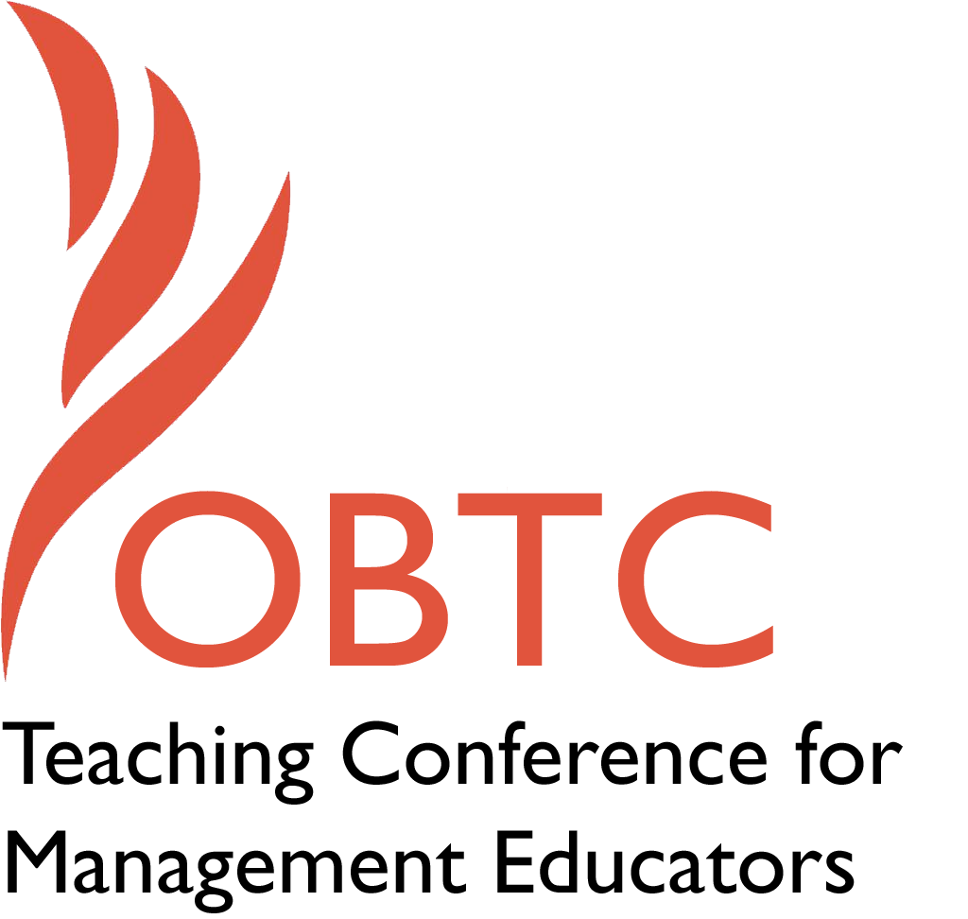

OBTC 2017 at Providence College
June 14th – 17th, 2017

Submission Template

SUBMISSION GUIDANCE
* Remove all identifying properties from this document *
* All files must be saved in PDF format *
*Please include ALL supplementary text at the end of this document* *Only one document should be submitted*

Submission Template for the
2017 OBTC Teaching Conference for Management Educators

- Title, Abstract & Keywords
In your abstract, please include a brief session description (not to exceed 100 words), and three to four keywords. If your proposal is accepted, this description will be printed in the conference program.

Title:
Gather around the garbage fire! Learning from experiential activities gone awry

Abstract:
While OBTC is a great place to pick up teaching tips from great educators; but what happens when attempts at engaging experiential exercises go “wrong”? Come join us as we “gather around the garbage fire” to experience and enjoy (read: schadenfreude) stories of experiential exercises that didn’t quite go the way they were intended. This session includes all types of exercises, online and in-class, across the spectrum of management topics. Share your stories as we all huddle around our smoking dumpster of broken dreams and plan how we can rescue our exercises from the flames.

Keywords:
Failure, Experiential Learning, Experimentation

- Teaching Implications:
What is the contribution of your session to management pedagogy/andragogy? Specifically, please include your learning objectives, and describe what management and/or teaching topics are relevant to your session, and why. Also, include theoretical, disciplinary, or theoretical foundations that will help reviewers understand how your ideas fit within the broader field of management.

In this session, participants gather to learn about a variety of experiential exercises that just didn’t work, both in face-to-face (in person) as well as some online settings. Although successful experiential exercises are frequently presented at OBTC, this session differs in that the facilitators share the pitfalls they encountered to allow our collective knowledge to grow. We have often heard some variant of the pop-culture management refrain to “fail fast and fail forward” (e.g., Maxwell, 1982) to encourage creative solutions to problems. This session demonstrates our willingness to do the same in the classroom. We have taken hockey legend Wayne Gretzky’s advice, “you miss 100% of the shots you don’t take,” and applied it in our classrooms. We’ve taken the shots even knowing some would miss. We have learned from the Chinese proverb that “failure is not falling down, but the refusal to get up.”

The exercises presented in this session differ from other OBTC sessions not in their solid grounding in experiential pedagogy and andragogy, as they share the foundations of successful exercises, but in the errors of execution that led to their lack of success. It is, however, this very lack of success that creates value in this session; the resilience and persistence of instructors who are willing to take chances and fail (sometimes spectacularly) has led to successes as well.
We know that research and practice intertwined, and our session title is a clear tribute to one of the most popular sessions at OBTC each year. Using our failure to create successful future iterations is at the heart of experiential learning (e.g. Kolb 1984; Kolb & Kolb, 2005). Just as we teach our students the cycle of experiential learning and how past experience informs future actions, we allow faculty to collectively learn from each others’ failures to inform future successful classroom initiatives.

With respect to our contribution, this unique gathering allows for all members of our community, from first-time attendees to those wearing T-Shirts from OBTCs long ago, to engage and contribute. Faculty at all career stages can learn about failed experiential exercises and participate in adapting these for future successes and innovations.

- Session Description and Plan:
What will you actually do in this session? If appropriate, please include a timeline estimating the activities will you facilitate: how long will they take, and how will participants be involved? Please remember that reviewers will be evaluating how well the time request matches the activities you’d like to do, and the extent you can reasonably accomplish the session’s goals. Reviewers will also be looking for how you are engaging the participants in the session.

Similar to the well-established inspiration for this session, after a brief introduction to the format of the session, each presenter will have three minutes to present his or her failed experiential exercise. Following this introduction, session attendees will engage in a (small group) speed-dating session, discussing with each presenter for 5 minutes about how participants might approach the exercise “next time” to make it work better.

Following this round-robin of disappointment, session attendees will be asked to contribute horror stories of their own as we roast metaphorical marshmallows over our steaming bin of failures. All attendees and participants will work together to overcome the unforeseen obstacles that heretofore prevented well-intentioned exercises from succeeding, and will leave with fresh ideas on how to resuscitate these exercises to allow the phoenix of their teaching dreams to rise again.

Timeline:
0.00-20.00 session facilitators present their failed exercises
20.00-50.00 “speed-dating” remedies with facilitators
50.00-75.00 Attendee horror stories and remedies
70.00-90.00 Recap and debrief of exercises for future iterations

- Application to Conference theme:
How does your session fit with the overall OBTC theme of Navigating the Changing Currents?

Our session features faculty who may have misread the charts while navigating the changing currents, but building on the themes of the past four OBTC conferences, we dare to be different (UNC - Asheville, 2013) while engaging participants’ voices to drive teaching innovation (Vanderbilt University, 2014) in a learning community (University of La Verne, 2015) that unites us in service (Walsh University, 2016) to each other.

- Unique Contribution to OBTC:
Have you presented the work in this proposal before? If so, how will it be different? Is this proposal under current review somewhere else? If so, please explain. How will your proposal be different for the OBTC conference?

This has not been submitted anywhere else.

