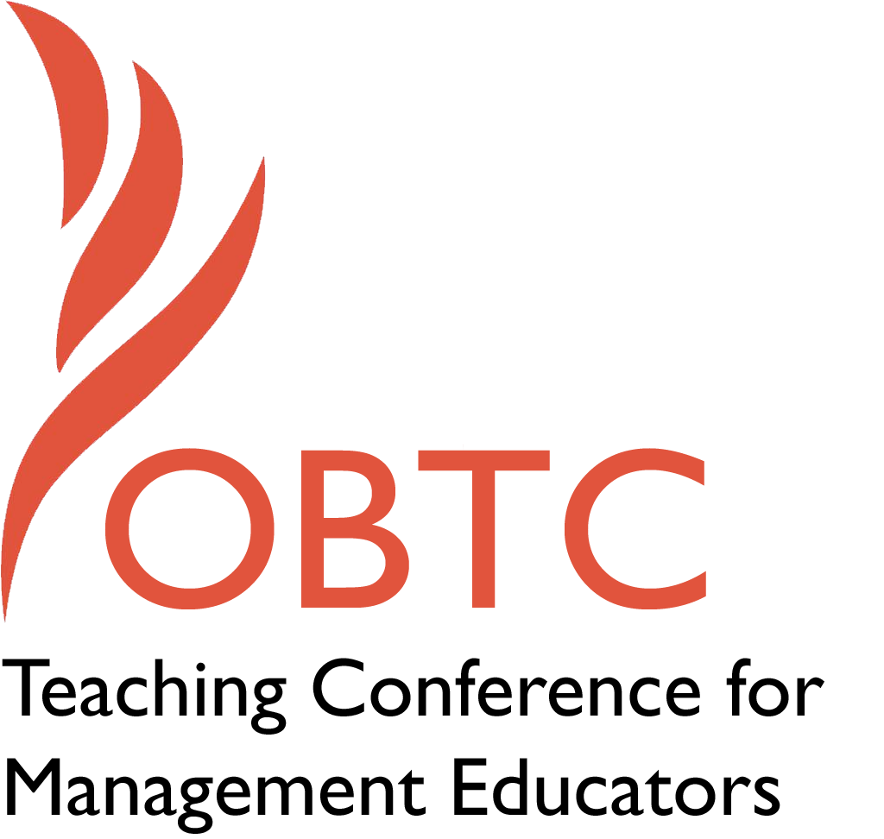

OBTC 2017 at Providence College
June 14th – 17th, 2017

Submission Template

SUBMISSION GUIDANCE
* Remove all identifying properties from this document *
* All files must be saved in PDF format *
*Please include ALL supplementary text at the end of this document* *Only one document should be submitted*

Submission Template for the
2017 OBTC Teaching Conference for Management Educators

- Title, Abstract & Keywords
In your abstract, please include a brief session description (not to exceed 100 words), and three to four keywords. If your proposal is accepted, this description will be printed in the conference program.

Not Seen and Not Heard: Building a Support System for Management Educators with Learning Disabilities

While much is known about teaching students with learning disabilities, almost nothing is known about the experiences of management educators who have learning disabilities. This roundtable builds on last year’s session which explores the experiences, opportunities, and barriers for faculty who identify, privately or publically, as learning disabled in academia. The first part of the session provides a space for educators to share their experiences with managing a learning disability in academia, or supporting others in this process. The second part is dedicated to developing a support system for educators with learning disabilities.

Keywords: Learning Disabilities, Diversity, Educators, Stigma

- Teaching Implications:
What is the contribution of your session to management pedagogy/andragogy? Specifically, please include your learning objectives, and describe what management and/or teaching topics are relevant to your session, and why. Also, include theoretical, disciplinary, or theoretical foundations that will help reviewers understand how your ideas fit within the broader field of management.

Through attending this workshop educators will:

- Understand the experiences of management educators who have learning disabilities
- Develop strategies towards effective teaching and research by educators with learning disabilities
- Gain awareness of learning disabilities across all stages of the academic career
- Understand preferred practices and language when working with a colleague with a learning disability
- Become better informed about the myths and stereotypes surrounding educators with learning disabilities
- Begin to build a support network of other management educators with learning disabilities

- Session Description and Plan:
What will you actually do in this session? If appropriate, please include a timeline estimating the activities will you facilitate: how long will they take, and how will participants be involved? Please remember that reviewers will be evaluating how well the time request matches the activities you’d like to do, and the extent you can reasonably accomplish the session’s goals. Reviewers will also be looking for how you are engaging the participants in the session.

- (20 min) Introduction of facilitators and attendees, answering;
  - How did I get here?
  - What do I hope to have happen? What questions do I want answered?
  - What are my experiences as (a) an educator with learning disabilities or (b) an educator working with colleagues or PhD students with learning disabilities?
- (20 min) After sharing these responses, we will have participants break into small groups (approximately 3 people per group) to further discuss personal stories and brainstorm strategies for supporting educators in their academic work (teaching, research, and service).
- (20 min) We will then come back together as a whole group to share our small group discussions. Steps to build a support community will be taken. Contact information will be shared between participants.

- Application to Conference theme:
How does your session fit with the overall OBTC theme of Navigating the Changing Currents?

This roundtable will serve to help educators with learning differences navigate the changing currents of their work place. A substantial literature search indicates that the study of disabilities in higher education research often focuses on physical disabilities and learning disabilities of students, rather than those of educators. To our knowledge, there is only one article in our field that addresses learning disabilities in faculty (Miller, 2011).However, how educators manage learning disabilities is an important topic that should explored, therefore we seek to create an inclusive climate where educators can be better heard and informed. Faculty with learning disabilities can be powerful mentors and allies to students with similar challenges, yet may feel pressure to “pass” as non-disabled in their working lives. Creating a support system which celebrates learning differences serves as a powerful message to our students and colleagues about who can thrive in the changing currents of academia. It is our hope that by elevating awareness of learning disabilities in the teaching profession, we will begin to question established recruitment and promotion practices in academia, increase diversity in our field, and inspire future generations of students with learning disabilities to fully engage in higher education.

- Unique Contribution to OBTC:
Have you presented the work in this proposal before? If so, how will it be different? Is this proposal under current review somewhere else? If so, please explain. How will your proposal be different for the OBTC conference?

This is a follow up to the round table that was presented at OBTC last year. The roundtable primarily centers around the personal experiences of the attendees, and will therefore provide a unique and enriching experience for those who participate. The proposal is not under review anywhere else at this time.

