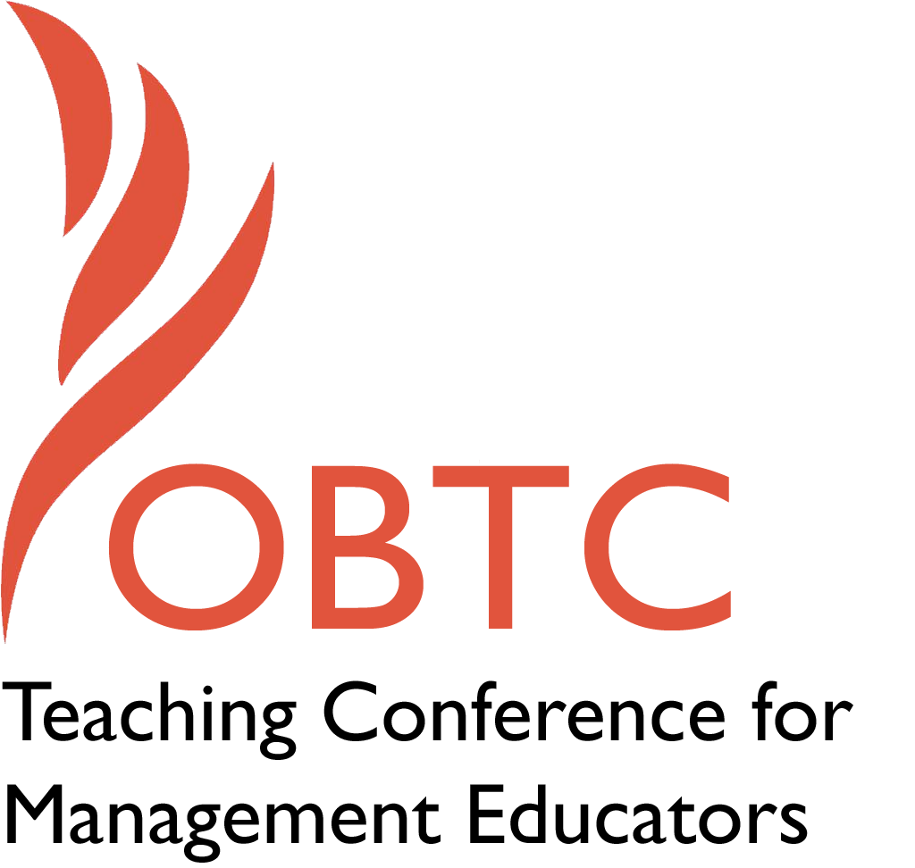

OBTC 2017 at Providence College
June 14th – 17th, 2017

Submission Template

SUBMISSION GUIDANCE
* Remove all identifying properties from this document *
* All files must be saved in PDF format *
*Please include ALL supplementary text at the end of this document* *Only one document should be submitted*

Submission Template for the
2017 OBTC Teaching Conference for Management Educators

- Title, Abstract & Keywords
In your abstract, please include a brief session description (not to exceed 100 words), and three to four keywords. If your proposal is accepted, this description will be printed in the conference program.

Developing Course Contexts that Facilitate Student Development

While meaningful course content is essential to student learning and development, the context within which it occurs is as important. However, most management educators do not develop their course contexts (i.e., structures, processes, and relationships). But educators typically do not receive any training or support, lack time because of increasing research demands, or concerns that experimenting with course context may lead to poor student evaluations. In the session, we will share our experiences with intentionally creating course contexts that facilitate student learning and development, as well ask participants to share their own experiences and discuss new possibilities.

Course context
Learning relationships
Learning processes
Learning structures

- Teaching Implications:
What is the contribution of your session to management pedagogy/andragogy? Specifically, please include your learning objectives, and describe what management and/or teaching topics are relevant to your session, and why. Also, include theoretical, disciplinary, or theoretical foundations that will help reviewers understand how your ideas fit within the broader field of management.

Learning Objectives
- Participants understand possibilities for developing course contexts that facilitate student learning and development.
- Participants will identify specific opportunities within their courses to experiment with altering their context to improve student learning and development.
- If there is sufficient time, presenters and participants will brainstorm new possibilities for building effective contexts.

New educators usually focus initially on mastering the course content. At the same time they intentionally create and improve the course assignments and tests. Unfortunately, rather than developing them in a way that facilitates student learning and development, the focus is often to figure out how to satisfy students, as new educators are concerned about the impact of their student ratings on the tenure and/or employment status. It seems it is the rare educator who actually focuses on his or her course context. This most often is no fault of their own, as educators have not received any education or support, and lack time because of increasing demands placed upon them.
There are limited resources written about developing course contexts (Jenster & Duncan, 1987; Baxter Magolda, 1999; Eriksen & Cooper, forthcoming) and often these are about achieving a specific objective such as student commitment (Jenster & Duncan, 1987) or self-authorship (Baxter Magolda, 1999). Thus, in this session, we would like to share our experience altering course context in our attempts to facilitate student learning and development.
Between the two of us we cover the spectrum of organizational studies. One of us creates contexts that focuses primarily on personal learning and development and the importance of introspection and the contribution of peers to that development. The other invites students to co-create contexts in order to understand the impact of systems and structures on individuals as well as group interactions. As Senge (2000) makes clear, “structure influences behavior.” In addition to learning how traditional classroom contexts limit learning and development, students have the ability to create - and change - classroom contexts in order to understand the impact of Senge’s principle.

Baxter Magolda, M. B. (1999). Creating contexts for learning and self-authorship. Nashville, TN: Vanderbilt University Press.

Eriksen, M. & Cooper, K (forthcoming). “Shared-Purpose Process: Implications and Possibilities for Student Learning, Development and Self-Transformation.” Journal of Management Education.

Jenster, P. V & Duncan, D. D. (1987). “Creating a context of commitment: Course agreements as a foundation.” Journal of Management Education, 11 (3), 60-71.
Senge, P. (2006). The Fifth Discipline: The Art & Practice of The Learning Organization. NY: Doubleday.

- Session Description and Plan:
What will you actually do in this session? If appropriate, please include a timeline estimating the activities will you facilitate: how long will they take, and how will participants be involved? Please remember that reviewers will be evaluating how well the time request matches the activities you’d like to do, and the extent you can reasonably accomplish the session’s goals. Reviewers will also be looking for how you are engaging the participants in the session.

- We will share our experiences with altering our course contexts in an attempt to facilitate student learning and development (15 minutes)

- We will engage in Q & A (15 minutes)

- Participants will be paired-up to share their experiences with course context, especially those in which they have experimented with improving context. For those participants who have not been as experimental, we will explore reasons why faculty are often inhibited from such experimenting (5 minutes)

- As a group, participants will discuss their pairs discussion, questions they might now have or what now seems possible in creating context in their courses (20 minutes).

- Ask participants willing to do so to share one experiment they commit to engaging in to improve course context. (5 minutes).

- Application to Conference theme:
How does your session fit with the overall OBTC theme of Navigating the Changing Currents?

So much has been written and discussed about the inability of business schools to keep up with the dramatic changes our students will face as they enter the business world (Mabey & Mayrhofer, 2015). We contend that changing currents has progressed to navigating whitewater rapids! Due to this mismatch between traditional classroom contexts and the changes our world faces, over the course of our careers we have increasingly realized the importance of our course contexts to students’ learning and development in preparation for post-grad work.

Mabey, C. & Mayrhofer, Magolda, M. B. (2015). Developing Leadership: Questions Business Schools Don't Ask. Thousand Oaks, CA: SAGE Publications.

- Unique Contribution to OBTC:
Have you presented the work in this proposal before? If so, how will it be different? Is this proposal under current review somewhere else? If so, please explain. How will your proposal be different for the OBTC conference?

We have not presented this work before.

