From student to executive: A strategic leadership
performance model for career enhancement

Prepared for Submission to 2017 OBTC Conference

- Title, Abstract & Keywords

Today’s employers are looking for graduates who enter the workforce as independent, skilled and adaptable leaders. Our unique OBTC session presents findings and draws on the expertise of the audience to discuss how to best serve our students by offering differentiated programming to serve all of our student leaders and their future employers. We introduce two original scholar-practitioner models of leadership education and practice. The first model explores strategic leadership competencies and how they are achieved through curricula, hands-on applied learning and unique modules. The second model invites a discussion for an accelerated timeline for strategic leadership development.

KEYWORDS: STRATEGIC LEADERSHIP, LEADERSHIP PERFORMANCE, STRATEGIC LEADERSHIP MODELS

- Teaching Implications:

The ultimate goal as educators serving students is to attract, develop and mentor high-potential undergraduate students who possess excellent skills in their chosen field and want to develop cutting-edge leadership potential. Not all students will be interested in the content or commitment. For students interested in the challenge, we created two models to achieve extraordinary strategic leadership skills throughout the duration of an undergraduate degree.
The primary focus of the models is to promote student development of core leadership skills needed to work effectively on project teams, succeed in complex assignments, and meet strategic objectives. These skills are among the most desirable when hiring recent graduates (Adams, 2014). Students are often unprepared for the leadership expectations early in their career; our models propose an accelerated timeline to better utilize their time as an undergraduate student.
Many undergraduate business programs promise to prepare students to lead after graduation in their career. What makes the proposed models different is that the goals are to prepare strategic leaders, individuals who recognize value-creating opportunity, mobilize their followers, and execute strategy. Students following this model envision the future, find defining moments to develop the full potential in people, and discover greater promise within organizations. Great leaders are often the difference between an organization that thrives or fails, one that seizes opportunities and one that chases others in the market. These original models aim to develop students into leaders who energize and mobilize people and resources in flexible, dynamic environments to create a viable future for all.

Davis Leadership Group*
In today’s organizations, performance is the price of entry for our students. Organizations expect entry-level talent to perform immediately and deliver at a high level against business objectives. While students must be great at their profession of accounting, engineering, media relations, medical science, teaching, human resource management, etc., dependence upon these foundational skills is not enough. Today’s organizations are excessively focused on the future, dealing with uncertainty and managing increasing levels of complexity, while they must also simultaneously focus on short-term stability. Strategic leadership refers to exactly that ability to collaboratively maintain a dual focus on a vision for the future and the operational mission of the present day (Hitt & Ireland, 1999).
As business educators, our goal is to help students graduate with the capacity to lead and the wisdom to know when to follow. We know that today’s students are tomorrow’s business leaders and the Davis Leadership Group is committed to instilling students with the right foundation--knowledge, experiences, and competencies--to accelerate their potential and learn to lead.
Organizations recognize that strategic leadership does not come easily in most corporations and that fewer than 10% of current leaders throughout organizational levels exhibit strategic skills (Beatty, 2010). Research indicates that a company’s level of leadership development has a greater impact on their long-term business performance than most other factors (Bersin, 2012). A recent employer survey found that executives are less interested in considering candidates with specific majors and more interested in candidates who have learned these key strategic skills. This considerable need by corporations to develop and leverage talent is addressed by the Davis Leadership Group.
-----------------------------------------
Insert Model 1 about here
-----------------------------------------
This original Strategic Leadership Competency model proposes that teaching students strategic leadership skills and developing their strategic leadership performance can be approached as a three-phase iterative process. First, students must recognize the fundamentals necessary to develop strategic-leadership skills. Recognize includes introductory-level business and management courses, learning agility, and thinking strategically. The second step, mobilize, refers to the process of creating an effective team environment. The third step, execute, describes the observable outcomes of effective strategic leadership. Across all of these steps is the concept of understanding one’s self and others, and this understanding deepens at each stage of the model.
Recognize: the first step is a simplified explanation of a broad and complex subject. The subcategory, Know Business, reflects an understanding of students knowing the core elements of business that are often taught in introductory courses. Think Strategically encompasses an understanding of knowing business from multiple perspectives, such that a student can think of the business as an open system with each area of business effecting other areas. While the current focus may be on something as discreet as compensation and payroll systems, the student would be able to see the relationship between this and the business as a whole. Generate Ideas and Focus speaks to creatively generating different means or process to achieve the same business goal. Learning agility refers to learning and cognitive flexibility that can be measured through basic psychological scales and developed through a breadth of experiences and training.
Mobilize: step two reflects not only Motivation to Lead or emergent leadership ability, but the desire and ability to positively challenge those around them. The skill of Develop and Inspire People suggests challenging and motivating others is a learned skill desirable to companies and a benefit to student leaders. Foster Collaboration and Teamwork and Leadership Presence and Communication are proposed components important to helping students facilitate and prepare for results.
Execute: the third step attempts to capture the realized outcome potential of effective strategic leaders. Established research has identified certain outcomes available to strategic leaders, and these are the outcomes we want our students to make possible. Act on Analysis and Value from Fit can be studied as a research construct. Other skills effective leaders emulate is the ability to Competitively Drive Results and Follow Through on Promises. Whereas some academic programs and businesses simply ask recent graduates to produce results and motivate others, we have developed these models to create a realistic and feasible way to prepare students to deliver on these ever-growing challenges.
-----------------------------------------
Insert Model 2 about here
-----------------------------------------
Model 2 depicts the accelerated timeline available to students enrolled in the Davis Leadership Group and demonstrates students' various choices to accelerate towards leadership in the real world. We provide opportunities for accelerated advancement for students in any program, and the student is given freedom to utilize the resources we provide.
The model demonstrates four curves increasing at different rates over time. As the student takes advantage of the recourses we provide, he/she increases the probability for maximum growth. For simplicity, our assumption is that the graphs for each track are generalized to the average student in each track. Nevertheless, a student's choices, involvement, and passion will dictate the individuals own path and curve.
The phases mark periods of time during an undergraduate degree which differ in course content, involvement, and learned skills. The content, involvement, and skills during each phase builds upon the next, providing an opportunity for growth at an increasing rate. Previous to Phase 1, students will have applied to and been accepted into different programs available through the college. The acceptance into these programs depends upon their previous preparation and performance in both practical and intellectual endeavors. Therefore, some students will enter their educational careers more prepared and more advanced than others. Our program provides opportunities to meet the needs of these varied individuals. Model 2 demonstrates this with varied starting positions in rate of growth for each classification of students.
During Phase 1, the Business Core focuses on providing students essential analytical and foundational skills to build upon. Assessments and feedback will solidify this foundation. Phase 2 focuses on helping students learn agility in their ability to access knowledge. During the Business Cluster, the students are mentored and coached how to utilize the analysis learned from Phase 1 and distinguish boundaries and bundle appropriate knowledge resources into capabilities. During Phase 3, students’ involvement increases as they take BA1000, join clubs, and participate in other focused efforts available within the college. By so doing, they will enhance their focus, drive, and passion towards leadership in a specific area of chosen expertise. By Phase 4, students will have gained the analytical skills, the learning agility, and the drive to hone those attributes towards leadership and motivation of others. Coursework (BA2000), internships, and leadership in major aspects of student-run organizations will enhance those attributes and prepare them for their career.
Model 1 and 2 center on an academic plan consisting of specific courses. Encouraging students to seek involvement opportunities incorporates practical, hands-on experiential exercises and activities that are designed to internalize the capabilities and mindset required for success as a strategic leader in organizations. This will necessitate that students learn the basic issues involved in leadership.
Possible courses to reach the model's goals consist of covering: (1) the complex and changing forces that make-up the landscape of a leader and how to effectively engage as a leader in these dynamic environments; (2) how to strategically communicate your leadership message through written and oral communication; (3) an understanding of individual and group behavior in the modern workplace with a focus on career readiness in management and team leadership; and (4) a practical and knowledge of organizational analysis and the consulting process tools, emphasizing the tools and techniques that are involved in leading organizations to effective performance.
The leadership performance models serve student needs for preparation and readiness upon graduation. These models benefit students by making them more marketable through rigorous strategic leadership academic curricula paired with hands-on applied learning and continuing education opportunities. Students completing an accelerated leadership performance program will be able to differentiate themselves from other candidates in a competitive job marketplace through their key business training and the ability to articulate how their leadership potential contributes to the strategic direction of their organization.
Existing strategic leadership research / models:
While existing leadership programs have had success, ours is the only strategic leadership undergraduate program we are aware of in the nation. Our undergraduates will become the strategic leaders that organizations want to hire, as they will know how to navigate the complex vision for the future while maintaining short-term performance. According to a recent study published in BizEd by the Association to Advance Collegiate Schools of Business, 80% of employers listed leadership as the number one most wanted skill in employees (Pincus & Rudnick, 2013).
Future research & direction
These leadership models have never before been introduced to an academic audience for feedback and evaluation. As we gather input and alternate perspectives towards our goal of accelerating strategic leadership performance development, our future research will change. These models will be used to further develop learning objectives and curriculum, both inside and outside classroom experiences. With these programs mentioned in Model 2, we have the unique opportunity to offer a wide range of curriculum, theory, and applied learning experiences (such as crisis or disaster scenarios, and executive role play). We plan to introduce these models to different groups of faculty and business leaders and various think groups to develop and hone the detailed objectives. We plan to do exactly this in an OBTC session where many great minds will meet together with the purpose of serving students.
Conclusion
Employers are searching for an increasing pool of talent with the set of knowledge and skills appropriate for leading at the strategic level in their organizations (Beatty, 2010). Therefore, a program such as the Strategic Leadership Business Certificate program, as it becomes institutionalized into the university and the region in which it resides, can provide corresponding benefits universities, its students, and its other stakeholders. An initiative such as the Davis Leadership Group is consistent with the College and University’s strategic plan, and can assist universities in its overall leadership development efforts.
We pair the theory and practice of leadership in our curriculum from the first day, accelerating students’ performance today and preparing them for faster growth throughout their career. We start with a foundation of classes, assessments, and skill cultivation that all students receive. From the core of our business curriculum and our innovative business cluster, students are taught the analytical skills needed for effective leadership like seeking and using feedback, applying strategic insight, making decisions, and solving complex problems with integrity.
Through assessments and coaching, students cultivate learning agility. It’s no cookie-cutter program; students are provided individual skills assessments and strategies to cultivate a willingness to learn. We combine a deeper understanding of personal learning and leadership styles that foster the emotional intelligence needed to operate independently with self-awareness. Students are empowered to feel comfortable with change, so they can adapt and take smart risks that drive results.
Our approach is not static. It’s dynamic and driven by student and market needs. Our students are empowered to shape their experience and our environment. Students launch new organizations. They seize opportunities to lead. They drive initiatives that transform the world. Through these experiences, our students develop a drive for excellence, perseverance, and the dedication to achieve distinction.
We approach leadership differently because we want to give students an advantage. Our students are transformed. They are competitive, not cruel. They are enthusiastic, not entitled. They are committed, principled, and innovative. They are ready to challenge the status quo, but with the humility to recognize they have much to learn.

*Named changed to remove identifying information

References
Adams, S. (2014). The 10 skills employers want most in 2015 graduates. Forbes.
Beatty, K. (2010). The three strengths of a true strategic leader. Forbes.
Bersin, J. (2012). It’s not the CEO, it’s the leadership strategy that matters. Forbes.
Boal, K. B., & Hooijbert, R. (2000). Strategic leadership research: Moving on. Leadership Quarterly, 11, 515-549.
Dries, N., & Pepermans, R. (2012). How to identify leadership potential: Development and testing of a consensus model. Human Resource Management, 51, 361-385.
Hitt, M., Haynes, K. T., and Serpa, R. (2010). Strategic leadership for the 21st century. Business Horizons, 53, 437-444.
Ireland, D. & Hitt, M. (1999). Achieving and maintaining strategic competitiveness in the 21st century: The role of strategic leadership. The Academy of Management Executive, 13, 43-57.
Pincus, J. D. & Rudnick, H. E. May/June 2013. Today’s business schools are ignoring one of their biggest blind sports: They don’t teach the relationship building skills essential for contemporary business leadership. BizEd.
Schoemaker, P. J. H., Krupp, S., & Howland, S. (2012). Strategic leadership: The essential skills. Harvard Business Review, 1-5.

Model 1: Strategic Leadership Competency Model
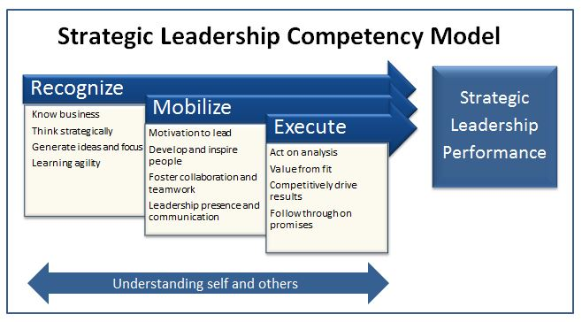

Model 2: Timeline for Ideal Strategic Leadership Development
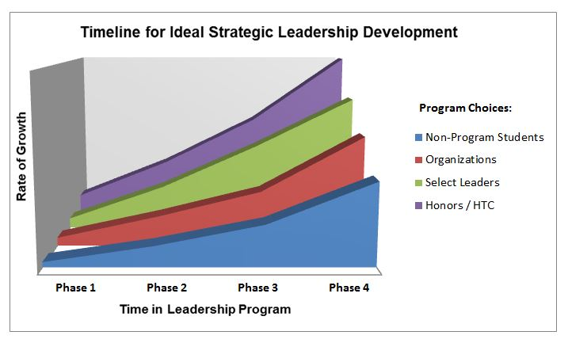

- Session Description and Plan:

This session will be an engaging discussion where participates will experience the dynamics of incorporating our strategic leadership models. We will first explain in detail the two models we have developed as both a concept and pedagogical tool. Then, we will ask participates to engage in a strategic-leadership case analysis.

We will give the participants a case study to read and reflect upon. This case will focus on changing currants in a real-world example. Thereafter, we will separate them into groups and ask them to solve the case by applying the three aspects of Model 1—recognize value by creating opportunity, mobilize their followers, and execute strategy. This will allow participants to experience the process of incorporating the model and navigate their way through a real-world situation.

Thereafter, the facilitators will apply the three aspects of Model 1 with the class as a whole. First, each team will present their analysis (with accompanying facilitator questions and teaching) to the rest of the participants. By so doing, members of other teams will “recognize” the value of other team ideas. Second, the facilitators will “mobilize” all of the participants as they vocalize similarities among plans proposed. This collaboration and teamwork will yield both alignment and a final strategy to implement among the whole class. Finally, the facilitators will assist the groups as they decide the specific steps of how they will “execute” the established strategy to solve the case.

We will conclude the session by debriefing the process. We will help the participants realize that they have experienced Model 1 both in their individual groups as well as with the class as a whole. We will then discuss how the experience could fit into each of the four phases described in Model 2. Finally, we will explain to them that the same method can be used with both undergraduate and graduate students to assist them in becoming strategic leaders.

- Application to Conference theme:

Students of today demand material that is applicable to both theoretical and practical foundations as well as current trends in the marketplace. These changing currents, which occur on a daily basis, must be met with a level of leadership that applies tested and valid theoretical and practical contributions to the fluctuating needs of students. Indeed, students cannot effectively confront today’s changing currents without learning those skill needed to become strategic leaders.

We believe that our session will be central to the OBTC theme: Strategic leaders must create compelling business strategy, build individual and team alignment, drive execution of results and do business in an ethical manner—all within a changing environment. In order to perform successfully in the marketplace, students must learn to meet the business challenges of increased global competition, advances in technology, and continually improving intellectual capital.

- Unique Contribution to OBTC:

This work has not been presented before and is not under review elsewhere.

