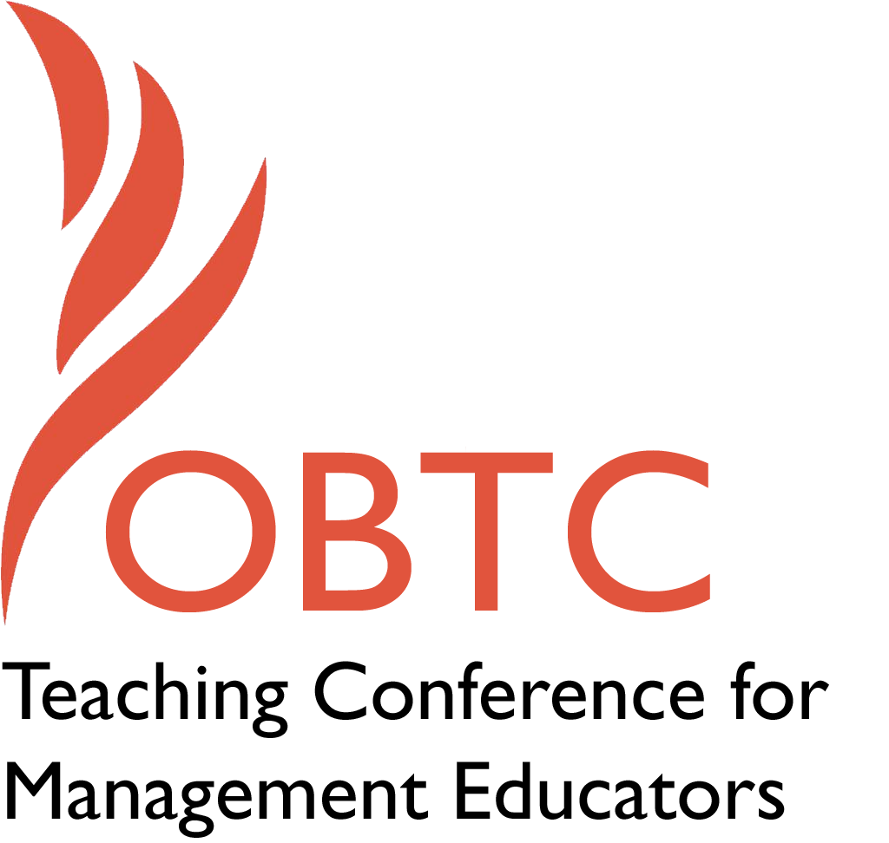

OBTC 2017 at Providence College
June 14th – 17th, 2017

Submission Template

SUBMISSION GUIDANCE
* Remove all identifying properties from this document *
* All files must be saved in PDF format *
*Please include ALL supplementary text at the end of this document* *Only one document should be submitted*

Submission Template for the
2017 OBTC Teaching Conference for Management Educators

- Title, Abstract & Keywords
In your abstract, please include a brief session description (not to exceed 100 words), and three to four keywords. If your proposal is accepted, this description will be printed in the conference program.

Eliciting Career Insight Through Classroom Interventions

In this session 2-3 classroom methods for helping management students identify their career values, identify potential career paths, and increase career self-efficacy will be used with the audience. Based upon field experiments in several undergraduate and MBA classrooms, interventions were evaluated for their impact upon these outcomes. Exercises in defining your calling, career success, and creating and reflecting on career timelines will be profiled and demonstrated to varying degrees. Debriefing will occur with the help of the audience participants.

Key Words: Career Success, Career Reflection, Career Development, Values Assessment

- Teaching Implications:

What is the contribution of your session to management pedagogy/andragogy? Specifically, please include your learning objectives, and describe what management and/or teaching topics are relevant to your session, and why. Also, include theoretical, disciplinary, or theoretical foundations that will help reviewers understand how your ideas fit within the broader field of management.

Recent studies (Briscoe, Unite, Lo Presti, 2016; Unite 2014) suggest that values-related career interventions have been more effective than “strategy/tactical” interventions in terms of driving self-directed management behavior as well as subjective career success. Our goal in this session is to demonstrate values interventions that help in varying degrees to guide students toward values self-awareness, values prioritization (as values apply to career), career self-efficacy, and psychological well-being.

Three methods are considered for demonstration. All will be profiled but their final selection will be based upon our research findings being analyzed across the current semester (and past semesters). The three methods are “defining one’s calling”, “career success”, and “career timelines.” These interventions will be demonstrated with the attending audience.

These methods are very important for helping students to define goals, goals that are the crux of their motivation to pursue management education in the first place. In addition to the demonstration of the exercise(s) we will present our beliefs and facilitate others’ on the needed contextual support in the classroom for successful student development and career success.

- Session Description and Plan:
What will you actually do in this session? If appropriate, please include a timeline estimating the activities will you facilitate: how long will they take, and how will participants be involved? Please remember that reviewers will be evaluating how well the time request matches the activities you’d like to do, and the extent you can reasonably accomplish the session’s goals. Reviewers will also be looking for how you are engaging the participants in the session.

Time Request: 60 minutes

Overview of theory and method 5 minutes

Intervention 1 and debrief 20 minutes
Intervention 2 and debrief 20 minutes

Discussion and conclusions 15 minutes

Participants will engage in a demonstration of Intervention 1 and 2. In the two interventions, each participant will produce specific outputs and receive interpretation of the same. They will receive feedback on their own values and career insight into career development possibilities, with the goal that their feedback and experience will be similar to what a student receives. Peer debriefing will occur in each subgroup. Within the discussion and conclusions section, we will create shared interpretation of the audience experience and outline implications for classroom practice.

- Application to Conference theme:
How does your session fit with the overall OBTC theme of Navigating the Changing Currents?

Ironically, values which are relatively stable, are key to students to navigating changing circumstances. According to protean and boundaryless career theory, both persons and organizational environments are changing in ways that challenge contemporary employees to continually redefine themselves. Values are key to this redefinition.

- Unique Contribution to OBTC:
Have you presented the work in this proposal before? If so, how will it be different? Is this proposal under current review somewhere else? If so, please explain. How will your proposal be different for the OBTC conference?

Portions of the study at conducted at the MBA level were presented at the 2016 Academy of Management meeting, but the discussion was theoretical and empirical, not focused on demonstrating these approaches nor eliciting audience reflection and sense making. In addition, one new method (the defining your career calling exercise) is added here, as well as the undergraduate application which was not part of the Academy of Management presentation, which was under 15 minutes.

References

Briscoe, J. P., Lo Presti, A., Unite, J. (2016). Can Protean Orientations Be Increased? Results of Classroom Interventions, Academy of Management, Careers/Human Resources/Organizational Behavior Divisions, Anaheim, CA, August 8.

Unite, J.A. (2014) A theoretical and practical application of the protean career: Do career values and skills training improve career decision-making? Dissertation. Department of Psychology, Northern Illinois University.

