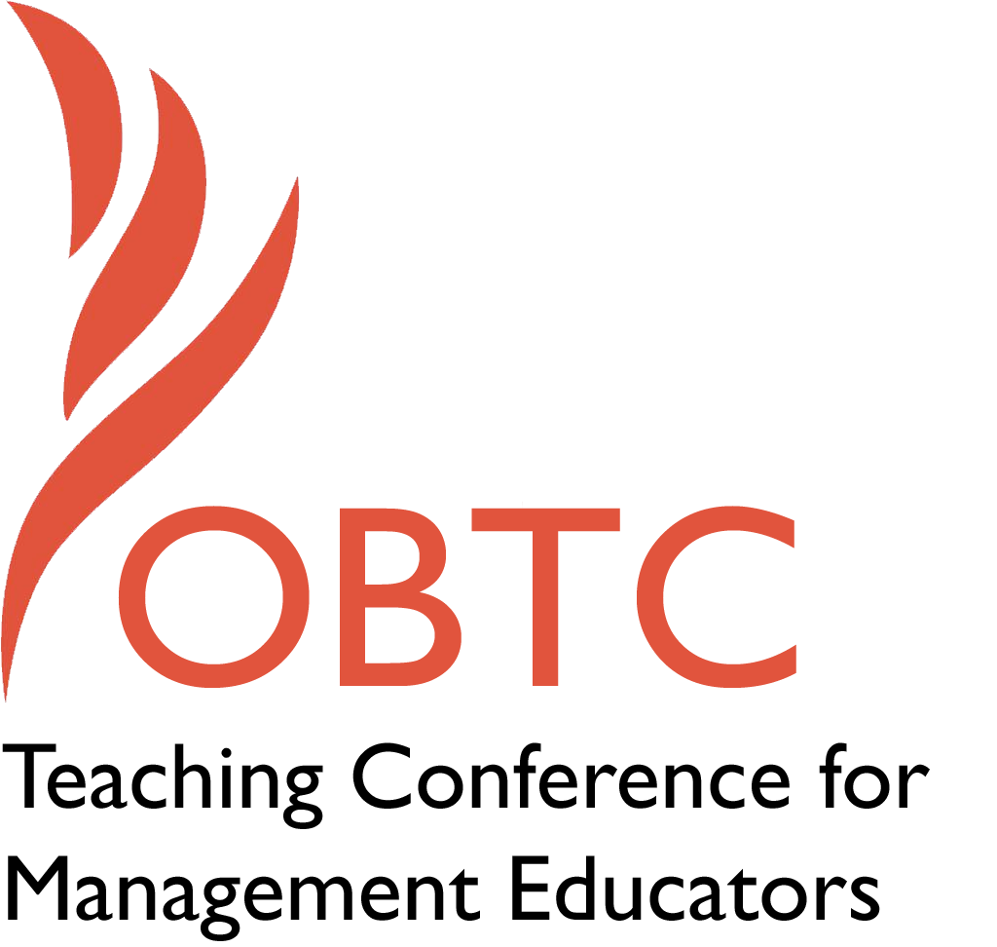

OBTC 2017 at Providence College
June 14th – 17th, 2017

Submission Template

SUBMISSION GUIDANCE
* Remove all identifying properties from this document *
* All files must be saved in PDF format *
*Please include ALL supplementary text at the end of this document* *Only one document should be submitted*

Submission Template for the
2017 OBTC Teaching Conference for Management Educators

- Title, Abstract & Keywords
In your abstract, please include a brief session description (not to exceed 100 words), and three to four keywords. If your proposal is accepted, this description will be printed in the conference program.

Ethical Issues with Experiential Activities – Experiential activities can be a powerful pedagogical tool to enhance conceptual and personal learning. However, they can also consume quite a bit of class time so how to gain the most benefit from time spent? One way is to integrate personal feedback, but a review of recent JME articles indicated that this is not frequently done. Doing so raises ethical issues. Most (higher) education focuses on conceptual awareness. Is personal feedback coercive in required courses? Even in elective courses, are there limits to students’ choices? Can instructor’s values become dominant? What are the ethical boundaries?
Keywords – Experiential activities, feedback, ethical limits

- Teaching Implications:
What is the contribution of your session to management pedagogy/andragogy? Specifically, please include your learning objectives, and describe what management and/or teaching topics are relevant to your session, and why. Also, include theoretical, disciplinary, or theoretical foundations that will help reviewers understand how your ideas fit within the broader field of management.

Experiential activities are used with increasing frequency in management education (and strongly supported by OBTC sessions). But do instructors consider some of the downsides especially when personal feedback (by the instructor or peers) is included? There is a large power discrepancy between instructor and student (similar to that between manager and employee) and do we tend to underestimate the potential for coercion (in both settings).

Increasingly, managers are taught to be “developers” of their people and give feedback (on the basis of the experiences they observe), but is this truly developmental or coercive to fit the leader’s (and organization’s) value system?

This issue is especially relevant given the increased diversity in our student population (and larger workforce). To what extent does feedback come out of the giver’s value system and may collide with that of the receiver?

- Session Description and Plan:
What will you actually do in this session? If appropriate, please include a timeline estimating the activities will you facilitate: how long will they take, and how will participants be involved? Please remember that reviewers will be evaluating how well the time request matches the activities you’d like to do, and the extent you can reasonably accomplish the session’s goals. Reviewers will also be looking for how you are engaging the participants in the session.

- Start with a brief review of the JME study plus examples of how feedback can be used to increase personal learning when integrated with experiential exercises. Then a few examples where I have observed psychological damage [7”]

- Participants, working in trios, share situations they might have seen (or have been concerned about) where there have been costs. These are listed on the board. [18”]

- General discussion and debate by the whole group. (The goal is to identify the main themes and trying to see if there are areas of consensus.) [30”]

- Conclusions [5”]

- Application to Conference theme:
How does your session fit with the overall OBTC theme of Navigating the Changing Currents?

There are two general currents this speaks to. One is navigating the tension between providing meaningful learning, but not being coercive and the second is navigating between developing the individual, but still helping that person be more effective in working with others.

- Unique Contribution to OBTC:
Have you presented the work in this proposal before? If so, how will it be different? Is this proposal under current review somewhere else? If so, please explain. How will your proposal be different for the OBTC conference?

No [but have presented other sessions at OBTC]

