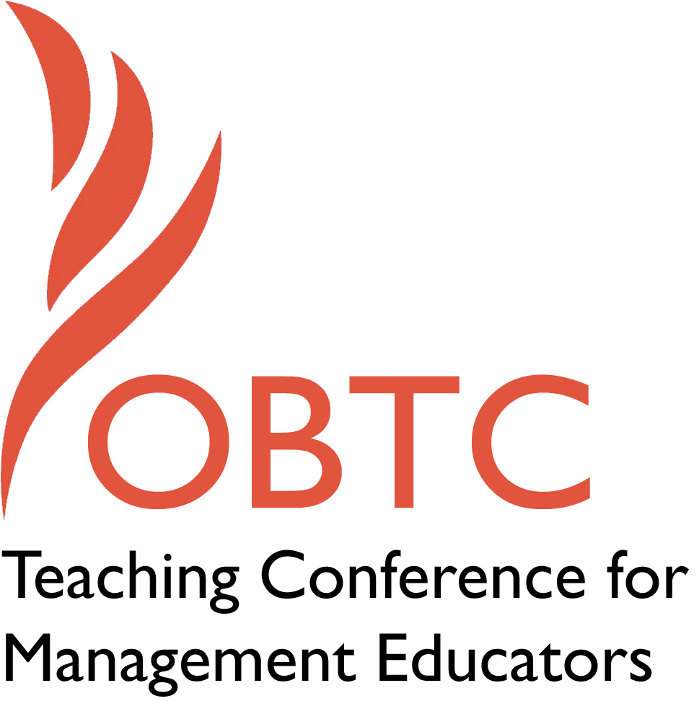

OBTC 2017 at Providence College
June 14th – 17th, 2017

Submission Template

SUBMISSION GUIDANCE
* Remove all identifying properties from this document *
* All files must be saved in PDF format *
*Please include ALL supplementary text at the end of this document* *Only one document should be submitted*

Submission Template for the
2017 OBTC Teaching Conference for Management Educators

- Title, Abstract & Keywords
In your abstract, please include a brief session description (not to exceed 100 words), and three to four keywords. If your proposal is accepted, this description will be printed in the conference program.

Creating a Pinterest Board for the Collaborative Sharing of Management Video Clips

Educators in management have recognized the potential value of using video clips in class to illustrate concepts. While such video clip use can be valuable, a significant problem for the educator is finding those clips appropriate to particular class concepts. This presentation offers one way to help this concern, a shared Pinterest board where management educators can find clips based on topic and share their own. How to use Pinterest is discussed as well how the board can function in a collaborative way. Attendees will be able to join the board as well as offer their suggestions for its improvement.

Video clips; Pinterest; Social media; Co-creation of knowledge

- Teaching Implications:
What is the contribution of your session to management pedagogy/andragogy? Specifically, please include your learning objectives, and describe what management and/or teaching topics are relevant to your session, and why. Also, include theoretical, disciplinary, or theoretical foundations that will help reviewers understand how your ideas fit within the broader field of management.

Learning Objectives:

Understand basic functions of Pinterest and how they can foster collaboration

Have the ability to post link to management related video on the Pinterest board

Consider potential uses in own teaching of such a shared board

Educators in management are constantly looking for the best ways to engage students and make course concepts meaningful to them. One tool that has received increased attention is the use of video clips in the management classroom (Billsbury, 2013). Scholars have recognized the value a good film or video clip can bring to the classroom, with research suggesting video clips can lead to greater understanding of class concepts and engagement with material (Champoux, 2001; Fee & Budde-Sung, 2014; Tyler, Anderson, & Tyler, 2009).

While a good video clip can be valuable for illustrating a class concept educators face a significant practical challenge: finding good clips for management constructs. This difficulty is compounded by the issue that different classes may have different time available to cover concepts. While a film like Remember the Titans might illustrate major OB topics (Holbrook, 2009) or a documentary about craft brewing illustrate industry evolution (Hayward & Jiang, 2016) for a particular course an instructor may only have time for a film clip 5 minutes or less. In such cases unless the instructor knows someone who already has such a clip general Internet or YouTube searches are often the only real means of potential discovery. And such searches can be fraught with irrelevant content. For just one example try searching for “cross-training” on YouTube, with almost all content about the fitness regime not the management concept.

This session offers one potential tool to help in the finding and sharing of video clips relevant to management course concepts. In the session I will present a Pinterest board devoted to the sharing of management topic video clips and relevant material. Pinterest is a social bookmarking web site where users can post links to online (or personally uploaded) content on topics of interest to them. Each of these posted links is called a “pin” with the site following a visual motif similar to a pinboard. The site allows each board to have multiple users adding such pins.

Pinterest has been primarily used for individual’s personal life interests such as sports, weddings, fashion, and food but it can also be used for sharing of job-related content with just one example being K-12 teachers sharing lesson plans and related class materials (for examples of this see: https://www.pinterest.com/teachers/). While Pinterest has not received much consideration by management educators (for an exception see Schmidt, 2016) a Pinterest board for sharing video clips could be a valuable resource. Educators can join the board and post links to their own clips they have found valuable in class use. Thus the board acts as both a way to find and share video clips relevant to management education topics.

In this session I will present the Management Teaching Video Clips Pinterest board (Mock up found in Appendix A). I will discuss how it can be useful for management educators and show some of the functionality possible of the board. I will discuss how we can use standards in how links are posted to increase the ease by which visitors to the board can find the topics of interest to them. I will show how people can follow the board and then be given permission to post their own links. I will leave time at the end of the session for people to share their own perspective on the board and to potentially sign up for the board itself.

- Session Description and Plan:
What will you actually do in this session? If appropriate, please include a timeline estimating the activities will you facilitate: how long will they take, and how will participants be involved? Please remember that reviewers will be evaluating how well the time request matches the activities you’d like to do, and the extent you can reasonably accomplish the session’s goals. Reviewers will also be looking for how you are engaging the participants in the session.

30 minute session

5 minutes: Describe generally Pinterest and how it functions (PowerPoint and Pinterest use)

10 minutes: Describe concept of the board itself with rationale and general ideas of how it would work (Powerpoint use)

8 minutes: Show actual board and how it functions. Show how users would use it to find videos, post to it and how new people would be added as editors (Pinterest use)

7 minutes: Focused time for audience questions, ideas, and general feedback. Potential time for people to get added to the board as editors.

- Application to Conference theme:
How does your session fit with the overall OBTC theme of Navigating the Changing Currents?

This session offers a fit with the theme in that it offers a way for new technology (social media) to be used as a way for educators to collaborate and share video clip content that will help them to better illustrate important class concepts. This can help to meet the challenge of getting students engaged in class with examples that are newer and fresher, connecting with students’ lives. The resources educators have to collaborate on and create course content is changing and Pinterest offers the potential for a valuable new tool for educators to work together.

- Unique Contribution to OBTC:
Have you presented the work in this proposal before? If so, how will it be different? Is this proposal under current review somewhere else? If so, please explain. How will your proposal be different for the OBTC conference?

This work has not been presented in any format before.

References

Billsbury, J. (2013). From persona non grata to mainstream: The use of film in management teaching as an example of how the discipline of management education is changing. Journal of Management Education, 37, 299-304.

Champoux, J. E. (2001). Using Film to Visualize Principles and Practices. Cincinnati, OH: Southwestern.

Fee, A. & Budde-Sung, A. E. K. (2014). Using video effectively in diverse classes: What students want. Journal of Management Education, 38, 843-874.

Hayward, S. D. & Jiang, D. S. (2016). Lunatics at the fringe: Teaching expository documentaries with Beer Wars. International Journal of Management Education, 14, 388-410.

Holbrook, R. L. (2009). OB in a video box: Using Remember the Titans as a microcosm for the organizational behavior course. Journal of Management Education, 33, 490-513.

Schmidt. G. B. (2016). Using Pinterest in the management classroom. Management Teaching Review, 1, 79-84.

Tyler, C. L., Anderson, M. H., & Tyler, J. M. (2009). Giving students new eyes: The benefits of having students find media clips to illustrate management concepts. Journal of Management Education, 33, 444-461.

Appendix 1: Example Board

