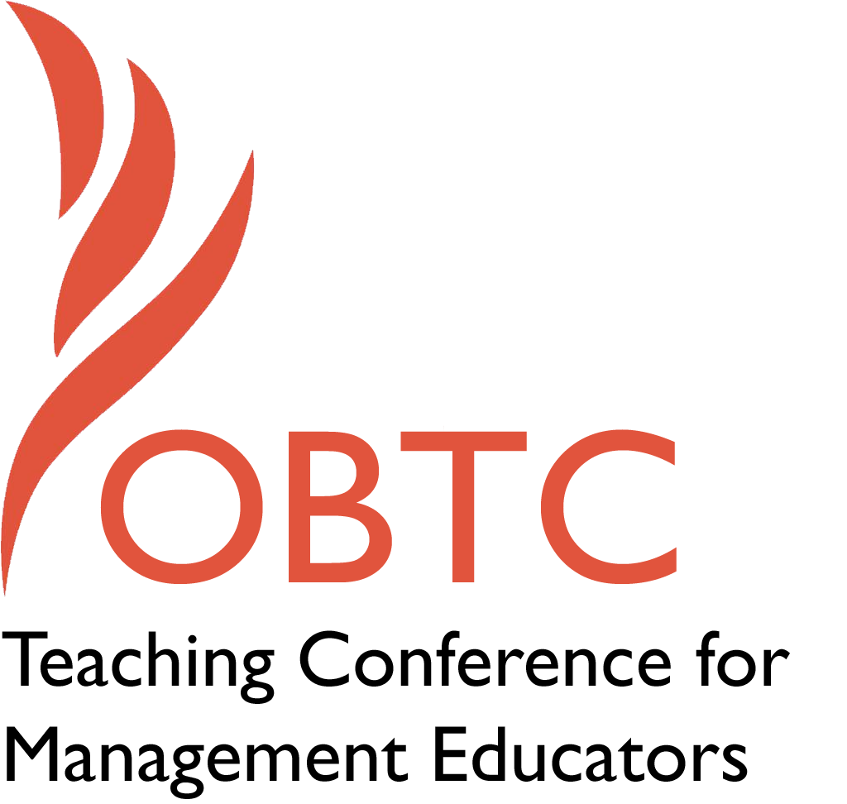

OBTC 2017 at Providence College
June 14th – 17th, 2017

Submission Template

SUBMISSION GUIDANCE
* Remove all identifying properties from this document *
* All files must be saved in PDF format *
*Please include ALL supplementary text at the end of this document* *Only one document should be submitted*

Submission Template for the
2017 OBTC Teaching Conference for Management Educators

- Title, Abstract & Keywords
In your abstract, please include a brief session description (not to exceed 100 words), and three to four keywords. If your proposal is accepted, this description will be printed in the conference program.

Title: Publish don’t perish: Charting the course for writing a book

Abstract:

Have you ever wanted to write a book, but not been sure how to start or were concerned about what is involved? What is the impact of the changing nature of the publishing industry on the likelihood of having your book published? This session provides an opportunity to interact with authors who have made the leap and a publisher who has made the transition from a large publishing house to his own independent company. They will share their experiences, answer questions, and offer advice. The goal is to encourage a community of authors who seek to navigate today’s publishing waters.

Key Words: Book, Writing, Publishing

- Teaching Implications:
What is the contribution of your session to management pedagogy/andragogy? Specifically, please include your learning objectives, and describe what management and/or teaching topics are relevant to your session, and why. Also, include theoretical, disciplinary, or theoretical foundations that will help reviewers understand how your ideas fit within the broader field of management.

Learning Objectives:
- Understand the process and challenges of publishing a book in today’s publishing environment
- Become familiar with typical trials and tribulations in the process of writing a book
- Learn approaches to develop a plan for writing your own textbook

There are two ways that this session involves how we approach teaching our courses. First, there are the traditional conflicting demands that we face as academics between teaching and publishing. Second, this session addresses how to overcome the limitations we often find when using existing textbooks.

Many of us had the axiom of publish or perish drilled through us in graduate school. Learning to navigate these demands while also focusing on our teaching and our students is a challenge to which most of us can relate. Writing a textbook as opposed to traditional journal articles offers a way reduce this conflict by enabling us to focus on both our students and writing simultaneously. Unlike most journal articles, books provide a publishable outlet for what we have learned in our classrooms. In addition, the writing we do for books is material that can be used directly in our courses. Indeed testing the materials we are writing in our classes while we are writing them allows for student input to make our final manuscript the best it can possibly be.

Of course, writing a book is not a panacea. Many of our colleagues have a very limited sense of what is acceptable publishing. To them, books should not be recognized or rewarded. This is one potential challenge to writing. Other challenges have to do with the publishing process itself and the dramatic changes in the industry in the last decade. First, while we may have been trained about how to publish a journal article, publishing a book represents a new venture and there are few people with experience in today’s publishing environment to offer advice.

Over the last ten years there has been a consolidation in the publishing industry through mergers and acquisitions. The industry has become much more competitive with the influx of e-books and reprints from questionable sources. As a result the largest publishers have dramatically reduced the number of titles they offer, instead focusing on the top-selling, high-volume introductory texts that can be marketed with online supplements that students must purchase (c.f., My Management Lab, McGraw-Hill Connect). On the surface this may be discouraging news for people interested in publishing a textbook, however these changing currents in the industry have led to smaller publishers filling the void for niche and smaller market books.

Despite these challenges, writing a book can be a rewarding experience. A problem that many of us have experienced with existing textbooks is that they are limited. These limitations may reside in how things are presented in the textbook, by the fact that the textbook does not cover material that we believe should be in it, or that it is more theoretical and less applied than our approach to our course. Because of this, many of us spend a great deal of time supplementing the textbook with other readings, assignments, and exercises. Writing a book is way to address those limitations and create an instructional tool that meets your expectations and needs. But before you can get started, there are a number of issues to be considered including how to select a publisher, the information that we need to provide, and other considerations you need to be aware of when working with a publisher. We will also address challenges in the process of writing the book (e.g., dividing up the work, consolidating multiple voices, handling revisions), developing supplements (e.g., what to include, who does what), and dealing with potentially jealous colleagues (financial rewards of a book).

- Session Description and Plan:
What will you actually do in this session? If appropriate, please include a timeline estimating the activities will you facilitate: how long will they take, and how will participants be involved? Please remember that reviewers will be evaluating how well the time request matches the activities you’d like to do, and the extent you can reasonably accomplish the session’s goals. Reviewers will also be looking for how you are engaging the participants in the session.

After a brief introduction of the panelists, attendees will be asked to introduce themselves and share why they are interested in the session to help ensure it meets the needs of the attendees. Each of the four authors will briefly share their experiences with writing a book. Next the publisher will give an overview of the changes in the publishing industry and what publishers are looking for in potential authors. Attendees will then have an opportunity to ask questions of the authors and publisher to help them become better prepared to write their own book.

Total time requested: 90 minutes allocated as follows:

Introductions 10 minutes

Author experiences (4 @ 5 minutes each) 20 minutes

Publisher’s viewpoint 20 minutes

Group discussion and Q&A 30 minutes

Summary and final advice 10 minutes

- Application to Conference theme:
How does your session fit with the overall OBTC theme of Navigating the Changing Currents?

The process of getting tenure and publishing according to your institution’s journal list exerts major pressure on how and what we write, and where we publish. Even after getting tenure, it is easy for our career to continue to be propelled by those same currents. Choosing to write a textbook, or anything off your institution’s journal list, can definitely feel like you are fighting against those currents. In addition, the changing nature of the publishing industry means that potential authors are in uncharted waters. This session is designed to provide advice and support to help people find their way into a new writing current.

- Unique Contribution to OBTC:
Have you presented the work in this proposal before? If so, how will it be different? Is this proposal under current review somewhere else? If so, please explain. How will your proposal be different for the OBTC conference?

Two of the panelists presented a session on publishing a book at OBTC in 2007. While the broad topic is the same, much has changed in the publishing industry in the last decade. As such, this session will be a current if not unique contribution to OBTC.

