Teaching with Twitter:

Connecting with the Community and Classes

MOBTC 2018

at Coastal Carolina University

June 6th – 9th, 2018

Abstract:
Twitter is a unique social networking tool in that it is a microblog that can be used to connect, converse, and build community. In this session, we will discuss the advantages and disadvantages of using Twitter to teach. We present two class activities that can be used to connect students with the community and world around them. We will engage participants in the session by demonstrating a Twitter chat and various techniques to enhance the effectiveness of using twitter to teach.

Keywords: Social media, connection, community

Introduction.

The use of social media in teaching has continued to increase (Chawinga, 2017), yet its role in education is still questioned. Some instructors shy away from it all together, either blocking cites or prohibiting students from using them. Others are ambivalent and tend to ignore them, while some instructors embrace the technology by incorporating it into teaching. We seek to better understand how to effectively utilize social media in teaching. In particular, we focus on the microblogging service of Twitter.

Twitter allows for brief exchanges of information or conversation. It can promote learning between peers or others through social connection and collective intelligence. Some researchers argue that Twitter may be the “social networking platform most amenable to ongoing, public dialogue” (Junco et al., 2011, p. 1). Advantages of Twitter are the ability to quickly communicate information and engage others through collaboration and interaction (Lu, 2011). Disadvantages of Twitter and social media in general include issues with privacy and academic integrity (Seaman & Tinti-Kane, 2013). Nonetheless, Twitter allows users to share ideas and resources, build connections, and offer social or developmental support (Carpenter, 2014). Twitter can be utilized in a variety of business courses including undergraduates, graduates, online, hybrid as well as with traditional or non-traditional students and international or domestic students.
The purpose of this session is to demonstrate two exercises using Twitter. The first will be a Twitter chat conducted during a regular class exercise and the second will be a Twitter application activity conducted throughout the course of a semester. The goal of both exercises was to connect students with the real world by building knowledge and social exchange through Twitter.
Theoretical Foundation/Teaching Implications.
The use of social media in general and Twitter in particular stems from research on computer-mediated communication such as media richness theory (Daft & Lengel, 1986). This theory differentiates various media based on their richness, or ability to convey information in a meaningful way. Media are considered richer if they are able to handle multiple information cues, provide feedback quickly, and are personalized. Twitter is a media of moderate richness as personalization and feedback are inherent, yet body language, nonverbal, and verbal cues are often missing from these exchanges.

Incorporating Twitter as a moderately rich communication medium in teaching can be beneficial by building more informal social exchanges that can enhance connection with others both within and outside of the classroom. As a social media platform, Twitter can be used synchronously or asynchronously. Research has demonstrated that when Twitter is used in higher education, students have higher satisfaction and greater engagement in their courses, and often tend to earn higher grades (Junco et al, 2011; Krutka, 2014; Rinaldo, Tapp, & Laverie, 2011). Students in classes that used Twitter felt a greater sense of community and connection with other students and the instructor (Krutka, 2014). Twitter encourages concise writing and informal learning, and can provide a voice to students, especially those that are more introverted and may be afraid to speak up in a face-to-face class (Voorn & Koomers, 2013).

- Learning Objectives.

- Build course engagement through activities using Twitter.
- Show how to enhance the effectiveness of using Twitter to teach through hashtags, lists, and other Twitter tools
- Connect with the community and classes using the Twitter social media platform

The teaching topics most relevant for using Twitter range as just about any topic can be discussed on this platform. We will discuss exercises done in marketing behavior courses as well as human resource management classes, but these activities could easily be incorporated into any management course.

Exercise Overview.

This session will discuss two exercises. The first will be a synchronous Twitter chat demonstration. The Twitter chat is advantageous because it provides students the ability to connect and communicate with professionals in the field in real time. The guidelines given to the class for this exercise are provided in Appendix A. Students were asked to participate in the chat during class time along with professionals from companies in the local area. Every 15 minutes, the professor asked a different question to keep the conversation moving. Statistics related to this exercise are provided in Appendix B. In order to demonstrate this activity, we will hold a live Twitter chat during the session with the hashtag #obtc2018.

The second exercise will be an asynchronous Twitter application activity. Students were asked to find an article related to the content discussed in class that week and post it with a comment to the professor and the class. They were also required to comment on at least another article posted by someone else in the class. Guidelines indicated that students needed to complete this at least three times throughout the semester (see Appendix B). Not only did this activity allow students to research and find real events related to the topic at hand in human resources, but it also provided a means to discuss and exchange thoughts on real and relevant issues. The benefits of conducting this exercise on Twitter as opposed to a learning management system discussion board was that professionals and others outside of the class would often comment, retweet, and like the articles, providing a greater sense of engagement with the material.

Session Description and Plan.

The session will incorporate demonstrations and small group activities to engage participants and actively facilitate an interactive session. A 60-minute session is requested but more or less time could be utilized if necessary. Specifically, the timeline for the session will be as follows:

- Introduce presenters and topic (5 minutes).
- Demonstrate basic elements of Twitter (10 minutes).
  - Account creation
  - Hashtags
  - Twitter Feed
  - Tweeting at Users
- Discuss Twitter exercises that can be used in the management classroom (15 minutes)
  - Twitter Chat
  - Twitter Application Activity
- Small Group Activity – Twitter Chat (20 minutes)
  - Hashtag: #obtc2018
  - Discussion Questions (new question every 5 minutes):
    - What are the advantages of using social media in teaching?
    - What are the disadvantages of using social media in teaching?
    - Why should Twitter be used in management education?
    - How can Twitter be used in management education?
- Debrief and Conclusion (10 minutes)

This session and the activities discussed relate to the OBTC conference theme of reflective reinvention because they provide a new and current way of increasing interaction and helping to build connection with the community, content, and class. They also provide an opportunity to discuss how social media can be incorporated in the future of management education.

References

Carpenter, J. P. (2014). Twitter’s capacity to support collaborative learning. International of Journal Social Media and Interactive Learning Environments, 2(2), 103–118.

Chawinga, W.D. (2017). Taking social media to a university classroom: Teaching and learning using Twitter and blogs. International Journal of Educational Technology in Higher Education, 14, 1-19.

Daft, R.L & Lengel, R.H. (1986). Organizational information requirements, media richness and structural design. Management Science. 32 (5): 554–571

Jones, A. (2015). How Twitter saved my literature class: a case study with discussion. In C. Wankel, M. Marovich, K. Miller, & J. Stanaityte (Eds.), Teaching Arts and Science with the New Social Media (pp. 91–105). Bingley: Emerald Group Publishing.

Junco, R., Heiberger, G., & Loken, E. (2011). The effect of Twitter on college student engagement and grades. Journal of Computer Assisted Learning, 27(2), 119–132.

Krutka, D. G. (2014). Social media as a catalyst for convergence culture: Immersing pre-service social studies teachers in the social media terrain. In W. B. Russell (Ed.), Digital social studies (pp. 271–302). Charlotte, NC: Information Age Publishing.

Lu, A. (2011, July 13). Twitter seen evolving into professional development tool. Education Week, 30(36), 20.

Rinaldo, S. B., Tapp, S., & Laverie, D. A. (2011). Learning by tweeting: Using Twitter as a pedagogical tool. Journal of Marketing Education, 33(2), 194–204.

Seaman, J., & Tinti-Kane, H. (2013, October). Social media for teaching and learning. Pearson Learning Solutions and Babson Survey Research Group. Retrieved from http://www.pearsonlearningsolutions.com/assets/downloads/reports/social-media-for-teaching-andlearning-2013-report.pdf#view=FitH,0.

Voorn, R. J. J., & Kommers, P. A. M. (2013). Social media and higher education: Introversion and collaborative learning from the student’s perspective. International Journal of Social Media and Interactive Learning Environments, 1(1), 59–73.

Appendix A

Twitter Chat Instructions
A Twitter chat gives you the opportunity to apply and discuss course topics in real-time with classmates and professionals in a fast-paced, virtual setting. The Twitter chat will occur during class on November 16, 2017.

How to Participate in a Twitter Chat
To effectively participate in a Twitter chat, you should:
  - Log in to Twitter at least five minutes before the start of the chat, which will begin at the same time as a regular class meeting.
    - Although you may participate using any device, I recommend using a desktop or laptop computer, so that you can use the web-based version of Twitter, instead of the Twitter app.
  - Type in #[class hashtag] in the search bar. Click on “Latest” to ensure that all tweets are available for viewing in real time.
  - Use the course hashtag (#[classhashtag]) and the Department hashtag [#departmenthashtag] in every tweet. If you do not use both hashtags, I will not see your tweet.

Some Items to Keep in Mind
- I will serve as the moderator of the chat, which means I will ask a new question every 10-15 minutes that the chat should center around.
- When I close one topic and move on to a new question, you should start to conclude your conversation on the original topic and move on to the current topic.
- Do not feel like you have to respond to every single tweet (there will be quite a few!), but you should participate regularly in the conversation.
- Side conversations are permitted and encouraged, but only if:
  - (1) they are related to the topics being discussed in the Twitter chat, and
  - (2) you continue to use the course hashtags in these side conversations.
- It is likely that the Twitter chat will feel hectic, but this is the nature of such chats. The purpose is to expose you to a new type of conversation that you may choose to engage in to keep up with what professionals in your field are discussing on Twitter.

Assessing Twitter Chat Participation
Please keep in mind the following participation guidelines:
- You should plan to actively tweet and read others’ tweets from the start of the chat until it is finished.
- Each tweet should add to the discussion in a thoughtful and intelligent manner.
- Tweets should demonstrate the application of the knowledge the student is gaining from the course to the discussion.
  - Tweets that simply state a student’s agreement with another student, without adding a new idea to the discussion, will not count as active participation.
- Each tweet should include the course and department hashtags, and be written using complete sentences and proper grammar and spelling.
- You should not type a response in another app, take a screen shot of it, and post the image in a tweet.
- Disrespectful and/or inappropriate tweets will result in an automatic “zero” for that day’s in-class activity.
- Creativity is encouraged – this means photos, GIFs, links to relevant articles, emojis, etc. are welcome!

Appendix B

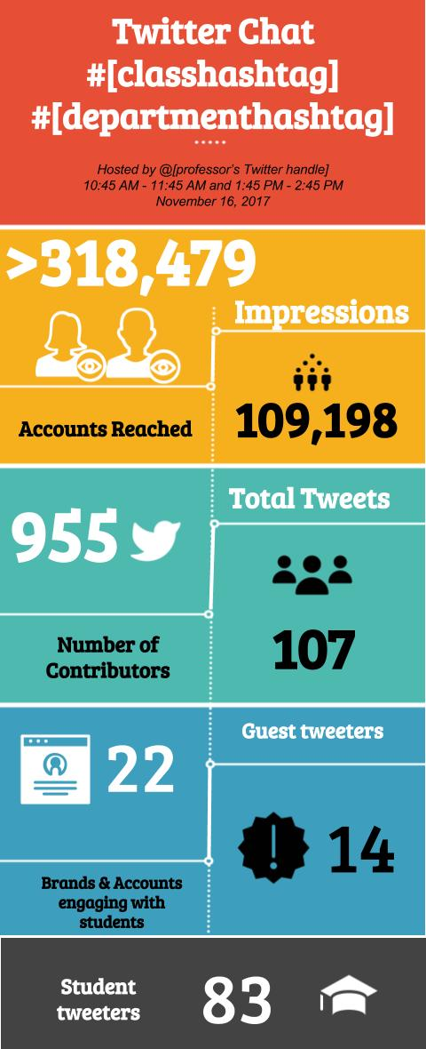

Appendix C

Guidelines for Course Engagement: Twitter Application
At least three times throughout the semester, you will be expected to share a recent event related to the class material. You may find articles in newspapers, magazines, or online that are relevant for the content we discuss in a particular week. This means you should be actively reviewing news sources each week to stay on top of events and activities related to the class. Once you have found an article, you should share it with the class on Twitter.
On Twitter, write a post about the article and why you find it interesting or relevant. Make sure to include my name so I know you are posting it (@ProfX on Twitter.com) as well as a link to the article.
Example: “@ProfX #[University]HR Union workers earn an average of 27% more than non-union workers. Do you think that is fair? I'd join! http://money.cnn.com/2015/02/24/news/economy/union-wages/”.
In addition to posting your article, you should also comment at least one other post made by a classmate. Please note that you may only share one event per topic each week (so don’t wait until the end to complete them all). Let me know if you have any questions.

