- Teaching Implications:

Introduction.

This session has the purpose of creating reflective conversations about the development of inquiry as a focus of pedagogy in our courses. Learning objectives include:
- Awareness of the potential for inquiry-focused pedagogy.
- Understanding of three different approaches to inquiry-focused pedagogy.
- Analysis and potential Application of inquiry-focused pedagogy to one’s own courses.

The questions “How might we modify a course to focus on inquiry, and what might be the consequences (good or bad) of such an action?” will be discussed during the roundtable.

The target audience is faculty interested in student-directed learning who might wish to explore how to make their teaching more inquiry-focused.

Theoretical Foundation/Teaching Implications.

Bloom’s taxonomy (1956) has long been turned to for guidance in designing curricula. The 2001 revision (Anderson & Krathwohl) has been widely accepted and is a source for the development of question stems (see Figure 1) that can assist in designing educational experiences. Faculty develop questions for students to answer as part of creating learning objective, crafting discussions, and putting together exams. The intent is to build students’ capabilities so they can operate at progressively advanced levels of Bloom’s taxonomy – moving from Knowledge and Comprehension towards Synthesis and Evaluation.

However, there is an inherent tension between a professor creating and posing questions for students to answer and the increasing instructional momentum toward student-directed learning. The questions developed for students may not address their individual zones of proximal development. Though instructors are told they should give students the hardest tasks they can accomplish, students are at various stages of learning so what is easy for one may be difficult for another (Wass & Golding, 2014). Asking questions places the professor in the traditional role of directing and evaluating, displacing students from the role of self-directed learners.

An alternative compatible with self-directed learning is to focus on inquiry itself as the subject of pedagogy. As Bowker (2010) writes:

“The flaw in most Socratic, critical, and problem-based approaches is that the teacher retains control of the inquiry. Students are asked to generate answers in accordance with their roles as naïve interlocutors, while the teacher plays Socrates. When the teacher is the one who constructs the most interesting questions, problems, or critical challenges, students become dependent upon the teacher to catalyze inquiry. On the other hand, a question-centered pedagogy proposes that these question-posing, problem-making functions be carefully handed over to students, so that students engage the course material as independent thinkers.”

At its most radical, one might consider the goal of education as not teaching “subjects” to students, but teaching students to ask effective questions across a broad range of subjects.

This session will provide a brief description my recent experience with inquiry-focused pedagogy in a senior Capstone course. Rather than focus on teaching the topic of strategy, students presented and taught the material while I focused on helping the students learn to ask one another questions based on the “Synthesis” and “Evaluation” levels of Bloom’s taxonomy.

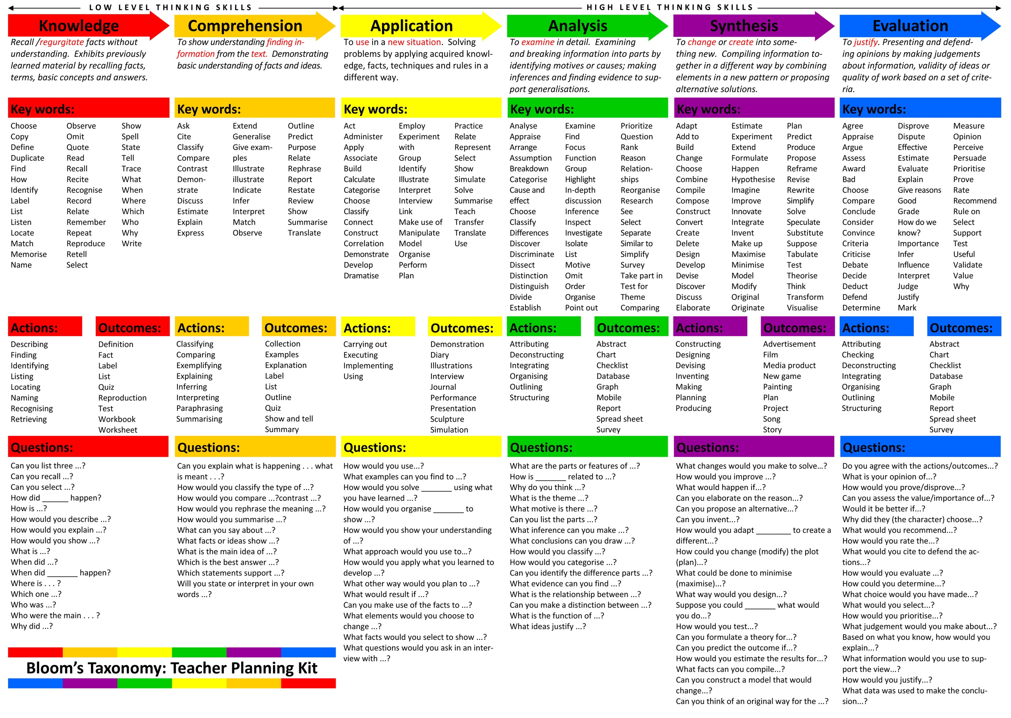

Figure 1.

I will compare my Capstone course to Putzel’s “XB” (2007) and “Harkness Learning” (Williams, 2014); two approaches that emphasize reflective, student-directed learning.

Putzel’s “XB” provides a student-directed “Classroom As Organization” structure for a course that is in many ways related to a T-Group. Students in “XB” manage an organizational structure (presented in the course manual) whose purpose is learning management. During the process they experience many of the dynamics and dilemmas that confront managers in “real” organizations. Like a T-Group, the focus of learning is inward, both individually and organizationally. Students are expected to reflect upon and inquire into their own and others’ actions and their consequences. As Senior Manager, the professor “teaching” the course refrains from actively directing the course of action unless absolutely necessary to provoke learning.

Harkness Learning, developed at Phillips Exeter Academy, operates around a “Harkness Table”, where a small group of students (typically around a dozen) engage in discussion and problem solving. The goal of Harkness Learning is collaborative inquiry, and so the nature of the questions developed by the students is central to learning. While readings and assignments are strictly adhered to, the substance of what occurs at a Harkness table is strictly determined by the students. Rather than focus on a devotion to arriving at the “truth” handed down from above (e.g., the instructor), the focus is on student self-determination and exploration, with the added benefit of developing student abilities to test and evaluate ideas.

Sharing aspects of both of these structures, my Capstone course tasked four-person student teams with creating and managing discussions of strategy among the remaining 20 people in the course as they progressed through topics of:
- Developing Vision and Mission Statements
- Performing External Audits
- Performing Internal Audits
- Establishing Long-Term Objectives
- Generating and Selecting Strategies
- Implementing Strategies
- Measuring and Evaluating Performance
Each team managed one discussion in each of the topics. Readings relevant to a topic were assigned by each team for their discussion. During the course students engaged in the Capsim strategy simulation as well as designed their own personal strategy for accomplishing life goals. As instructor, rather than addressing the subject of strategy, I focused attention on the quality of the questions and responses during the discussion. Students improved their abilities to develop questions reflecting higher levels of Bloom’s taxonomy and to manage a sustained peer to peer discussion.

After presenting and clarifying these three course designs, most of the session will be spent in roundtables reflecting on and discussing the questions “How might we modify a course to focus on inquiry, and what might be the consequences (good or bad) of such an action?”. This session will contribute to effective teaching and learning in the field of management by promoting reflection and reassessment of the approaches we faculty use to provoke learning.

Anderson, L. W., & Krathwohl, D. R. (Eds.). (2001). A taxonomy for learning, teaching and assessing: A revision of Bloom's Taxonomy of educational outcomes: Complete edition, New York: Longman.
Bloom, B., Englehart, M., Furst, E., Hill, W., & Krathwohl, D. (1956). Taxonomy of educational objectives: The classification of educational goals. Handbook I: Cognitive domain. New York, Toronto: Longmans, Green.
Bowker, M. (2010), “Teaching students to ask questions instead of answering them”, Thought & Action: The NEA Higher Education Journal, 26 (1), 127-134.
Putzel, R. (2007) XB: “New-Paradigm Management Of The Classroom As A Complex Organization”, Journal of Business and Leadership: Research, Practice, and Teaching, 3 (1), 136-143.
Wass, R., & Golding, C. (2014). Sharpening a tool for teaching: the zone of proximal development. Teaching in Higher Education, 19(6), 671-684.
Williams, G. (2014), “Harkness Learning: Principles of a Radical American Pedagogy”, Journal of Pedagogic Development, 4(3), 58-67.

- Session Description and Plan:

00:00 – 00:15 – Introduce participants to inquiry-focused pedagogy in student-directed classroom designs.
00:15 – 00:45 – Engage in discussion of “How might we modify a course to focus on inquiry, and what might be the consequences (good or bad) of such an action?”
00:45 – 01:00 – Debrief and discuss table outcomes

