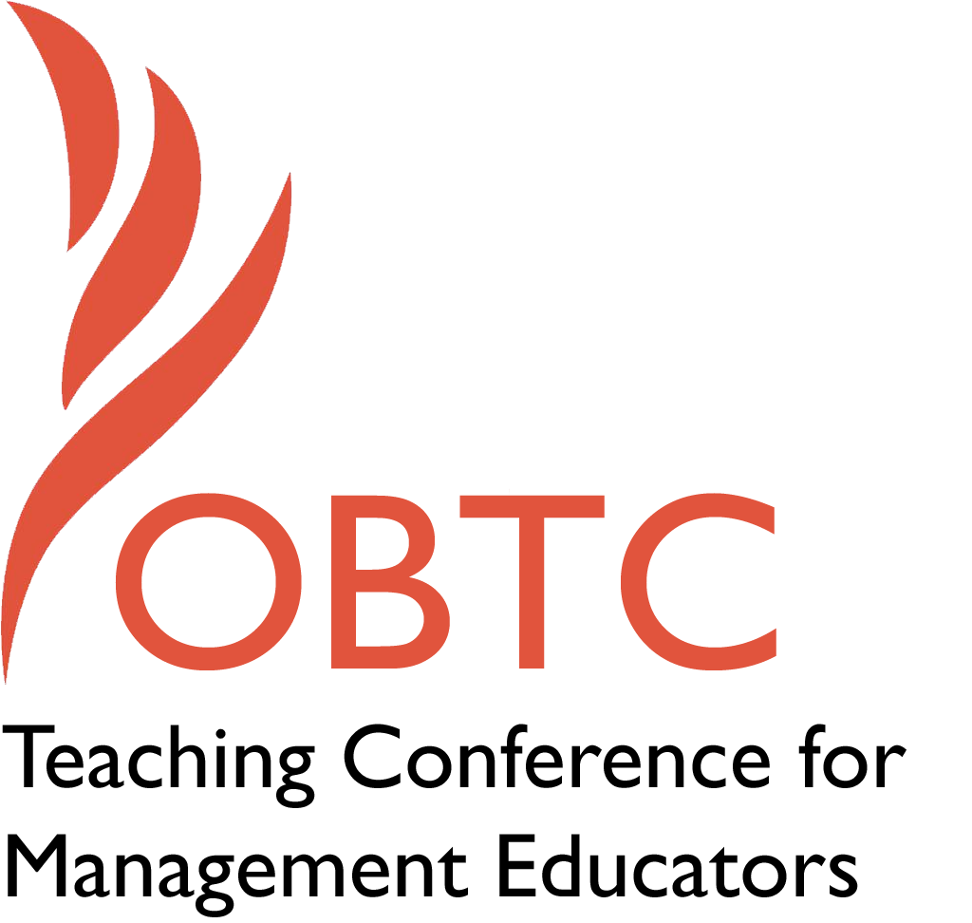

IOBTC 2016 at

University of Winchester

July 8th – 9th, 2016

Submission Template

SUBMISSION GUIDANCE
* Remove all identifying properties from this document *
* All files must be saved in PDF format *
*Please include ALL supplementary text at the end of this document* *Only one document should be submitted*

Submission Template for the 2016 IOBTC
International Teaching Conference for Management Educators

- Title of Proposal:
You’ve got the music in you: Elevating the teaching process by connecting music and management.

- Abstract:
Please include a brief session description (not to exceed 100 words).If your proposal is accepted, this description will be printed in the conference program.

Engaging multiple senses increases student attention and the possibility of learning and retention. And, we would argue, it elevates the classroom process. How, then, to make this work with music? Perhaps you’ve seen others use music in the classroom, but are worried that students won’t appreciate your musical taste, or worse, that they disapprove of “edutainment.” This session will feature examples of using music to positive effect, as well as a process, and a practicum, for so doing.

- Keywords:
Use three or four keywords to describe your session.

Music, arts, engagement, learning

- Format
X Activity or exercise
X General discussion session

- Time Requested:
20 Minutes
_ 30 Minutes
X 60 Minutes

- Planning Details:
Does your session have any special requirements for space or materials?

The room must be equipped with a computer, projector or large screen, internet with good bandwidth, and, most important, external speakers. Flipcharts for small groups will be helpful.

- Learning Objectives or Goals for the Session:
What are 2-4 specific learning outcomes that participants will get from your session?

- Introduce approaches for using music in the management classroom
- Minimize fears related to the appropriateness and consonance of implementing music in the classroom
- Create specific plans for using music to illustrate management concepts

- Management or Teaching Topics:
Describe what management and/or teaching topics are relevant to your session, and why. Are there theoretical, disciplinary, or theoretical foundations that will help reviewers understand how your ideas fit within the broader field of management?

Many contemporary students are millennials—aged 18-26—who have been plugged into multi-tasking, multimedia environments since birth. Maintaining their attention in the classroom, while essential for learning, is difficult, as faculty compete with “needs” for continuous texting, surfing, and social networking. OBTC faculty have long known the virtues of experiential learning, and continue to utilize and experiment with myriad activities and approaches to facilitate student engagement and learning. The reason is backed by research, such as that contained in How People Learn (National Academy of Sciences, 2000). Learning is enhanced when:
- Students’ prior knowledge is made visible, allowing them to correct misperceptions and build new concepts on prior knowledge
- Concepts are personally meaningful, which comes from relevance outside the classroom and use (i.e., practice) of key ideas
- Students think about their own thinking (metacognitive)

Bringing music into the classroom has a direct effect on the first two, and our experiences confirm this. Playing clips of familiar songs can provide a launching point for a discussion on important management topics such diversity, creativity, emotion, teamwork and culture and the implications therein. However, some faculty abstain from such an approach, perhaps due to fears that they won’t be taken seriously (i.e., “edutainment”), students won’t appreciate their musical selections or that there’s insufficient time in a learning-objective rich and time poor curriculum.

In this session, combining activity and discussion, we first frame the opportunity and share some results from using music in the classroom. We then present a framework for challenging preconceived ideas about using music to connect with students and increase their learning, such as:
- Our musical tastes are compatible, i.e., students “get” our selections/artists
- Our musical tastes clash or aren’t appreciated, i.e., students don’t like “old” music
- Music is inappropriate in a management classroom

We then offer up ways to elevate engagement and facilitate learning, even when musical styles differ, or if faculty lack the courage to take the risk of bringing music into the classroom. Some specific examples we plan to share include:

Example—Managing Across Cultures (Maury)
Using the music of Azerbaijani singer/pianist/composer Aziza Mustafa Zadeh, paired with either my own case “Kerstin Berger” or “Johannes van den Bosch” by DiStefano. Zadeh’s career spans several countries and cultures, and her music is a fusion of heritages and styles. I start the music — typically “Passion” from Dance of Fire — a few minutes before class. As participants settle, I ask what kind of music we are listening to. Because there are many cultural and musical elements embedded in the piece, students tend to give a wide variety of answers: jazz, folk, flamenco. Occasionally someone identifies the Asian / Middle Eastern influence, and as I reveal the identity of the performer I briefly describe her history (which includes significant hardship) and the challenges and ultimate success she attained in crossing borders to Germany, where she is renowned in the jazz community.
To illustrate the potential of cross-cultural teams, I then play a video of Zadeh and Bobby McFerrin singing the Habañera from Bizet’s Carmen: (http://www.youtube.com/watch?v=pphopoCD4_A ). This French operatic piece on a Spanish theme, sung a cappella by an Azerbaijani woman and an African-American man at a jazz festival in Germany, is an exquisite example of multi-cultural work. As I usually teach full-time executives or MBAs with significant experience, I then ask how many have worked across cultures (often a large majority). I ask them to think of a cross-cultural team of which they have been a member, and if any of these has attained the level of performance we just witnessed. If the answer is yes, we explore what and why and note it down. Usually it is no, and we discuss why such teams tend to have difficulty. I then go into the case, making links with the musical example and participants’ own experience.
During the ensuing discussion I continue where the teaching note stops, asking at a number of points in the case if they have ever experienced “a situation like this”, bringing in their cultures and interests, current events, relevant issues for the group, and occasionally my own background. It is never a random walk however: There are always a model and a set of slides to refer to. For this topic I use the Cultural Perspectives model by DiStefano and Maznevski, which gives them both a logic and process for managing across cultures as well as comparative data on their own countries. Students thus leave the class with at least four elements:
- The case and its lessons
- The musical example(s)
- Lessons from one another’s own experience
- The research model, with data, as applied to practice

Example – Lifelong Learning and Careers (Maury)
Often my last session, particularly with MBAs, will be about this topic. I introduce it by asking students if they can be music critics for a moment. By now they have probably seen and heard a number of my musical examples and are more than happy to take a more active role in this part of the class. I first play a recording of a smooth, traditional jazz piece – “Autumn Leaves”— and ask for reactions. Though many like the piece, most say that it is the kind of thing they might hear in an elevator or a hotel lobby—just background. I ask what level of energy the musicians are putting forth. The answer is usually “low”. I ask what kind of musicians they imagine are playing. Invariably someone suggests “older” or “too used to doing this”. I then play another cut, which after a long and agitated musical introduction turns out to be a (very different) rendering of the same piece. This time the characterizations are “jazz concert”, “high energy”, and “younger musicians”. I ask if there is any possibility that the musicians, or at least the pianists at the core of each group, could be the same. Most say no, but some suggest that the first cut might be the same musician(s) at a later stage of their career. “How much later?” I ask. “Ten or twenty years” is the typical reply.
I then reveal that both cuts are in fact by the great jazz pianist Ahmad Jamal, and that the first cut is in fact the earlier one – from the 1958 album, Poinciana, that made him famous, while the second, more innovative cut is from his 70th anniversary concert at Olympia in Paris – 42 years later. I compare Jamal with more typical musicians, for example the Beach Boys, who continue to play 40+ years on but have been for years only a shadow of what they were in their heyday, essentially repeating what they’ve always done with more weathered/strained voices.
The example(s) serve to introduce the crucial question, how do you continue to perform well, and to learn and grow, over the course of a long career or a lifetime? This is particularly relevant if students are currently on the job market, but it also speaks to executives who may have become “stuck” in their jobs or behaviours and need to find ways to break out of a rut, at least in learning terms. I often teach the short, career-oriented Mark Margolis and Emilio Kornau pair of cases, which contrast a serial entrepreneur of highly variable success with a “company star” who suddenly finds himself out of a job and, eventually, driving a taxi. I also sometimes use the Vinesh Juglal: South African Entrepreneur case, which has even more of a “wild west” career flavour, and occasionally also use my article “Back to Square Zero: The Post-Corporate Career” (from Organizational Dynamics).
The key issues for discussion are always the same: what is success, how can it be sustained, and how much does one have to adapt in order to survive and grow? Are people like Jamal, Margolis, or Juglal especially resilient, or can most people recover, adapt, and learn, or sustain very long-term performance in the same job, provided it is one they love? Is Kornau successful because of his long and illustrious company career, even though he ends up in a lesser one? And finally, who enacts careers, companies or individuals? This class invariably leaves participants thinking about these issues long after the session, and the course, have finished.

Example - Leading Yourself and Others (Let students decide and present the music and related lesson) (Suzanne)

Requiring students—individually or in small groups—to present management concepts through music offers some distinct advantages. Faculty offer a broad list of topics, establish guidelines (e.g., “The presentation must not exceed 30 minutes, must demonstrate the concept, and must utilize participative methods to ensure audience members recognize the concept’s importance and implications in the workplace or career. Presenters have the option of playing recorded music, but should also consider additional, creative means, such as recorded concerts or bringing instruments into the classroom.”) Empowered to choose, they embrace the example/s and their meaning/connection well before they present. By teaching others, the lessons learned are greater than the passive process of “being taught” (i.e., Confucius) by a professor whose taste in music may, at first, not sync with that of the students. Their small group discussions (“I was thinking of this song because it reminds us that…”, “That’s good, I only realized now how much the words motivate me to think about…”) reinforce the importance of the integration of professional and personal effectiveness reflected in music and vice versa. The discussions also provide students with team-based opportunity to be open to new ideas, collaborative in choosing/problem solving, and creative in planning their approach.

Faculty benefit as well. We are exposed to music we might not otherwise hear from students who occupy a different generation…and add to our own repertoire for future classes. We ensure that students connect to potentially more preferred music of their peers (and reinforce those connections where needed). Finally, we get to learn, and model the benefits—processes and outcomes—of leaders sharing their (professorial) power with subordinates.

- Session Description and Plan:
What will you actually do in this session? What activities will you facilitate, how long will they take, and how will participants be involved? Reviewers will be evaluating how well the time request matches the activities you’d like to do, and the extent you can reasonably accomplish the session’s goals. Reviewers will also be looking for how you are engaging the participants in the session. Include a timeline for your session.
60 minute discussion with active demonstrations
0-:10 Introduce session, share example/demonstration, frame the opportunity
:10-:30 Small group discussion of preconceived ideas and how to overcome
:30-:45 Report out, including examples/demonstrations
:45-55 Planning next steps
:55-:60 Conclusion/wrap-up

- For Activities and Exercises:
Attach any materials needed to run the activity and debriefing questions. Evidence for effectiveness may also be included.

- Implications for Teaching or for Teachers:
What is the contribution of your session?

Please see above.

- Application to Conference Theme:
How does your session fit with the overall IOBTC theme of Elevating Aspirations?
IOBTC is in no small measure about teaching, and about elevating the process and dialogue in the classroom as well as the aspirations of instructors and learners alike. Arts and music well applied are a particularly effective means of taking teaching and learning to a higher level; thus we see this session fitting well with the conference theme.

- Unique Contribution to IOBTC:
Have you presented the work in this proposal before? If so, how will it be different? Is this proposal under current review somewhere else? If so, please explain. How will your proposal be different for the IOBTC conference?

An earlier version of this session was presented at OBTC 2014 at Vanderbilt University (and was very well received). It has not been presented elsewhere nor is it under review. In fact it is appropriate, in our view, primarily for the audience and format of IOBTC rather than for any other outlet.
- References and/or Additional Materials:

Bransford, J., Brown, A., & Cocking, R. (2000). How People Learn: Brain, Mind, Experience, and School. Expanded version. Washington, D.C., National Academy Press, p. 33.

Case studies and articles by Maury Peiperl referenced above are all contained in Jick, T.D., and Peiperl, M (2011): Managing Change: Cases and Concepts (3rd Edition), Burr Ridge, IL.: Irwin/McGraw-Hill.

