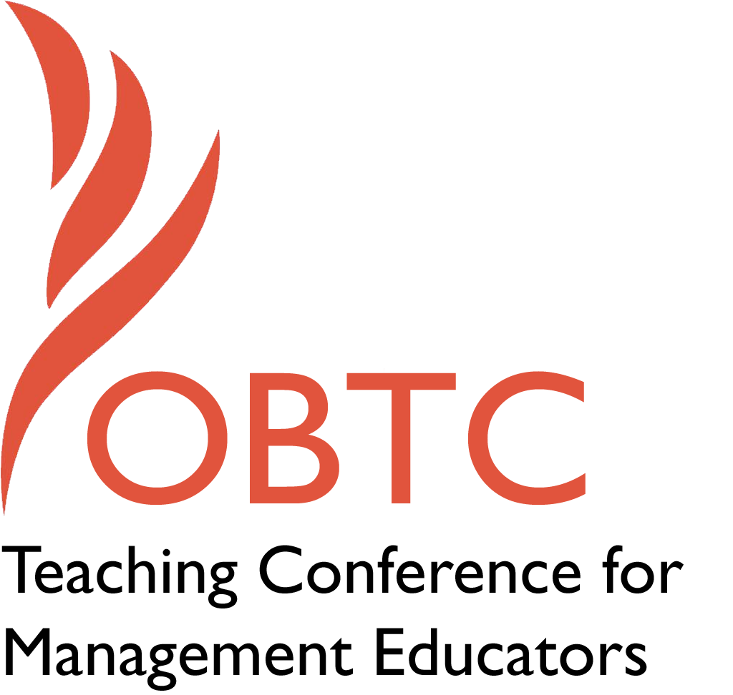

IOBTC 2016 at

University of Winchester

July 8th – 9th, 2016

Submission Template

SUBMISSION GUIDANCE
* Remove all identifying properties from this document *
* All files must be saved in PDF format *
*Please include ALL supplementary text at the end of this document* *Only one document should be submitted*

Submission Template for the 2016 IOBTC
International Teaching Conference for Management Educators

- Title of Proposal:
I Want to be a Better Teacher – But I Don’t Know How

- Abstract:
Please include a brief session description (not to exceed 100 words).If your proposal is accepted, this description will be printed in the conference program.

Many of us come to this profession with aspirations to change the world through our teaching. We want to find the best teacher within us (Quinn, Heynoski, Thomas, & Spreitzer, 2014), but it is challenging since teaching is a complex and passionate experience (Brookfield, 1990). There are plenty of materials available telling us how we should improve our teaching; however these suggestions will only work effectively if they align with our natural talents. This interactive session will begin the process of assisting us in identifying our natural talents and aligning them with the important activities (traits, behaviors) of the teaching profession.

- Keywords:
Use three or four keywords to describe your session.
Improving teaching; natural talents, teaching practices

- Format
X Activity or exercise
General discussion session

- Time Requested:
20 Minutes
30 Minutes
X 60 Minutes

- Planning Details:
Does your session have any special requirements for space or materials?

Tables and chairs

- Learning Objectives or Goals for the Session:
What are 2-4 specific learning outcomes that participants will get from your session?

Identify critical behaviors that great teachers’ exhibit.

Begin the process of identifying your own natural talents

To learn how your own natural talents align with the behaviors of great teachers

- Management or Teaching Topics:
Describe what management and/or teaching topics are relevant to your session, and why. Please include theoretical, disciplinary, or theoretical foundations that will help reviewers understand how your ideas fit within the broader field of management.

As management educators we are all involved in the teaching–learning transaction, so it is always relevant to learn more about how to best convey the course content related to management. This interactive session draws from a seminal study of practices of the best college teachers (Bain, 2004) and from more than five decades of research by the Gallup Organization about developing natural talents. The focus of this session will be on how our natural talents can be aligned with teaching activities and pedagogy (Liesveld & Miller, 2005).

- Session Description and Plan:
What will you actually do in this session? What activities will you facilitate, how long will they take, and how will participants be involved? Reviewers will be evaluating how well the time request matches the activities you’d like to do, and the extent you can reasonably accomplish the session’s goals. Reviewers will also be looking for how you are engaging the participants in the session. Include a timeline for your session.

5 minutes: Introduction to the session

10 minutes: What the Best College Teachers Do (activity)

20 minutes: What I Do Best exercise (activity)

10 minutes: Alignment between What I Do best with What the Best College Teachers Do (activity)

10 minutes: Discussion, Reflection, Action Step (activity)

5 minutes: Wrap Up

- For Activities and Exercises:
Attach any materials needed to run the activity and debriefing questions. Evidence for effectiveness may also be included.

Attached

- Implications for Teaching or for Teachers:
What is the contribution of your session?

We cannot become a type of teacher that goes against our nature and values, but we can be improve of the natural teacher we were born to be. This activities during this session help the participants to begin the journey of identifying what natural talents they bring to their profession and how to align those natural talents with what are considered best practices of college teachers.

- Application to Conference Theme:
How does your session fit with the overall IOBTC theme of Elevating Aspirations?
As we expressed in our abstract, we believe we all came to this profession with elevated aspirations to change the world through our teaching. We love the discipline of management and want our students to improve the discipline when they enter the organizational world. The more we can do this well – and do this based on what we do best – the more we realize our desire to change the world. This opportunity should then elevate our aspiration both for our teaching and for the future of organizations.

- Unique Contribution to IOBTC:
Have you presented the work in this proposal before? If so, how will it be different? Is this proposal under current review somewhere else? If so, please explain. How will your proposal be different for the IOBTC conference?

This proposal is not under review at any other conference or journal. We have used a variation of the What I Do Best exercise at the American Association for Adult and Continuing Education annual conference. There it was a more general session on adult learning, and was not focused on what college teachers do best, which will be the focus of this session.

- References and/or Additional Materials:

Bain, K. 2004. What the best college teachers do. Cambridge, MA: Harvard University Press.

Brookfield, S.D. 1990. The skillful teacher. San Francisco, CA: Jossey-Bass.

Liesveld, R., & Miller, J.A. 2005. Teach with your strengths. New York, NY: Gallup Press.

Quinn, R.E., Heynoski, K., Thomas, M., & Spreitzer, G.M. 2014. The best teacher in you. San Francisco, CA: Berrett-Koehler Publishers, Inc.

What I Do Best

What I Do Best | What I Must Do To Be Successful as a Teacher (Top Five Things)

Debriefing Questions

Would someone tell the group how they currently use one of their What I Do Best items to achieve one of the behaviors of great teachers.
Would someone tell the group about an Aha! moment where you just realized that you can use one of your What I Do Best items to enhance one of the behaviors of great teachers.
Completing an action plan to take action on developing one of your What I Do Best items.
What I Do Best Development Action Plan
Which What I Do Best item do you want to focus on during the school year?

Why would this item be important to develop?

What are two or three action steps you plan on taking?

1.

2.

3.

I will know I have improved my use of this item when . . .

When will you review your action plan?___________________

Small changes, over time, can make a BIG difference!

Signature:___________________ Date:___________

