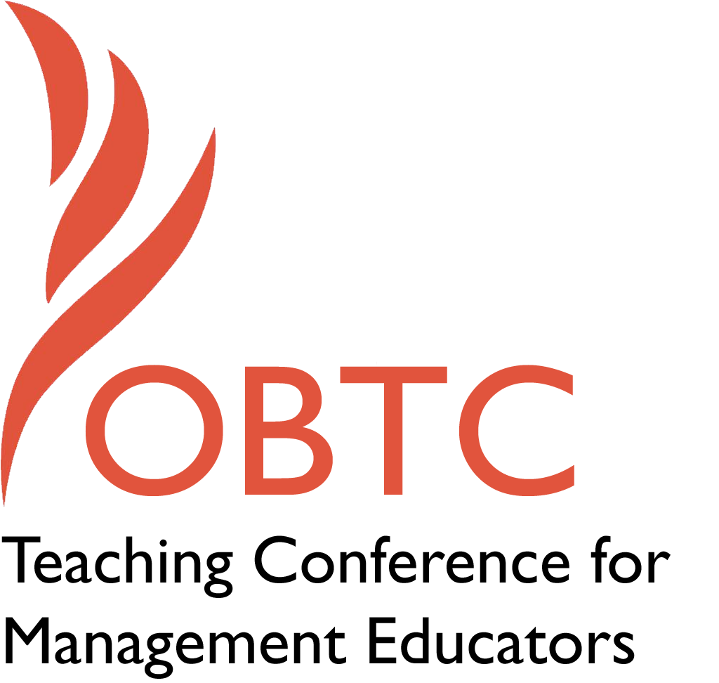

IOBTC 2016 at

University of Winchester

July 8th – 9th, 2016

Submission Template

SUBMISSION GUIDANCE
* Remove all identifying properties from this document *
* All files must be saved in PDF format *
*Please include ALL supplementary text at the end of this document* *Only one document should be submitted*

Submission Template for the 2016 IOBTC
International Teaching Conference for Management Educators

- Title of Proposal:
Educate, Entertain, and Energize your classes with JeopHRdy

- Abstract:
Please include a brief session description (not to exceed 100 words).If your proposal is accepted, this description will be printed in the conference program.

Can students learn concepts and have fun at the same time? Yes, they can if instructors include game-formats as one of their pedagogies. The classroom becomes an enlivened learning community as students aspire to become both learners and winners.
I have adopted JeopHRdy successfully in all my HRM courses. For my undergraduates, I use this teaching method to review chapter materials for all exams. For my graduates, I use this approach to enhance understanding of chapter concepts. My students’ feedback suggest that faculty should adopt this method to not only enhance engagement, but also to bring entertainment into their classes.
(100 words)

- Keywords:
Use three or four keywords to describe your session.
- Lively learning experience
- Active teaching approach
- Engaging class environment

- Format
Activity or exercise
X General discussion session

- Time Requested:
20 Minutes
30 Minutes
X 60 Minutes

- Planning Details:
Does your session have any special requirements for space or materials?

Equipment for power point presentation

- Learning Objectives or Goals for the Session:
What are 2-4 specific learning outcomes that participants will get from your session?

- To discuss how I have modified the popular entertainment show into JeopHRdy in my classes
- To share the REP phases that I have developed for this learning format (Review, Engage, and Participate)
- To provide various formats and incentives that faculty can adopt for different class sizes/courses

- Management or Teaching Topics:
Describe what management and/or teaching topics are relevant to your session, and why. Please include theoretical, disciplinary, or theoretical foundations that will help reviewers understand how your ideas fit within the broader field of management.

Scholars suggest teaching via any popular game-formats (such as Jeopardy, Who wants to be a Millionaire) enhances student engagement. These methods are considered proactive and dynamic pedagogies as students become responsible for their own learning outcomes. In these active approaches, the traditional teaching format changes and the spotlight moves from the teacher to the student. Students not only get the limelight in the class, but also acquire skills to become independent learners (Sarason & Banbury, 2004; Weimer, 2002).
Scholars often lean on passive teaching methods that they forget to create a passion for the subjects or generate vibrant learning environments (Robinson & Aronica, 2009). Pedagogies that allow students to actively participate will definitely motivate, aspire, and engage them to superior learning outcomes (Beard & Wilson, 2006). Weimer (2002) suggests that the more exposure students have to self-learning methods, the more enduring and valuable their education will be.
There are several learning advantages for providing Jeopardy in any learning situation. First, it creates a visual learning interface that students truly enjoy and relate to. Today’s student population spend a substantial time with many forms of electronic devices. Any interaction with technology will create student engagement and rouse their intellectual curiosity. Second, it generates a competitive atmosphere as students want to be recognized not only among their peers, but also test their own learning aspirations. Third, it facilitates rapid cognition and knowledge recall which are important elements in a students’ learning taxonomy. Fourth, it provides a lively learning experience and becomes a welcome change from traditional pedagogies (such as lectures, case studies, discussion questions) (Benek-Rivera & Mathews, 2004; Simkin, 2013).

There are some disadvantages also associated with this learning method. First, students may experience social anxiety when they provide the wrong answers in front of their classmates. Second, some students might not like to participate in a competitive learning environment where the focus is completely on the student. Third, this method might give room for social idling as some students may unjustifiably get the credit as proactive team members answer the majority of the winning points. Finally, this method is predominantly used for knowledge recall which may exclude other important learning skills (such as analyzing, evaluating etc). (Benek-Rivera & Mathews, 2004; Simkin, 2013).

Several studies (Benek-Rivera & Mathews, 2004; Azriel, Erthal, & Starr, 2005; Simkin, 2013)) have explored the outcomes of faculty adopting the Jeopardy game-format in different business classes. Azriel, Erthal, & Starr (2005) identified in an empirical study that the majority of the students rated these games as an excellent learning method to review chapter concepts. Benek-Rivera & Mathews (2004) observed that students were not only more alert and competitive during these review sessions, but it also helped create excellent team spirit. Simkin (2013) in a study of undergraduate students in information systems indicated that students found this method entertaining and reinforcing. While many of these studies have demonstrated the use of these games as excellent review methods, I will show how I use this game format to make students think critically also. I have used this method not only to help students build knowledge recall, but also to develop their analytical skills.

The theoretical foundation that supports this research is experiential learning theory (ELT) (Kolb, 1984). This theory emphasizes the learner’s active role in his or her accumulation of knowledge (Beard & Wilson, 2006). Kolb (1984) refers to this as a “transactional” experience as the student becomes absorbed and integrated in the learning environment. In experiential learning, the student may experience any of these four stages: 1) the Concrete Experience, 2) Reflection Observation, 3) Abstract Conceptualization, and 4) Active Participation. The most important outcome of these environments is that the participants proactively seek their knowledge (Kolb, 1984; McCarthy, 2010).

In the context of my JeopHRdy game, students experience the first stage of the ELT when they see the answer prompt on the screen. As soon as students see the prompt, they move to the second stage and reflect on all the possible responses they can provide. They might also experience the third stage of clarifying concepts either with others or to themselves. Finally, students becomes involved actively in the learning outcome by pressing the buzzer or raising their hands to provide the answer.

- Session Description and Plan:
What will you actually do in this session? What activities will you facilitate, how long will they take, and how will participants be involved? Reviewers will be evaluating how well the time request matches the activities you’d like to do, and the extent you can reasonably accomplish the session’s goals. Reviewers will also be looking for how you are engaging the participants in the session. Include a timeline for your session.

- Presentation
20 minutes: My presentation will detail three specific themes. First, I will describe how I have modified the popular television game to my class room environment as JeopHRdy. Second, I will share the REP (Review, Engage, and Participate) phases that I have created for this learning method. Finally, I will also discuss various formats that can be used for different class sizes (individual versus team) and incentives that can be offered to students. I will also share my power points that I have used both in my graduate and undergraduate classes.

2. Q & A

15 minutes: I will allow sufficient time for Q & A from the audience.

3. Audience Activities

25 minutes: I will provide activity handouts and ask faculty to develop five (5) answers/questions they can use for any class/course. This might provide a preliminary experience and glimpse into this format. Second, I will solicit their responses to the advantages and disadvantages of various formats of the game that can be adopted (teams versus individuals). I will share my personal experiences from my various classes. I will also ask faculty to identify various forms of incentives that can be tied to this assignment.
- For Activities and Exercises:
Attach any materials needed to run the activity and debriefing questions. Evidence for effectiveness may also be included.
Appendix 1: Activity Handout
Appendix 2: Jeopardy game plan for an undergraduate HRM class

- Implications for Teaching or for Teachers:
What is the contribution of your session?
I will share various websites that allow faculty to create friendly interactive Jeopardy presentations. I will demonstrate how I use the various tools provided in these websites such as the popular Jeopardy music, applaud/boo, and timer, among others. I will have a couple of faculty from the audience perform a JeopHRdy demo of the questions they have created during my session.

- Application to Conference Theme:
How does your session fit with the overall IOBTC theme of Elevating Aspirations?

This session fits aptly with the conference theme of “elevating aspirations.” JeopHRdy learning experiences provide students the opportunities to embrace new learning models and also nudges them to become independent learners. My experience of adopting this approach is students come to class motivated to compete with their peers and also enhance their own knowledge. I have observed students glow with the attention as they are being cheered by their peers to answer questions. This learning environment in my classes have become both entertaining and engaging.

- Unique Contribution to IOBTC:
Have you presented the work in this proposal before? If so, how will it be different? Is this proposal under current review somewhere else? If so, please explain. How will your proposal be different for the IOBTC conference?

I have not presented this proposal anywhere else nor is it under consideration for review in any journal.

- References and/or Additional Materials:

Azriel, J., Erthal, M., & Starr, E. (2005). Answers, questions, and deceptions: What is the role of games in business education Journal of Education for Business, 81(1), 9-13.

Beard, C. & Wilson, J. (2006). Experiential learning. A best practice handbook for educators and trainers. Second edition. Kogan Page Limited. London and Philadelphia.

Benek-Rivera, J. & Mathews, V. (2004). Active Learning with Jeopardy: Students ask the questions. Journal of Management Education, 28(1), 104-118.

Kolb, D. (1984). Experiential learning: experience as the source of learning and development. Englewood Cliffs, NJ: Prentice Hall.

McCarthy, M (2010). Experiential Learning Theory: From Theory To Practice. Journal of Business & Economics Research, 8(5), 131-140.

Pillay, S. & James, R. (2013). Gaming across cultures: experimenting with alternate pedagogies. Education + Training, 55 (1), 7-22.

Robinson, K. & Aronica, L. (2009).The Element: How your passion changes anything. Viking. New York.
Sarason, Y. & Banbury, C. (2004). Active learning facilitated by using a game-show format or who doesn’t want to be a millionaire. Journal of Management Education, 28 (4), 509-518.

Simkin, M. (2013). Playing Jeopardy in the Classroom: An empirical study. Journal of Information Systems Education, 24(3), 203-210.

Weimer, M. (2002). Learner-Centered Teaching. Jossey-Bass. San Francisco.

APPENDIX 1: AUDIENCE ACTIVITY HANDOUT

- Please create between three to five answers and questions relevant to your subjects/courses?

- How many students do you have typically in your classes? (this could predict or direct the answer to the next question)

- Do you want to create individual or team competitive environments in your classrooms? What are the advantages or disadvantages you identify with each?

- Individual:

- Team:

- What incentives can you provide for students to become more involved in this learning method? (think of how you can integrate this activity into any of the other graded assignments)

APPENDIX 2: Jeopardy Game plan for an undergraduate HRM class

Chapter 5: Training and Developing Employees

- Answer: Analyze-design-develop-implement-evaluate training process
- (Q) Question: What is ADDIE?

- A: Showing the trainees the right way of doing something and providing feedback
- Q: What is behavior modeling?

- A: Providing training through internal intranet portals.
- Q: What is learning portals?

- A: Trainees learn work-related behaviors on simulated equipment
- Q: What is vestibule training?

- A: Reaction-Learning-Behavior and Results
- Q: What are the methods to evaluate training?

Chapter 6: Performance Management

- A: Rating employee’s positive behavior on one trait to reflect behavior on other traits
- Q: What is the halo effect?

- A: Rating of an employee’s performance as average in all categories
- Q: What is central tendency?

- A: Employees are rated on measurable goals
- Q: What is MBO?

- A; Employees are rated on narratives of good and poor performance
- Q: What is BARS?

- A: Collecting performance information from supervisors, subordinates, peers, and customers
- What is 360 degree feedback?

Chapter 7: Compensating Employees

- A: Employees earn less than $455 a week
- Q: What is nonexempt?

- A: Factors that help managers compare the worth of different jobs
- Q: What are compensable factors?

- A: Employees are paid for each unit of work
- A: What is piecework?

- A: Employers share their financial gains or profits with their employees
- Q: What is gain-sharing?

- A: Private employers have to continue paying benefits to terminated employees for 18 months
- Q: What is COBRA?

Chapter 8: Managing employee ethics

A: The standards that employees use to decide their conduct of behavior
Q: What is ethics?

A: Rules, penalties, and appeal process
Q: What are the three pillars of ethics?

A: Direct disregard of boss’s orders
Q: What is insubordination?

A: Employee are dismissed due to lack of work
Q: What is a layoff?

A: Requires employers of 100 or more employees to give 60 days of notice for laying off 50 employees
Q: What is the WARN act?

