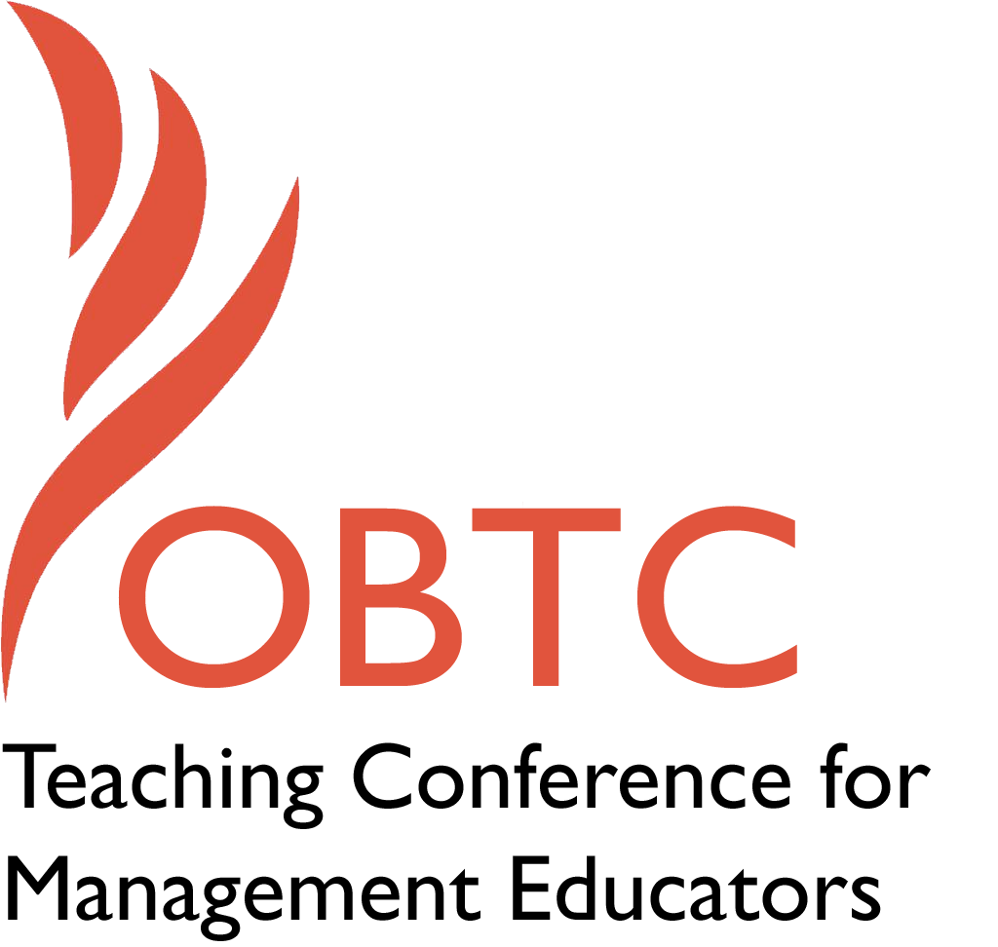

IOBTC 2016 at

University of Winchester

July 8th – 9th, 2016

Submission Template

SUBMISSION GUIDANCE
* Remove all identifying properties from this document *
* All files must be saved in PDF format *
*Please include ALL supplementary text at the end of this document* *Only one document should be submitted*

Submission Template for the 2016 IOBTC
International Teaching Conference for Management Educators

- Title of Proposal:
What’s So Funny? Using International Comedy to teach International Organizational Behavior Concepts

- Abstract:
Please include a brief session description (not to exceed 100 words).If your proposal is accepted, this description will be printed in the conference program.

Humor is said to be culturally determined. What one considers funny in one culture may or may not be funny in another. Humor is embedded in the cultural context of the individual telling the joke. By better understanding the cultural context of the humor, we develop a deeper understanding of the culture from which the humor originates. In this session, we will view videos clips of comedians, movies and tv shows from around the world. Come & watch and bring & share the name of your favorite comedy or comedian from another country.

- Keywords:
Use three or four keywords to describe your session.
Humor, Culture awareness

- Format
Activity or exercise
X General discussion session

- Time Requested:
20 Minutes
30 Minutes
X 60 Minutes

- Planning Details:
Does your session have any special requirements for space or materials?
None. Just a computer with speakers and overhead for showing the videos.

- Learning Objectives or Goals for the Session:
What are 2-4 specific learning outcomes that participants will get from your session?
- Leverage humor in developing organizational relationships
- Gain a better understanding of other cultures
- Incorporate innovative teaching tool into curriculum

- Management or Teaching Topics:
Describe what management and/or teaching topics are relevant to your session, and why. Please include theoretical, disciplinary, or theoretical foundations that will help reviewers understand how your ideas fit within the broader field of management.

The teaching topics for this session include general management topics will vary according to the episodes viewed and discussed. The topics will include occupational stress, work teams, work/family issues, national culture, and work behaviors.

The topics are intended to assist attendees in gaining a better understanding of how organizations and individuals within those organizations operate in other cultures.
The session will also demonstrate humorous cultural encounters that may have gone awry when cultures collide.

Two texts provide the foundation for the videos used in this session, although attendees may reference their own Organizational Behavior or General Management texts: (See page 7 for details of video clips.)

Adler, N. J., & Gundersen, A. (2007). International dimensions of organizational behavior. Cengage Learning.

Williams, C. (2015). MGMT 8 Edition. Cengage Learning.

- Session Description and Plan:
What will you actually do in this session? What activities will you facilitate, how long will they take, and how will participants be involved? Reviewers will be evaluating how well the time request matches the activities you’d like to do, and the extent you can reasonably accomplish the session’s goals. Reviewers will also be looking for how you are engaging the participants in the session. Include a timeline for your session.

I will provide background information as the theoretical underpinnings of using humor to better understand organizational behavior. After each video there will be discussion questions including whether or not attendees found the clip funny, why would it be funny in that culture, and how using this type of humor in that particular culture would help to enhance organizational relationships.
(See Chart on pages 7 – 8.)

- For Activities and Exercises:
Attach any materials needed to run the activity and debriefing questions. Evidence for effectiveness may also be included.

Just a computer with speakers and overhead for showing the videos.

- Implications for Teaching or for Teachers:
What is the contribution of your session?
This session is intended to give teachers a collection of humorous anecdotes that help to develop a deeper understanding of organizations within different cultures.

- Application to Conference Theme:
How does your session fit with the overall IOBTC theme of Elevating Aspirations?
This session is intended to elevate one’s cultural intelligence when working with people organizations and individuals that are different from one’s own culture.

- Unique Contribution to IOBTC:
Have you presented the work in this proposal before? If so, how will it be different? Is this proposal under current review somewhere else? If so, please explain. How will your proposal be different for the IOBTC conference?

No, I have not presented this material before
- References and/or Additional Materials:

No additional materials required.

Video Clips
TEXT:
Adler, N. J., & Gundersen, A. (2007). International dimensions of organizational behavior. Cengage Learning.
Chapter 3 – Communicating Across Cultures
Short 2-3 minute clips of each of the following videos will be shown with discussion following each clip, and how it is tied to the text.
- Introduction: Short discussion:

Why is something funny in one culture and not another? How does understanding a culture’s humor help you to better understand that culture? What types of humorous videos do you use for teaching? Why have they been successful? Which ones were not successful and why?

- p. 73, Topic: Cross-Cultural Misperception

Cross cultural communication | Pellegrino Riccardi | TEDxBergen

https://www.youtube.com/watch?v=YMyofREc5Jk

- p. 76, Topic: Stereotypes

Humor and culture in international business | Chris Smit | TEDxLeuven

https://www.youtube.com/watch?v=MB6NXzGKMKg&list=PLtmzpP-YKbLs33elFydI1kv7owxRL4V24&index=3

- p. 81, Topic: Cultural self-awareness

Trevor Noah - Live at the Apollo - London

https://www.youtube.com/watch?v=2LQw_J-sbeU

Chapter 6 – Leading Globally, p. 157 - 174

Davos 2015 - Performance The New Global Village

https://www.youtube.com/watch?v=IxGZ1Tl3lU4

TEXT:

Williams, C. (2015). MGMT 8 Edition. Cengage Learning.

Topic: Chapter 8, Global Management - Licensing

Exporting Raymond

http://www.imdb.com/title/tt1356763/

Additional Clips and discussion if time permits:

Discussion: Russell Peters has the most international audiences of any internationally known comedian. One very short clip of his work will be shown, followed by a discussion of what makes his work so appealing to such a widely diverse audience.

Adler text, p. 82 – 83 Cross-cultural awareness

Trevor Noah: Crazy Normal - Attention All Passengers

https://www.youtube.com/watch?v=Xiqwkx4oujo

