Learning by wandering around
http://mobts.org/conference/i2018/author/submit.php
Abstract This approach was pioneered in 2005 and has been considerably expanded and refined since then. Learners have to wander in an urban area, which can be unfamiliar, but it works equally even in totally familiar areas. Out of everyday artefacts that have been closely noticed and inspected on the walk, participants need to invent and imaginative story, which they then return to base to present persuasively orally. There are key constraints such as no use of electronic media, and only drawing on the five senses. The method is widely used within the business school from executives to undergraduates.

Keywords: artful inquiry, dérive, walking, pedagogic innovation
INTRODUCTION
In 2005, an experimental activity was introduced in an MBA elective, to ask students to wander around an urban area and uncover examples of “flow” (Csíkszentmihályi, 1990). The results and student enthusiasm were so impressive that this was quickly evolved into a formalised learning activity, which has subsequently proved to be extremely convenient in allowing for high-engagement learning activities by small groups, including within large cohorts of well over 200 students, without placing demands on syndicate room space or tutoring.
The urban area presents a surprising amount of chance depending on the specific location, time of day, weather, who or what is on the street etc. The urban area is also characterised by immense ambiguity, and the activity is designed to encourage participants to accept and live with the ambiguity. It metaphorically mirrors the reality of chance and ambiguity that is commonplace in business, but difficult to reproduce educationally except perhaps in simulations and games. Some participants feel compelled to try to revert the activity to what they are educationally familiar with. But it is not a treasure hunt or guided walk. The aim is not as in a treasure hunt to find something predetermined. The aim is to imagine, in the context of business and management, what something might be or represent. Emphasis is placed on using all five senses and one’s imagination. Some participants still persist in their default use of an internet search engine, use of which is explicitly discouraged.
It has been taken up as a core year 1 pedagogy in the School of Health Sciences, and its use with nurse students has won a national prize for innovative pedagogy. It has also been taken up in other universities and as a format within conferences. Another business school that has taken a very similar approach is ESCP, Paris (Bureau and Fendt , 2011). The activity has been undertaken in many other countries both by its developers and by other academics leading it locally. It has (to our surprise) also been successfully used in rural areas, most notably in the countryside around a snowbound ski resort in Finland.
For learners who have a strong belief that the only important knowledge is that which can be transmitted, the approach is problematic from the very start, but the great majority of participants are sufficiently open minded to take the activity seriously. Nevertheless, because it is so different in intent and implementation from classic high school and university learning methods, a large amount of effort has been devoted to constantly improving the framing of the activity, both academically and in gaining endorsements from business executives, up to and including CEOs. For undergraduates a substantial briefing manual is provided.
THEORETICAL FOUNDATION/TEACHING IMPLICATIONS
The underlying purpose of the method is to help learners/executives/academics to come to terms with and possibly reinvent the fast-changing world of VUCA (volatility, uncertainty, complexity and ambiguity) and is very much in line with the kind of active learning advocated for business schools by Crosby et al (2011) in the wake of the financial crisis.
Only after several years of implementation at MBA and MSc level, did the authors come across what proved to be a key theoretical underpinning, in the work of Guy Debord, a French Marxist social scientist, one of the situationists. Debord had advocated the dérive (drift), a method of urban drifting, as a stimulus to rethinking the urban condition:
“One of the basic situationist practices is the dérive [literally: “drifting”], a technique of rapid passage through varied ambiances. Dérives involve playful-constructive behaviour and awareness of psychogeographical effects, and are thus quite different from the classic notions of journey or stroll.” (Debord, 1955)
Learners are given deliberately open-ended topics such as "find and report back on creativity in the area you have been assigned". The question is not meant to be addressed by using a smartphone for documentary research or by Google. It is to be addressed through all five senses in an authentic physical environment that is three dimensional and indeed conversational. The presentation of the findings is a very important aspect of the dérive, not least the development of a compelling narrative out of what is essentially a walk heavily influenced by accident.
We point out to students the irony of capitalist business schools drawing explicitly on the work of a Marxist author, though we underline that both ourselves and Debord were concerned with disruptive innovation, in our case in conventional learning processes rather than political change. An important purpose of the dérive is to disrupt the idea that there is "one right way" of learning. This is particularly important in professional education, where a manager, an educator, a doctor, or a lawyer are often dealing with problematic human and social issues which do not have correct text book answers.
There is a considerable and growing literature on dérives, with different academic disciplines evolving their configuration and deployment to suit their pedagogic and research needs (Stilgoe, 1998, Coverley, 2012)
This theory was subsequently augmented with theories relating to “noticing” (Neugarten, 2003; Neugarten, 2006), particularly after 2008 before which all of government, media, academic and business had shown a marked lack of curiosity about financial risks, and failed to take notice of the small minority of concerned commentators. A key meeting was with large employers in the summer of 2010, which led us to develop a framework of the “intuitive” managerial qualities which such employers were now requiring in addition to the more conventional rational qualities upon which almost all business school syllabuses were then focussed. These qualities are:
- self-aware
- reflective
- perceptive
- imaginative
- critical
- persuasive
The dérive calls for student groups to provide evidence of their use of all six of these in a context of uncertainty and ambiguity; there are few other conventional learning methods that can achieve meeting such a coverage.
The specific objectives of the activity are:
- To enhance close “noticing” of the physical world
- To simulate “management by wandering around”
- To address uncertainty and chance in an unfamiliar setting
- To develop conversational skills outside conventional meeting settings
It can have diversity of configuration: it is typically used foundationally in term 1 of both masters and undergraduate courses, in induction programmes, and as an important way of highlighting issues surrounding imagination in particular (in modules on innovation and creativity), not least on executive short courses. One important configuration is the “research dérive”, which is walked by those interested in research and development into the dérive format itself. It is also used by researchers in any subject as a team-building exercise or at problematic points in a collaboration as a stimulus to unfreezing of ideas or relationships.
There are significant implications relating to student safety, particularly in urban areas which might be problematic, and where groups of diverse students closely examining urban areas including photographically can lead to problems with security guards in particular. A significant part of the briefing is devoted to public safety and legal dimensions.

LEARNING OBJECTIVES
The session involves active learning which encourage participants:
- To perceive and notice the everyday world with different viewpoints from what they use in everyday work
- To create original and imaginative ideas through conversation
- To present their ideas persuasively
- To reflect thoughtfully on the lessons learned
- To amend the activity to use locally for specific audiences and purposes
A wander can have a wide variety of aims. In Nursing it is used specifically to absorb the ambience of the area surrounding a teaching hospital. But our own use is primarily about systematically practicing curiosity and imagination. The activity is designed for the full spectrum of management learners: executives, MBA, MSc, BSc and academic development. Each has a slightly different version. The version proposed for Maynooth is the version specifically designed for use by those involved in academia for an event based in an academic location.
It is used as an integral part of the syllabus, in the most extensive form at undergraduate level, where it I occupies three weeks of an 11 week first year module on the practice of management as follows:
Week 4: Briefing and group planning activity
Week 5: Actual walk (no class)
Week 6: Presentations of findings
The process for undergraduates is summarised in Figure 1
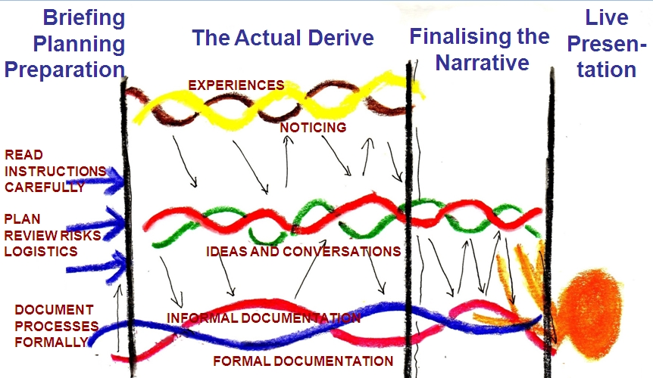
Figure 1
For executive education and academic development conferences, by contrast it can be used in its most concentrated form, where the entire briefing-walk-present-debrief is compressed into a 60 minute conference slot.
EXERCISE OVERVIEW
The class leader needs to carry out a reconnaissance and identify up to 6 locations for the activity. More than one group can work in a location at a time. Participants will work in teams of 2-5, and are allocated to teams on arrival. Up to 32 is a comfortable maximum number for the activity.

ACTIVITY BRIEFING
- Somewhere within 100 metres from the start is known to be located a profound metaphorical symbol of successful imaginative university life. In a group you have to walk up to 100 metres from the start point in a direction you will be given.
- Your group task is to (1) discuss then select an “everyday” object as the symbol, then (2) examine it closely from all perspectives with all 5 senses. (3) Document it as comprehensively as possible. These three tasks require a maximum of 10 minutes in total.
- Then in another 8 minutes including the walk back to the start, as a team identify the two key themes which tell a compelling story about why this is the profound symbol of business academia. Write your answer legibly in one or two sentences on the index card. You may be asked publicly to provide shareable evidence of your documentation in the plenary.

The assessment criteria for the activity emphasises imagination:
- Novel
- Interesting
- Obvious - FAIL
- Cliché, Banal, Boring - FAIL

SESSION DESCRIPTION

Activity - Dérive | Mins | Materials | Participant  Engagement
Allocate to teams as arrive | - |  | Greet new colleagues
Briefing for Activity | 10 | Worksheet | Clarify
Wander about and formulate answers | 20 |  | Intensive group activity
Report Back | 20 | Index cards; ideally via document camera | Each group presents & also questions others
Tutor debrief on detailed lessons for faculty and for learners | 20 | Handout | Q&A
Group discussion of how to evolve and implement locally | 20 |  | Audience-interest driven

Based on our own experience and that of colleagues who have introduced non-standard learning methods such as the dérive, we developed some advice for those considering such methods:
Thinking of using a dérive in your discipline?
- It is not a conventional learning method. It can lead to opposition from a vocal minority of students. It can also be opposed/attacked by academic colleagues who are doubtful about its pedagogic value. You need to prepare well for both types of opposition.
- Where there is a signature pedagogy in a discipline, other pedagogies may be treated as less important or even unhelpful.
- It is vital to carry out a research dérive with colleagues before considering for student use
- Then speak to others who have attempted innovations in your discipline. If possible also discuss with those who have already implemented dérives in any discipline.
- It is worth doing experimentally “under the radar” first e.g. with volunteer students
- It took us a decade to be able fully to frame and explain the pedagogic and discipline-related rationale.
- If physical place or artefacts are important in your discipline then this is a definite plus factor.
- Try to make sure you personally are involved in discussions e.g. in the committees which approve new curricula and modules.

BIBLIOGRAPHY
Bureau S., Fendt J., (2011), "Entrepreneurship and Situationism: A Détournement",
Proceedings of the European Group of Organization Studies, 2011, June 6-9,
Gothenburg, Sweden.

Colby, A., Ehrlich, T., Sullivan, B., & Dolle, J. (2011). Rethinking Undergraduate Business Education: Liberal Learning for the Profession. San Francisco: Jossey-
Bass.
Coverley, Merlin (2012). The Art of Wandering: the Writer as Walker Oldcastle Books:
Harpenden

Csíkszentmihályi, Mihály (1990), Flow: The Psychology of Optimal Experience, New
York: Harper and Row

Debord, G. (1955) Introduction à une critique de la géographie urbain, Les Lèves nues,
(6 Septembre), Retrieved December 11 2011, from
http://library.nothingness.org/articles/SI/en/display/314
McDonough, Tom (2010) The Situationists and the City: A Reader Verso Books: London
Neugarten, M.L. (2003) Seeing and Noticing: an Optical Perspective on Competitive
Intelligence, Journal of Competitive Intelligence and Management 1(1) (Spring),
pp. 93–104.

Neugarten, M.L. (2006) Foresight – are we looking in the right direction? Futures, 38(8),
pp. 894–907.
Stilgoe, J.R. (1998) Outside Lies Magic: Regaining History and Awareness in Everyday
Places. NY: Walker & Company.

