Introduction:
Traveling with students is an excellent way to reinforce classroom learning, build relationships, and create affective connections with the university. Plus, it is tremendous fun. Let’s plan a trip together. The intended outcome is to develop a plan for travel and a group of professors that are interested in creating a multi-university travel group or even Business Student Conference. By teaming up the likelihood of us meeting group minimums is far greater, our students will have the benefit of meeting others with similar interests from across the country and we will all be able to continue our teaching society goals.
Theoretical Foundation/Teaching Implications:
Research supports the benefits of student travel. Experiential learning is based upon students experiencing education versus being told education (Kolb, 1984). One of the most powerful experiential activities students can enjoy is a well-planned learning excusion (Broomhall et al., 2010). In learning excusions, students participate in all four of the learning steps presented by Kolb in 1984 and as shown below:
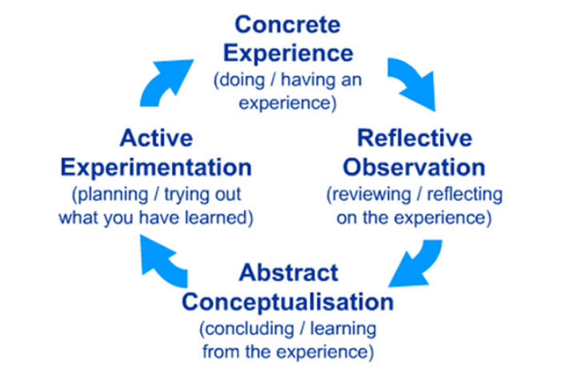
Concrete Experience: students have a unique learning experience while on a trip.
Reflective Observation: Learning while on the trip is extremely powerful because students are able to review and reflect upon the learning throughout the experience, every day applying yesterday’s learning to today’s lesson (Morgan, 2010; Mouton, 2002).
Abstract Conceptualization: as the trip comes to an end, reflection on the trip occurs as a complete package, reviewing the lessons as a whole instead of day by day experiences.
Active Experimentation: Now students have returned “transformed” from who they previously were. Their increased knowledge is reflected upon each time a new person asks “How did the trip go?!” (Morgan, 2010)
Students retain the lessons learned from educational trips for an extended period of time. This is largely due to two powerful learning theories. Depth of processing theory (Craik & Tulving, 1975) describes how learning is committed to long term memory though frequent and increasing depth that the information is processed. Excursion trips allow information to be processed daily at a minimum as students are living the learning experience. The processing is further heightened by the constant review each time they talk about their trip upon their return. The second learning theory is emotional learning (Armony & LeDoux, 1997; Markowitsch & Staniloiu, 2011). When someone has an experience that creates stirs emotions, that memory is “tagged.” Tagged memories are powerful and are retained far longer than non-tagged memories. Student excursions are frequently emotional experiences with such emotions as happiness, sadness (common among service-learning trips), surprise and possibly fear (fear of the unknown, fear of travel, etc.).
Further benefits of student travel in higher education have recently been explored (Ross, 2019). After qualitative data from two international trips of students stating the experience was the absolute highlight of their academic careers, one researcher decided to take it a step further and see how such a powerful experience influenced behavior. While only 17 students participated in the excursion, there was a 100% participation rate. 100% of students agreed that the excursion helped them feel more connected to the university and the School of Business. 100% of students felt more engaged with the School of Business faculty. Several other questions were asked, but perhaps the most interesting was that 73% of students were more likely to volunteer with the university and 53% were more likely to donate money to the university because of the trip. Student travel positively influences behavior.
Session Description:
Student travel is an excellent experiential learning opportunity. Traveling together would make it even more fun and educational for us and for the students. This session is about coming up with a travel idea that we could all do together and creating a travel network. The ideal participant will be professors that are interested in increasing student travel in their school of business. The session discussant is willing to lead the creation and execution of a major travel event.
10 min – Benefit of student travel. The power of group travel!
25 min – Brainstorming on a multi-university group travel event. What is everyone looking for? What is a key price point? What could we do together?
15 min – Discussion of a recent theme park excursion
Recently I completed an amazing Business School theme park business trip to Disney World and Universal Studios. We covered topics such as marketing, finance, leadership, teamwork, culture, business development, operations, and more. The agenda is below. We could easily make this a business student conference or multi university travel event.
10 min – Review brainstorming and share contact information for further planning

