Designing Courses to Develop Students’ Personal Resilience:
A “Hidden Curriculum” to Facilitate Student Success

Abstract
Personal Resilience, the ability to pick ones’ self up after a setback and try again, has been linked to many positive outcomes including adaptability, optimism, determination and perseverance (Nolen-Hoeksema, Girgus, & Seligman, 1986; Masten, 2001; Taormina, 2015; Walker, 2015; Walker et al 2019). However, the pursuit of easily measured academic outcomes can come at the expense of accomplishing objectives like learning to be resilient that could more directly relate to long-term student success. What are some ways to foster personal resilience?

In this roundtable we will explore potential adaptations to undergraduate courses that are designed to build personal resilience. These include both course structures and instructor behaviors.

Keywords
Resilience, experiential learning, hidden curriculum

Time Requested:
60 Minutes (Roundtable)

Introduction.

This session has the purpose of creating reflective conversations about the development of personal resilience through experiential learning in our courses. Learning objectives include:

- Awareness of the potential for developing personal resilience through experiential coursework and specific activities to foster it.
- Understanding of key components of the course structure that can foster resilience.
- Personal self-knowledge of difficulties and barriers to adopt behaviors and skills needed to apply the practices to one’s own courses.
The questions “How might we structure an experiential course that develops personal resilience among students?” and “What potential issues might arise during the course?” will be discussed during the roundtable.

The target audience is faculty interested in using experiential learning in their classrooms to develop personal resilience among their students as part of the “hidden curriculum”, i.e., not formally stated learning objectives.

Theoretical Foundation

The concept of resilience has a long history, with roots in Seligman’s (1972) work on learned helplessness. For the purposes of our research, we define resilience as “the ability to recover in the face of setbacks or adversity”. We further view this ability as having six components:

- The ability to “reframe” and create new personal narratives.
Getting “stuck” can be a result of a personal narrative that narrows the arena of possible action. “Reframing” can change the story to one that provides new opportunities for action.
- Desensitization to failures.
The emotional impact of failure can immobilize an individual while she/he strives to process what has happened. Inoculation can prepare individuals to manage future setbacks.
- Learning from mistakes and successes to enhance learning and growth.
Past successes and, especially, failures, provide opportunities for growth. Learning from past experiences gives students the ability to know how to react in the future.
- Motivation to act.
Resilience requires that one act in the face of a setback. The motivation to act is needed to recover from adversity.
- Capacity to act effectively.
When an individual does act, repeated failure can limit future attempts. The effectiveness of action is critical to recovery from a setback.
- Ability to acquire new knowledge and skills.
Part of recovering from a setback is the ability to extend capabilities into new areas. The acquisition of new knowledge and skills is essential to this.
We propose that each of these components can be developed through its own causal process, which can form a part of a “hidden curriculum”, not listed as a traditional learning objective, yet which adds to the potential for success of our students. The six causal processes are:
- Scaffolding reflective inquiry increases the ability to “reframe” and create new personal narratives.
- Designing planned failures into the classroom increases desensitization to failure.
- Rich feedback increases learning from mistakes and successes to enhance learning and growth.
- The support of peers increases the motivation to act.
- Advice and guidance from respected experts increases the capacity to act effectively.
- Increasing challenges (at the Zone of Proximal Development) increases the ability to acquire new knowledge and skills.
These six causal processes can be combined to form a teleological model of resilience development. Van de Ven and Poole (1995, p. 516) describe such models as follows: [T]eleological models incorporate the systems theory assumption of equifinality (i.e., there are several equally effective ways to achieve a goal). The model is illustrated in Figure 1.

Figure 1
Teleological Process Model of Resilience Development

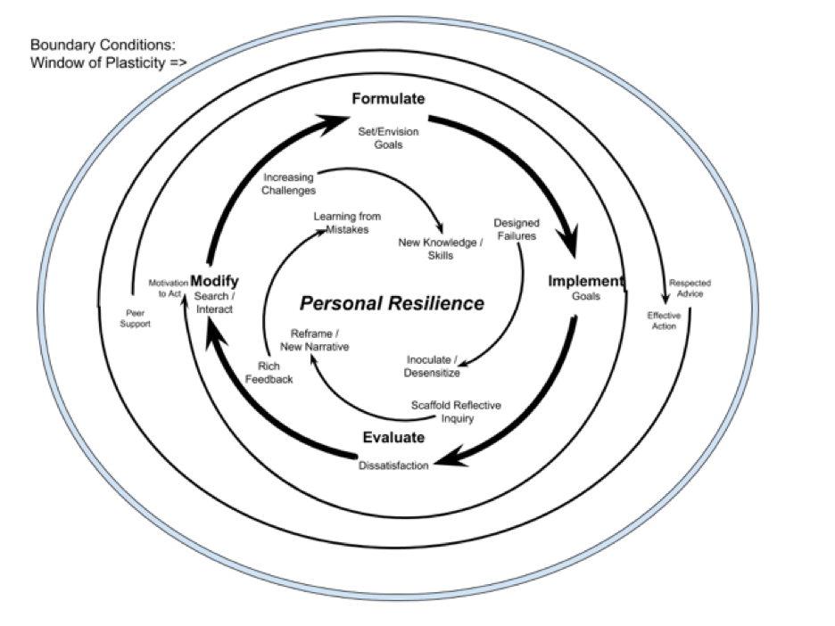
Walker et. al. (in press) have provided some evidence that supports the efficacy of this teleological view of resilience development among college or university students. The “window of plasticity” forming the boundary conditions comprise situations where significant personal change can be expected, such as might be typically associated with a university experience.

Teaching Approach and Implications

This session will provide a brief description of our recent experiences with experiential undergraduate courses (entitled “eXperience Based Organizational Behavior” and “Strategy Capstone” as they were structured to develop personal resilience. While significantly different, the courses have some common factors in terms of their structure and approaches to teaching. A major component of both courses are simulation games, which provide a student-directed setting to experience decision-making and team dynamics in a relatively safe environment. The simulation games provide a good deal of ambiguity, which is further reinforced by the actions of the professor, who intentionally does not provide clear direction to the students. Several associated characteristics of the course are described below:

Provide Scaffolding Reflection Opportunities
Sample Intervention
In a business leadership simulation, the instructor provides students (individually and in teams) unlimited opportunities to pursue self-chosen strategies and to process their decisions to see results immediately. The instructor also provides students guidelines to measure the success of their efforts. Students compare their actions and results to those of other students and teams. The instructor requires students periodically to present their reasoning and approach to the class and to describe the impact and how they will apply what they have experienced to consequent learning. The instructor also requires students to think through their decision-making processes and to describe how the challenges and actions apply to personal success principles in their intended careers.

Design Opportunities for Failure
Sample Intervention
In this example, students grapple with leadership cases of such complexity and ambiguity that most students fail with their initial efforts (Walker et al., 2019, p. 229). Even when the students begin to master the tasks, the leadership case exercises are designed so that there is only one winner for each case (that is, all the others fail) (Walker et al., 2019, p. 229). The tasks also increase in difficulty and complexity as the cases unfold, thereby increasing the likelihood of student failure. The instructor reassures students that failure is typical at this stage of their development and that they will eventually succeed if they persist. Students are thus encouraged to continue their efforts even in the face of failure and eventually to learn to meet expectations. In some cases, the instructor provides students with other tasks wherein they will succeed.
Create a Feedback-rich Environment
Sample Intervention
Individual and team results in competitive activities are displayed immediately and universally in a way that all students see the feedback simultaneously. Teams also fill out formal evaluations after each major team deliverable (minimum every five weeks) based on established criteria for each team member’s qualitative (things such as teamwork, dependability, and communication) and quantitative (things such as profit, margin, and customer satisfaction) contributions. Students can also assess decision impact and progress multiple times (as often as they desire) during the process of the experiential interventions. They receive frequent feedback from many sources, including student leaders and peers, instructors, computer models, and worldwide competitors.

Foster Venues for Peer Support
Sample Intervention
Students directly evaluate their peers on the extent that their peers have helped other individuals and teams in the course (Walker et al., 2019, p. 230). Also, designing differentiated roles, where each student needs to do a part of a job to make the whole class function, means that there are functional dependencies that encourage peer support. These differentiated roles can include tasks specifically designed to improve peer relations. These roles also may include having some students be accountable for evaluating and maintaining a positive team climate by scheduling informal team-building activities into the team calendar or noticing when other team members are struggling and providing them with compassionate assistance.

Provide a Valued, “High-Reputation” Mentor
Sample Intervention
The instructor has weekly out-of-class meetings with students who elect or choose to act as “course leaders” (or “department heads”) to discuss problems and issues raised by both the instructor and the students (Walker et al., 2019, p. 231). Students are willing to do this because they are working to make the whole class succeed, not just themselves (see Causal Process 2, Intervention two, above), and helping other students means that their grades will improve. During these meetings, the instructor raises issues and suggests potential solutions. The focus is on improving student learning in the course as a whole, through focused attention by both the instructor and student course leaders who have the respect of other students.

Provide Increasingly Difficult Challenges
Sample Intervention
In this scenario, the instructor closely monitors how students are performing and challenges them to greater and greater efforts. The instructor provides students with increasingly difficult and ambiguous tasks as the students master earlier levels of difficulty and ambiguity. The coursework is designed so one classroom experience builds upon another and becomes more complex, unpredictable, and challenging as the semester progresses (Walker et al., 2019, p. 231). The instructor rewards superior efforts and results, while introducing new concepts and activities that are just beyond the students’ current abilities. The instructor also provides examples from more experienced students that are calibrated to display quality work product that is at or just beyond the students’ current capabilities.

After presenting and clarifying the structure and teaching processes to support learning resilience, most of the session will be spent in roundtables reflecting on and discussing questions such as “How might aspects of this be integrated in our curricula? What issues or weaknesses might prevent implementation or arise during it?” This session will contribute to effective teaching and learning in the field of management by promoting reflection and reassessment of the approaches we faculty use to provoke learning.

Bibliography

Andrews, C. P. (2007). Service-learning: Applications and research in business. Journal of Education for Business, 83, 19-26.
Bureau, D. A., Cole, J. S., & McCormick, A. C. (2014). Frequent Participation in Service Learning: Examining Institutional Differences and Individual Benefits. New Directions for Institutional Research, 2014(162), 17–27. https://doi-org.cyrano.ucmo.edu/10.1002/ir.20074
Butin, D. W. (2005). Service-learning in higher education: Critical issues and directions. New York: Palgrave Macmillan.
Lewin, K. (1946), Action Research and Minority Problems. Journal of Social Issues, 2: 34-46. doi:10.1111/j.1540-4560.1946.tb02295.x
Larson, E., & Drexler, J. A. (2010). Project Management in Real Time: A Service-Learning Project. Journal of Management Education, 34(4), 551–573. https://doi.org/10.1177/1052562909335860
Robinson, D. F., Sherwood, A. L., & DePaolo, C. A. (2010). Service-Learning by Doing: How a Student-run Consulting Company finds Relevance and Purpose in a Business Strategy Capstone Course. Journal of Management Education, 34(1), 88–112. https://doi.org/10.1177/1052562909339025
Simons, T. L. (1999). Behavioral integrity as a critical ingredient for transformational leadership. Journal of Organizational Change Management, 12(2), 89-104. Retrieved from https://login.cyrano.ucmo.edu/login?url=https://search-proquest-com.cyrano.ucmo.edu/docview/197590842?accountid=6143
Thomas, K. M., & Landau, H. (2002). Organizational development students as engaged learners and reflective practitioners: The role of service learning in teaching OD. Organization Development Journal, 20(3), 88-99. Retrieved from https://login.cyrano.ucmo.edu/login?url=https://search-proquest-com.cyrano.ucmo.edu/docview/197988316?accountid=6143
Zlotkowski, E. (1999). Pedagogy and engagement. In R.G. Bringle, R. Games, & E.A. Malloy's (Eds). Colleges and universities as citizens (p. 96-120). Boston: Allyn & Bacon.

Session Description
00:00 – 00:15 – Introduce participants to a teleological model for the development of personal resilience in the classroom.
00:15 – 00:45 – Engage in discussion of “How might aspects of this be integrated in our curricula? What issues or weaknesses might prevent implementation or arise during it?”
00:45 – 01:00 – Debrief and discuss table outcomes

