Can You Escape? Using Escape Mobile App Games to Teach Experiential Learning Online

Abstract
Mobile app escape games are excellent tools to teach experiential learning in an online context. Through the act of solving puzzles to escape the rooms, students will directly experience a learning process in which they need to discover new information and clues, adjust their strategies repeatedly, and become more aware of the way they learn. Escape games are versatile and can be used in any kind of classrooms (online asynchronous, online synchronous, hybrid, in-person) with any population of students (undergraduate, graduate, continuing education).

Keywords
Experiential learning, online education, learning styles

Introduction and Theoretical Foundation
You found yourself trapped in a locked room. How would you get out?
When classes moved online during the COVID-19 pandemic, instructors found themselves unable to immediately translate their in-class experiential learning activities for use in a virtual environment. Experiential learning theory (ELT; Kolb, 1984, 2015) has played an essential role in management education in the past few decades (Lund Dean & Forray, 2015) due to its ability to engage students and improve learning outcomes (Burch et al., 2019), as well as its inclusion as a requirement for AACSB certification in business schools (Association to Advance Collegiate Business Schools, 2018). ELT proposes that “learning is the process whereby knowledge is created through the transformation of experience” (Kolb, 1984, p. 38) that involves the integrated functioning of the whole person—experiencing, reflecting, thinking, and acting. Based on individual preferences, each learner has a primary learning style; however, they could also change their learning styles to adapt to specific situations, and the more they do so, the higher their learning flexibility (Sharma & Kolb, 2011).
Teaching about ELT often involves first asking students to complete the Learning Style Inventory (LSI; Kolb & Kolb, 2013) to identify their learning style, and then employing some kind of experiential activities to help them understand more about how learning styles work. These types of activities help students become aware of how they learn and their learning identity (Kolb, 2015; Trinh, 2019), the similarities and differences among the different learning styles, the strengths and weaknesses of each learning style, and how the different learning styles may work together. While these activities can be facilitated easily in in-person classrooms, converting them into an online learning context is not always straightforward as the direct experience of the experiential exercise becomes difficult to implement. This is where mobile app escape games can be utilized to enhance both teaching and learning experiences.

Teaching Implications and Learning Objectives
The popularity of escape games as a recreational activity and an educational tool is rising (Adams et al., 2018; Eukel et al., 2017; Vörös & Sárközi, 2017). They are of a type of puzzle game in which players find hidden clues to solve puzzles, unlock locks, and escape an enclosed environment, often a room, within a predetermined period of time. Educators have adopted escape games due to their ability to foster communication, teamwork, creativity, and leadership (López-Pernas et al., 2019) that is fun, engaging, and experiential (Gómez-Urquiza et al., 2019; Hermanns et al., 2017; Peleg et al., 2019). The physical version of these games can be found in most cities, while there are a large number of mobile escape games for both Android and iOS that are available for free or at a low cost in online app stores. App-based games have become more popular during COVID’s shelter-in-place. Most games have a central theme or storyline (e.g., escape the prison, the palace, or the vacation house; solve the mysterious murder) with a great deal of stylistic variation. Some games are divided into small increments (i.e., escaping one small room leads to another small room, or one level leads to the next), while others are larger in scope (i.e., the whole palace is locked and players have multiple puzzles to solve at one time). Some progress linearly with one clue leading to the next, whereas others may have many clues available at once and players have to determine which clue solves which puzzle. The mechanics of how puzzles are solved also vary substantially among games. It may be based on detailed observation, logical deduction, simple calculation, common sense, or creative usage of common objects. The level of difficulty of these games varies widely and having more experience does not necessarily mean one escapes faster.
Using app-based escape games helps instructors teach their students to:
- Become aware of how they utilize their learning styles in a learning activity
- Increase awareness about the strengths and weaknesses of their dominant learning styles
- Articulate how their learning flexibility and learning identity influence the way they learn
- Develop action plans for personal and/or professional development based on this improved awareness

Exercise Overview
The mobile app escape games can be used to teach experiential learning online with any population of students (undergraduate, graduate, continuing education). The exercise can be structured in four phases:
- Instructors ask students to play a particular escape game. The difficulty of the game can vary, for example, from “The Birdcage” as easy to “Aloha” as difficult.
- Students write a short reflection about their escape experience, as well as how it helps them understand more about their learning styles, learning identity, and learning flexibility.
- These reflections are then shared with all students in the class on an asynchronous discussion board and/or in synchronous small group breakouts on Zoom. Students could comment, sympathize, and share moments they enjoy from the game with one another (e.g., “I thought the maneuver of the coconuts was smart.”).
- Instructor ties this activity to experiential learning concepts. In either asynchronous discussions or live lecture, instructors can help students make sense of their experience using experiential learning terminologies while also highlighting their strengths and areas of improvement.
Playing and discussing escape games lead students through two experiential learning cycles (see Figure 1). When playing the game (cycle 1), students experience first-hand the process of interacting with objects on the game platform (e.g., furniture to move, doors to open, light switches to turn) and searching for the information they need (concrete experience – CE). They also need to think about how to solve problems or where clues and hidden objects may be (abstract conceptualization – AC). They need to be observant of where things are and how things work, as well as to reflect on what goes wrong when they make mistakes (reflective observation – RO). Subsequently, they would need to try different approaches or change their strategies in order to find the correct answers (active experimentation – AE). After this gameplay experience (cycle 1 becomes the concrete experience at the beginning of cycle 2), the self-reflection prompt helps students reflect on how their learning identity, learning style, and learning flexibility influence what they did in the game (RO). This reflection process spills over to the discussion and the instructor’s debriefing, helping them connect their experience with concepts from experiential learning theory (AC) to better understand the way they learn and identify an action plan for future improvements (AE). Please see Appendix 1 for a list of guiding discussion and debrief questions.
Depending on the learning objectives of the class, instructors should be intentional about how much instruction to give students and the level of difficulty for the game. A simple instruction, such as “play the game and escape the room,” with no further explanation would be effective if instructors want students to be aware of how they react and what they do when facing ambiguity and crucial information is lacking. Students with a positive learning identity—those who see themselves as learners and believe in their abilities to learn—would usually push forward and try to figure out the answers. Students with weak or negative learning identity—those who shy away from learning new things—would already be hesitant about this experience (Trinh, 2019), even though instructions about how to play are easy to locate when the game starts. In my own teaching experience, easy games are effective at engaging and retaining “novice gamers,” students with relatively low interest in games and puzzles in general. On the other hand, more avid gamers who are used to the gaming environment and have been exposed to a wider variety of games would find these easy games boring. Another benefit of using a difficult escape game, such as “Aloha,” is to purposefully place students in confrontation with failures, thus forcing students to change their strategies and get external help when what they are trying is not working. This roadblock makes them more aware of their learning resilience, an aspect of learning identity, as well as learning flexibility (Trinh, 2019). In my experience, the students that can persevere and effectively ask for help tend to enjoy the game more, while those that cannot often feel frustrated and absolutely hate it.
Escape app games can also be incorporated effectively in hybrid or in-person classes. Instructors could ask students to individually play the games before class, then move parts or all of the reflection, discussion, and debriefing to class time. Students could also bring their phones or tablets to class to play either individually or as a team. Because of the wide variety of games in this genre, it is quite easy to modify them for different purposes (such as ice breakers) and to teach different skills, such as teamwork (when instructors ask a student team to manage an escape together, not individually). Escape games are especially helpful to teach creative problem solving skills and thinking outside of the box, because the answers are often not straightforward, unlike solving a math problem (Adams et al., 2018; Gómez-Urquiza et al., 2019; López-Pernas et al., 2019).
Here are some student comments about this activity:
- “I really enjoy the sensory experience of moving things and trying out different approaches to find a solution. I search for alternative clues quickly when action and experiencing didn't yield results.”
- “Not knowing what to expect and how to move, I thought one of the levels, the bird was attached to an explosive device (this is what it looked like to me)- whatever issues I harbored about playing an online mobile game was suspended for a bit as I thought: wow, if I don't solve this quickly, the bird will blow up... because this is my assumption about online games... that at some point, something will blow up. It was interesting to me that I cared-- perhaps this was part of the experiencing aspect of my being in the learning cycle.”
- “I think the game overall did force me to bounce around the [experiential learning cycle] as well. Going from reflecting to quickly deciding to needing to just move through experiencing and jump back to analyzing and thinking. It was a surprisingly effective method to get me to move quickly around into different learning styles.”

---------------------------------------------------------------
Insert Figure 1 about here
---------------------------------------------------------------

Session Description
I propose the following format for this 60-minute session:
- Introduction (5 minutes): Quick introduction of the objectives of the session and overview of escape games
- Play the game (25 minutes): Participants will be asked to download “The Birdcage” escape game to their mobile devices. They will be given 20 minutes to play the first three levels of the game (some will be slower and some will be faster).
- Reflection (5 minutes): Participants will be placed into smaller breakout groups of 2-3 people to reflect on their gameplay experience.
- Debrief (10 minutes): I will conduct a debrief session as if I were teaching my classes, using some of the prompts in Appendix 1.
- Discussion and closure (15 minutes): I will then expand the discussion for all participants to share their thoughts about the exercise and how it could be helpful in their own classes.

References
Adams, V., Burger, S., Crawford, K., & Setter, R. (2018). Can you escape? Creating an escape room to facilitate active learning. Journal for Nurses in Professional Development, 34(2), E1–E5.
Association to Advance Collegiate Business Schools. (2018). AACSB business accreditation standards for business programs. Association to Advance Collegiate Business Schools (AACSB). https://www.aacsb.edu/accreditation/standards/business
Burch, G. F., Giambatista, R., Batchelor, J. H., Burch, J. J., Hoover, J. D., & Heller, N. A. (2019). A meta-analysis of the relationship between experiential learning and learning outcomes. Decision Sciences Journal of Innovative Education, 17(3), 239–273. https://doi.org/10.1111/dsji.12188
Eukel, H. N., Frenzel, J. E., & Cernusca, D. (2017). Educational gaming for pharmacy students–design and evaluation of a diabetes-themed escape room. American Journal of Pharmaceutical Education, 81(7).
Gómez-Urquiza, J. L., Gómez-Salgado, J., Albendín-García, L., Correa-Rodríguez, M., González-Jiménez, E., & Cañadas-De la Fuente, G. A. (2019). The impact on nursing students’ opinions and motivation of using a “Nursing Escape Room” as a teaching game: A descriptive study. Nurse Education Today, 72, 73–76.
Hermanns, M., Deal, B., Hillhouse, S., Opella, J. B., Faigle, C., & Campbell IV, R. H. (2017). Using an" Escape Room" toolbox approach to enhance pharmacology education.
Kolb, A. Y., & Kolb, D. A. (2013). The Kolb Learning Style Inventory 4.0: A Comprehensive Guide to the Theory, Psychometrics, Research on Validity and Educational Applications.
Kolb, D. A. (1984). Experiential learning: Experience as the source of learning and development. Prentice-Hall.
Kolb, D. A. (2015). Experiential learning: Experience as the source of learning and development (2nd ed.). Pearson.
López-Pernas, S., Gordillo, A., Barra, E., & Quemada, J. (2019). Examining the use of an educational escape room for teaching programming in a higher education setting. IEEE Access, 7, 31723–31737.
Lund Dean, K., & Forray, J. M. (2015). Breaking through without crashing through. Journal of Management Education, 39(5), 543–548.
Peleg, R., Yayon, M., Katchevich, D., Moria-Shipony, M., & Blonder, R. (2019). A lab-based chemical escape room: Educational, mobile, and fun! Journal of Chemical Education, 96(5), 955–960.
Sharma, G., & Kolb, D. A. (2011). The learning flexibility index: Assessing contextual flexibility in learning style. In S. Rayner & E. Cools (Eds.), Style differences in cognition, learning and management: Theory, research and practice. Routledge.
Trinh, M. P. (2019). Learning identity, flexibility, and lifelong experiential learning. In J. Aldag (Ed.), Oxford Research Encyclopedia of Business and Management. Oxford University Press.
Vörös, A. I. V., & Sárközi, Z. (2017). Physics escape room as an educational tool. AIP Conference Proceedings, 1916(1), 050002.

Figure 1
Playing and discussing escape games lead students through two experiential learning cycles
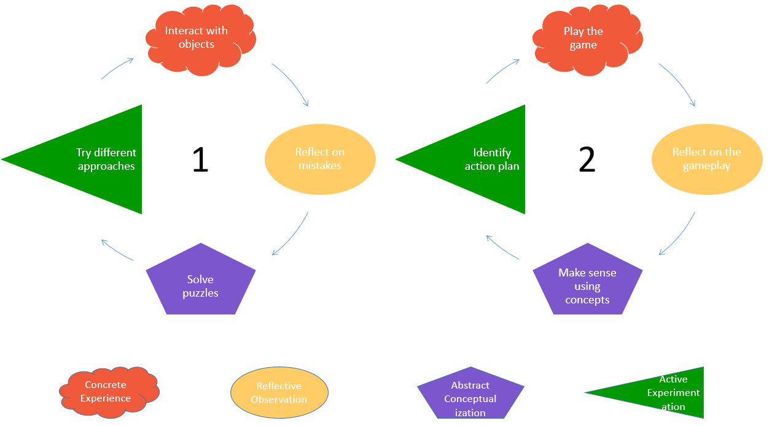
Appendix 1
Guiding questions for reflection, discussion, and debrief
- Learning style prompts: What did you do in the game? How did these actions reflect your learning preference and learning style? Did you act consistent with or different from your dominant learning style? How well did this strategy work for you? Which part of the game was the easiest (or hardest)? Which learning mode was the easiest (or most difficult) for you? Which part of the game did you enjoy the most?
- Learning flexibility prompts: When something you tried did not work, what did you do? How often do you change your strategy or approach? If there was a moment when you felt stuck and helpless, what was it about? What was surprising or unexpected to you? What is one thing you would change about the way you played this game? If we play another game like this, what would you do differently?
- Learning identity prompts: Have you ever done something like this? How did you feel about the entire experience? How did you find the information you need? When you encounter difficulties, what did you do? Did you ever want to just give up? How did you get the help you needed? What are your strengths in this learning process? Did you utilize your strengths during the game? What are some things you want to work on?

If there is a way to send prework to participants, this portion will be prework to be completed before the session starts.

