ABSTRACT

Title: FACILITATING DESIGN THINKING ACTIVITIES
USING THE MURAL APP, AN ONLINE TOOL FOR
COLLABORATIVE PROBLEM SOLVING

With the aid of MURAL, a visual online team collaborative tool, this activity seeks to guide MOBTS participants to use design thinking to solve management problems innovatively and creatively. MURAL can be used in online undergraduate and graduate classes to innovatively address real life issues or analyze business and management case studies. Instructors can use MURAL effectively in Change Management classes, Business Ethics classes, Strategy Capstone classes, and Organizational Behavior classes. My purpose for this activity, is to employ the use of MURAL as a collaborative tool, to guide MOBTS conference participants to use the design thinking process to address a management problem and in doing so, explore their own capacity and identity to be an agent for change. Participants will learn to use MURAL effectively in a management classroom setting.

Keywords: Design Thinking, MURAL visual collaboration tool, Creativity.

Introduction:
In the wake of the COVID 19 pandemic, the need to facilitate effective online collaboration has become increasingly important for organizations, management teams, and myriads of stakeholders. Collaborating with others to make decisions, to interact, and solve problems becomes easier with an online interface - like the MURAL app - that is user friendly, easy to navigate, drives creativity, and encourages near real life interactions.
From using MURAL in faculty and student team meetings and workshops over the past one year, I find that it proves to be an effective online tool that helps student and faculty teams to collaborate and think critically while solving problems in an innovative manner. Students and faculty report that MURAL is fun and effective! MURAL can be used in online undergraduate and graduate classes to innovatively address real life issues or analyze business and management case studies. Instructors can use MURAL effectively in Change Management classes, Business Ethics classes, Strategy Capstone classes, and Organizational Behavior classes.
The way MURAL works is that it provides virtual whiteboards (called murals) where team members can interact and brainstorm while visually mapping and integrating different kinds of ideas and content, organizing them, and developing real solutions to complex challenges. A screenshot of a recent mural board activity can be found in Appendix A. My purpose for this activity, is to employ the use of MURAL as a collaborative tool, to guide MOBTS conference participants to use the design thinking process to address a management problem and in doing so, explore their own capacity and identity to be an agent for change. Participants will learn to use MURAL effectively in a management classroom setting.

Theoretical Foundation/Teaching Implications
Design thinking has become a popular management concept for solving business problems (Robbins, Coulter, & Decenzo, 2017). Design thinking is playing a big role in organizations today, helping them to be more innovative in addressing complex problems (Brown & Katz, 2019; Dunne, 2018; Liedtka, 2014). Design thinking holds great promise for transforming management teaching and education (Dunne & Martin, 2006). Using design thinking to innovate is producing better experiences and building better processes for teams. Design thinking offers the tools to innovate better, for teams, organizations, and their stakeholders.
Design thinking is all about finding the optimal solution that matches the needs of stakeholders. It is about finding a solution which does not yet exist (Brown, 2005). It is about exploring what is not yet, but which is possible to be. For example, businesses which innovate using design thinking, first seeks to get a deep understanding of customers needs and wants. Thereafter, they are able to translate these insights into viable and usable products and services for customers (Robins,Couter, & Decenzo, 2017). In summary, design thinking is a process that emphasizes action-based problem-solving, and involves developing a deep understanding of a problem, brainstorming solutions to the problem, and then building and testing those solutions.
The design thinking process consists of 5 steps: (1) Empathize (2) Define (3) Ideate, (4) Prototype and (5) Test. Empathize, deals with getting a deeper understanding of the needs and wants of the target users. It entails learning deeply about your users and trying to figure out what matters to them. Define, the second step, deals with clearly articulating the problem you want to solve. Ideate, the third step, is when the team brainstorms and comes up with as many creative solutions as possible. Here wild ideas are encouraged! The team generates as many creative ideas as possible while withholding judgement. Thereafter the team selects the most viable ideas and solutions from the pool of creative ideas that have been generated. Prototype, step 4, is about designing a series of prototypes to test all or part of the selected solutions. The last step, test, is when the team shares their prototype with the original users to gain feedback on what worked and what did not.
The design thinking process is highly iterative. Teams are encouraged to fail often and fail early. In this way, viable solutions which match user needs are eventually arrived at as quickly as possible. Management students can benefit from learning and participating in the process of design thinking because it helps them develop a mindset of empathy, collaboration, optimism, embracing failure, creative confidence, and a bias toward action.
Learning Objectives
At the end of this activity, participants will be able to:
- Understand the design thinking process and how it helps to improve business decisions and outcomes.
- Explore the use of the MURAL collaborative tool to enhance team collaborative processes and for generating practical solutions.
- Use the MURAL virtual collaborative tool and design thinking principles to address a business problem and learn how to work as a dynamic problem solver.
- Practice the design thinking mindsets of empathy, collaboration, optimism, embracing failure, creative confidence, and a bias toward action.
- Explore their own capacity and identity for being an agent for change.

Exercise Overview
As mentioned earlier, the goal of this activity is to guide participants through the design thinking process sing the MURAL online collaborative tool. MURAL integrates seamlessly with Zoom. In the First step, the facilitator shares a real-world problem, a management case study with a problem to be solved, or an ethical issue or situation or a change management problem with participants. If a case study is shared with participants, a one page mini- case which can be read and understood in about 5 minutes is highly encouraged for the purpose of the MOBTS conference. Thereafter, the facilitator shares the design thinking process and principles with the team as a viable process for addressing problems in a creative and innovative manner. The facilitator emphasizes the need to deeply understand the problem at hand from the users’ and stakeholders’ points of view. In typical design thinking teams, participants learn more about users and stakeholders’ needs by conducting interviews and by learning, through research, about their unique situation. This is the empathy step.
The facilitator then shares the MURAL screen via Zoom. As mentioned earlier, the mural contains full suite of collaboration and guided teamwork tools to engage meeting participants in real time, including “facilitation superpowers” and visual templates and frameworks. The Superpowers include the ability of the facilitator to “summon” participants to the present mural tab in focus, so they do not get lost on the mural board, and among other things, to direct idea generations process and to conduct “voting” sessions. Through the MURAL collaboration window inside of Zoom, all meeting participants can join in the visual collaboration by adding ideas and feedback via sticky notes to specific parts of the mural.
MURAL is free to use and anyone can participate whether they have a MURAL membership or not. MURAL is free for faculty and students also. Using guided visual methods to focus the collaborative work, the facilitator can accelerate the imagination of the team to uncover new solutions, align the team, and create a plan of action in real time.
Session Description
Timing
The case discussion can be structured to accommodate a 90- minute session. An outline of the timing for a 90-minute session is included.
Table I: Outline for a 90-minute session
Agenda | Activity | Time Allotted
Opening | - Facilitator makes a presentation about design thinking and elicits discussion with all participants about the design thinking process:  - Q1: What is the design thinking process?  - Q2: How can we use design thinking to solve management problems today? Why is design thinking a superior decision-making process?  - Q3: What are examples of organizations that have successfully used design thinking with innovative outcomes? | 20 min.
Group Activities/  Assignment | - Facilitator shares a current management problem with participants. This could be an occurrence in the news, a one-page decision mini-case study, an ethical dilemma situation or a change management decision situation.  - Facilitator shares the MURAL with all participants and ensures that all participants are visible on the mural and that each participant can post his/her ideas on sticky notes on the mural.  - Facilitator leads the team through these steps:  Step 1: Identify all users and stakeholders in this problem situation.  Step 2: Identify the different needs of these users and stakeholder groups.  Step 3: Use MURAL to vote to select just one user group to focus on.  Step 4: Lead the team to generate ways in which the specific need of this user group can be met. Here each team member is encouraged to generate at least ten ideas per minute.  Step 5: Use MURAL to vote to select just one solution out of the many solutions generated by all participants.  Step 6: Lead participants to develop a prototype of the solution. | 40 min.
Debriefing | - Participants discuss the activity class (i.e., on their analyses, decisions, and recommendations).  - Participants discuss their experience with the design thinking process.  - Participants discuss their experience, attitude, and lessons learned from using MURAL for the design thinking challenge. | 20 min.
Closing | Reflection:  Q1: What did you learn from this experience?  Q2: How does the design thinking process encourage innovation and a bias to action?  Q3: Was it fun? Do you think you will use this activity for students in your class? | 10 min.

References
Brown, T., & Katz, B. (2019). Change by design: how design thinking transforms organizations and inspires innovation (Vol. 20091). New York, NY: HarperBusiness.
Dunne, D. (2018). Implementing design thinking in organizations: an exploratory study. Journal of Organization Design, 7(1), 1-16.
Dunne, D., & Martin, R. (2006). Design thinking and how it will change management education: An interview and discussion. Academy of Management Learning & Education, 5(4), 512-523.
Liedtka, J. (2014). Innovative ways companies are using design thinking. Strategy & Leadership.
Robbins, S. P., Coulter, M. K., & DeCenzo, D. A. (2017). Fundamentals of management.
T. Brown, “Strategy by Design,” Fast Company, June 2005, pp. 52–54

Appendix A: Sample Mural Board.
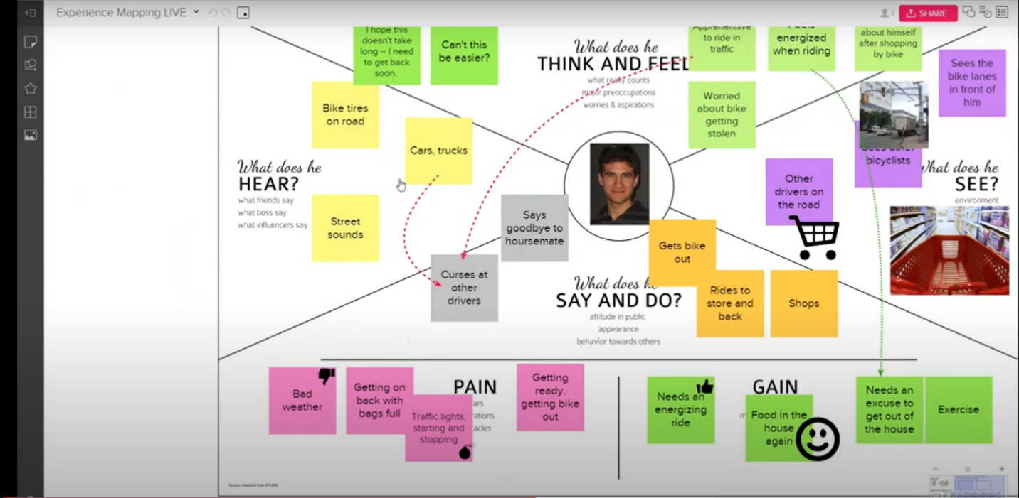
Source: https://www.youtube.com/watch?v=JuH32nMYWU4
Other Resources:
Video Tutorial: What is MURAL?
https://support.mural.co/en/articles/2113692-video-tutorial-what-is-mural

