Title: Bystander Support

Abstract:
Using YouTube videos from Emtrain.com, participants witness various types of microaggressions and discrimination issues. For each analysis, breakout room participants are asked to identify who in their group will watch the Instigator and Target. All others are to focus on possible actions the Bystander could take in support of the Target. The Instigator and Target observers take on that perspective for the interaction and explain it. Using the Giving Voice to Values approach, the Bystanders suggest ways they could intercede to change the path of the interaction. After each video, the interaction is examined across all groups in the room. During the exercise debrief, the impact of the interactions is examined in terms of the impact on the organization.

Keywords: Microaggressions; Interventions; Giving Voice to Values

Introduction
Participants watch incidents of microaggressions in videos produced by Emtrain.com. By clearly identifying that the behavior is discriminatory, it provides an opportunity to consider what steps they as bystanders could take to mitigate harm experienced by the target of the incident. Also, by asking participants to consider how the instigator may be unaware of the biases exhibited and why the interaction could be hurtful to the target, they can safely identify biases in the other that they may unconsciously hold as well. Since participants cycle through the observational roles of Instigator, Target, and Bystanders for the 4 videos, they each look at the interaction from a specific lens.

Theoretical Foundation/Teaching Implications
This exercise applies issues of diversity, equity, and inclusion to Mary Gentile’s Giving Voice to Values approach to ethics. “Giving Voice to Values explores the near-term skills needed to deal with ethical challenges and values conflicts. This means knowing what to say, who to say it to, and how to say it when you know what is right in a particular situation.” (https://www.cfainstitute.org/en/ethics-standards/ethics/giving-voice-to-values )

Learning Objectives
- Understand perspectives in discriminatory interactions
- Identify unconscious biases in others
- Develop and rehearse scripts to use to intervene as bystanders or targets

Exercise Overview
Participants will sample the Bystander Support exercise (see Appendix A) in this 30-minute activity session. A classroom setup where the attendees can be divided into groups is desirable. Internet access and a classroom projection system where the example YouTube videoes could be shown to all participants is needed.
Debrief questions focus on why the Instigator acted as they did and the biases at play; why the interaction was hurtful to the Target; What recommendations for action you have for the Bystanders to take to mitigate the harm.

Session Description
Participants will be assigned to observe the Instigator, or the Target, or to act as a Bystanders to the video interactions they will watch. I would then play one of the Emtrain.com microaggression videos which lasts between 1 to 4 minutes. After the video, those watching the Instigator would comment on why they may have acted as they did. What kind of biases, conscious or unconscious, may have been at play? Those observing the Target would discuss how the interaction negatively impacted them. The Bystanders would share how a bystander to the interaction could have responded to mitigate the harm. A sample of some of the other videos could be shown, depending on the time left in the 30-minute activity session.

Appendix A
Description:
Using YouTube videos from Emtrain, participants witness various types of microaggressions and discrimination issues. For each analysis, breakout room participants are assigned one of four roles: Offender; Target; Bystander; Interaction Observer. They attempt to take on the perspective of their assigned role for the interaction and explain it. The Bystander suggests ways they could intercede to change the path of the interaction.

Goals:
- How to detect microaggressions
- How to constructively address microaggressions
- How to act as an ally

Bystander Support Setup:
- Will be run in the classroom
- Install +Bystander Support.pptx on both classroom PC
- Have students cluster in groups of 6
- In the classroom - share the first video and stop share at the appropriate spots. Skip the natural hair segment in the middle.
- Examples of Workplace Microaggressions -- age; natural hair; where from
  - https://www.youtube.com/watch?v=XjgozDwAjqg

- Activate the links for the 4 clips listed below and be prepared to play on request:
  - Video #1 How to Spot Retaliation – Female team member was talked over, ideas taken, then excluded from team meeting. [1:23]
https://www.youtube.com/watch?v=fzvq_x4XV6Q

  - Video #2 Example of Gender Bias in the Workplace –gender of new employee Chris is a mystery to other employees [4:05]
https://www.youtube.com/watch?v=YbMQ5YapnfE&ab_channel=Emtrain

  - Video #3 Example of Unconscious Racial Bias in the Workplace – black and white women in restaurant [1:58]
https://www.youtube.com/watch?v=ufu_RlvACNM&ab_channel=Emtrain

  - Video #4 Example of Gender Bias in the Workplace -- pregnant black woman seeking advancement from white male [2:11]
https://www.youtube.com/watch?v=MmAOzZyaHMo

Materials:
- Team # Name Tents
- Responding to Microaggressions and Bias laminated handout

- Mosquitos as microaggressions
https://youtu.be/nQ9l7y4UuxY

- Examples of Workplace Microaggressions -- age; natural hair; where from
https://www.youtube.com/watch?v=XjgozDwAjqg
Note: In order to use one of our videos in your training program, simply: (1) subscribe to our YouTube channel; and (2) post on LinkedIn, Twitter, and Facebook that you use Emtrain's free, relatable YouTube content for your organization!

- Video #1 How to Spot Retaliation – Female team member was talked over, ideas taken, then excluded from team meeting. [1:23]
https://www.youtube.com/watch?v=fzvq_x4XV6Q

- Video #2 Example of Gender Bias in the Workplace –gender of new employee Chris is a mystery to other employees [4:05]
https://www.youtube.com/watch?v=YbMQ5YapnfE&ab_channel=Emtrain

- Video #3 Example of Unconscious Racial Bias in the Workplace – black and white women in restaurant [1:58]
https://www.youtube.com/watch?v=ufu_RlvACNM&ab_channel=Emtrain

- Video #4 Example of Gender Bias in the Workplace -- pregnant black woman seeking advancement from white male [2:11]
https://www.youtube.com/watch?v=MmAOzZyaHMo

- Load the +Bystander Intervention.pptx slide from the Bystander Support folder on the classroom PC

Background image for PP
https://encrypted-tbn0.gstatic.com/images?q=tbn:ANd9GcSRE-6O-7srHibpD7Oq9aJ_gWHgJfVdM6yRhA&usqp=CAU

Optional videos:
- Video #1 Example of Racial Discrimination in the Workplace – reaction to BLM statement [2:53]
https://www.youtube.com/watch?v=wDwVtGofMDo&ab_channel=Emtrain
- My Name is Jennifer (Trans Workplace Discrimination) – co-worker of transitioning person uses the wrong name [1:42]
https://www.youtube.com/watch?v=IxVrDQd7jhU&ab_channel=Emtrain
- Examples of Culturally Inappropriate Humor in the Workplace -- co-workers joking using racial stereotypes [1:19]
https://www.youtube.com/watch?v=54vHW7Kagvg&ab_channel=Emtrain
- Respecting Different Employee Values – co workers at a bar comment on man wearing NRA shirt and offends their co-worker [1:31]
https://www.youtube.com/watch?v=B8E50nA0Ifg
- Power Implications and Inclusive Workplaces – female doesn’t speak up in meetings; reflected in boss’ evaluation [1:37]
https://www.youtube.com/watch?v=M7xGncgBoSg
- To help you think about how a Bystander might intervene, please watch this video:
https://www.youtube.com/watch?v=mt7X5tjp9Js

Activity:
Exercise is to be run in the classroom. Have students cluster in groups of 6. Faculty choice on whether to work with their teams or in mixed groups.

Display slide as people enter the classroom:
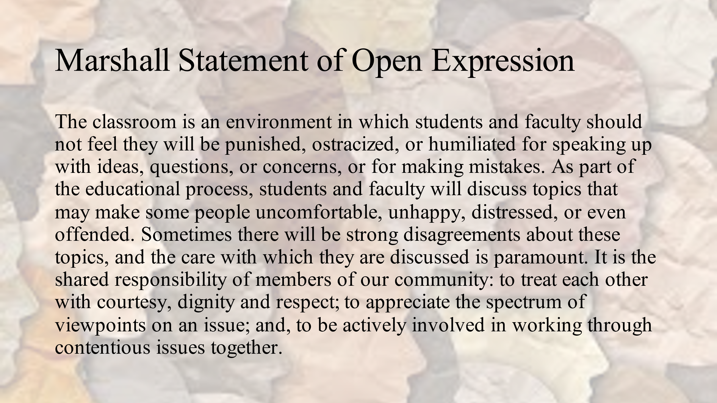
- Announce: “Welcome to the ELC annex today! I’m _________________ and I will be facilitating today’s exercise, Bystander Support.
We are going to examine microaggressions, why they can be hurtful, and what a Bystander could do to support the Target of a microaggression.”

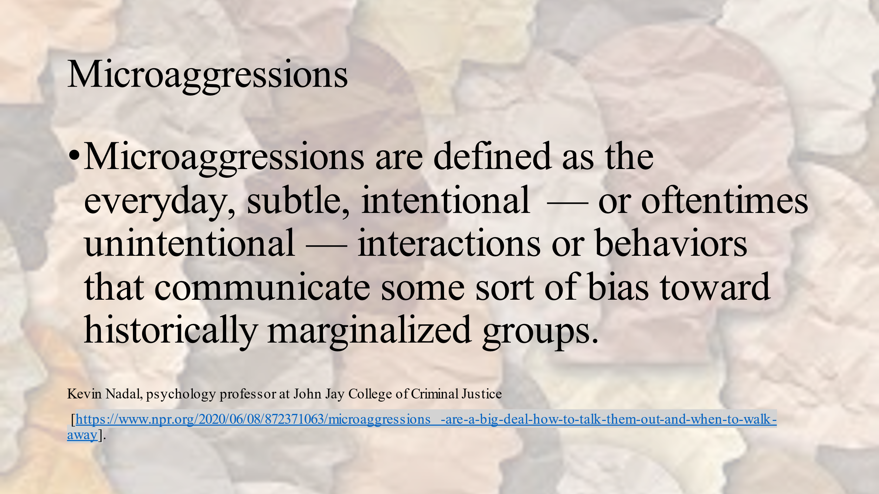

We will now show an animated way to think of the cumulative impact of microagressions.
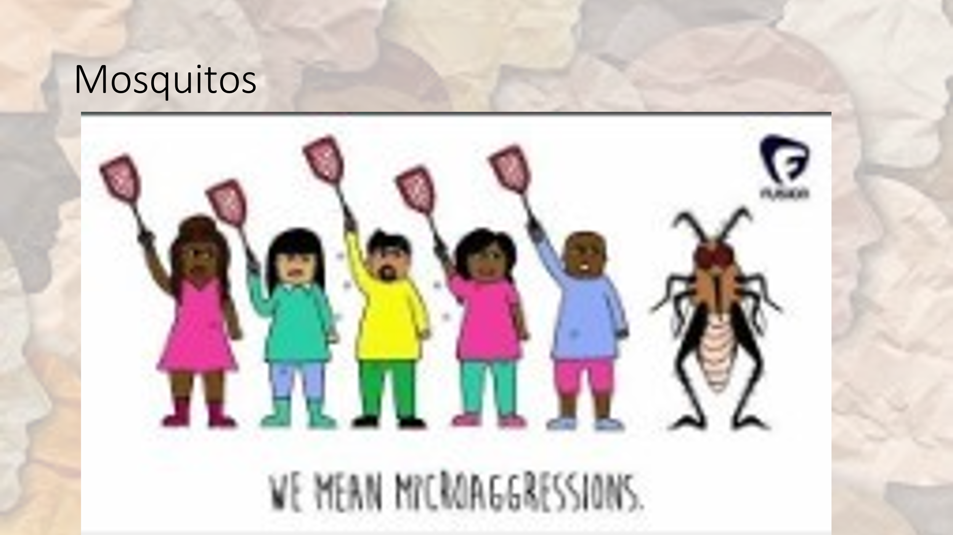

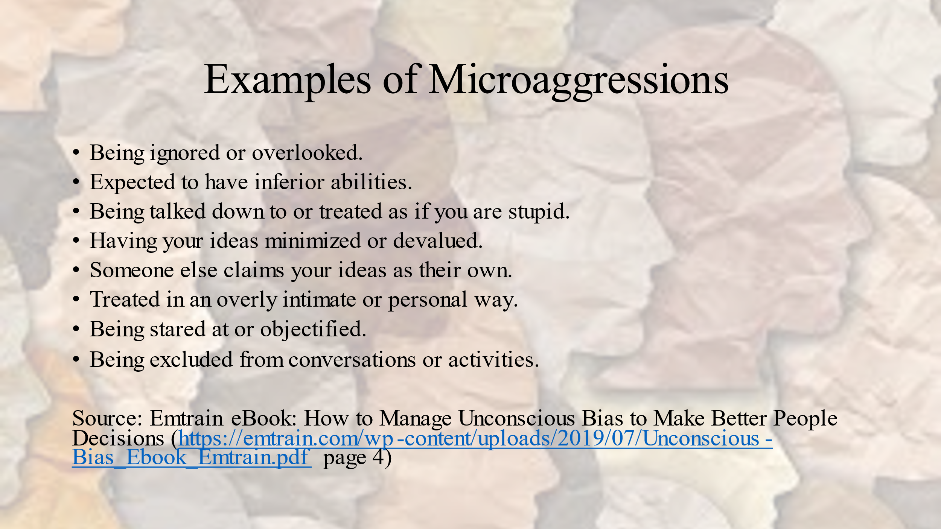

“The USC Race and Equity Center offers these agreements and suggestions for having sensitive discussions:”
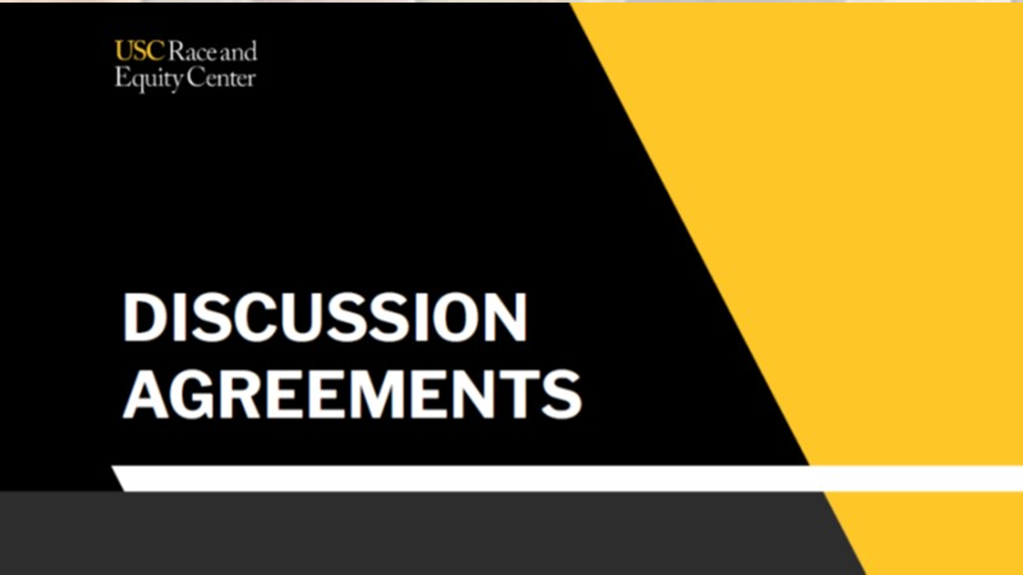

“Here are things to keep in mind as we discuss these situations.”
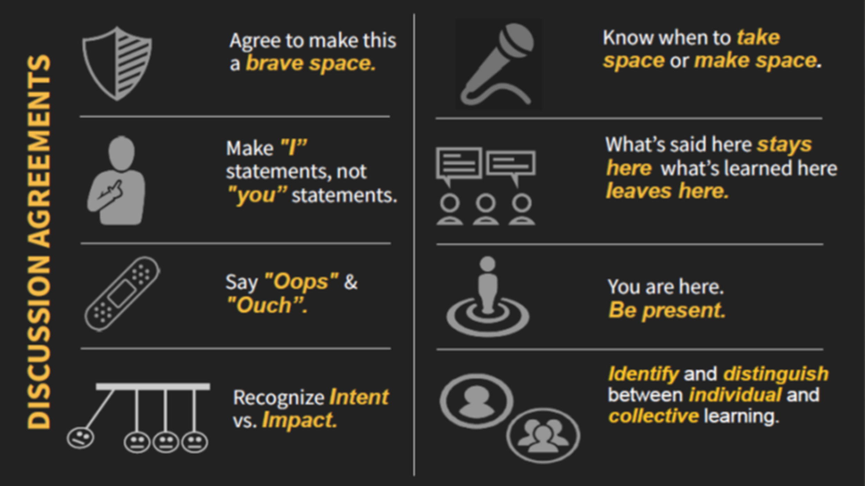

“Here is an example of a micro aggressive comment and the Target’s response.”

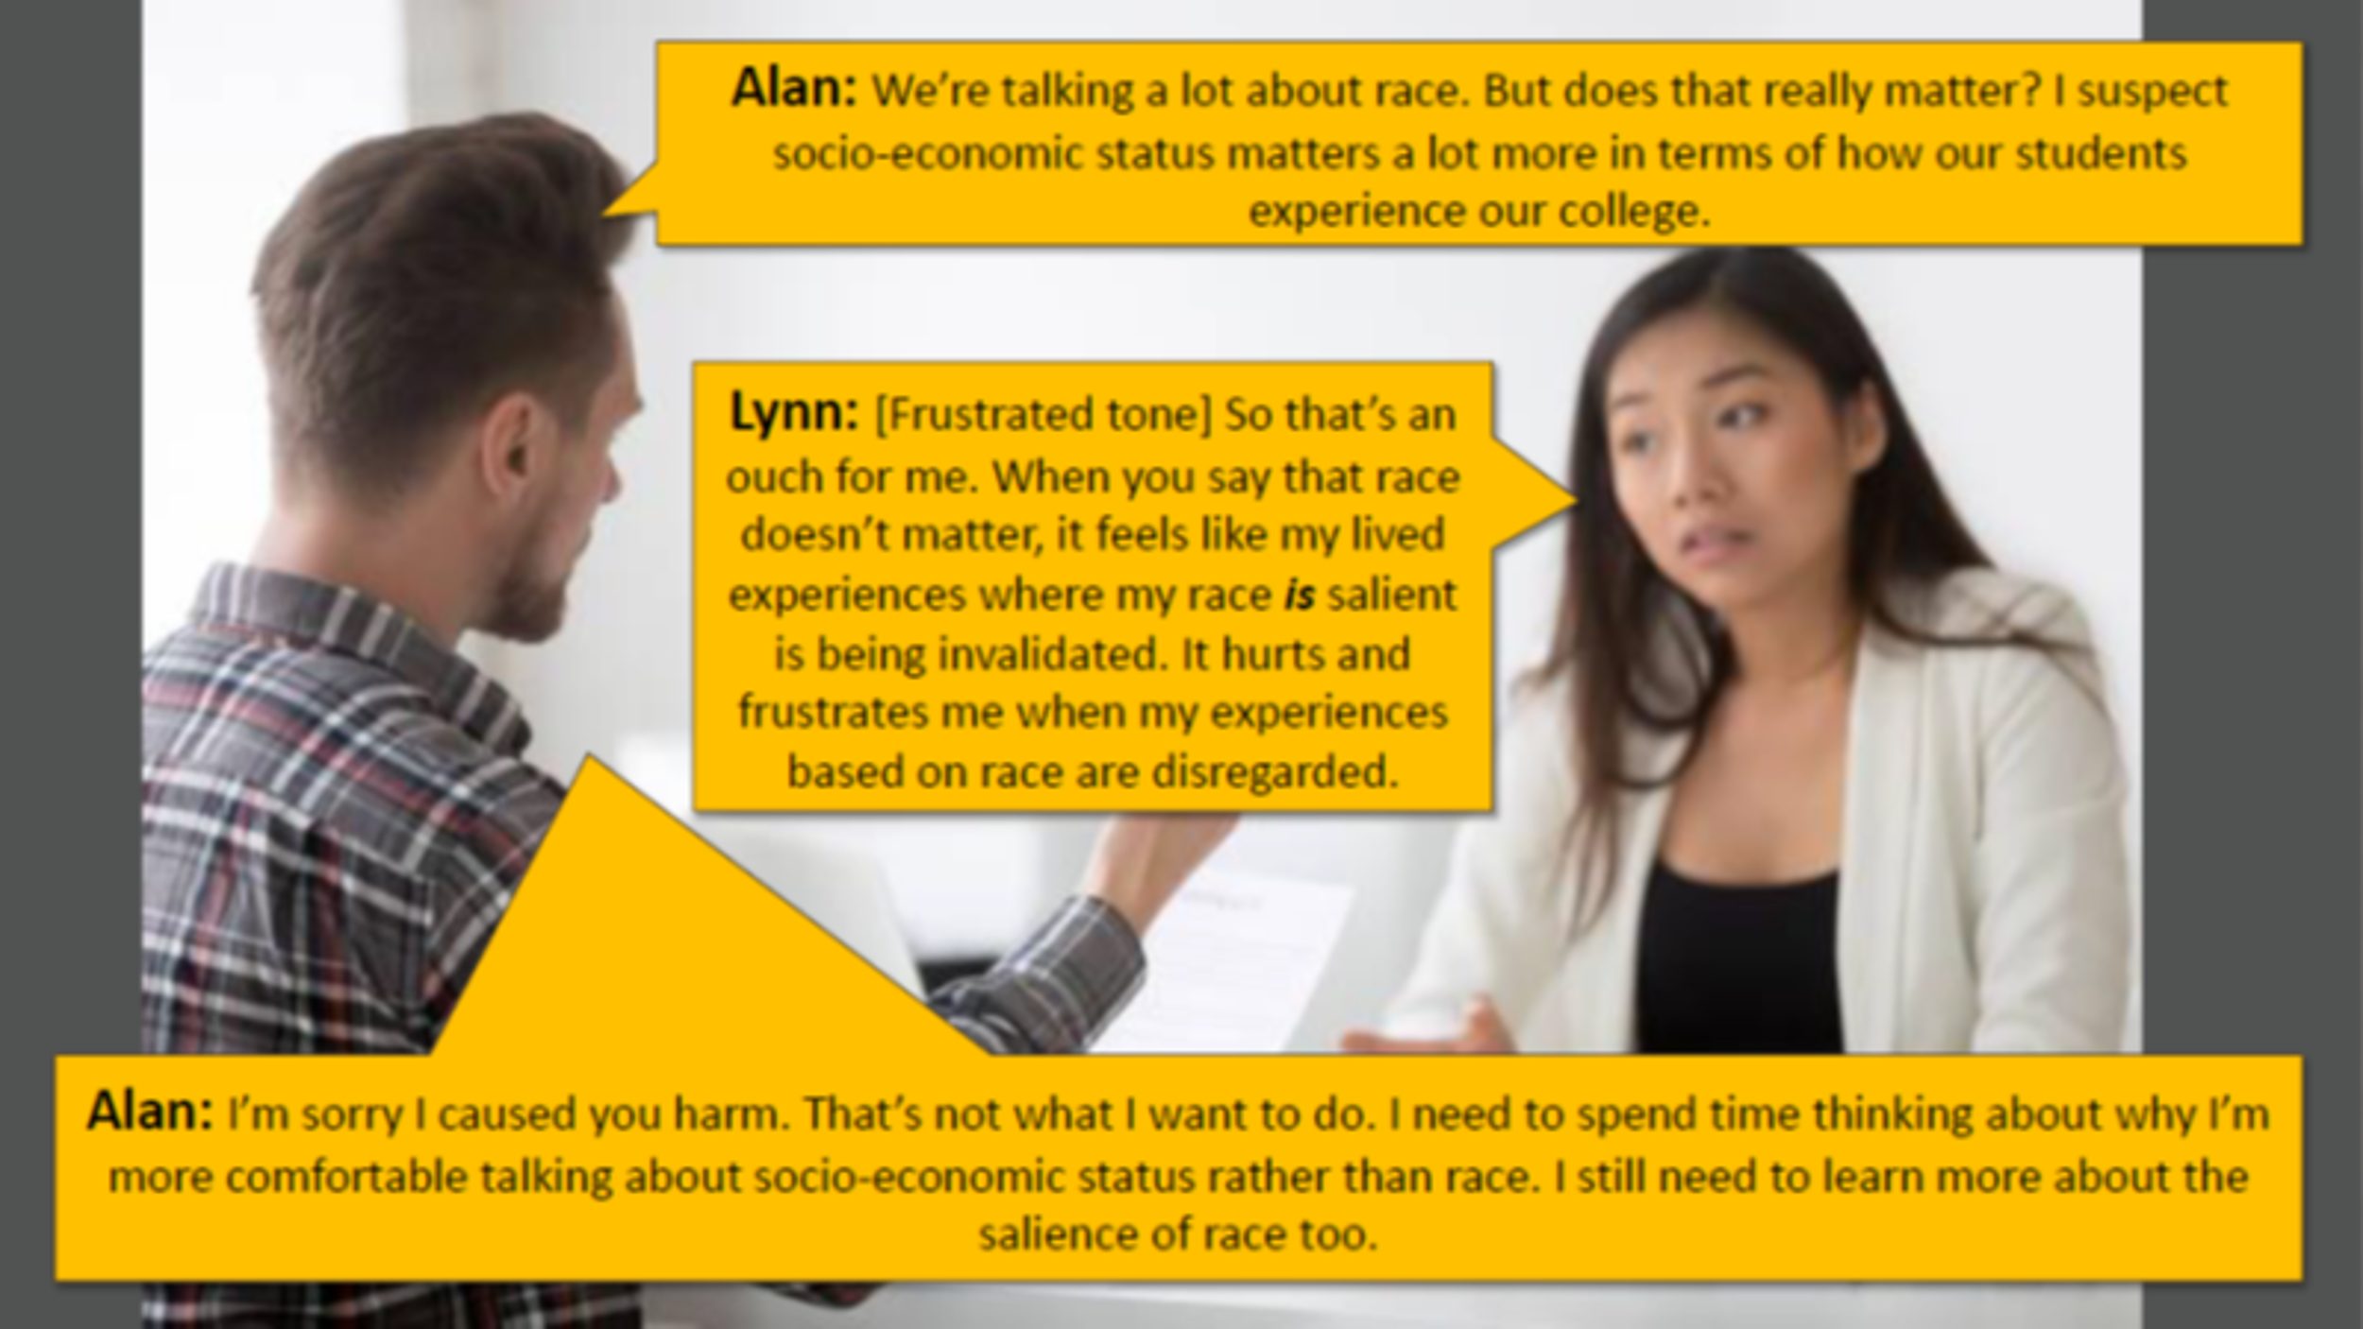

“Before we dig it, we want to recognize that some of the situations may be triggering to some participants today…..”
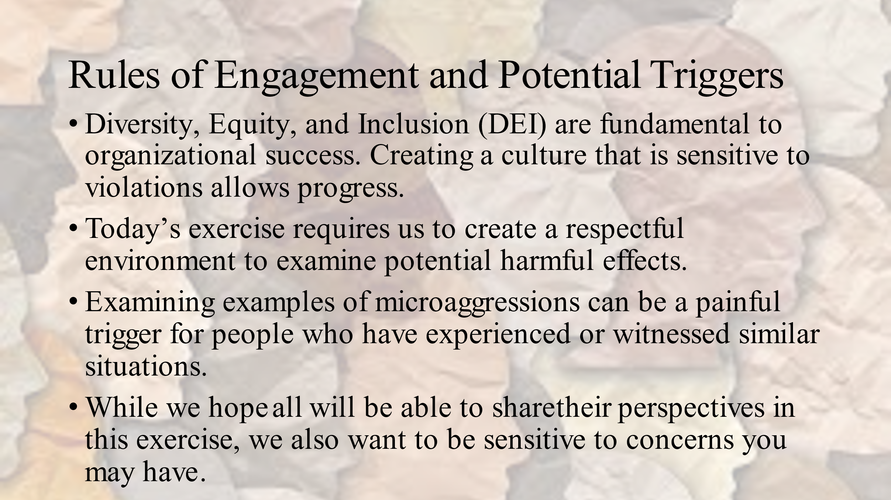

“You will be watching videos portraying workplace microaggressions. We hope you will use the Giving Voice to Values approach when analyzing the interactions.”
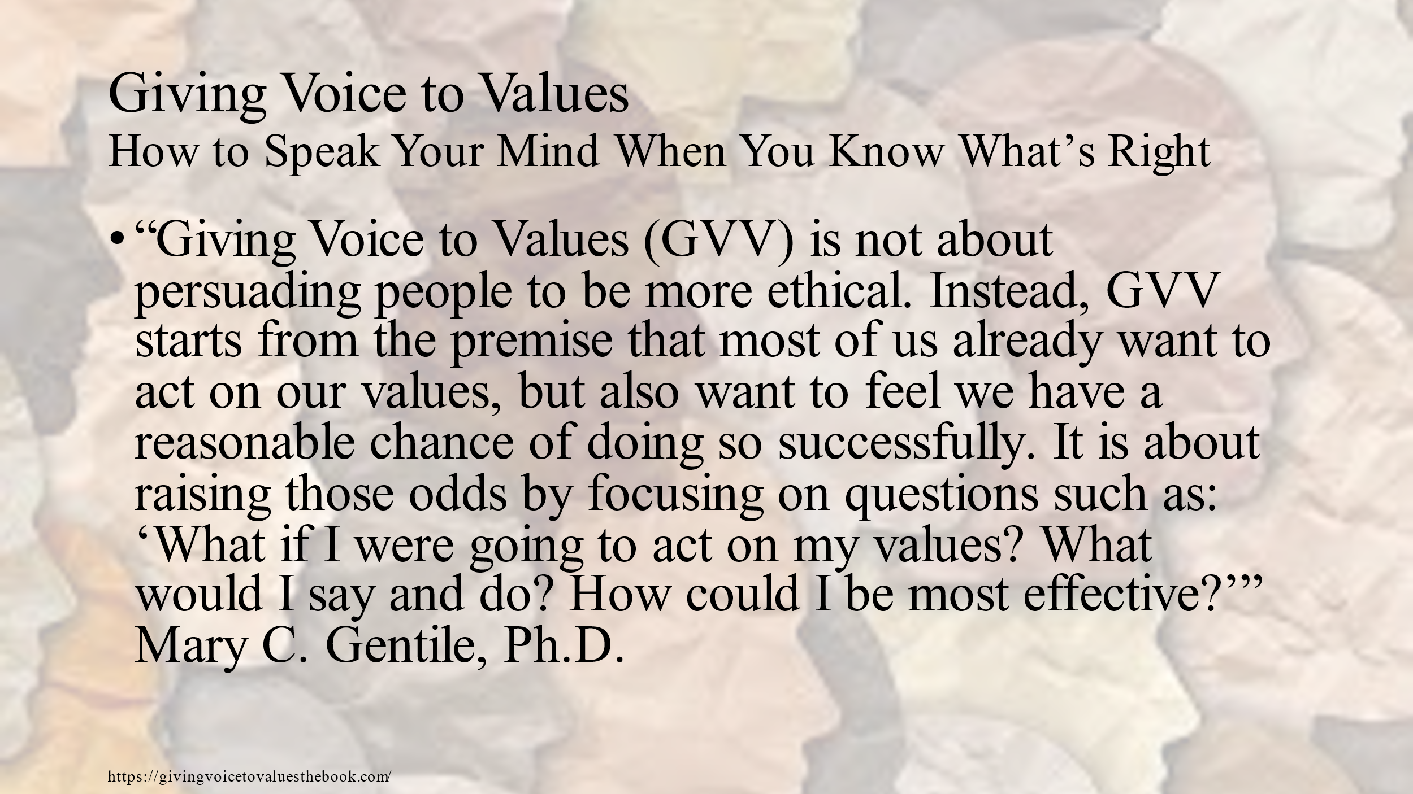

“Let’s go over the roles you will be taking. After a practice video clips you will make sure that someone is taking a different role for each of the 4 videos you will watch with your team. Let’s go over the roles:”
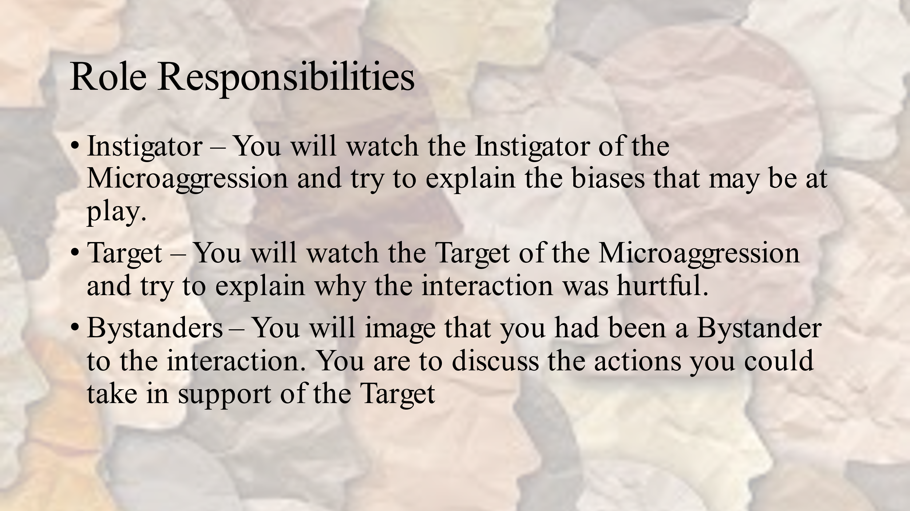
“You are going to be watching some video clips reenacting various kinds of biases and discrimination. For each video, 2 people on your team will take the perspective of the Instigator or the Target. What might they be thinking? The other people on the team will act as if they had been a Bystander to the interaction. The Bystander role is tasked with identifying what they, as Bystanders, could have done after witnessing the interaction There will be up to 4 different clips so each member of the group will have the opportunity to take on different roles/perspectives.
Please note that although you have volunteered to take a specific perspective for a video, you are encouraged to share your insights on any aspect of the interaction during your group’s 5 -minute discussion.
I want to take a moment and address some techniques to use in the Bystander role. Finding ways to not only act as an ally for the Target, you need to be sensitive about preserving workplace relationships. Here is also a sheet with suggestions on RESPONDING TO MICROAGGRESSIONS AND BIAS to share with your group.”

Distribute the laminate RESPONDING TO MICROAGGRESSIONS AND BIAS handout to each group.

Let’s talk a bit about our reluctance to addressing problem behavior:

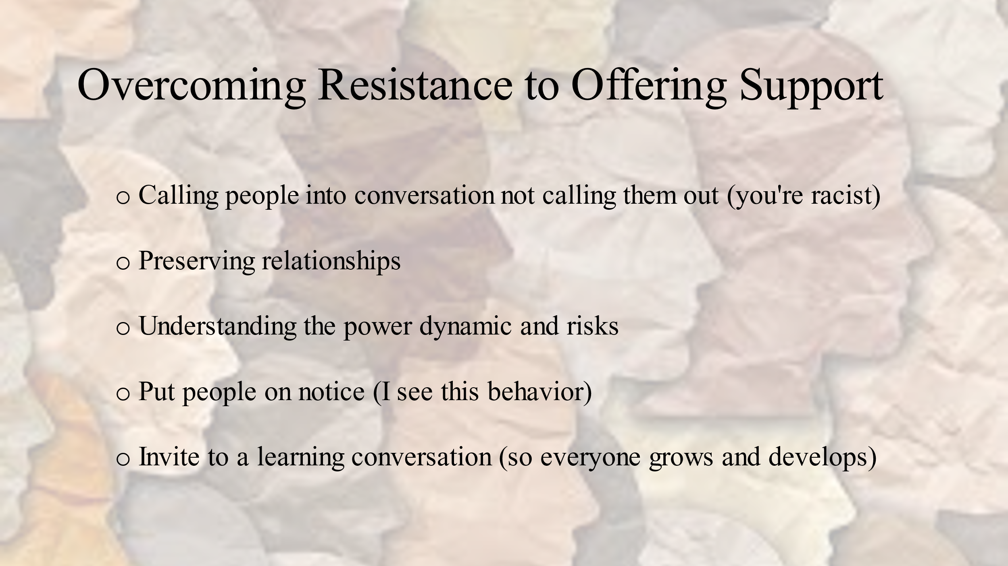

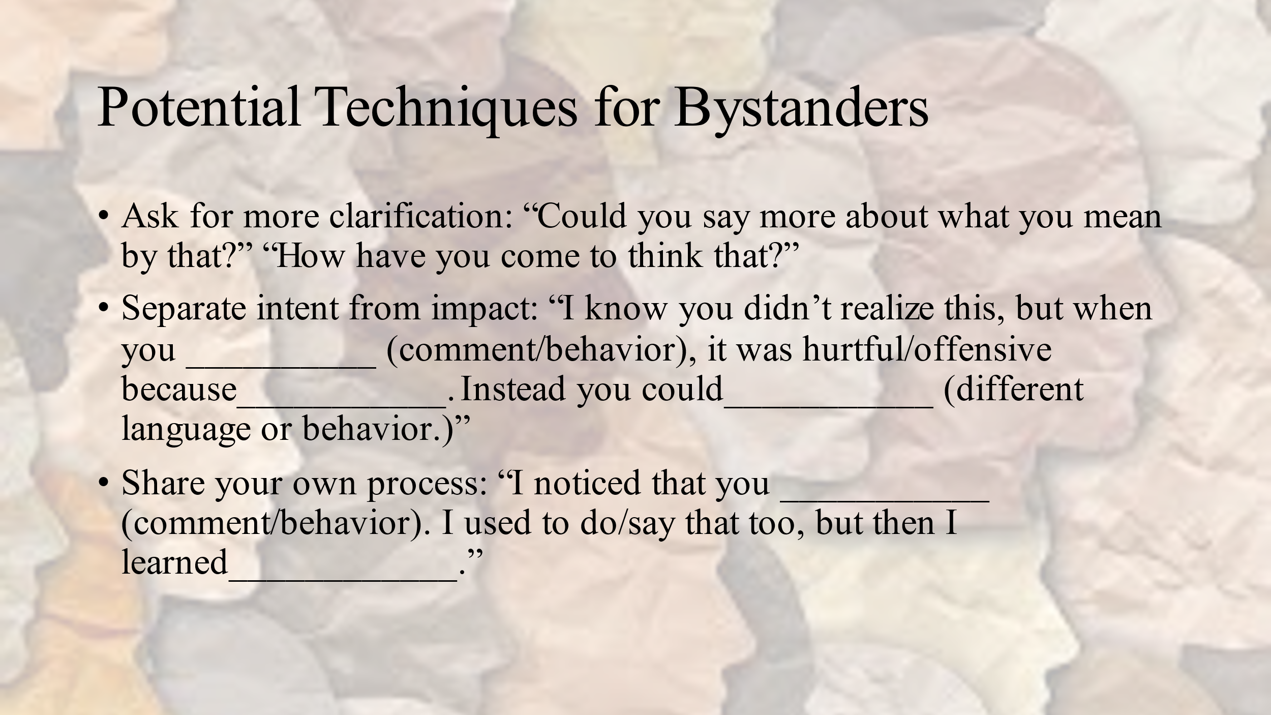
“To get started, we are going to watch a micro-aggressive episode, spending a few minutes discussing both. In your breakout group, you will discuss the perspectives of both the Instigator and the Target and then share approaches a Bystander might take to redirect.”
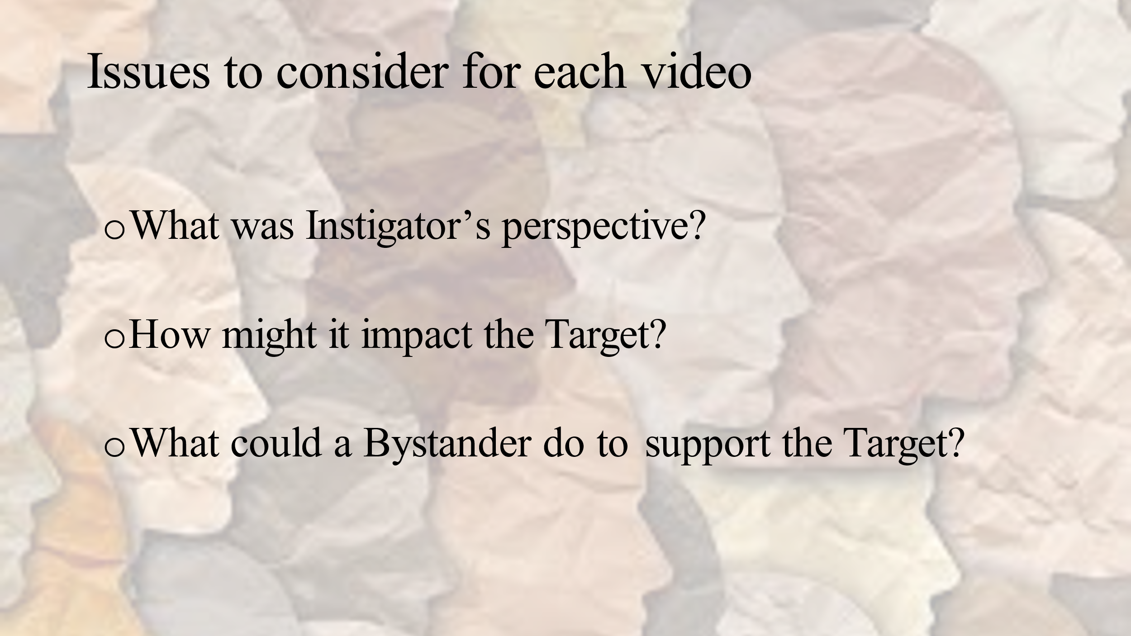

Prep video link and be ready to start it at the third segment at the 1:04 mark.
- Examples of Workplace Microaggressions -- age; natural hair; where from
https://www.youtube.com/watch?v=XjgozDwAjqg
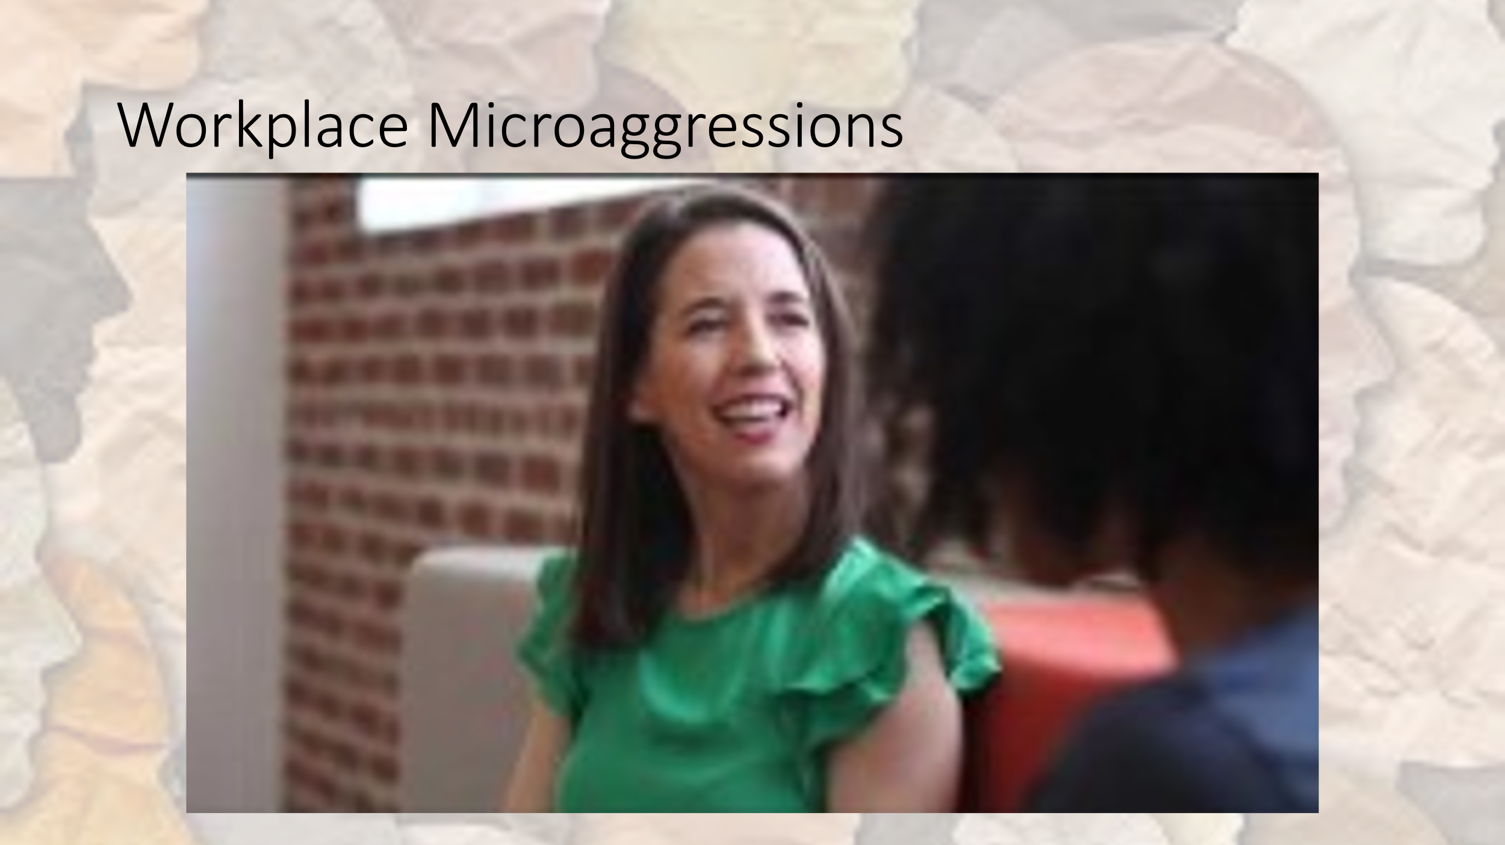

- After ‘where from’ clip, announce: “Let’s take a look at perspectives, keeping in mind that microaggressions often are unintentional.
  - What was Instigator’s “before that” perspective?
  - How might it impact the Target?
  - What could a Bystander do to redirect the situation?

“As you will continue with other videos in the ELC rooms, this is the type of discussion you should have with each clip.”

- Announce: “Please make sure that someone on your team is focusing on the Instigator and someone else is focused on the Target. Everyone else will be Bystanders.”

Prepare to play video #1.

- Video #1 How to Spot Retaliation – Female team member was talked over, ideas taken, then excluded from team meeting. [1:23]
https://www.youtube.com/watch?v=fzvq_x4XV6Q
- White woman in meeting with male teammates is talked over, ignore, or had her ideas taken. She stands up for herself and then her co-workers meet on Zoom without her.

- After the video ends, announce: “Please begin your 5-minute discussion.
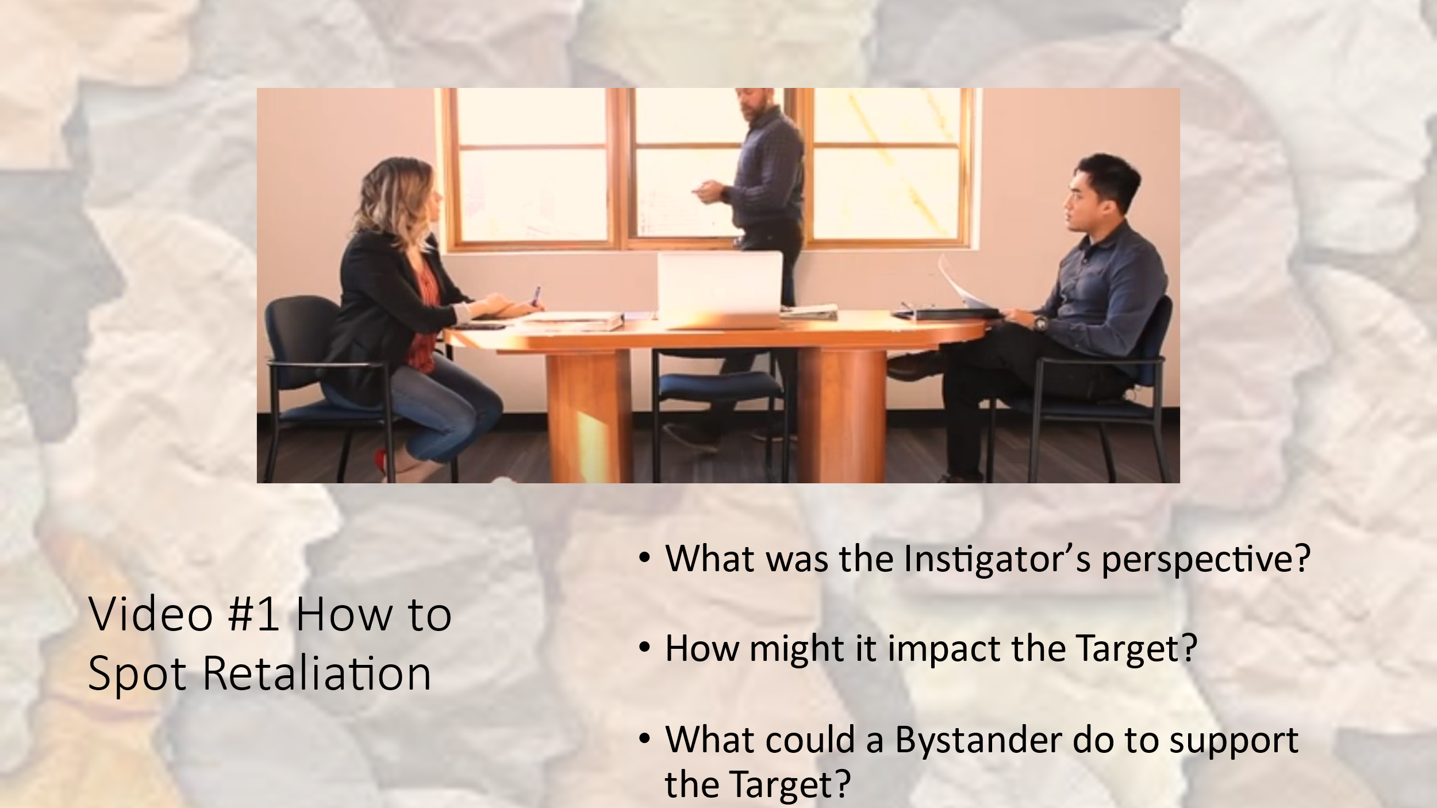
- After the 5-minute discussion, announce: “Let’s hear your thoughts.”

- After the discussion, announce: We are about ready to start our second video. Just a reminder, have different people focus on the Instigator and Targets.”

Prepare to play video #2.
- Video #2 Example of Gender Bias in the Workplace –gender of new employee Chris is a mystery to other employees [4:05]
https://www.youtube.com/watch?v=YbMQ5YapnfE&ab_channel=Emtrain
- Employees are unsure of the gender of the new employee Chris. The white male asks probing questions and follows Chris to the bathroom. The female employees react to his probing.

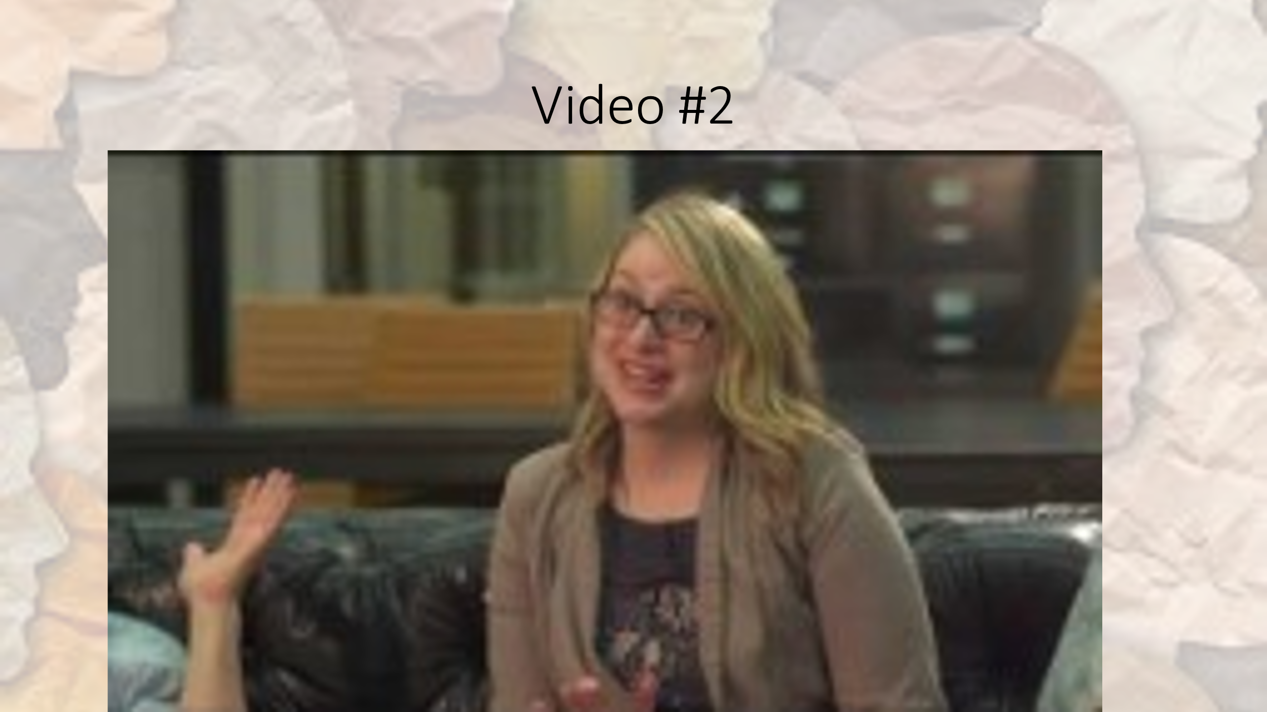

- After the video ends, announce: “Please begin your 5-minute discussion.
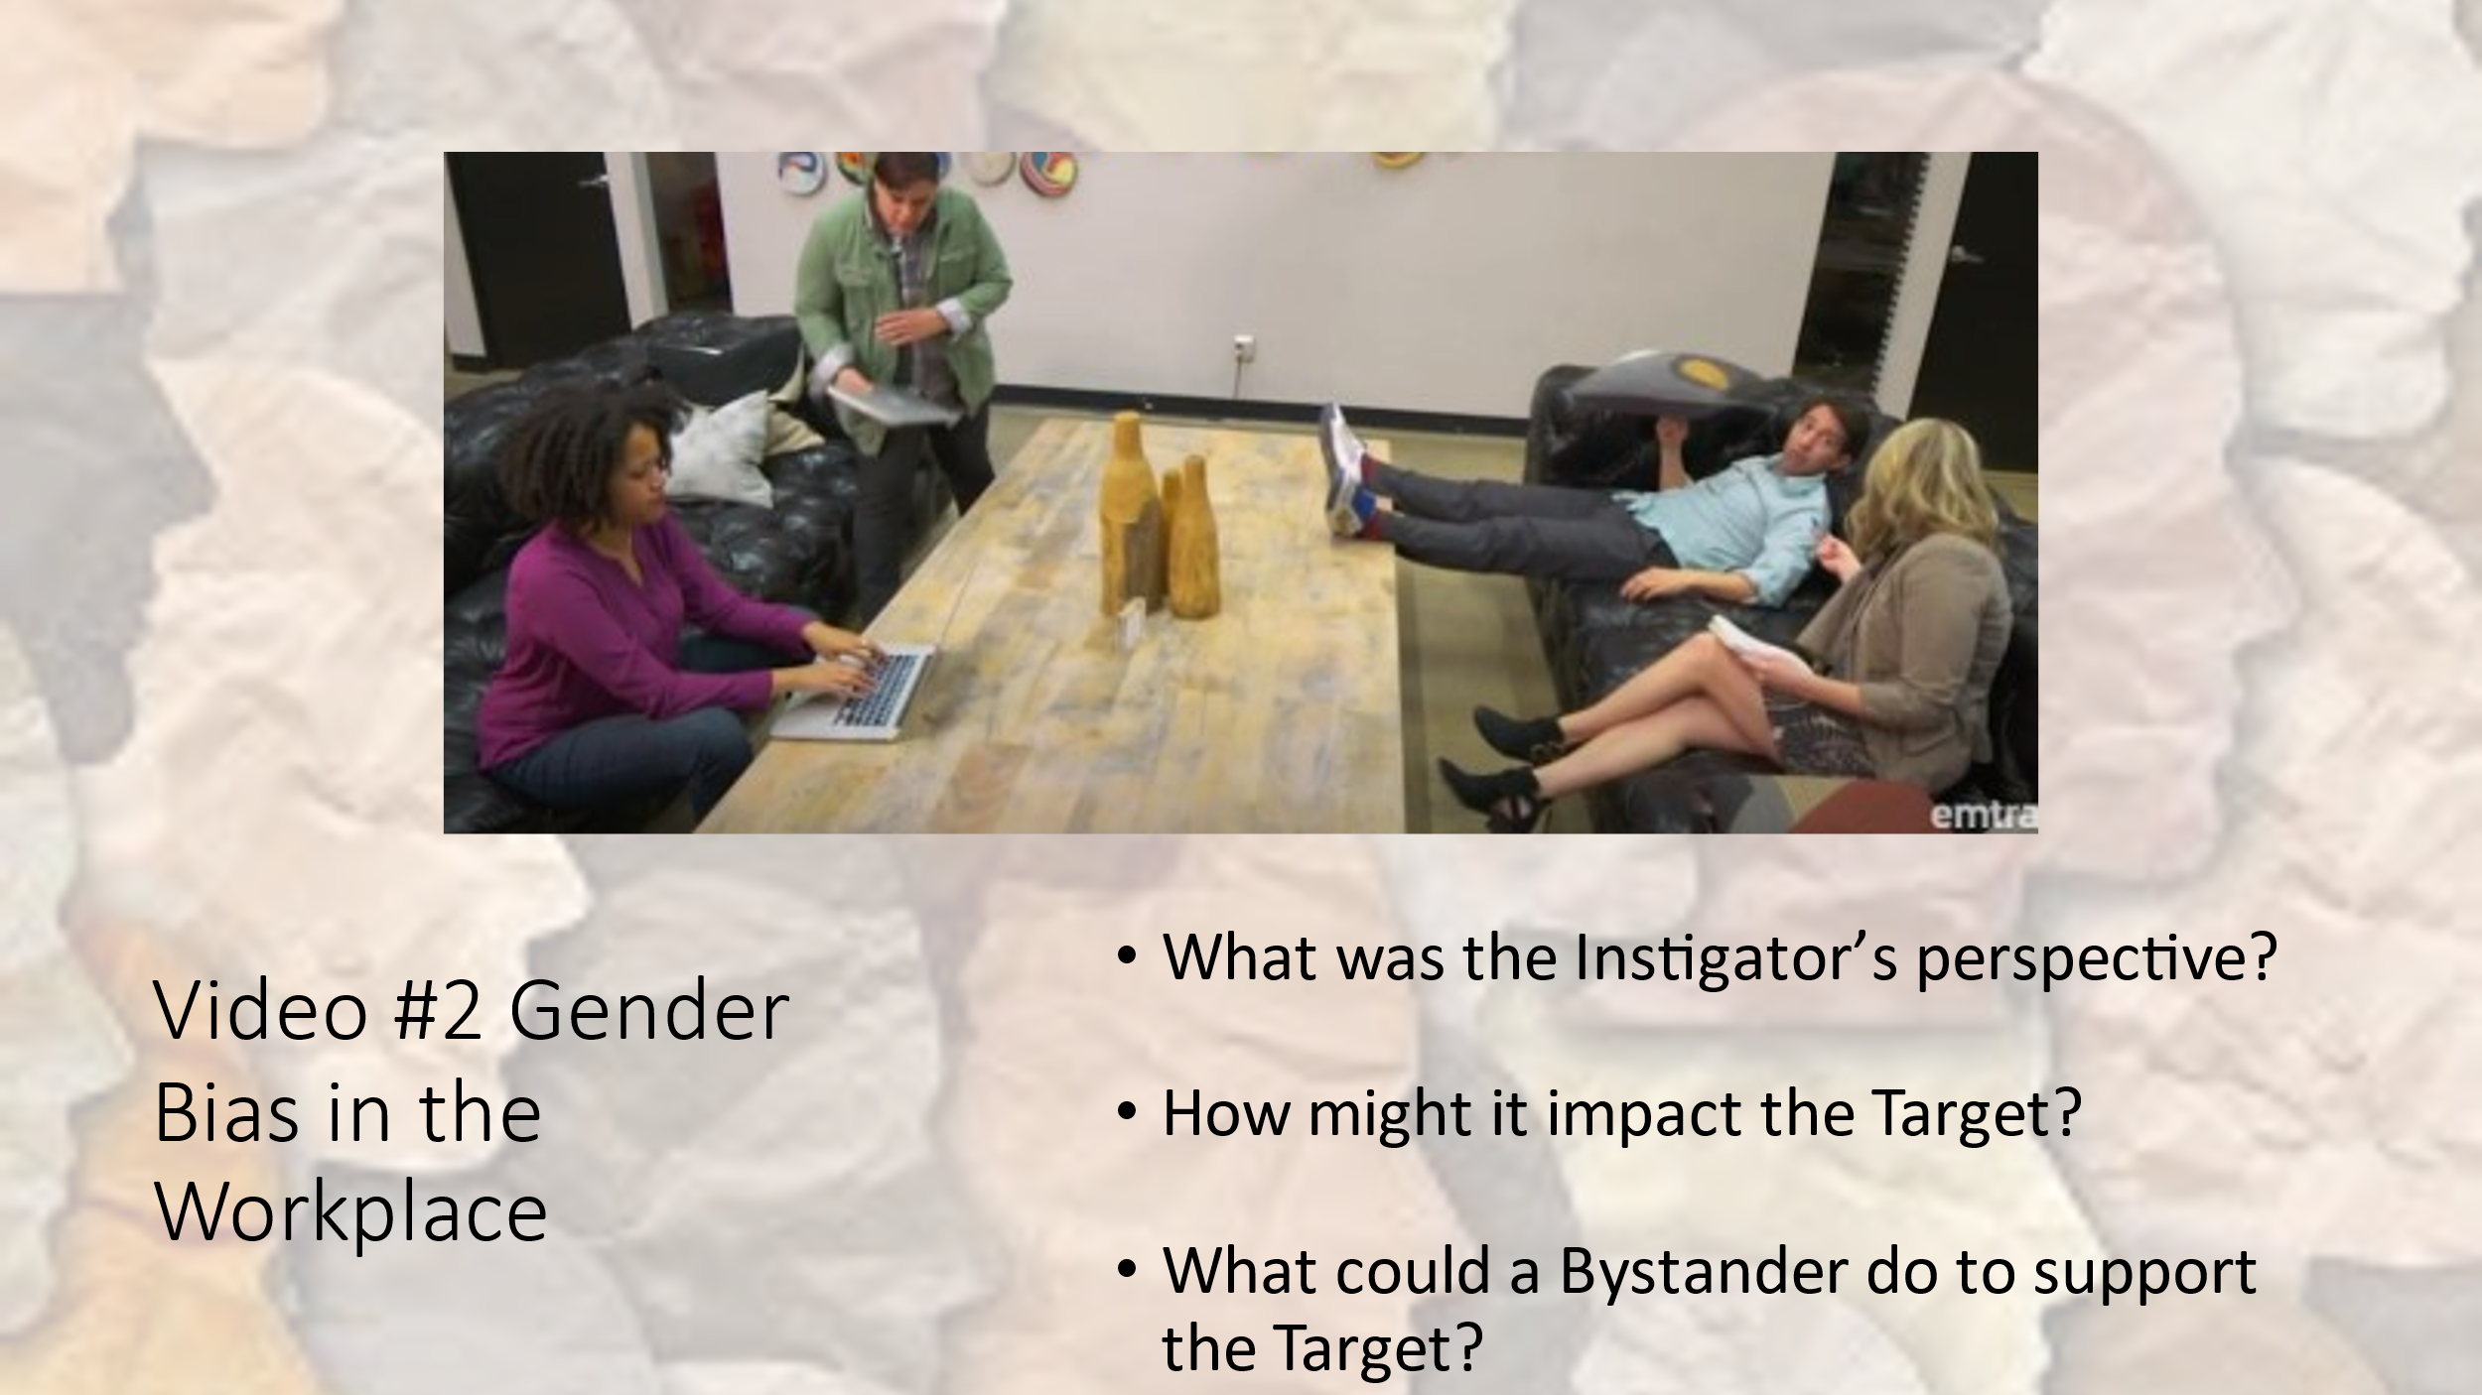
- After the 5-minute discussion, announce: “Let’s hear your thoughts.”

- After the discussion, announce: “We are about ready to start our third video. Just a reminder, time for new people to focus on the Instigator and Target.”

Prepare to play video #3.
- Video #3 Example of Unconscious Racial Bias in the Workplace – black and white women in restaurant [1:58]
https://www.youtube.com/watch?v=ufu_RlvACNM&ab_channel=Emtrain
- White woman asks server to call the police on a group of black boys outside the restaurant. Black woman’s son was one of them.

- After the video ends, announce: “Please begin your 5-minute discussion.
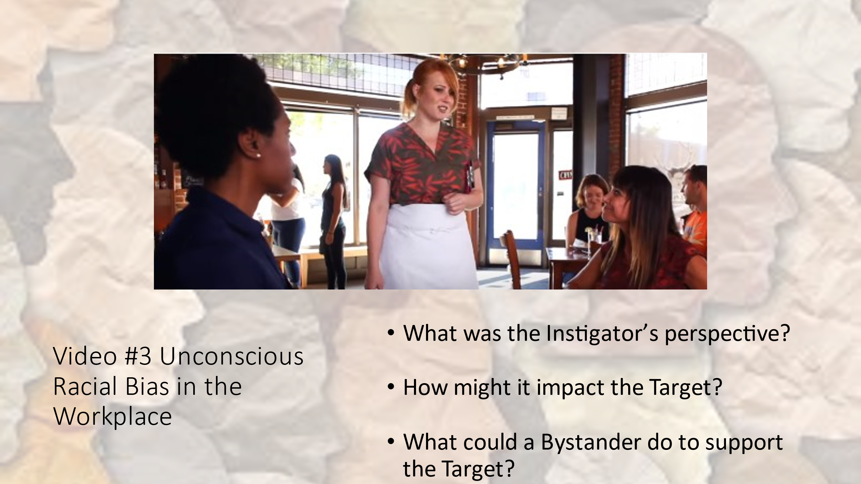
- After the 5-minute discussion, announce: “Let’s hear your thoughts.”

- After the discussion, announce: “We are about ready to start our fourth video. Just a reminder, new people should watch the Instigator and Target. When the video ends you will begin your 5-minute discussion. Please note that this interaction is taking place in the corner of a cafeteria, not a private office. Bystanders have overheard the interaction.”

Prepare to play video #4.
- Video #4 Example of Gender Bias in the Workplace -- pregnant black woman seeking advancement from white male [2:11]
https://www.youtube.com/watch?v=MmAOzZyaHMo
- White male questions why a pregnant mom wants the open director position. Uses “team player” criteria when she states she is going to HR.

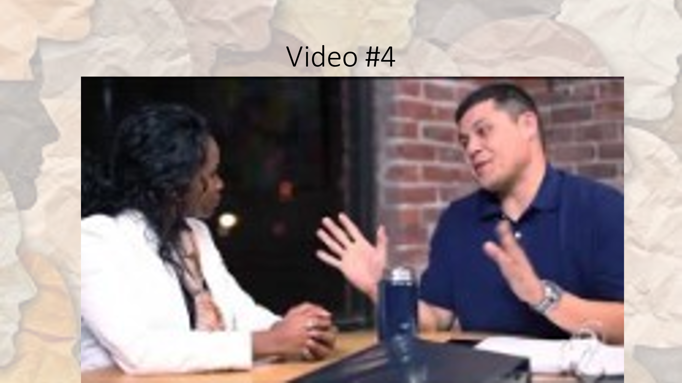
- After the video ends, announce: “Please begin your 5-minute Discussion.”
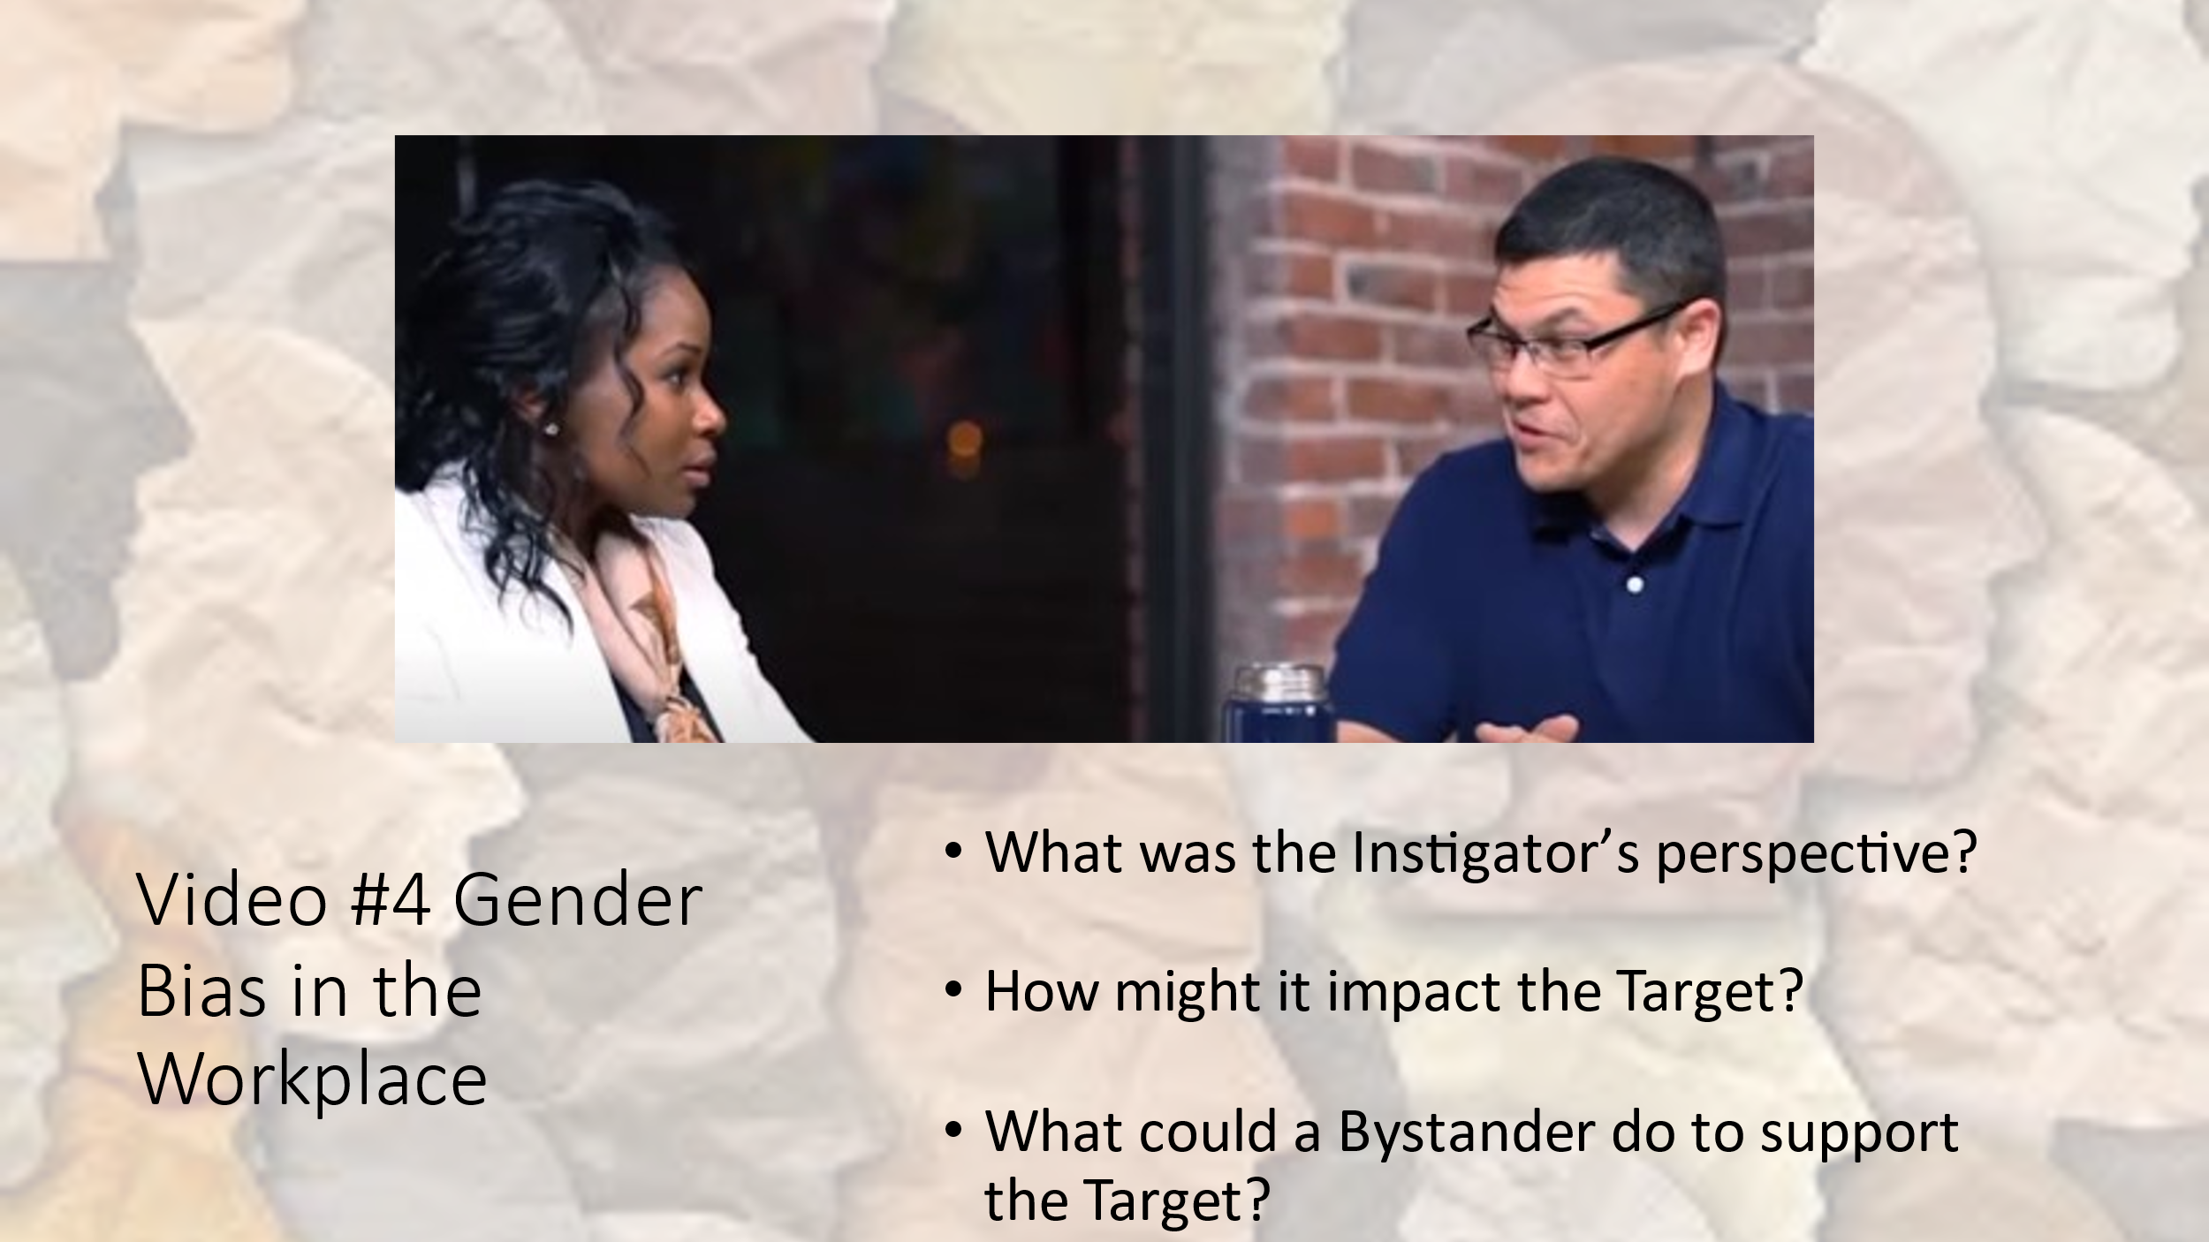
- After the 5-minute discussion, announce: “Let’s hear your thoughts for each role.”

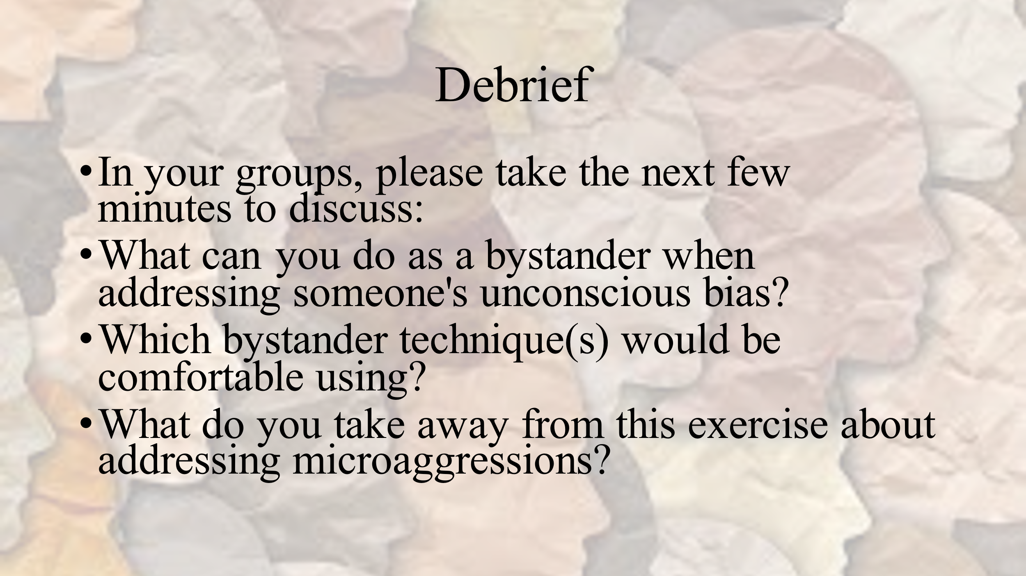

Debrief

The bulk of the debrief will occur in the discussions following each video

- What are some reactions you have to this exercise?

- How did you approach the situation that would not only address the harm but preserve a valued relationship?

- What did this exercise demonstrate to you about what a bystander can do in the face of unconscious bias?

- What is the impact to an organization when microaggressions are prevalent? What can we do about it?

- How can organizations increase inclusion and a sense of belonging for employees?

- What were some of the most effective intervention strategies used today?

- As either a Target, a Bystander or potential Ally, what takeaways to do you have to this exercise?

Final slide at end of session:
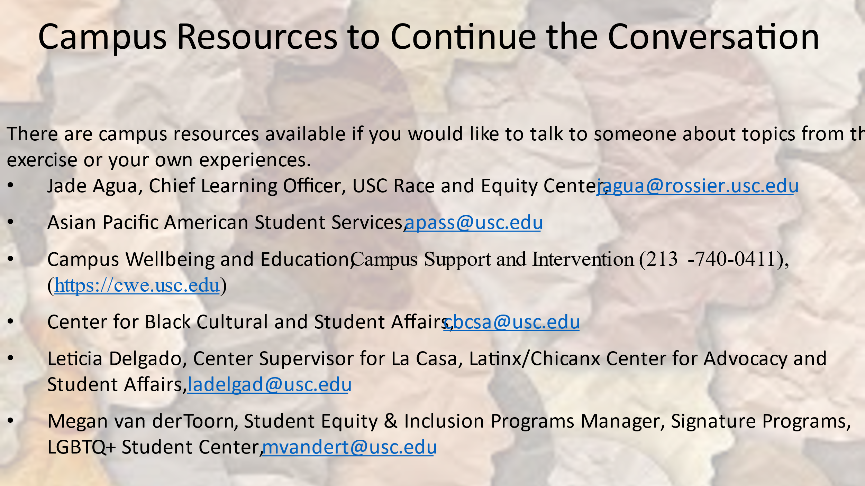
- Optional - Display the Bystander Intervention slide and talk about the 5Ds.
https://www.ihollaback.org/bystanderintervention/

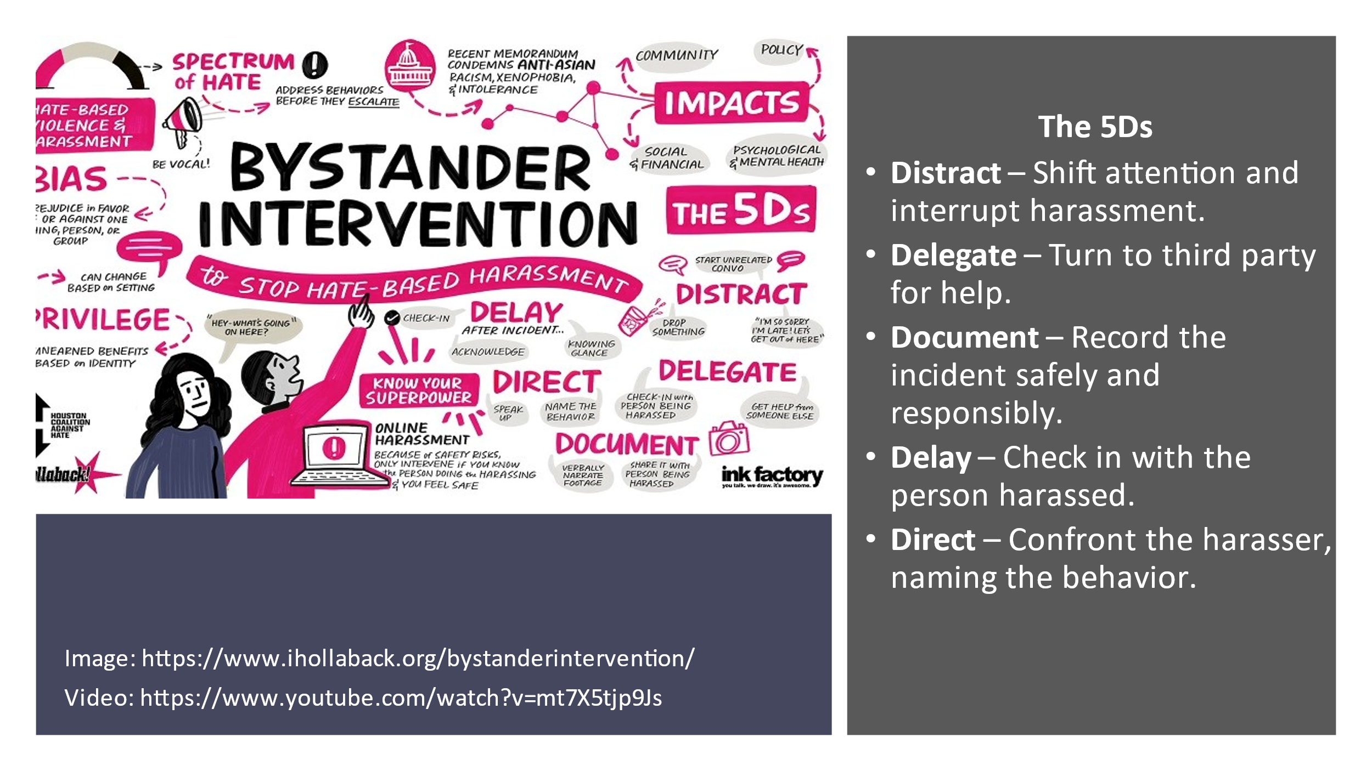

RESPONDING TO MICROAGGRESSIONS AND BIAS

RESTATE OR PARAPHRASE. “I think I heard you saying____________ (paraphrase their comments). Is that correct?” υ
ASK FOR CLARIFICATION OR MORE INFORMATION. “Could you say more about what you mean by that?” “How have you come to think that?” υ
ACKNOWLEDGE THE FEELINGS BEHIND THE STATEMENT. Express empathy and compassion. “It sounds like you’re really frustrated/nervous/angry…….” “I can understand that you’re upset when you feel disrespected.” υ
SEPARATE INTENT FROM IMPACT. “I know you didn’t realize this, but when you __________ (comment/behavior), it was hurtful/offensive because___________. Instead, you could___________ (different language or behavior.)” υ
SHARE YOUR OWN PROCESS. “I noticed that you ___________ (comment/behavior). I used to do/say that too, but then I learned____________.” υ
EXPRESS YOUR FEELINGS. “When you _____________ (comment/behavior), I felt ____________ (feeling) and I would like you to________________.” υ
CHALLENGE THE STEREOTYPE. Give information, share your own experience and/or offer alternative perspectives. “Actually, in my experience__________________.” “I think that’s a stereotype. I’ve learned that___________________.” “Another way to look at it is _________________.” υ
APPEAL TO VALUES AND PRINCIPLES. “I know you really care about _________. Acting in this way really undermines those intentions.” υ
PROMOTE EMPATHY. Ask how they would feel if someone said something like that about their group, or their friend/partner/child. “I know you don’t like the stereotypes about ______ (their group), how do you think he feels when he hears those things about his group?” “How would you feel if someone said that about/did that to your sister or girlfriend?” υ
TELL THEM THEY’RE TOO SMART OR TOO GOOD TO SAY THINGS LIKE THAT. “Come on. You’re too smart to say something so ignorant/offensive.” υ
PRETEND YOU DON’T UNDERSTAND. As people try to explain their comments, they often realize how silly they sound. “I don’t get it…….” “Why is that funny? υ
USE HUMOR. Exaggerate comment, use gentle sarcasm. “She plays like a girl?” You mean she plays like Serena Williams?” Or Mia Hamm? υ
POINT OUT WHAT THEY HAVE IN COMMON WITH THE OTHER PERSON. “I’m tired of hearing your Muslim jokes. Do you know he’s also studying ______ and likes to _________? You may want to talk with him about that. You actually have a lot in common.” υ
W.I.I.F.T. (What’s in it for them). Explain why diversity or that individual/group can be helpful/valuable. “I know you’re not comfortable with _____ but they can help us reach out to/better serve other groups on campus/in the community.” “In the real world, we are going to have to work with all sorts of people, so might as well learn how to do it here.” υ REMIND THEM OF THE RULES OR POLICIES. “That behavior is against our code of conduct and could really get you in trouble.”

