Discovering the Culture at SpaceX

Abstract

I will share a case study I developed on what is like to work at SpaceX. This case can be used to help students develop mastery in identifying Schein’s three levels of culture and for developing insights on the role of the founder in setting their organization’s culture and for more advanced classes developing interventions to change aspects of the culture. Students find the case interesting and a great way to get practice in culture analysis.
Key words: culture, SpaceX

Discovering the Culture at SpaceX

SpaceX is an aerospace company that has developed reusable rockets and is now the vehicle of choice for delivering materials and American astronauts to the International Space Station. It was founded by Elon Musk in 2002 (Mission, n.d.). The company presents a great opportunity to study culture and the influence of the founder in a company’s culture. The oversized presence of Elon Musk provides an interesting starting place. The students know Musk and many admire him, this might change with all the Twitter scandals that have been popping up, and it all contributes to a mythology around him. This increases the attractiveness of the case, a factor that has been shown to be a key driver for learning success (You, 2022).
SpaceX’s culture is an interesting case because of the amount of contradiction that exists in the culture. Aided by Schein’s (1990) three levels of culture we explore the interactions within cultural artifacts and espoused values, and we begin the understand the underlying assumptions that make it all come together. The analysis is not simple as it is not clear whether it is a culture worth emulating or not. The experiences of employees are mixed, with people loving the mission, making humans an interplanetary species, and then finding the work dehumanizing and full of long hours and not many other sources of rewards beyond seeing the rockets take off. Sull et al. (2022) found that SpaceX’s high attrition rate, which is standard deviations higher than competitors, is related to toxic work culture.

Theoretical Foundations
Case studies are a key delivery method used by business schools. Harvard Business School was the pioneer in the use of this method (Farashahi & Tajeddin, 2018). Case studies help students through inductive reasoning to connect a real-world example to concepts discussed in class. In the case study referenced in this session, the case is a narrative intended to help students put in practice concepts that have been shared with them, connecting those theoretical concepts to what they can look like in a particular example (Farashahi & Tajeddin, 2018), then move towards analysis, synthesis and/or evaluation (Ambrosini et al., 2010). It is an active learning method, its success depends on students being prepared, engaged and willing to participate. Case studies make knowledge concrete (Rendtorff, 2015). They present an ideal opportunity to complete one of the steps of Kolb’s (1984) experiential learning model where they test their mental models and knowledge.
Case studies have been shown to be more effective than lecture in terms of helping students develop problem-solving skills, interpersonal skills and improving self-awareness (Farashahi & Tajeddin, 2018). They also yield higher rates of knowledge retention than other delivery methods (Van Eynde & Spencer, 1988). You (2022) finds that cases help students develop higher order thinking skills but not always support theory building. Clearly there is a place for lectures, simulations and case studies in our classes. Case studies are a great tool we can take advantage of.
Understanding organizational culture is a useful skill for our students given how much it influences employee’s behaviors (Black & Warhurst, 2019), intention to stay in the organization (Sull et a., 2022), and as an enabler or inhibitor of the success of the organization (Alvesson & Sveningsson, 2015).
The analysis of the case study is built around Schein’s (1990) concept of culture and the three levels of culture. The lecture where I use the case study begins by presenting the definition and then explaining the three levels. Then the students begin by answering the question of identifying the elements that go into the three levels of culture.
Schein (1990, p. 111) defines culture as:
Culture can now be defined as (a) a pattern of basic assumptions, (b) invented, discovered, or developed by a given group, (c) as it learned to cope with its problems of external adaptation and internal integration, (d) that has worked well enough to be considered valid and, therefore (e) is to be taught to new members as the (f) correct way to perceive, think, and feel in relation to those problems.
I want to draw your attention to part (d) that mentions that the things that become part of the culture are solutions that have work well, this will play a key part in the analysis of the case.
Furthermore, Schein (1990) describe three levels that are fundamental to be able to analyze the culture of an organization. The first level artifacts, refers to things that we can see and feel as we go around the place, things like the organizational structure, dress code, office layout, emotional intensity, annual reports, statements, etc. The second level espoused values, are all about what the organization says they are about, how they explain things, these include values, norms, philosophies, how they present to the world. The third level underlying assumptions, is all about how the members of the organization think about things, this includes thought processes, mental models, how do they decide how to behave and perceive. This level is where we get the meaning of the other two. It is important to notice that there can be contradictions between what one can see and what the organization says and it is usually by understanding the assumptions that we can make sense of those contradictions. These contradictions are an important place to begin to understand the culture, we should try to understand what is the assumption that results in those apparently contradictory elements.
A couple of things to keep in mind for the case are: that the way the organizational responds to emotionally charged events can create norms that become part of the culture, especially in terms of how leadership reacts to them; and that the way the company recruits, selects, and promotes are primary mechanisms to strengthen the culture.
Finally, the case will explore the role of the founder in creating the organization’s culture. In the case of SpaceX, Musk is an outsized character that has significant influence in the organization. He has kept the organization private which furthers his impact. Schein (1995) describes how founders by force of their personality create an organization and being to form its culture. They bring their own assumptions about how organizations should work and embed them into all the ways the organization works. They will always have a part in the organization’s culture, it might lessen as time goes by, but their impact continues to be felt since they are the ones that had the idea for the organization and how it would fulfill its goals. By definition things become part of the culture if they prove to be successful, therefore if the organization succeeds the assumptions brought by the founder to the organization are reinforced and will be further embedded in the culture. Some of the most significant messages the founder gives are how they act as role model, what they pay attention to and how they react to critical events.
Learning Objectives
After completing the analysis of the case study students will be able to:
- Analyze the culture of organizations based on Schein’s model.
- Recognize the impact of the founder in aa organization’s culture.
- Propose changes that might improve the organization’s culture.
Exercise Overview
The text of the case with the analysis questions should be assigned ahead of the class when the analysis will be done. The students must come prepared to discuss the elements of the case.
The case analysis takes one 75-minute lecture. For the introduction and theoretical framework, the definition of culture and the three levels should be introduced in the beginning. Then proceed in order with the discussion questions at the end of the case study. The text for the case study can be found in Appendix A, and the teaching notes in Appendix B.
The case has been used with undergraduate students to great success but the question about changes to the culture seems to be a better fit for graduate level classes where the students might have more familiarity with the concept of culture.
Session Description
I am requesting a 45-minute session where I will introduce the benefits of the use of a case study (5 minutes) then a description of the organization and what the case study contains (5 minutes). We will then review the content of the teaching notes and highlight how the case illustrates the concepts we want to make sure the students remember. I will try to engage with the participants to see if more ideas can be added to the teaching notes (25 minutes). I would like to spend the final 10 minutes sharing my process to create the case and brainstorm other potential case studies we might want to work on.

References
Alvesson, M. & Sveningsson, S. (2015). Changing Organizational Culture: Cultural Change Work in Progress. Routledge.
Ambrosini, V; Bowman, C. & Collier, N. (2010). Using teaching case studies for management research. Strategic Organization, 8(3), 206-229.
Black, K. & Warhurrst, R. (2019). Seeing the unseen: Visualizing organizational culture in the classroom. Management Teaching Review, 4(3) 258-270
Farashahi, M. & Tajeddin, M. (2018). Effectiveness of teaching methods in business education: A comparison study on the learning outcomes of lectures, case studies and simulations. The International Journal of Management Education, 16(2018), 131-142.
Kolb, D. A. (1984). Experiential Learning: Experience as the Source of Learning and Development, Prentice-Hall Inc.
Mission (n.d.). https://www.spacex.com/mission/
Rendtorff, J. D. (2015). Case studies, ethics, philosophy, and liberal learning for the management profession. Journal of Management Education, 39(2), 36-55.
Schein, E. H. (1990). Organizational Culture. American Psychologist, 45(2), 109-119.
Schein, E. H. (1995). The role of the founder in creating organizational culture. Family Business Review, 8(3), 221-238.
Sull, D.; Sull, C. & Zweig, B. (2022). Toxic culture is driving the great resignation. MIT Sloan Management Review.
Van Eynde, D. F. & Spencer, R. W. (1998). Lecture versus experiential learning: Their differential effects on long-term memory. Organization Behaviour Teaching Review, 12(4), 52-58.
You, J. J. (2022). A ‘sensitizing’ perspective on understanding students’ learning experiences in case studies. The International Journal of Management Education, 20 (2022).

Appendix A – Case Study

SpaceX is a company in the aerospace industry that has focused on creating rockets and has a mission to make humans a multiplanetary species. It is the only company that is capable of reusing its rockets which significantly reduces the cost of missions. It is the first commercial company to deliver people and cargo to the International Space Station. They also offer low orbit flights for people to experience space for a fee.

The company was started by Elon Musk in 2002 when he invited Tom Mueller, a rocket engineer, to join what would become SpaceX. The initial motivation was to get people interested in space by growing the first plant on Mars, by November 2005, the company had grown to 160 employees. Musk interviewed and approved all of the employees. Musk hired young overachievers and poached top executives from other aerospace companies. By 2012, Musk owned about two thirds of the company and the value of SpaceX was $1.3 billion. By November 2022, the valuation had risen to $150 billion and employs over 11,000 employees. The company remains private.

SpaceX’s key competitive advantage is the reusability of its rockets and up to now they are the only company able to do deliveries to the space station. Blue Origin and Virgin Galactic are key competitors but have not been as successful as SpaceX.

The rockets are assembled in its headquarters in Hawthorne, CA. The company is vertically integrated, producing all the parts of the vehicle there.

A key element of SpaceX success has been recruiting world-class talent and an intense focus on the mission, to enable life on other planets. One of the key elements that attracts talent to the organization is the ability to have a strong impact in an important area that can change the future of the human race. The company reminds and highlights it mission everywhere. Employees feel the strong draw to solve complex problems with tangible impact and the company points out that working there has the potential to change life on Earth and beyond. The company describes its employee retention as strong with an average tenure of 3.6 years.

There are almost no private offices, even Elon Musk, the founder, has a cubicle. People have access to the factory and are able to see the entire process of rocket building in person or from the comfort of their cubicles through a system of cameras. You can tell who works at SpaceX because they are covered in swag.

When interviewing current and former employees many of them do bring up the importance of the mission and how being part of it is fulfilling. They describe the experience of watching the launch of the rocket together as deeply meaningful. The people working there are smart, passionate and driven creating a stimulating environment. One is given responsibility quickly, but little guidance to be successful. The department one works in makes a difference, some are flexible about where and when to work while in others people have to clock in and out. Working in an industry leader has an added significance. One of the defining qualities of SpaceX is their intense culture of learning and improvement, every rocket failure was taken as a learning opportunity that built step by step the most successful commercial aerospace company.

The pace of work is punishing with long hours and little space to have a work-life balance. The impact of burnout is reflected in the tenure of people working at SpaceX, about 3 to 5 years. There are complaints about low salaries for the industry and the lack of a 401K which will have lasting impact on people’s wealth. Even interns feel the pressure to work long hours. People are chided if they work less than 10 hours a day. At the same time, time can feel like it is flying because the work is always interesting and there are perks around the office like FroYo, a masseuse, etc. People are told during the hiring process “if you want as hard as it gets, then great. If not, then you should not come here.”

With regards to how the organization is perceived there are some mixed insights, some find the culture exciting and positive, while others indicate some problems growing in the organization. The words amazing and toxic come up again and again, as well as fratty and elitist. It is not an environment where people are friendly or supportive of each other, is every person for themselves and sink or swim. If that is an environment where one thrives, there are a lot of opportunities to learn and have an impact.

One of the issues that comes up is the single-minded focus on results from management. This results in short deadlines, increasing the pressure on employees and hurting their well-being. Management does not treat employees or the public with respect. There is a need to stroke their egos to be able to move ahead. Managers are young and inexperienced and tend to shift the blame away from themselves. There is a lot of petty politics, gossip and favoritism. Workers have heard their managers making fun of workers and calling them names. The management style is strongly influenced by Elon Musk and his management style.

Musk changes deadlines without realizing the impact it might have on people and threatens to fire people if those deadlines are not met. After watching the first successful rocket launch Musk’s comment was: “this is just the first step of many.” Musk drives people hard even to distraction, but at the same time drives them to things they never knew were possible. In a staff memo he wrote: “Please prepare yourself for a level of intensity that is greater than anything most of you have experienced before…Revolutionizing industries is not for the faint of heart.” He is seen as a tyrant, autocratic and blunt to those who work with him, his business tactics are suspicious or at least appalling. Some describe his style as abusive. He makes promises he does not hold himself to, shifts goals constantly, tells people that their efforts will never be enough. Some describe him as one that sees employees as a resource to be mined rather than a team to be lead. Employees have learned to avoid him. Yet, he has successfully built a successful aerospace company, a goal that has evaded many, and for a time was the richest man in the world.

In 2019 SpaceX fired around 10% of its workforce in what some employees called a purge. The process was unusual. Employees were told on a Friday that a significant portion of employees were going to be fired and everyone was told to leave early that day and then they would receive an email on Saturday to know whether they had a job on Monday or not. Some did not receive an email and had to call a special number to be told what their status was. There were no explanations as to why you were fired and were told just not to come again unless you were returning company property. Managers are required to receive training on how to discourage unions.

While the company says it strives to create an inclusive workspace, the focus seems to be on encouraging discussions on ideas and little on what the experience of workers is. It has resulted in a company with little diversity, strongly male dominated where harassment is tolerated and HR does not support employees and rarely dismisses perpetrators.

Many current and former employees of SpaceX have come forward with stories of harassment and inaction from the company, with interns who are hoping for a permanent job being particularly vulnerable to harassment. A former intern in 2016 and 2017 described how most of the other interns had stories about uncomfortable situations. One example is an intern who encountered a male employee, who was invited for drinks by her housemate, drunk attempting to enter her bedroom, banging on the door and rattling the doorknob. She brought up the issue to HR. The man remained at the company. Other interns have experienced sexual assaults, again with no repercussions to the perpetrators. Some examples are groping, hugging without consent, staring at women while they work, hitting on women, pressuring people to dance, unwanted touching. All of these reported to HR but nothing was done. HR suggested that these issues were too private to discuss with the perpetrators and that instead they would have training programs. There was no process on how to deal with harassment behavior, even with the no-tolerance and no-asshole policy the organization touts. Employees seem emboldened in this behavior by lewd comments Musk has tweeted about women’s bodies and taunting employees who have reported misconduct. For example:

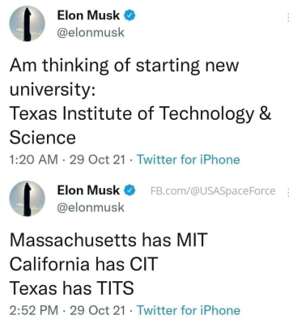

When the harassment issues appeared in the press, SpaceX’s President sent an email that along with wishing people a happy holiday season said they would investigate all the claims and take action. She said “we can't fix what we don’t know.” This implies that executive level officers do not discuss the frequency of harassment within their groups. The news of the organization paying $250,000 to flight attendant who says she was sexually harassed by Elon Musk prompted several members of the organization to write a letter and ask others to sign it. The letter pointed out that there was a problem when every Tweet Elon Musk sends is seen as a statement from SpaceX given his status as owner, CEO and spokesperson. The letter also pointed out a gap between what SpaceX says it is about and the company culture, specifically in terms of employee conduct and asked for a commitment for a transparent process to respond to claims of misconduct. As a result of the letter, 8 people were fired due to using company resources for outside activity and distracting the organization. The fired employees have filed charges with federal regulators accusing the company of retaliatory behavior.

SpaceX while describing all the lofty aspirations of wanting to colonize other planets takes poor care of our own Earth. They do not have an environmental plan, nor do they attempt to minimize their carbon footprint. When an employee developed a plan for carbon neutrality, Musk was dismissive. The effort grew to include other engineers who volunteered their time to develop the plan but management has declined to engage.

After the pandemic’s peak SpaceX required workers to spend at least 40 hours in the office, with Musk suggesting that it was needed because people had been slacking off.

Some images of SpaceX:

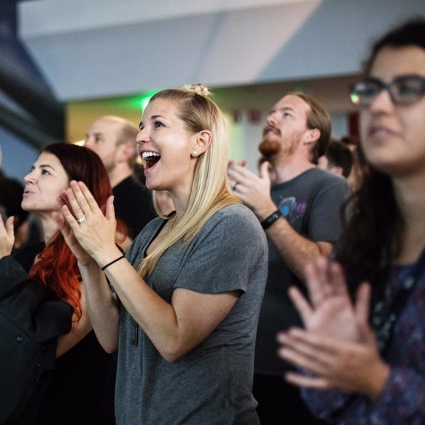
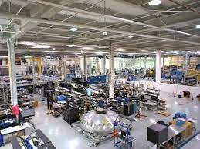
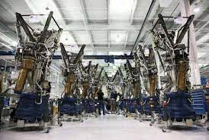

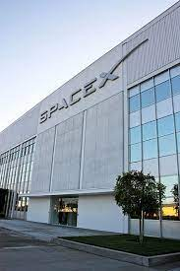

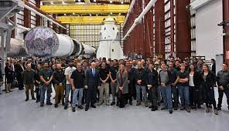

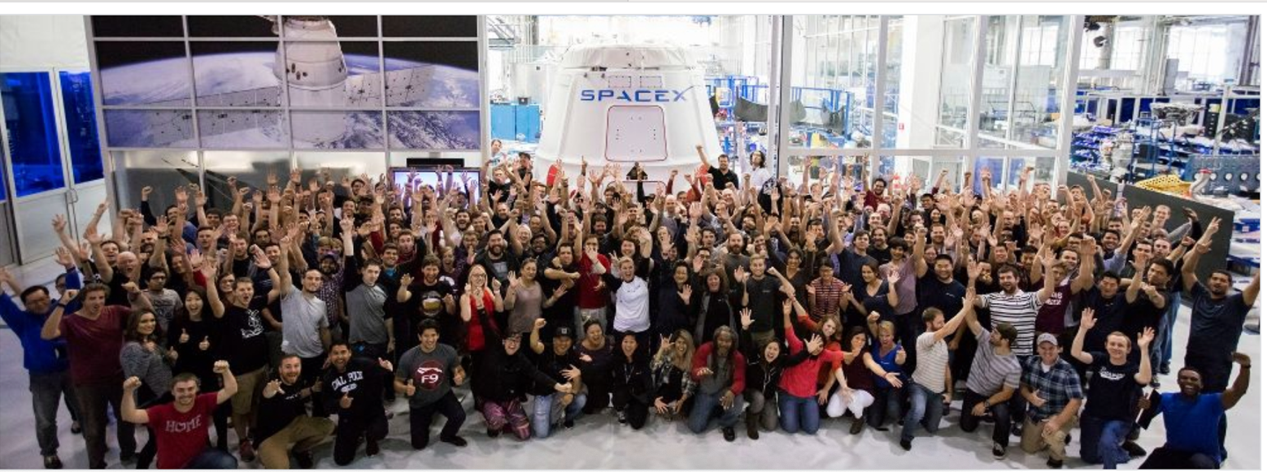

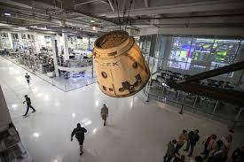

Discussion Questions:

1.- Identify the elements in the three levels of culture defined earlier.
2.- Identify contradictions between what the company says they are about and what they actually do. What can explain those contradictions?
3.- What is the effect of the reaction to the letter to the President written by employees on the organizational culture?
4.- How does Elon Musk founding of the organization affect the culture at SpaceX?
5.- If you were to change something about the organization’s culture, what would it be and how would you go about it?
References:

Belfiore, M. (2009, September 1). Behind the scenes with the world’s most ambitious rocket makers. Popular Mechanics. https://www.popularmechanics.com/space/rockets/a5073/4328638/

Boehm, J. (2017). What is it like to work at SpaceX?. Retrieved December 4, 2022 from www.quora.com/what-is-it-like-to-work-at-SpaceX

Careers (n.d.) SpaceX. Retrieved December 31, 2021 from https://www.spacex.com/careers/

Eidelson, J. & Grush, L. (2022, November 17). SpaceX is accused of illegally firing workers over Musk comments. Bloomberg.com

Elliot, R. (2022, June 02). Elon Musk tells Tesla, SpaceX employees to return to the office; workers must spend at least 40 hours a week in person, Mr. Musk says. Wall Street Journal.

Elon Musk anticipates third IPO in three years with SpaceX. Bloomberg. Retrieved December 31, 2021 from https://www.bloomberg.com/news/articles/2012-02-09/musk-sees-good-chance-of-spacex-stock-offering-by-next-year

Hadero, H. & Groves, S. (2022, November 17). Fired SpaceX employees accuse company of violating labor law. https://www.wjtv.com/news/national/ap-fired-spacex-employees-accuse-company-of-violating-labor-law/

Isaacson, W (2021, July 23). What makes Elon Musk different; nonfiction. The New York Times.

Klotz, A. (Host) (2020, May 27). SpaceX COO on prospects for starship launcher (Podcast episode) In Aviation Week’s Check 6. Aviation Week Network

Kosak, A. (n.d.). At SpaceX, we’re told we can change the world. O couldn’t, however, stop getting sexually harassed. https://www.lioness.co/post/at-spacex-we-re-told-we-can-change-the-world-just-don-t-try-to-stop-the-sexual-harassment

Maidenberg, M. (2022, June 16). Some SpaceX employees criticize Elon Musk’s behavior in letter; company needs to separate itself from CEO’s personal brand, letter to management says, Wall Street Journal.

Melby, C. (2012, May 12). How Elon Musk became a billionaire twice over. Forbes.com. https://www.forbes.com/sites/calebmelby/2012/03/12/how-elon-musk-became-a-billionaire-twice-over/?sh=795177071c88

Mission (n.d.) SpaceX retrieved December 31, 2021 from https://www.spacex.com/mission/

Mitchell, R. (2022, Nov 14). Is the world’s richest person the world’s worst boss? What it’s like working for Elon Musk. Los Angeles Times. https://www.latimes.com/business/story/2022-11-14/elon-musk-toxic-boss-timeline

Muegge, S. & Reid, E. (2019). Elon Musk and SpaceX: A case study of entrepreneurship as emancipation. Technology Innovation Management Review, 9(8), 18-29.

Ohnsman, A. (2021, December 14). Tesla hit by 6 more sexual harassment claims. Retrieved December 30 2021 from https://www.forbes.com/sites/alanohnsman/2021/12/14/tesla-hit-by-6-more-sexual-harassment-claims/?sh=754014485def

Rai, A. (2022, November 28). 8 Employees fired for criticizing Elon Musk in a letter. www.inventiva.co.in/trends/8-spacex-employees-fired-critizing/

Ralph, E. (2019, January 14). SpaceX lays off 10% of staff by email as Falcon Heavy, BFR and Starlink ramp up. Teslarati. Retrieved December 31 2021 from https://www.teslarati.com/spacex-10-percent-workforce-fired-bfr-starlink-launches/

Roulette, J. (2021,Demver 15). Former interns say SpaceX ignored sexual harassment incidents. The New York Times, 3.

Scheiber, N. & Mac, R. (2022, November 18). 8 as SpaceX cite reprisal over Musk. The New York Times.

Seedhouse, E. (2013). SpaceX: Making Commercial Spaceflight a Reality. Springer Science+Business Media.

Sheets, M (2021, October 8). Elon Musk’s SpaceX hits $100 billion valuation after secondary share sale. Retrieved December 31, 2021 from https://www.cnbc.com/2021/10/08/elon-musks-spacex-valuation-100-billion.html

Smith, Z. S. (2022, May 19). SpaceX reportedly paid $250,000 to settle sexual harassment accusation against Elon Musk. Forbes.com

SpaceX (n.d.) Forbes. Retrieved December 30, 2021 from https://www.forbes.com/companies/spacex/?sh=305e2782393a

SpaceX Reviews (n.d.) Glassdoor. Retrieved December 30, 2021 from https://www.glassdoor.com/Reviews/SpaceX-Reviews-E40371.htm

Tan, G.; Ludlow, E. & Turner, G. (2022, November 15). SpaceX is in fundraising talks that would value the company at over $150 billion. Bloomberg.com

Vance, A. (2012). Elon musk, man of tomorrow. Bloomberg Businessweek, 4296, 74-79

Vance, A (2020). The hero we deserve. Bloomberg Businessweek, 4658, 46-51

Wu, A. & Calic, G. (2022). Does Elon Mush have a strategy? Harvard Business Review Digital Articles.
Appendix B- Teaching Notes
SpaceX Case Teaching Notes

The instructor should define organizational culture, Schein’s definition is included in the body of this submission.

Then describe Schein’s three levels of organizational culture: artifacts, things we can see; espoused values, things the company says they are about; and finally, underlying assumption, the mental models that the organization’s member hold.

1.- Identify the elements in the three levels of culture defined earlier.

The instructor can use a board divided into three parts or three slides where information gets entered.

Some potential responses are described below:

Artifacts
- Plain offices, everyone in cubicles
- American flag
- Open area layout
- Casual dress
- Participate in Pride month
- Clean automated factory
- $150 Billion valuation
- Private company
- 11K employees
- Mission is everywhere
- Low salaries and few benefits
- Petty politics
- Gossip
- Elon Musk
- People wear swag
- 40 hours in the office are required
- People work very long hours and the weekend
- Watch launches together
- Able to walk around the factory and see the whole rocket building process
- Fratty atmosphere, bro culture
- Continuous improvement

Espoused Values
- Enable life on other planets
- Recruit world-class talent
- Potential to change life on earth and beyond
- Need to produce results quickly
- Prepare yourself for a level of intensity that is greater than anything you have experienced before
- Revolutionizing industries is not for the faint of heart
- Strive to create an inclusive workplace
- No tolerance and no asshole policy
- “We cannot fix what we don’t know”
- Continuously improve processes
Underlying Assumptions
- People want challenging and meaningful jobs and that is enough
- Smart people do not need guidance or support
- Work should be number 1 focus
- Good employees work long hours and do not complain
- We are cool and edgy
- Sink or swim and if you swim you can do a lot
- Musk is always right and is our role model
- Employees are not that important we will always find more
- Diversity is about ideas we do not care about other things
- HR is for protecting the company
- We are about results
- Do not challenge Musk

It is important to point out to the students how the different levels connect. The focus on mission and pride working there that shows in the espoused values, links to the artifacts of people wearing swag, working long hours. The assumption of being cool and edgy, connects to the espoused value of hiring world-class talent ready to produce results.

Overall, is a mixed experience to be part of the culture. The mission seems to override all other concerns and people are split between it and the reality of the long hours of work, uncertainty and not a welcoming environment. But since the company has been so successful any attempt to change something would prove to be difficult as elements in the culture get strengthened by the success of the organization.

2.- Identify contradictions between what the company says they are about and what the actually do. What can explain those contradictions?
Some examples are: while the company says they are about diversity, and have a not tolerance and no asshole rule, they do not value all employees the same, and there is harassment in the workplace that has not been handled properly. The unifying elements here is the assumption that good employees do not complain, therefore the ones complaining are in the wrong and nothing needs to be changed. The absence of a policy to deal with misconduct can be explain by the assumption that HR is about protecting the company, and that those are not the important things, what matters is the mission.

The value of continuous improvement only applies to the work, the people who wrote a letter proposing improvement to how the company handles things were fired, clearly the assumption of not challenging Musk and that good employees do not complain are stronger.

The value of changing life on earth does not include taking on environmental responsibilities within the organization. The underlying assumption that they are all about the mission as in making humans interplanetary species which overwrites other issues.

3.- What is the effect of the reaction to the letter to the President written by employees on the organizational culture?
As listed in the body of the submission, the way leaders react to critical incidents has a strong impact on what practices get embedded into the culture. The decision to fire the authors of the letter, creates a clear way to succeed at SpaceX, not complaining or questioning Musk. The swiftness of the response and the lack of ambiguity will make the message stronger.

4.- How does Elon Musk founding of the organization affect the culture at SpaceX?
The abrasiveness of Musk has permeated the organization as well as the culture of hard work and no questioning. Musk has set himself as an example of what a good employee is, one that works really hard. The way he talks about women and his behavior can be seen as support for the fratty atmosphere and problems with sexual harassment. The strong focus on mission, the willingness to invest his own money and the perseverance he has shown after initial failures, has also shown in the strong dedication to mission that employees have and the learning culture around launches and technology.
5.- If you were to change something about the organization’s culture, what would it be and how would you go about it?
The instructor can open the discussion around whether something needs to change or not. Many employees are happy with how the organization is but still their turnover is high, even though the company says their retention numbers are great. There seems to be an opportunity to create a better environment.
The success of the firm will make it harder to institute any changes as those actions that have proven to help the company be successful are what becomes part of the culture. Therefore, it would be a significant challenge to change anything at SpaceX.
One idea the instructor can introduce is the idea offered by Carroll & Quijada (2004) to take some parts of the culture and leverage those to effect change in other areas. Therefore, one could use the culture of learning and improvement in the area of technology and expand it to the way work gets done and to introduce ways to make work less likely to produce burnout. The ideas would have to be coached, then, around how it would be better for accomplishing the mission. Proposing improvements to work schedules based on things like, better work/life balance or being nice, would not be successful as those are not things that are important to the culture of the organization.
References:
Carroll, J. S., & Quijada, M. A. (2004). Redirecting traditional professional values to support safety: changing organisational culture in health care. BMJ Quality & Safety, 13(suppl 2), ii16-ii21.

