Title:
Online Experiential Exercise – Equity Split
Abstract:
In this communication exercise, teams are given different clues to a logic puzzle. In the online version, teams are in breakout rooms and select a messenger who will go to the main Zoom room to write messages to the messengers from the other teams then return. They need to share clues rather than assumptions, but that is something they must discover. Their team can only solve the puzzle by acquiring clues from the other teams, so trust is essential. Verbal interaction is prohibited, and written messages are only sent to individual messengers. Can also be run via an in-person version.
Keywords:
Communication; Logic puzzle; Hybrid experiential exercise

Introduction:
In this exercise, participants learn to navigate communication obstacles to achieve the goal of sharing information to solve a logic puzzle. Each team is given incomplete information and must gather needed information from other teams. By sharing among the teams, members can identify the partner who is to receive the 30% equity and the function she/he performs. Teams can only communication with other groups through written messages to gather clues and share information.
This exercise has been run with undergraduates, graduates, and executive groups.
Theoretical Foundation/Teaching Implications:
Kolb’s experiential cycle, 1984. In order to solve the logic puzzle, participants must identify effective methods in sharing information and collaboration within the team. The online version encourages the use of tools for recording information and recognition of individual approaches to problem-solving.
Learning Objectives:
- To examine the effect of decentralization on the communication process
- To experience collaboration as well as competition as groups work on a common goal
- Development of trust to facilitate sharing of critical information
- Explore effective methods of virtual communication
Exercise Overview:
This exercise has been run both in-person and via Zoom. The sessions have been 110 minutes long with roughly 20-30 minutes of debrief included. Typically, teams are randomly assigned but it is possible to use pre-assigned teams. Individuals are provided with a situation sheet and teams are provided with their clues, either printed cards or a link to an audio recording of the assigned clues. All teams are dependent on receiving the clues from other teams in order to solve the logic puzzle. Participants experience the need to build trust, effectively communicate and problem solve in an interdependent situation.
Session Description:
This will be a 45-minute fully online session. A Zoom link will be provided to participants. The exercise will be introduced, and the Situation handout link provided. Participants will be sent to breakout rooms to review the task and select a messenger to return to the main Zoom room to message the other teams’ messengers. After a few minutes, the specific audio clues link will be delivered to each room. Messengers will be called to the main Zoom room and the communication restrictions will be explained. Each messenger can return to their breakout room when desired. Messengers will be called back after about 5 minutes and periodically until the 30 minutes for puzzle solving are up. Messengers can choose to return or not. Everyone will be called back to the main Zoom room to share the answer and debrief the exercise. The full instructions including typical debrief questions are in the Facilitator’s Guide in Appendix A.

Appendix A

Description:
In this exercise, participants learn to navigate communication obstacles to achieve the goal of sharing information to solve a logic puzzle. Each team is given incomplete information and must gather needed information from other teams. By sharing among the teams, members can identify the partner who is to receive the 30% equity and the function she/he performs. Teams can only communication with other groups through written messages to gather clues and share information.

Facilitator Note: Would need to develop a shared method of delivering information to participants. We have used Google Drive for this exercise but have removed the links on this Facilitator’s Guide. Rather than written clues, we send audio versions of the clues for each team. This is done to require that all participants carefully listen to their clues and create the written version that they will share with other messengers. Otherwise, it becomes a simple cut and paste.

Goals:
- To examine the effect of decentralization on the communication process
- To experience collaboration as well as competition as groups work on a common goal
- Development of trust to facilitate sharing of critical information
- Explore effective methods of virtual communication
Setup:
- Each breakout room is assigned a color [As long as there is a Pink and a Blue room, all clues are in circulation.]
  - Pink
  - Yellow
  - Green
  - Blue
  - Tan
  - Red [if needed]
Place the in the chat box:
- +Equity Split Situation link
https://drive.google.com
- Equity Split Instruction Recap link
https://drive.google.com
- Equity Split Answer Sheet Jamboard
https://drive.google.com

Materials:
- +Equity Split Situation link
https://drive.google.com
- Equity Split Instruction Recap link
https://drive.google.com
- Equity Split Answer Sheet Jamboard
https://jamboard.google.com

Pink Team
Equity Split Audio Clues:
https://drive.google.com

Yellow Team
Equity Split Audio Clues:
https://drive.google.com

Green Team
Equity Split Audio Clues:
https://drive.google.com

Blue Team
Equity Split Audio Clues:
https://drive.google.com

Tan Team
Equity Split Audio Clues:
https://drive.google.com

Red Team
https://drive.google.com

- Final Answer to Equity Split Logic Puzzle
https://drive.google.com

Activity:

Setup the breakout sections with the colors assigned
  - #1 -Pink
  - #2 - Yellow
  - #3 - Green
  - #4 - Blue
  - #5 – Tan
  - #6 – Red [if needed]

Place the +Equity Split Situation, Equity Split Instruction Recap and Equity Split Answer Sheet links in the chat box.
- +Equity Split Situation link
https://drive.google.com

- Equity Split Instruction Recap link
https://drive.google.com

- Equity Split Answer Sheet Jamboard
https://jamboard.google.com

- Announce: “Welcome to the online Experiential Learning Center (ELC). I’m _______________, and with my colleague ______ we will be facilitating today’s exercise. You will be working with your group to solve a logic puzzle.
I will randomly assign you to breakout sessions. We will come to each breakout session to share an audio recording of 4 clues to help you solve the puzzle. You are not to share the audio link outside of your Breakout room. Since there are more than 4 clues distributed amongst the breakouts, you will need to find ways to interact with other groups to solve the puzzle. [Of course, not all groups or individuals may be operating with similar motivations.] You are seeking to solve:
- The person who is to receive the 30% equity in Four Trojans, Inc. and their company function,
- The function and seating location of each person at the meeting.

In your own group, you may confer verbally, but all communications between groups must be in writing. Clues may be exchanged between groups by sending written messages through Chat by the Messenger when in the main room. Please note that each group has a designated color. Today we are using the following groups: Pink, Yellow, Green, Blue and Tan.
Since you cannot send messages between breakout rooms, let me explain how you will send and receive messages.
First of all, as soon as everyone enters their breakout room, note the color assigned to your breakout group. If you click on the 3 dots in the top right corner of your picture, you will see the rename function. At the beginning of your name, please add the color assigned to your breakout group. For instance, if I was assigned to a red group, I would change my name to Red ______________.
After everyone introduces themselves and discusses how they want to work together, each breakout group will identify their messenger. This person will be the one that will move between the main room and their breakout group by clicking on the breakout icon at the bottom of their zoom screen. At regular intervals, all messengers will be invited to the main room to send and receive chat messages. That invitation will be sent via a broadcast message from the facilitator to all participants. The message will last for about 15 seconds so be on the lookout for it. Messengers are not permitted to speak to each other, just send and receive chats while in the main room. Do NOT sent the audio link or Google Jamboard , emails, slack, etc., to anyone outside of your breakout room. Only written chats sent directly to individuals, one at a time are permitted.
When your group feels you have solved the puzzle, use the ? at the bottom of the zoom screen to summon me or ______ to verify your answers. We will only tell you whether the answer is right or wrong. There will be no indication of what is wrong.
You have 40 minutes to complete this task; the task is complete only when all groups have the correct answer to the puzzle. (Be sure to give the groups a "10-minutes-remaining" warning.) Please go to the chat box to retrieve links to the description of the situation you will be working to solve, a link to a viewable-only Google Jamboard answer sheet and a recap of these instructions.
The Google Jamboard with the Answer Sheet in the CHAT is for viewing only. If your team would like to use it, just one person in each breakout room will need to copy it and share the new link with the other team members. The “Make a copy” option is accessed by clicking on the 3 dots next to the “Share” button on the top right of the Jamboard page. When you open the copy, you need to click “Share” and choose “Anyone on the internet with this link can edit” by, changing it from viewer to editor. Then “Copy link” and place the link in the CHAT for “everyone” in your breakout room. All members of the breakout room will be able to write to the new copy.
If you need me to come to your room, just click on the ? at the bottom of your screen to summon me.
Please ask your questions now before I send you to your rooms.”

Randomly assign to 5 breakout sessions which have the colors in the names. If needed, you can use 6 rooms using the Red Team Clues. If running with just 2 rooms, using the Pink and Blue Clues disburses all 6 clues.

Go to each breakout room and share the audio link corresponding to their room color and the room specific answer sheet:
Pink Team
Equity Split Audio Clues:
https://drive.google.com

Yellow Team
Equity Split Audio Clues:
https://drive.google.com

Green Team
Equity Split Audio Clues:
https://drive.google.com

Blue Team
Equity Split Audio Clues:
https://drive.google.com

Tan Team
Equity Split Audio Clues:
https://drive.google.com
Red Team
https://drive.google.com

Below are the clues that are given through the audio link for each room. The PP slides are not shown, only the audio link is delivered to each room. This is included only so you are aware of the clues that are shared with each room.

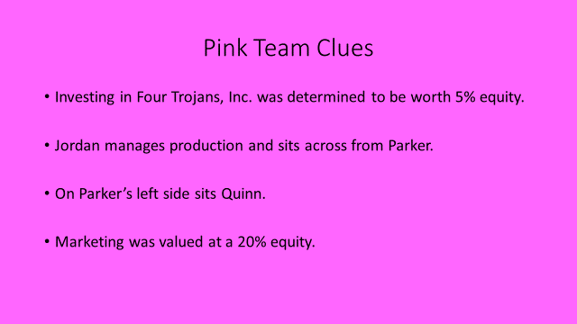
https://drive.google.com

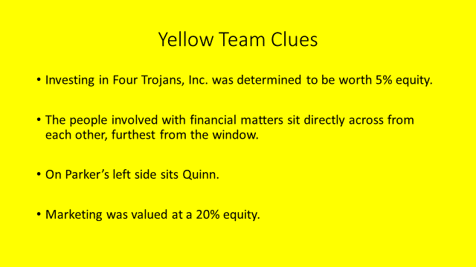
https://drive.google.com

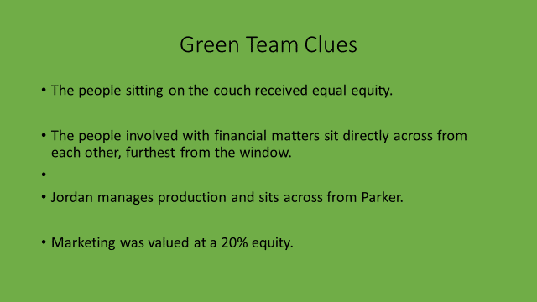
https://drive.google.com
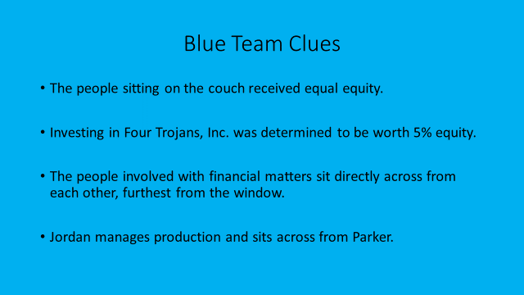
https://drive.google.com
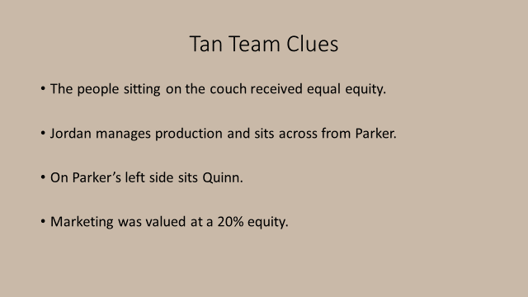
https://drive.google.com
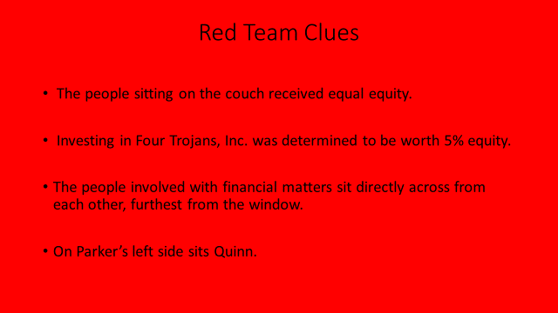
https://drive.google.com

- After visiting the last room, wait 3 minutes and send out this broadcast: At this time, all Messengers should leave their breakout room to come to the main room.

- Once all messengers are in the main room, announce: “Let me explain how messaging will happen. First, there is no talking. You must use the chat box, selecting the individual you wish to send a message to. Do not select everyone. I will know if you do that since I am part of everyone.
While you are here as a Messenger, you cannot write to your group’s shared documents. Your sharing must wait until you return to your rooms.
When you are done sending and receiving messages, you can return to your breakout session by selecting the Breakout icon and rejoining your room.
I will send another Broadcast message when it is time to come back to main room in about 5 minutes. Any questions?”

If messengers want more frequent meetups, adjust the time. Continue the Broadcast messages until time is up.

Messengers - If you want to, please join the other Messengers back in the main room. Your choice.

# minutes remain. If Messengers need to CHAT, you are welcome to come to the main room.

Throughout the session, pop into each room to see how they are doing. If the groups appear to be struggling and believe they do not have enough information or the correct information, you may want to reassure them that all the necessary information has been distributed to the groups. They may want to focus on exact clues rather than what groups are thinking are the right answers. (facts vs. analysis)

As groups summon you to verify their answers, you simply tell them if they are right or wrong. No further clues or hints.

When groups submit the correct answers, note their time but ask that they stay in their room until summoned to the main room for the debrief.

- After 40 minutes, broadcast: At this time, please join me in the main room for the debrief. Closing breakout rooms now.

If several groups were unable to submit correct answers you may wish to display (using screen share) the Equity Split Answer Sheet with Rationale and allow participants to read the solution. (3-5 min.)

DEBRIEF

Publishing:
- Reactions to the exercise
- May display last page of the Facilitator’s Guide with answers and rationale if not all completed the puzzle
Processing:
- Ask each team to comment:
  - How did you go about organizing this task?
  - How did being online impact the process?
- Do you expect the results of the activity would have been different if communication had been exchanged orally rather than in writing? (May discuss problems experienced with sending, filtering, and understanding communication.)
- What was the role of cooperation within groups and between groups? What facilitated/ hindered this process?
- Did you form opinions of other groups based on their behaviors? Or their messages?
- What was the role of trust in this activity?
- What problem solving techniques/strategies proved to be effective?
Generalizing:
- Can you think of a situation in a business setting that would be similar to the task in this exercise?
- Do organizations use problem-solving techniques similar to the ones your group used?
- Where would these be effective and where might they be ineffective?
- How do organizations communicate between departments? How different or similar?
Applying:
- What did you take away from this experience that you can apply in real life in work teams?
- When communicating with other groups, what would you do differently? The same?

Clues:
- The people sitting on the couch received equal equity.

- Investing in Four Trojans, Inc. was determined to be worth 5% equity.

- The people involved with financial matters sit directly across from each other, furthest from the window.

- Jordan manages production and sits across from Parker.

- On Parker’s left side sits Quinn.

- Marketing was valued at a 20% equity.

NOTE: Any distribution may be used so long as each of the six clues are distributed throughout and no one group has all six. Remember to verify that all six clues have been distributed.

Blue Pink Yellow Tan Green Red
1,2,3,4, 2,4,5,6 2,3,5,6 1,4,5,6 1,3,4,6 1,2,3,5
The Equity Situation

Four University of Southern California Marshall School Graduates, Jordan, Parker, Riley, and Quinn, have created a startup company called Four Trojans, Inc. They are meeting to determine the equity split amongst the partners who all had made significant investments, and their Angel Investor, Angel.

After intense discussions, they have agreed on the skills/talents that have contributed the most to the success of Four Trojans, Inc. – marketing, management, production, investment/funding and accounting.

The equity amounts they have determined that correspond to the contributions are: 30%, 25%, 20%, 20%, and 5%. Although they agreed that one partner would receive 30%, they had not explicitly named the person or their contribution. They have decided to have a secret ballot of sorts to identify who the majority felt deserved the 30%. To have a bit of fun, they have decided to vote using Sacagawea dollar coins. With eyes closed and on the count of 5, each participant tossed their coin towards the person that would get the 30% equity. The sound of 4 coins hitting the window broke the silence. Use the Equity Answer Sheet to identify the position of each person, their role in Four Trojans, and their equity. It will help solve the mystery of who received the 30% and what function they perform for Four Trojans, Inc.?

https://qz.com/work/1496160/where-you-sit-at-a-meeting-may-say-something-about-your-role/

Equity Split Instruction Recap

Here is a recap of the instructions you were given before being sent to your breakout sessions.

- Click on the 3 dots in the upper right hand corner of your image on Zoom to add the color assigned to your breakout room to your name. Example: Red Tommy Trojan.

- Introduce yourself to your teammates and discuss your approach to solving the puzzle and obtaining additional clues.

- Identify who will be your Messenger. This person will go to the main room when invited by the broadcast message. Using the Chat box, they will send written messages directly to the Messengers from the other teams (Pink, Yellow, Green, Blue, and Tan) while all in the main room. Talking in the main room is not permitted during the Messenger sessions. Do not share the audio clues with any Messengers. Only written communication is allowed between the subgroups and Messengers are the only ones responsible for this function.

- Messengers will move between their Breakout groups and the main room by using the Breakout icon at the bottom of their screens.

- The Facilitator or ELC Staff member will come to each breakout session to deliver a link containing an audio recording of your Team’s 4 Clues. Do NOT share this link with any other Team. Feel free to write down the Clues as you listen to them and you can listen to them multiple times. Written messages sent directly to individual Team Messengers are how your Messenger will communicate with other teams only when in the main room.

- Once you feel that you have the correct answer to all parts of this puzzle, summon the facilitator to your breakout room for verification of your answers. The facilitator or ELC staff will only tell you if your answer is right or wrong as a whole. If any part of the answer is wrong, you will be asked to continue working on the puzzle. Since each sub-group is being timed, it is important that you make the facilitator aware of your answer just as soon as you think you have it. There is also no penalty for being wrong so you can submit your answers more than one time!

- The task is considered completed only after ALL the subgroups have the CORRECT answer!

- You can summon the Facilitator to come to your room at any time by clicking on the question mark at the bottom of your Zoom screen.

Good luck and have fun!

