Title: SWOT: Not just for marketing, a Sweet Way Of Teaching!
Authors: Patricia Hubbard
Format: Activity or exercise
Time requested: 60 minutes
Abstract
Experiential learning is a foundational method of teaching and demonstrating knowledge for students. This session will show an interactive activity that builds on students’ professional development and real-world skills. In this session, participants will do a hands-on activity using digital tools. This activity was used in postgraduate business courses for students to prepare business plans. It demonstrates the use of collaborative and digital tools that can be used for face-to-face or virtual learning environments. Participants will complete the activity and share learnings from the experience. As we progress into the future, students will need to obtain more professional skills and creative thinking using digital tools.
Keywords: employability, graduates, professional development

Introduction
Experiential learning is becoming a prevalent method in the classroom to provide students with a rich understanding. This activity will have a hands-on experiential learning experience for participants using the SWOT framework. SWOT is not just a framework for marketing students, and I have found it enhances students’ ability to solve real-world problems for companies. This is typically targeted at postgraduate students that are preparing business plans but could be used in other undergraduate settings. It is applicable in online or face-to-face settings. Students can experience a real work application of the framework and practice key communication skills such as teamwork, collaboration, presentation, and soft skills. The activity in this session will centre around the preparation for a business plan for a particular company. By determining the SWOT analysis, participants can learn a lot about a company in a desktop review. This activity demonstrates the use of digital collaborative tools in the classroom and ideas to unpack student work.
Background on the key concepts
SWOT stands for Strengths, Weaknesses, Opportunities, and Threats (see Appendix A for more information).
Strengths and weaknesses are internal to your company—things that you have some control over and can change.
Examples include who is on your team, your patents and intellectual property, and your location.
Opportunities and threats are external — things that are going on outside your company, in the larger market. You can take advantage of opportunities and protect against threats, but you can’t change them.
Examples include competitors, prices of raw materials, and customer shopping trends.

Theoretical Foundation/Teaching Implications
The interactive session includes at least one or two research-informed learnings that teaching staff can experience as students and reflect on as academics (Lave & Wenger, 1991). Sharing collective wisdom in a session allows the opportunity for a thorough interrogation of teaching techniques before application in teaching sessions (Bocala, 2015).

An overall framework to represent the shift to online and in-person teaching activity options is the Technological Pedagogical Content Knowledge (TPACK) which strives to determine what teachers need to incorporate technology into their teaching (Herring, Koehler and Mishra, 2016). A key component of this framework is how teachers might develop this knowledge in the post-covid teaching environment. Further, Rapanta, Botturi, Goodyear, Guardia, & Koole (2020) discuss the pedagogical content knowledge (PCK) framework and its application during this time. This activity considers the need to be flexible and agile with future teaching ideas and applications.

The structure of the courses brings in experiential learning opportunities to ensure that what students learn applies to their careers. Bruni-Bossio and Delbaere (2020) demonstrated that professional development workshops developed students’ tangible and intangible skills. Our course experience offers another perspective and guidance on other universities that wish to change the perceptions of learning value.

The main purpose of this session is to provide an opportunity for participants to engage with other participants on the topics relevant to a business course in a way that increases employability to graduates and meets the workforce’s needs.

Learning Objectives
This activity was used in a postgraduate business course titled Professional Development. The objective of this course was to demonstrate business skills such as writing business plans to students in team settings. By the end of the class, the students create a full business plan-type summary poster for presentation, and this activity is a crucial part for them to dive deeper into business analysis. This course used a mix of team-based learning sessions in two-hour blocks each week to deliver content and the LMS for flipped classroom content. The course, as it was delivered, had sound and well-researched underpinnings and had mostly relevant and targeted material in connection to the Learning Outcomes (LOs).

The course learning objectives connected to this activity were:
LO1 Apply effective professional interpersonal communication skills in business contexts.
4a. Communication (Oral)
4c. Engagement (Collaboration)
LO4 Develop a personal professional profile that presents your knowledge, skills, and attributes to potential employers.
4a. Communication (Oral)
4b. Communication (Written)
5a. Independence

Exercise Overview
The activity will be conducted over a 60-minute session and can be scaled for any size of the class. The teacher will provide the class with a digital copy of the Google Slides template via a link that can be used on any student device. The activity can be modified easily for in-person or virtual delivery as it is all web-based tools (see Appendix B). I have run this activity multiple times with postgraduate students, and their feedback is positive. Students enjoy the real work application and see it as a consulting opportunity. It gives participants hands-on learning and using real companies provides an application component to their careers. The activity can be compressed or expanded depending on time and the number of participants. Also, the debrief of the activity is provided by the students which gives them additional presentation skills and real work application. The teacher also provides a debrief of the activity and context around the summarised learnings.

Session Description
This session will primarily be hands-on with participants using the digital tools provided to participate in the same activity students completed. The teams or pairs in the session will use Google Slides to create a mini presentation on the topic and present it back to the session. This is replicating the activity as the students completed it in the course using desktop research on the company to compile SWOT information for a mini-presentation to the class.
Timeline (60 minutes)
0-5 minutes | Introduction
5 – 15 minutes | Background and Activity/Tools Briefing
15-45 minutes | Hands-on Team/Pairs SWOT Activity
45-55 minutes | Mini presentations (Teams/Pairs)
55-60 minutes | Conclusion/Learnings

References
Bocala, C. (2015). From Experience to Expertise: The Development of Teachers'
Learning in Lesson Study. Journal of Teacher Education, 66(4), 349-362.
Bruni-Bossio, V., & Delbaere, M. (2021). Not everything important is taught in the
classroom: Using cocurricular professional development workshops to enhance student careers. Journal of Management Education, 45(2), 265-292.
Herring, M. C., Koehler, M. J., & Mishra, P. (Eds.). (2016). Handbook of
technological pedagogical content knowledge (TPACK) for educators. Routledge.
Lave, J., & Wenger, E. (1991). Situated learning: Legitimate peripheral participation.
Cambridge university press.
Rapanta, C., Botturi, L., Goodyear, P., Guardia, L., & Koole, M. (2020). Online
university teaching during and after the Covid-19 crisis: Refocusing teacher presence and learning activity. Postdigital Science and Education, 2(3), 923–945.

Appendix A
SWOT Background
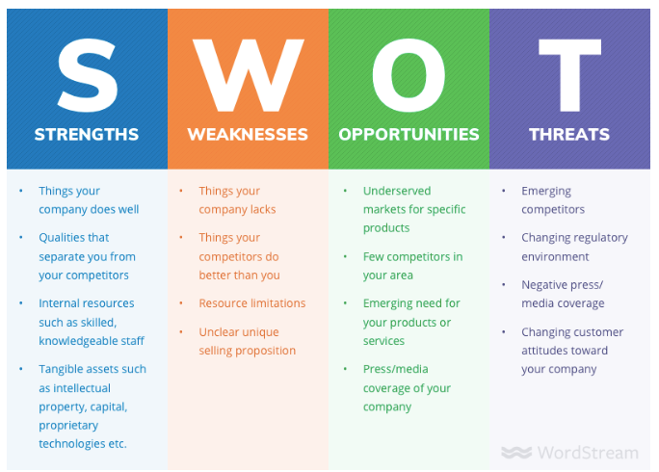
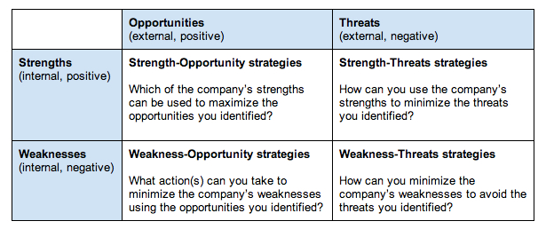

Appendix B
Screenshots of Google Slides used for activity
