MOBTS Oceania Conference February 1 – 3, 2023

Submission for Session Format – Roundtable

Session Title: Virtual Action Learning – Students feel lift-off, but what’s the view from the cockpit?

Abstract:

Higher education has become the staging ground for a myriad of engagement strategies as teaching academics around the world respond to the higher education challenges in a Covid and post-Covid environment. Whilst evidence exists as to the success of action learning as an effective student engagement strategy (Rimanoczy, 2016), there appears to have been less focus on understanding and evaluating the challenges of implementation from the teacher’s perspective (Brook et al., 2021). Our ongoing research considers this aspect of developing and implementing an action learning approach in both an undergraduate and a postgraduate program, within the private higher education sector.

Key Words: Action learning; Active Learning; Student engagement; Teacher perspective

Introduction:

For some time now academics have understood student engagement as a critical indicator of how higher education students experience their learning, although the contested term continues to deliver various definitions and interpretations. This has been exacerbated by the increasing global competition for students and concern for their progression and completion, but especially the consequences of the COVID 19 pandemic, where focus shifted from face-to-face teaching to the necessary enlarged and challenging online experience. One paper by Pickford (2016:30) offers a useful multi-dimensional conceptualization of student engagement dimensions, emphasizing the need to consider engagement in terms across student body, mind, and heart, reproduced in Diagram 1 below.

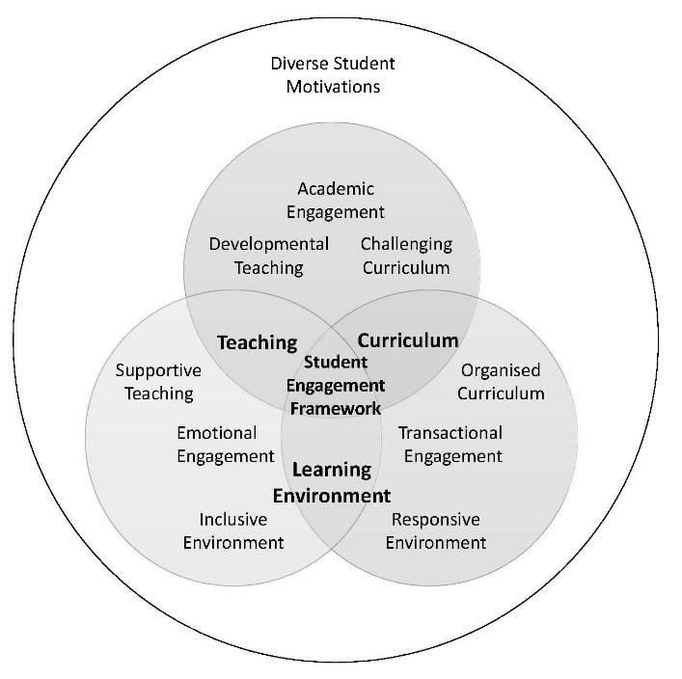
Diagram 1: An embedded multi-dimensional student engagement framework (Pickford, 2016; 30)

Tight (2020: 689), like many others, links student engagement and student retention as critical contemporary concerns for higher education, arguing that research on engagement now dominates, ostensibly because of changing financial landscapes that prioritize a shift from student to institutional responsibility. Global regulators also are concerned with engagement as it relates particularly to completion rates.
Moreover, given that engagement is affected by the academic approach to learning and teaching, it is not surprising that, with the rise of educational technology, engagement is now linked to the question of its use, for example, in blended learning. Sahni (2019:1) researched the impact of blended learning on student engagement, focused on an Organizational Behavior course over a semester, and found that student motivation increased with enhanced control over their learning in terms of place, time and pace involved. He states that the research provides “evidence for the positive outcomes of a blended learning approach; leads to higher student achievement and improves student engagement.”
Nowadays, sophisticated use of course learning analytics can be used to enhance engagement, supporting the engagement of both students and academics (Brown et al, 2022). Gamification and design thinking are now more extensively used as part of instructional design to enhance engagement (Garden and Rivera, 2022). Yet technology tools often lead rather than enable learning and teaching and, therefore, the extent of student engagement.
One more long-lived approach to student engagement before such sophistication, that of action learning, has nevertheless been regarded as a crucial tool in enhancing student engagement as reinforced in many recent research studies (e.g., Omiyefa, 2021; Brook et al, 2021). Yet, whilst positive for students involved, little work is evident on the issues teaching staff confront when introducing action research into their classrooms, challenges that need consideration to ensure that the many benefits of action learning result in increased student engagement and its positive consequences. That is the key focus of the Roundtable proposed.

Theoretical foundations

Our Roundtable discussions reflect the application of action learning in higher education as a means of maximising student engagement. In doing so it builds on the theoretical foundations embedded in both action learning as a pedagogical process, as well as interconnected characteristics of student engagement which links organisational, subject, and teaching challenges within our tertiary institutes, all of which respond to what should be a student-centric approach by our higher education systems.
Action learning in a classroom situation provides students with agency for their learning (Lombardi et al., 2021) and, therefore, relies on mutual responsibilities between the student and the teacher, with a focused reliance on the adequate class preparation responsibility of the student and appropriate and structured facilitation on the part of the teacher. This moves the classroom dynamics from a passive traditional teaching methodology to advancing higher learning outcomes and knowledge integration. Both these desired outcomes are consistent with many course and subject level learning outcomes from across higher education institutes and consistent with the Australian regulator TEQSA’s messaging regarding the constructive alignment process of reflecting learning outcomes with assignment structure and content.
Whilst active learning and action learning contain different elements involved in their execution, they are based on similar fundamental constructs and, accordingly, our approach in this roundtable discussion is built on key elements of action learning, principally the notion of programed knowledge, insightful questioning, and reflective practice. This underlying connection between action learning and active learning is further clarified when considering the work of Bransford et al. (2000) which further highlighted the key elements of active learning involving students taking control of their learning through metacognitive sense making, self-assessment and reflection, all readily recognised attributes of action learning. Such comparisons have been identified by Han (2021) where action learning has been shown to be a key approach in active learning and enhancing student engagement.
Such a focus on course and subject level learning outcomes is highlighted by Oliver & Jorre de St Jorre (2018) where comparisons are made of the attributes that higher education providers most frequently emphasise and those most poorly rated by students in Australia’s Quality In Learning And Teaching (QILT) surveys (2015, 2016b). The results suggest critical and analytical thinking; ability to learn and work independently, and problem-solving, are potentially the types of skills that students will need into the future. These skills need to be reflected in course and subject level learning outcomes and are ably met through a focused approach to action learning as a principal method of engaging with students and improving, over time, their ability to develop the sorts of skills identified in the QILT Surveys.
At the heart of our focus on maximising student engagement is the application of student-centricity becoming a principal means of addressing this issue as depicted in Diagram 2 below.

Teaching challenges
Subject challenges
Organisational challenges

Diagram 2: Interrelationships for maximising student engagement
(Rosenbaum, More & Razi, 2022)

In this context we consider the necessary interrelationships between subject matter, teaching challenges and organisational issues at the institutional level as the necessary elements underpinning levels of student engagement.
The organisational challenges reflect the need for higher education institutions to ensure that internal resource requirements that support both academic capability and implementation are provided at levels to adequately and effectively accelerate the ability to respond to broad-based solutions targeting student engagement.
The subject matter element is best considered in terms of relevant subject matter characteristics that need to be considered when understanding the way students engage best with the material necessary to achieve technical competence in the subject matter and how these are best linked to both course and subject matter learning outcomes.
The teaching challenges are best characterised by the technical skills teachers require to effectively engage with their students by relaying necessary knowledge and practice. However, these teaching challenges go beyond this very fundamental requirement which has always been at the heart of didactic learning approaches (White et al., 2015). Rather, engagement at the action learning level is a means of transferring ownership for learning to the student by developing a broad set of skills enabled by the teacher and learning context. Such skills enable the student to use base-level information to research topics and engage with fellow students to consider and apply wide-ranging options. Students then learn from such an iterative process and develop solutions to complex questions and scenarios, reflect on outcomes, and consider the iterative approach to solution development in line with an experiential approach to learning (Kolb & Kolb, 2009), focusing on the original experiential learning model involving concrete experience, reflective observation, abstract conceptualisation, and active experimentation.
Student centricity has received limited focus in the research literature where the move from teacher centricity has been identified in teaching in hospitality and tourism education (Thaliath, 2015); highlighted in relation to curriculum development (Taimela, 2019), and within the US community college system (Lockemy & Summers, 1993). The interrelated issues identified in our student engagement framework suggest that, to successfully focus on student needs and requirements and, therefore, address effective student engagement levels, all challenges identified in this framework must be understood and addressed to ensure outcomes of maximising student engagement are achieved. The VUCAD world that we face challenges our higher education environment with global competition accelerating; technologies converging; skills for employability changing, and the demands of life-long learning signifying our learning frameworks must rapidly evolve to deal with the escalating need to maximise student engagement – for the sake of successful student experience leading to lifelong learning capabilities.
One of the fundamental starting points in this relationship identified in Diagram 2 is preparing academics in designing and implementing action learning through professional development, leading to appropriate course and assessment design, as well as subject delivery methods using action learning principles and processes. The course and subject design support student advantage across cognitive (e.g. reflection), affective (e.g. positive interactions), and behavioural (e.g. developing agency) approaches, whilst the assessment design enhances academic integrity and assessment security in a growing contract cheating environment.

Session Description

This session will be conducted in face-to-face mode of 60-minute duration. The structure of this session will be as follows:

- The first 10-minutes will introduce Action Learning as an important student engagement strategy and briefly raise the challenges that higher education institutions face to implement it. During this part of the session, the group will be presented with summary qualitative and quantitative data regarding outcomes of recent Action Learning examples in some private higher education institutes . This will be in diagrammatic form for easy absorption. Participants will then be asked to discuss these results and identify what this could mean for their own teaching practices whilst considering any relevant cultural implications?

- This will be followed by 40-minutes of discussion in groups which will be facilitated by moderators the three authors of this Proposal, who will act as facilitators. One participant from each of these sub-groups will be appointed to present findings and conclusions when the sub-groups are re-joined. The extent to which the entire Roundtable can be split into 3 groups will depend on the total number of participants, and, accordingly, flexibility with this aspect of the session will need to be applied. Participants will be encouraged to discuss the topic and provide their perspectives to the 4 challenges identified below, where these challenges will, in themselves, be presented and discussed in an action learning framework. Within these questions there are opportunities to explore other issues raised by participants in the context of the session title.

Action Learning questions for the Group to consider:

- In the context of Diagram 1 and Diagram 2 of the detailed proposal document, what should be the institutional responses that support academic efforts in implementing action learning?

- In the context of blended learning, in various versions, defining the possible future for subject design and delivery across many if not all higher education institutions, what are the challenges in synchronous and asynchronous modes of action learning and how could these be addressed?

- To what extent is reflection and reflective practice an important skill for graduates? How should this be considered from an assessment perspective either at a personal or group level?

If there are sub-groups, these will be brought together into the one group to present and discuss overall ‘findings and conclusions’ during the last 10-minutes.

The last few minutes of the roundtable will wrap up and consider the next steps at an institutional level.

Participants will go away from the Roundtable with an enhanced theoretical and practical understanding of Action Learning, some examples of its use in classrooms, some ways of dealing with the challenges of its implementation from the teacher’s perspective, and can be part of a growing global network of those interested in Action Learning.

References:

Bransford, J.D., Brown, A.L., & Cocking, R.R. (eds.). (2000). How people learn: Brain, mind, experience, and school (Expanded ed.). National Academies Press.

Brook, C., Lawlesss, A. & Sanyal, C (2021), “Adaptive action learning: a refusal to define,” Action Learning: Research and Practice, 18:1, 1-4.

Brown, A. Lawrence, J, Basson, M. and Remond, P, (2022), “A conceptual framework to enhance student online learning and engagement in higher education,” Higher Education Research & Development, vol. 41, 2, 284-299.

Garden, C. & Rivera, E. (2022), “Gamified Learning in Higher Education: An Instructional Design Method to Improve Engagement,” Handbook of Research on the Influence and Effectiveness of Gamification in Education, IGI Global, 497-520.

Han, S. J., Lim, D. H., & Jung, E. (2021). A collaborative active learning model as a vehicle for online team learning in higher education. In Research Anthology on Developing Effective Online Learning Courses (pp. 217-236). IGI Global.

Kolb, A. Y., & Kolb, D. A. (2009). Experiential learning theory: A dynamic, holistic approach to management learning, education and development. The SAGE handbook of management learning, education and development, 42, 68.

Lockemy, M. J., & Summers, S. (1993). From Teacher Centered to Student Centered Learning.

Lombardi, D., Shipley, T. F., & Astronomy Team, Biology Team, Chemistry Team, Engineering Team, Geography Team, Geoscience Team, and Physics Team. (2021). The curious construct of active learning. Psychological Science in the Public Interest, 22(1), 8-43.

Omiyefa, M. (2021), “Action Learning Strategy and Students’ Knowledge of Character Education Concepts in Social Studies,” Anatolia Journal of Education, vol 6, no. 1, 67-78.

Oliver, B., & Jorre de St Jorre, T. (2018). Graduate attributes for 2020 and beyond: Recommendations for Australian higher education providers. Higher Education Research & Development, 37(4), 821-836.

Pickford, R. (2016), “Student Engagement: Body, Mind and Heart – a Proposal for an Embedded Multi-Dimensional Student Engagement Multiple-Dimensional Student Engagement Framework,” Journal of Perspectives in Applied Academic Practice, 4 (2), 25-32.

QILT. (2015, 2016a, 2016b). Student Experience Survey national reports. Australian Government Department of Education and Training

Rimanoczy, I. (2016). Stop teaching: Principles and practices for responsible management education. Business Expert Press.

Sahni, J. (2019), “Does Blended Learning Enhance Student Engagement? Evidence from Higher Education,” Journal of e-Learning and Higher Education, vol. 2019, 2169-0359).

Taimela, S. (2019). Exploring Student-Centricity In Curriculum Development. In EDULEARN19 Proceedings (pp. 6559-6563). IATED.

Thaliath, A. (2015), From Teacher Centric to Student Centric Learning: Building Teaching Effectiveness in Hospitality and Tourism Education-A Critical Perspective. International Journal of Engineering Technology, Management and Applied Sciences, vol. 3 (5), 124-128

Tight, M, 2020, “Student retention and engagement in higher education,” Journal of Further and Higher Education, 44:5, 689-704, DOI:10.1080/0309877X.2019.1576860.

White, P. J., Larson, I., Styles, K., Yuriev, E., Evans, D. R., Short, J. L., ... & Eise, N. (2015). Using active learning strategies to shift student attitudes and behaviours about learning and teaching in a research intensive educational context. Pharmacy Education, 15.

